Location and Boundaries

The site is located in a rural location in Hampshire, with the nearest town being Romsey, which is approx. 3 miles away. The site is not located in an area of Special Scientific Interest, Area of Outstanding Natural Beauty, National Park or Special Conservation Area.
The site is surrounded by an old landfill site to the north and east, a HWRC site to the south and a road to the west, with farmers field on the other side of the road. There are residential properties north of the historic landfill to the North 200m from the sites northern boundary.

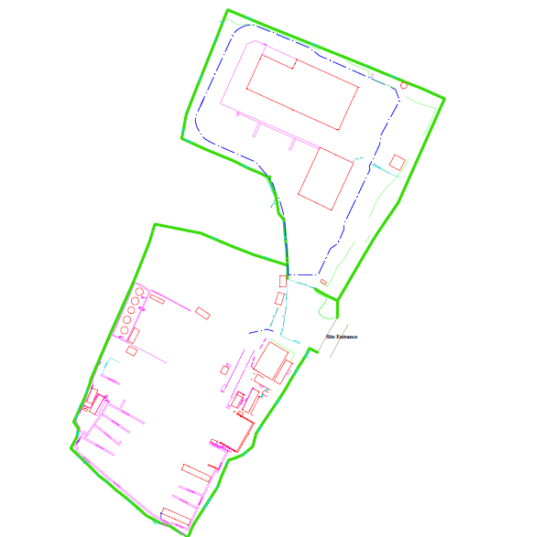

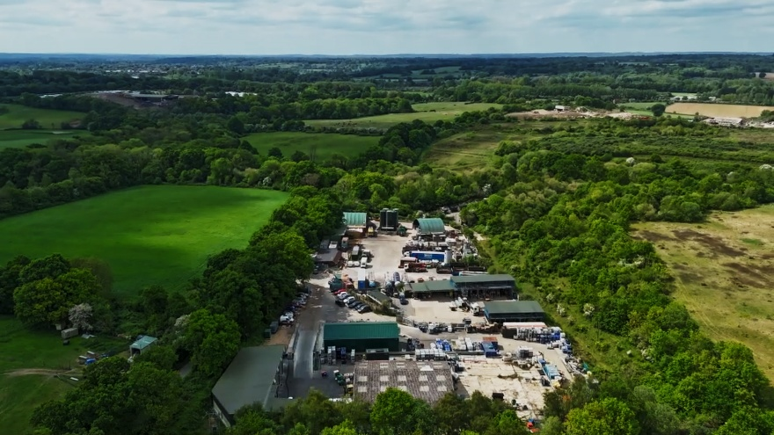
Historically the site was occupied by a sawmill in the north and a tarmac business in the south. The site is surrounded by mature trees bordering the historic landfill and the road to the North and West. There is a solid fence that surrounds the southern boundary and a palisade fence around the remainder of the facility. Access to the facility is via bunny lane where there is a security barrier and lockable gates to prevent unauthorised access to members of the public or vehicles during operating hours and secure the site when not operational.
Site Conditions & Background of Developments

In 2018 the business was purchased by GRG Waste UK. The site has undergone extensive improvements since it’s purchase and a substantial permit variation was submitted in 2022 and issued in April 2023. This was to reflect a reduction in tonnages across the site, addition of new activities and new storage areas and improved infrastructure across the site through investments in the below infrastructure;

- New bulk storage tank farm bund installed as fixed installation with concrete bunding. This was designed in accordance with CIRIA guidance complete with fixed installation of actuated valves, level gauges, designated offload ports and local HMI panel and carbon abatement for waste engine oil storage and transfer
- New Transfer station portal frame packaged waste storage building with designated fire rated segregation between bays and thermal imagine cameras and detection, designed in accordance with CIRIA guidance and installation of a new tertiary containment wall. This was designed in accordance with current HSG71 guidance and EA fire prevention plan guidance
- New Plastics/Packaging recycling building within self-contained bunded impermeable storage area (This new area was constructed as part of the development)
- Bund wall improvements across the lower yard area including a new 750mm containment wall along the boundary across the lowest side of the facility to future proof the site for climate change events and provide additional containment if required in the event of a fire
- Addition of new road sweeper waste recycling process including dewatering equipment and associated wash water storage
- New storage tanks replacing older storage tanks within the lower yard tank farm
- Addition of new bunded storage bays D12 & D13 for handling excess solids from road tankers or road sweepers
- Addition of a LEV cabinet for handling flammable packaging and flammable wastes extracted through a 2-stage carbon filter and designated emission point
- Various areas of concrete replacement, GRP lining of drains in storage areas & upgraded electrics / infrastructure within process or storage areas
- Investment in a new containerised laboratory complete with ED-XRF analyser, Calorimeter, Spectrometer, Flash Point tester & associated infrastructure to allow robust testing of wastes received at the facility

The improvements represented approximately 1.7 Million pounds invested in the facility to bring it into line with current guidance on storage and containment as well as addition of new buildings to house new infrastructure.

Since the variation BKPs business has changed and the facility is moving away from a lot of the waste treatment processes the site completed and is removing them within this variation to better reflect the business direction. This information is covered within the non-technical summary but the impact of this is that the number and nature of vehicles the site can accept will reduce as the business becomes more focused on packaged wastes as opposed to tankers or road sweepers.

The site has done further concrete improvement and bunding investments since 2023 to allow full segregation of any storage and process areas from non-storage, non-process areas to allow this uncontaminated water from impermeable surfaces to be safely discharged to the environment without the risk of contamination. This includes a number of additional bunds added as detailed within the surface water management documentation,

The detail on this is included within the risk assessment below as well as a ground water risk assessment submitted within this application and detail on the daily operation and management of each operation is included within the associated SOPs.

As part of this variation as well as removing installation activities the site wants to add waste/mixing and blending of hazardous and non-hazardous wastes to allow more efficient disposal at third party facilities. Hazardous and Non-Hazardous wastes will not be mixed and the detail on this activity is covered within the associated standard operating procedures.

Contents of Risk Assessment

A1a) – Mixing Blending – Water/Ground
A1b) – Mixing/Blending – Air
A1c) – Mixing/Blending – Noise
A1d) – Mixing/Blending – Accidents

B1a) – Lower Yard Including Surface Water Management – Water/Ground
B1b) – Lower Yard Including Surface Water Management – Air
B1c) – Lower Yard Including Surface Water Management – Noise
B1d) – Lower Yard Including Surface Water Management - Accidents

Hazard | Receptor | Pathway | Risk Management and Control measures | Probability of Hazard | Consequence | What is the overall risk
A1.a) New Activity – Waste Mixing / Blending - Accidents risk assessment and management plan – To Water / Ground
A1ai) Release to water through uncontrolled run off or overfilling of vessels | Release to groundwater | Ground | Operation completed within self-bunded steel cabinet with >110% containment for containers within it at any given time. Cabinet within tertiary containment of impermeable concrete wider transfer station yard with large containment capacity. Operator manages process and ensures all containers to be filled have sufficient capacity to receive the volumes within them. All operation completed within designated bund and all potential spillages are contained and spills managed by operator | Unlikely | Contamination of groundwater or land through infiltration | Not significant
A1aii) Release to water through spillage | Release to ground water | Ground | All waste materials associated with this activity stored in concrete fire rated impermeable storage bays with sealed impermeable sumps. All bays designed to provide >110% of largest container within and larger impermeable tertiary containment. Spillages during operation are contained within cabinet bund. Spillages in storage locations are cleaned following the site spillage procedure and residues can be jetted into local sumps and pumped out and disposed of to a licenced 3rd party facility. Integrity checks and visual checks of site infrastructure completed daily as well as inventory checks to ensure no containers are leaking by site management team or site chemists | Unlikely | Contamination of Ground Water or land through infiltration | Not Significant
aiii) | Contaminated Water | Ground | All operations completed within building within bunded area. All waste storage within buildings within wider bunded area. All water from transfer station area transferred offsite and treated as contaminated as per BKP-SO-Surface Water Management. Tertiary bunded area designed in accordance with CIRIA 736 | Unlikely | Contaminated of Ground Water or land through infiltration | Not Significant
A1 b) New Activity – Waste Mixing / Blending - Accidents risk assessment and management plan – To Air
A1bi)Release of pollutants to air through normal operations | Local Population | Air | Mixing and Blending completed within LEV Cabinet onsite. Containers are pumped out within cabinet using air pumps and receiving containers are dip filled to prevent splashing and additional VOC release. Displaced air from containers being filled is abated within the cabinet as 1st stage through 205L Granular activated carbon drum. All air from within the cabinet is extracted through 2 stage carbon filter external to the building and then released to atmosphere through vent exhaust line above building in accordance with HSG 258 requirements. Carbon within cabinet is changed by operator a minimum of 3 monthly to avoid saturation and carbon on main LEV cabinet carbon filter housing is replaced a minimum of annually. VOC monitoring completed in the cabinet by operator when cabinet is in use using calibrated handheld VOC monitors to ensure no VOCs being emitted in operation. Operators trained in work instruction and operating procedure. MCERTS emissions monitoring completed when cabinet is in use every 6 months in-line with permit. requirements. Cabinet in use for under 2 hours daily. Nearest residential receptor is 200m North of site location shown in figure 1 in this document, prevailing winds are Southwest to West in site location shown in figure 2 so any air emissions are directed across the facility during normal wind conditions and in opposing direction of any human receptors. No HP6 category 1 and 2 materials are mixed or blended during the operation. All materials compatibility tested prior to mixing and blending and excluded wastes prohibited. All operations managed by trained HNC qualified chemists and compatibility testing completed in robust onsite laboratory by laboratory chemist as detailed in SOP  Operation completed poses no greater risk than current IBC washing activity as same materials are processed with same exclusions on prohibited chemistry with same VOCs present. Empty IBCs are full of solvent vapours which are displaced and abated by carbon as per current setup. Transferring full containers of same materials e.g. 20L containers into IBCs is same as washing 1 x IBC with 50L of residues and transferring this to another IBC | Unlikely | Release of VOCs, potential adverse health effects to local population if at significantly high concentration and duration | Not significant
A1bii) Release of pollutants to air during normal operations | Local population and environmental receptors | Air | No concentrated acids or concentrated ammonia compounds are to be bulked/mixed onside to prevent any air emissions.  All material is tested upon waste receipt prior in onsite laboratory and desktop assessment completed prior to potential bulking / mixing / blending operation being completed  All material is compatibility tested in the onsite laboratory following the SOP and Lab SOP for this operation prior to any bulking/mixing taking place ensure no reactions occur during the operation  All material is pumped from containers ad container being filled is fitted with local carbon abatement within cabinet  Any concentrated / fuming materials are sent directly to suitable third-party facilities in their original containers  Carbon abatement system on LEV has impregnated Lime carbon as a precautionary measure to abate any acidic gases and this is maintained and replaced at a minimum of annually  If any fuming occurs operators/chemists are to stop operation immediately and consult site manager | Unlikely | Release of Acidic Gases or Ammonia, would potentially cause harm to local human health or environmental receptors | Not significant
A1biii) Release of pollutants to air during normal operations | Local environment al sensitive receptors | Air | Operational controls present as detailed within bi) previously ensure no release of significant Airbourne pollutants during normal operations. Nearest SSI is River Test 1.5KM from site. Local wildlife sites included within figure 3 and nearest wildlife site is >230m from air emissions point. | Unlikely | Release of VOCs, Off-site Environmental Impact | Not significant
A1biv) Release of dust during normal operations | Local population & environmental receptors | Air | No dusty materials blended or mixed within this operation or repacked onsite. Dusty materials excluded from repacking operations and not requested in mixing and blending. Air abatement has fabric particle filter as first stage prior to 2 stage carbon abatement to ensure any incidental dust is filtered prior to emission to atmosphere. Abatement system is maintained to ensure efficacy | Unlikely | Nuisance dust from extraction system | Not significant
A1bv) Release of pollutants to Air through fugitive emissions | Local population and environmental receptors | Air | Abnormal operation risk mitigated by below;  - Compatibility testing completed for all materials in onsite laboratory in accordance with EA/HSE joint guidance –‘’Compatibility Testing Guidance for Bulking Operations in the Waste Treatment Industry’’ to prevent incompatible materials being mixed  - Desktop assessments completed prior to any mixing of materials by HNC qualified chemist. This checked against acceptable list by hazard statement  - All operations supervised by trained HNC Chemists and trained Operators wearing full RPE and antistatic clothing. System is COMPEX inspected, all elements are earthed and extraction system is tested annually in accordance with HSG 258  - All receiving containers dip filled with pump and containers to be emptied by pump to prevent splashing or additional VOC release by pouring  - All primary displaced air from filling operations passed through primary carbon filter drum within cabinet, this is in addition to main carbon filter housing mounted within extraction system adjacent to emissions point. Both systems maintained to ensure efficacy  - VOCs monitored within cabinet with calibrated ATEX VOC monitor by operator or chemist whilst in use at filling end of cabinet where highest likelihood of displaced VOCs. Upon high VOC readings (>50mg/m3) inside cabinet operation is stopped and reported to site management to investigate root cause and remedial action completed (Cease mixing / blending of material or replace primary abatement system within cabinet) | Unlikely | Release of VOCs – Impact to local human health populations | Not significant
A1bvi) Odours from routine Operations | Local population and environmental receptors | Air | Control measures as detailed in bi). Containers only opened within LEV for this operation if potential to cause any odours and all containers pumped out and dip filled (other than at initial sampling in waste reception within reception area within building. Additional controls specifically relating to odorous materials are individual risk assessment and exclusion of specific waste types known to be highly odorous from this operation as detailed within the SOP-Appendix 2 – Compatibility Matrix such as mercaptans or any concentrated acids. Dual Granular Activated Carbon abatement is an effective technique for managing odours and VOCs so when management system is followed this unlikely to cause any nuisance odours during normal operations. No food wastes or putrescible wastes accepted onsite for this operation | Unlikely | Nuisance Odours to local neighbours | Not significant
A1 c) New Activity – Waste Mixing / Blending - Accidents risk assessment and management plan – Noise
A1ci) Noise from Operation within LEV | Local population and Environmental Receptors | Noise | All equipment for this operation is currently in use for decontaminating IBCs. Air Compressor housed within building and fan for LEV housed within acoustic housing. Both produce no offsite noise impact. Air diaphragm pumps are used within the cabinet itself as zoned area which is within a building. Fan and compressors serviced and inspected to ensure efficiency of system and operating under normal conditions and balanced I.e. no excessive noise from operations as part of COMPEX / PSSR with written scheme of examination for compressor. Site does not sit within any areas of SSSI and is neighboured to the north where the operation is completed by established tree border and a closed landfill. Residential property 200m across the landfill and through 2 sets of established trees. West of the site is agricultural land and to the south is a remainder of the site itself and 200+ metres or so a civic amenity site. No issues regarding noise from any existing operations relating to the LEV have ever been raised | Unlikely | Nuisance noise to local neighbours or receptors | Unlikely
A1cii) Noise from Associated Activities | Local population and environmental receptors | Noise | New operation utilising same FLTs and HGVs for delivering and removing blended wastes from site. No increase in total throughputs for the site and has been substantial reduction in permitted tonnages as part of previous permit variation. All storage and waste infrastructure associated with the activity is existing from previous investments and in-line with CIRIA and HSG guidance  Operation only completed during site operational hours | Unlikely | Nuisance noise to local receptors | Not significant
A1 d) New Activity – Waste Mixing / Blending - Accidents risk assessment and management plan – Accidents
A1di) Accidents – Fire – From Mixing / Blending Activity – Static Discharge or Exothermic Reaction | Local population and environmental receptors | Emissions from fire | All staff completing the activity are trained and materials thoroughly assessed at desktop and laboratory analysis stage  All equipment for handling flammable materials is COMPEX Inspected and operators wear anti-static clothing and footwear which is checked prior to usage. Checks on Newson Gale earthing equipment within cabinet used before use to eliminate risk of static discharges  VOC monitor used within cabinet when in use to allow operator to see if excessive VOCs and flammable atmosphere present increasing risk of fire.  Suitable Fire extinguishers available local to LEV for flammable liquid fires and operators trained in their use  Handheld temperature monitors in use for checking stock prior to input into operation and post mixing blending. DSEAR assessment for site completed to ensure proper zoning and appropriate equipment use in designated areas | Unlikely | Potential smoke emissions from burning materials | Not significant
A1dii) Accidents – Fire – From Mixing / Blending Activity – Damage to property | Site Infrastructure | Damage caused by Fire | Metal Cabinet non-combustible and adequately bunded to contain volume of liquids within and fire water. Local valve available to safely remove fire water from cabinet if required. Building it’s stored within is non-combustible and cabinet surrounded by concrete fire walls on 3 sides which are 2 hour fire rated.  Cabinet located away from offices or main throughfare of staff and traffic onsite  Segregation of other combustible materials >6m (or via fire wall) whilst cabinet is in use to prevent propagation  All isolations and electrics can be safely isolated outside the cabinet by operator in event of accident. Only supply to cabinet is compressed air for Air Operated Diaphragm pump (AODP)  Suitable Fire extinguishers present and staff trained in their use | Unlikely | Significant Damage, pause in operations and potential risk to environment | No Likely
A1diii) Accidents – Exposure to staff in Mixing/blending operation | BKP Employees | Inhalation or Contact exposure to chemicals within the waste | All staff trained in the use of equipment  All staff wearing positive pressure RPE (air-fed hood) where appropriate as well as chemical resistant suits and footwear, gloves  Staff operate on ‘’clean air’’ side of LEV booth to reduce exposure in accordance with HSG 258 best practise  Use of handheld VOC monitors to monitor VOCs present within cabinet from a human health and environmental perspective and emissions
B1 a) Lower Yard – All Activities Including Surface Water Management – Water / Ground
B1 ai) Fugitive emissions via Soakaway | Release to Ground Water of rainwater from non-process non-storage areas in lower yard | Ground via Soakaway in lower yard car park (SO) | Site storage and operations segregated by engineering controls – Details of management and infrastructure included within BKP-SO- Surface Water Management & 3 Appendix documents showing infrastructure in place and management system  Only tested surface water from surface water discharged to soakaway after polishing  Only tested water can be manually discharged and any water cannot reach unmade ground without manual pumping – Manual testing and management controls and sign off for all discharges  Discharge pumps isolated when not in use so cannot be operated without manual operator input  In event of spillages / fire all surface water will be tankered offsite to suitable 3rd party facility – BKP-SO-Appendix 3 - Rainfall and Surface Water Management Process Flow  All water from within storage / process areas tankered offsite to 3rd party treatment facility and treated as contaminated  Site operates daily walkround checks completed by site management to check infrastructure, bunding and engineering controls and to ensure no spillages have taken place  All local bunds within any storage / process areas emptied daily to retain capacity  All waste storage areas are bunded as detailed within BKP-SO-Appendix 1 - Hazardous Waste Secondary Containment by Site Area for Waste Storage  Water polished with granular activated carbon as precautionary measure after filtration to ensure discharge poses no environmental risk  Granular activated carbon replaced 6 monthly, 2 stage system to ensure efficacy – Operator may replace more frequently if required when operational and will depend on throughput / rainfall  All vessels within bunded areas or self-bunded tanks fitted with high level alarms and actuated valves to prevent overfilling when installed. All vessels stored within impermeable concrete area as denoted on site plan EMP011-BKP-FPP-V08-01 -Lower Yard Layout  Onsite interceptor for surface water periodically maintained to ensure it is working effectively and free from solids  No waste storage or processing completed within catchment area for surface water discharge so poses negligible risk of contamination  Only vehicle movements within the area  Site operates a spillage procedure and any spills within areas of fuel/oil from vehicles will be cleaned and remediated and resulting residues treated via Oil water process and effluent tankered offsite or transferred directly offsite if required based on laboratory analysis BKP-SO-Appendix 3 - Rainfall and Surface Water Management Process Flow  All effluent from transfer station, plastics plant or waste storage bunds tested prior to transfer offsite as potentially contaminated  All secondary containment systems designed in accordance with CIRIA 736 and tank farm bunds have sufficient capacity for 25% or 110% of largest container (whichever is larger) plus rainfall and 100mm freeboard | Unlikely | Ground and Ground Water contamination of secondary aquifer | Not significant
B1 aii) Fugitive Emissions to Sewer via Discharge Consent | Release to Foul Sewer of Uncontaminated Rainwater via Discharge Pipeline – Downstream WWT Works and Sewage Discharge Outlet | Potentially contaminated effluent released into sewage network | Same segregation and engineering controls as detailed within B1 ai)  All water segregated and from non-storage, non-process areas that is discharged to foul sewer. No process effluents and only fixed pipework exists from surface water management system and not from main lower yard tank farm so only surface water can be discharged  All water tested prior to discharge in accordance with Sewage treatment undertakers consent and results and samples retained and refrigerated for compliance testing weekly by them  Surface water only discharged in accordance with requirements of discharge consent to prevent any downstream issues with receiving facility – Maximum daily tonnages and specific requirements on flow rates and weather conditions as per previous consent requirements  All equipment with consent including flow meters maintained and calibrated in accordance with requirements of consent  Only water can be discharged by manual pumps after testing and sign off by site management. Pumps isolated when not in use and all valves closed so no water can leave site without manual operator input | Unlikely | Downstream contamination if contaminants unable to be treated by STW | Not significant
B aiii) Fugitive Emissions to Ground or Ground Water from Spillages or waste operations within lower yard | Site Operations – All Lower Yard area – Ground Water or Ground | Ground within permitted area and ground water | All lower yard is impermeable concrete surface with sealed impermeable sumps within any waste storage areas for collection of local spillages  Tertiary containment bund wall in lower yard acts to contain all water or liquids onsite including any fire water in event of fire and local containment bunds being breached. Detail on infrastructure and fire water containment included within BKP-SO-Appendix 1 - Hazardous Waste Secondary Containment by Site Area for Waste Storage & BKP008 - Fire Prevention Plan V8  Bunds and infrastructure inspected on a daily basis to ensure they maintain integrity  Site Interceptor cleaned and inspected periodically including NDT testing every 3 years | Unlikely
B1 b) Lower Yard – All Activities Including Surface Water Management – Air
B bi) Air Emissions – Lower Yard | All local receptors and environment | Air emissions across surface water treatment | No expected air emissions from surface water management as uncontaminated rainwater, no contaminants within the water so no emissions expected | Unlikely | No Impact | Not significant
B bii) Odour – Lower Yard | All local receptors and environment | Odour from surface water treatment or other lower yard activities | Existing surface water retained now and tankered offsite so by processing this promptly expecting to reduce potential odours or water becoming stagnant whilst waiting to be tankered offsite or WWT works to be able to receive  Water itself is rain water only and odourless  Removal of waste activities should have an overall reduction on potential odours across lower yard area as activities like road sweeper recycling or centrifugation have been removed | Unlikely | Nuisance odours to local receptors from stagnant water | Not significant
B1 b) Lower Yard – All Activities Including Surface Water Management – Noise
B1 bi) Noise from Surface Water Management and permit variation changes | Local Residents, Industrial neighbours and environmental receptors | Noise from all waste activities as part of variation | Removal of centrifugation and road sweeper waste recycling will overall have a significant noise reduction across the facility.  Road sweepers themselves are noisy when reversing and opening their back doors to unload and will no longer be accepted onsite  The centrifuges in acoustic containers in the lower yard still generate noise which will be removed as part of this variation with the activity removal  Surface water management system comprises of existing operational items used onsite – Electrically Operated diaphragm pumps are used and <65d. They are located 100+ metres from site southern boundary and 300+ metres from nearest residential receptor so will be at background noise levels before leaving the site. The Interceptor pump is contained within the interceptor itself and produces no additional noise as per current. The filter press will remain closed as a polishing aid and produces no noise  Site operations will be overseen during site normal operational hours and discharges will not occur outside of these hours unless in abnormal rainfall or potential flooding events as determined by the site management team. As this operation produces no offsite noise impact
B1 d) Lower Yard – All Activities Including Surface Water Management – Accidents
B1 di) Accidents – Surface Water Management System | BKP Employees, Contractors or local neighbours | Potential harm to human health of environment from accidents | System installed and electrically tested by specialist contractors with suitable IP rating for all electrical connections  All vessels fitted with level gauges and overflow protection and bunding  HMI panel controls pumps with logic to prevent overfilling  Pumps and filters maintained inline with manufacturers recommendations  Carbon filters replaced and serviced in accordance with supplier guidance and GAC replaced 6 monthly as a minimum  Trained operators and training given on commissioning of system  Surface water only pumped so no risk of accident from hazards within the material  High level access for storage vessels where required with walkways and handrails | Not Likely | Potential harm to BKP employees or contractors | Not significant
B1 dii) Accidents – Wider Lower yard permit changes | BKP Employees, Contractors or local neighbours | Potential harm to human health of environment from accidents | Rotating equipment and electrical hazard of centrifuges removed as part of variation  Road sweeper recycling plant and associated hazards removed as part of variation  Site wide cleanliness improved reducing mud or dirt around lower yard and resultant slip hazards due to no road sweeper waste recycling | Not Likely | Potential harm to BKP employees or contractors | Not significant

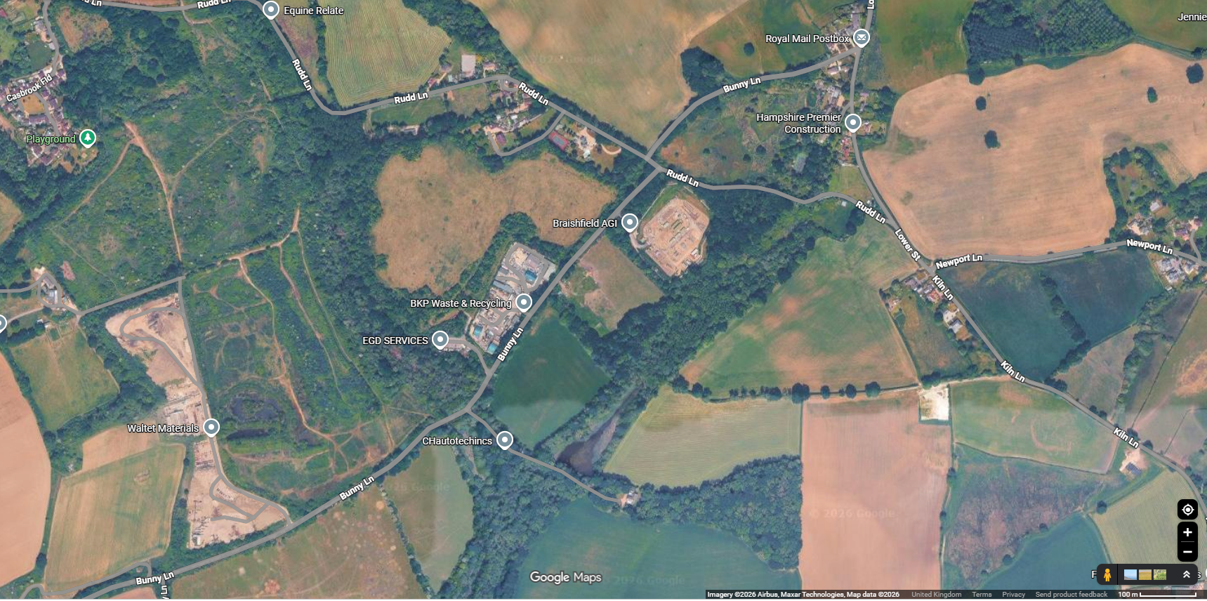
Figure 1 – Site location showing residential properties 200m to the North of sites Northern boundary
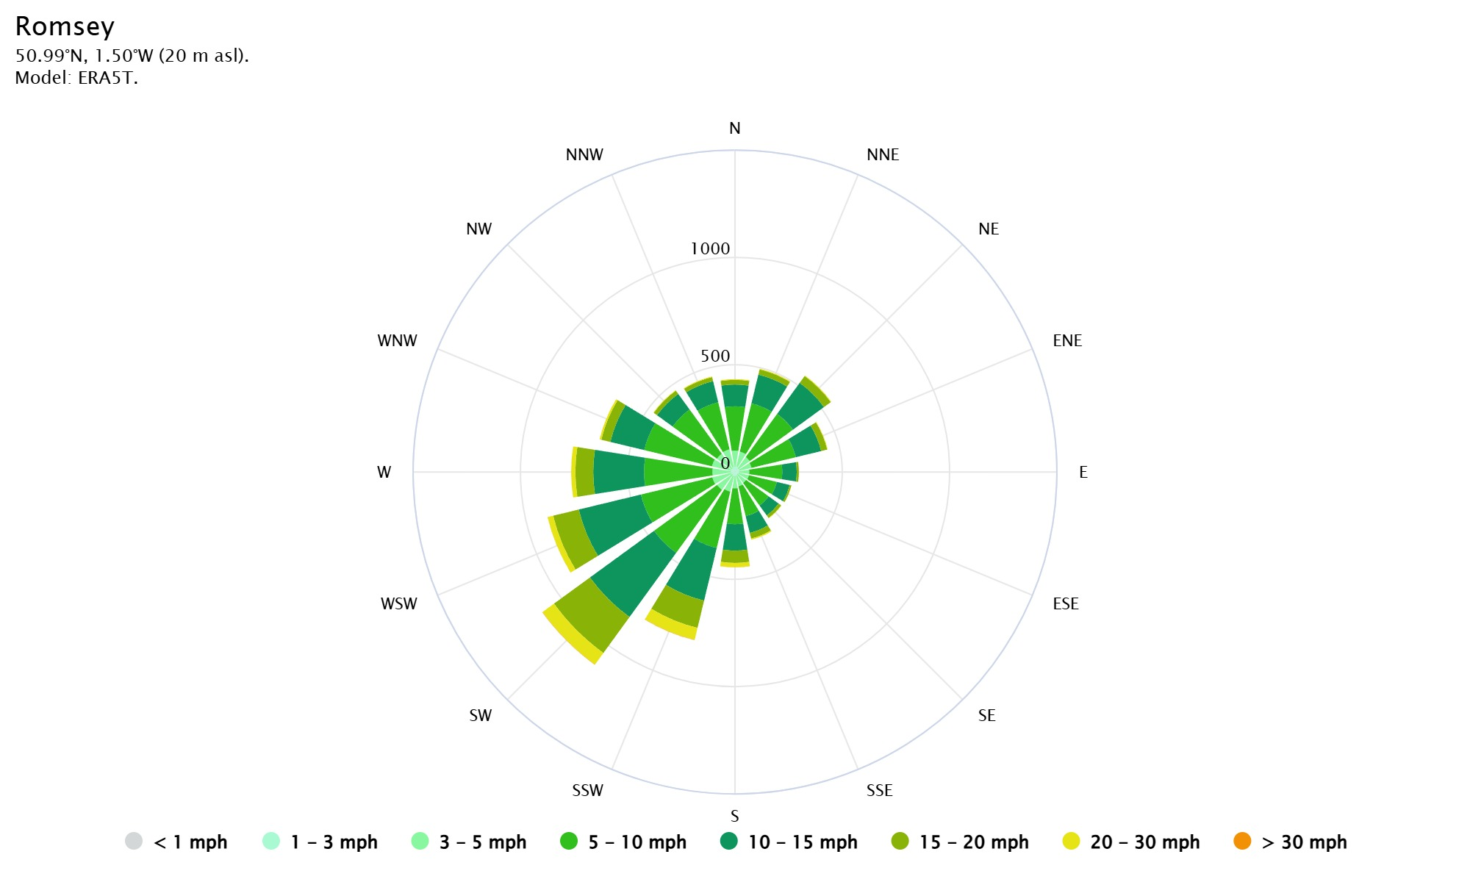
Figure 2 – Wind Rose Data – Romsey – Source – Meteoblue

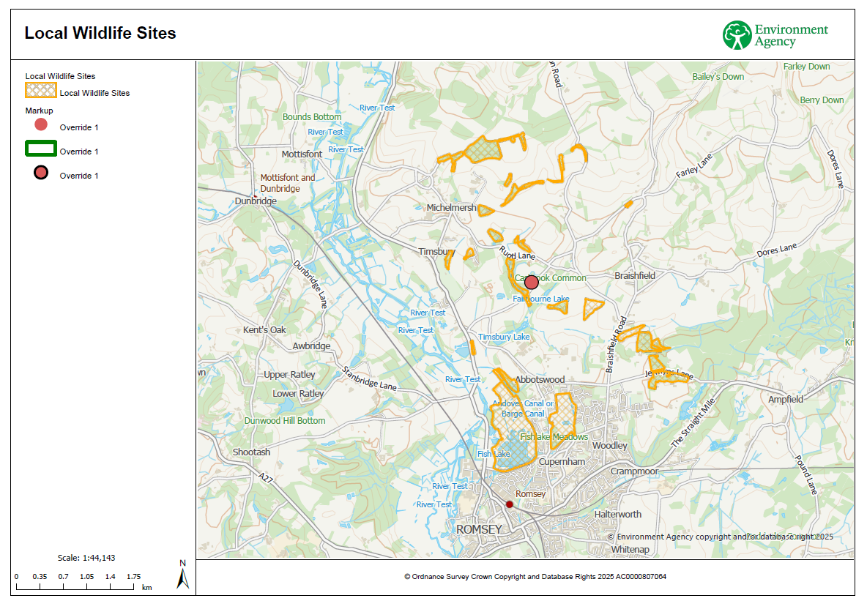
Figure 3 – Local Wildlife sites – Source – Environment Agency Habitats Assessment
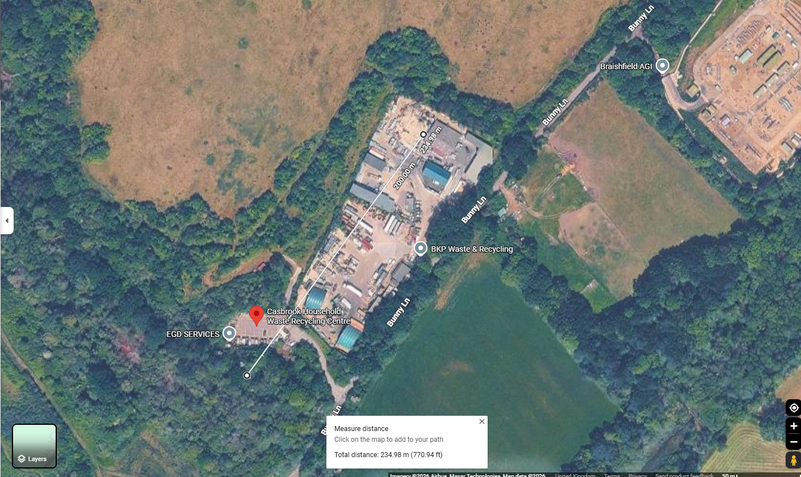
Figure 4 – Distance to nearest local wildlife site from AE1
Reference | Description | Direction & Minimum Distance from Boundary | Comments
1 | Residential Property | NE, 210M
2 | Residential Property | N, 200M
3 | Residential Property | NW, 760M
4 | Residential Property | NW, 890M
5 | Yokesford Industrial Estate, Industrial | N, 800M
6 | HWRC | SW, 65M
7 | Waste Recycling Facility | W, 530M
8 | Footpath, Public Right of Way | SE, 550M
9 | Bunny Lane, Minor Road | E, <5M
10 | A3057 Stockbridge Road (A Road, Single Track) | SW, 1,200M
11 | Stream (Casbrook) | SW, 180M
12 | Bunny Lane Rubbish Tip Wood | S, 70M
13 | Timsbury Lake | SW, 800M
14 | River Test, SSSI | SW, 1500M
15 | Solent & Southampton Water, SSSI, RAMSAR | S, 14,000M
16 | Emer Bog cSAC/SAC | SE, 2000KM
17 | Mottisfont Bats, cSAC/SAC | W, 5000KM

Review / amendment history:
Version | Date | Initials and comments
1 | 17/07/26 | SMcN, Creation, Reviewed DG

By signing this risk assessment, you acknowledge that you have read and understood it and will meet the control measures detailed above:

Name: | Signature: | Date:

