Standard Operating Procedures |  | SOP Ref: | BKP-PCK-09
Approved & Issued by: | L Dryden |  | Written by: | Stuart McNish
Operational Area: | BKP Environmental Romsey
Title: | Pre-Treatment of IBCs in Extracted Cabinet
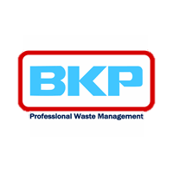

1. Activity

This activity is to ensure the safe and compliant operation of the LEV cabinet and the washing equipment within it. The cabinet and the equipment is COMPEX inspected to ensure continuity and earthing within a designated zone 1 area is compliant with all relevant legislation. The extraction system is installed and tested (COMPEX) and flow rate inspected and tested in accordance with HSG 258 to ensure compliance and sufficient air changes within the space. The outputs from the cabinet are filtered through a 3-stage filtration system (Fabric for dust, Impregnated Carbon for Acid Gases and Granular Activated Carbon for VOCs) prior to release to atmosphere. This is monitored in accordance with our environmental permit. This procedure details all steps to safely operate and use the cabinet and the equipment inside in a controlled manner to ensure the containers inside are suitably washed for pressure testing elsewhere onsite for reuse and the residues are transferred for treatment offsite.

2. Persons at Risk

- Operator
- Other yard operatives
- Driver
- General public
- Contractors and visitors
- Shared Site Occupancy

3. Hazards

- Slips, trips, falls
- Exposure to chemicals residues in the empty packaging
- Exposure to chemicals in the wash solution
- Mechanical hazards from equipment such drum crusher or wash head
- Spillage of chemicals
- Manual handling
- Electrical hazards
- Static Charges
- Likely Flammable Atmosphere in operation
- Potential Explosion if VOC above LEL and ignition sources

4. Procedures

  - This document provides the procedures for safe operation of the extracted LEV cabinet and the Air-powered wash head, the associated air diaphragm pump, pipework and the Newson Gale bond-rite safety equipment and Newson Gale static tester installed onsite. This also details the necessary chemical checks required prior to washing and the PPE requirement of operators within the area depending on chemical hazards present.

Roles and Responsibilities

  - The General Manager has responsibility for ensuring these procedures are adhered to which includes communication with staff and contractors, and the provision of adequate training.

1.3 The Transfer Station Manager has responsibility for ensuring these procedures are followed and material through the process is effectively washed and cleaned prior to recycling and the residues from the process are disposed of appropriately.

Purpose

1.4 The purpose of these procedures is to guide staff in the conduct of their duties safely, ensuring no environmental impact from the operation. The objective is to safely decontaminate containers to enable their reuse or, if unsuitable for reuse, their recovery through the granulation process or washing and pressure testing process located within the plastics recycling area. This process is for higher hazard containers or odorous containers that require additional engineering and safety controls than the normal plant. This includes containers with flammable residues, odorous or toxic containers, some environmentally hazardous or strongly corrosive containers that cannot be safely washed in the normal process. The set up is designed to ensure minimum operator interaction whilst the containers are being washed and all odour/vapours when containers are opened/closed are extracted through an LEV system. Whilst the process is running, Operators should be stood well outside of the process area, using the control panel which is mounted on the wall approximately 2 metres from the cabinet.

1.5 Prior to process
The following PPE is required as a minimum:
Antistatic, chemical resistant coveralls – BS EN 1149-5

Antistatic, chemical resistant safety footwear – BS EN 20345:2011
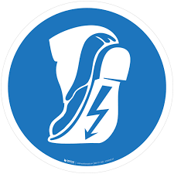
Air-fed hood PRE, with appropriate filters for the hazard – Refer to Coveralls and RPE poster

Antistatic, chemical resistant glove – BS EN 16350:2014


Prior to starting the process, ensure that:

- The Air Flow Monitoring is within Date (14 months)
- The COMPEX Inspection is in date (2 years)
- The Carbon Filters have been replaced / serviced in-line with Environmental permit limits (This is done via periodic monitoring and testing)
- There are no visual signs of damage to any of the equipment
- No waste / other items stored in general area surrounding cabinet
- The cabinet is clean and free from material
- The Earthing strap is attached to wash head from cabling
- There is no visible damage to any connections or earthing joints around system
- The pumps and all associated pipework are connected
- There are suitable IBCs for transfer of residues are in place
- There is a suitable carbon drum inside for material being processed (as directed by chemist - standard carbon, acid carbon or amine carbon)
- All Newson Gale equipment in place
- The Operator has checked that footwear is compliant with cabinet on Newson Gale footplate checker (anti-static)
- That suitable Anti-static PPE for the task is worn
- The handheld VOC monitoring equipment is placed inside the cabinet

The photo below shows the anti-static footwear checker, which shall be used to check there is no static build up on the operator’s footwear prior to use on each occasion:
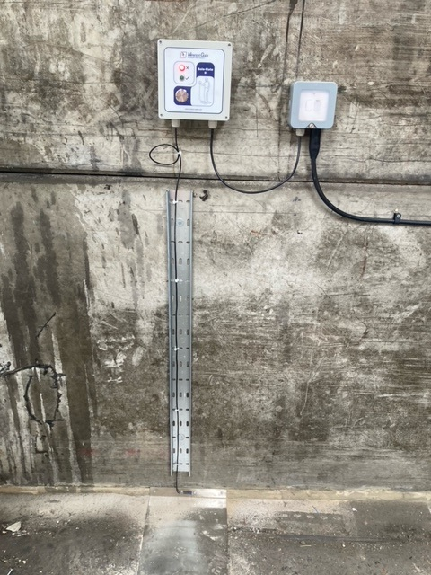

Figure 1 – Newson Gale Footplate checker

1.6 To process

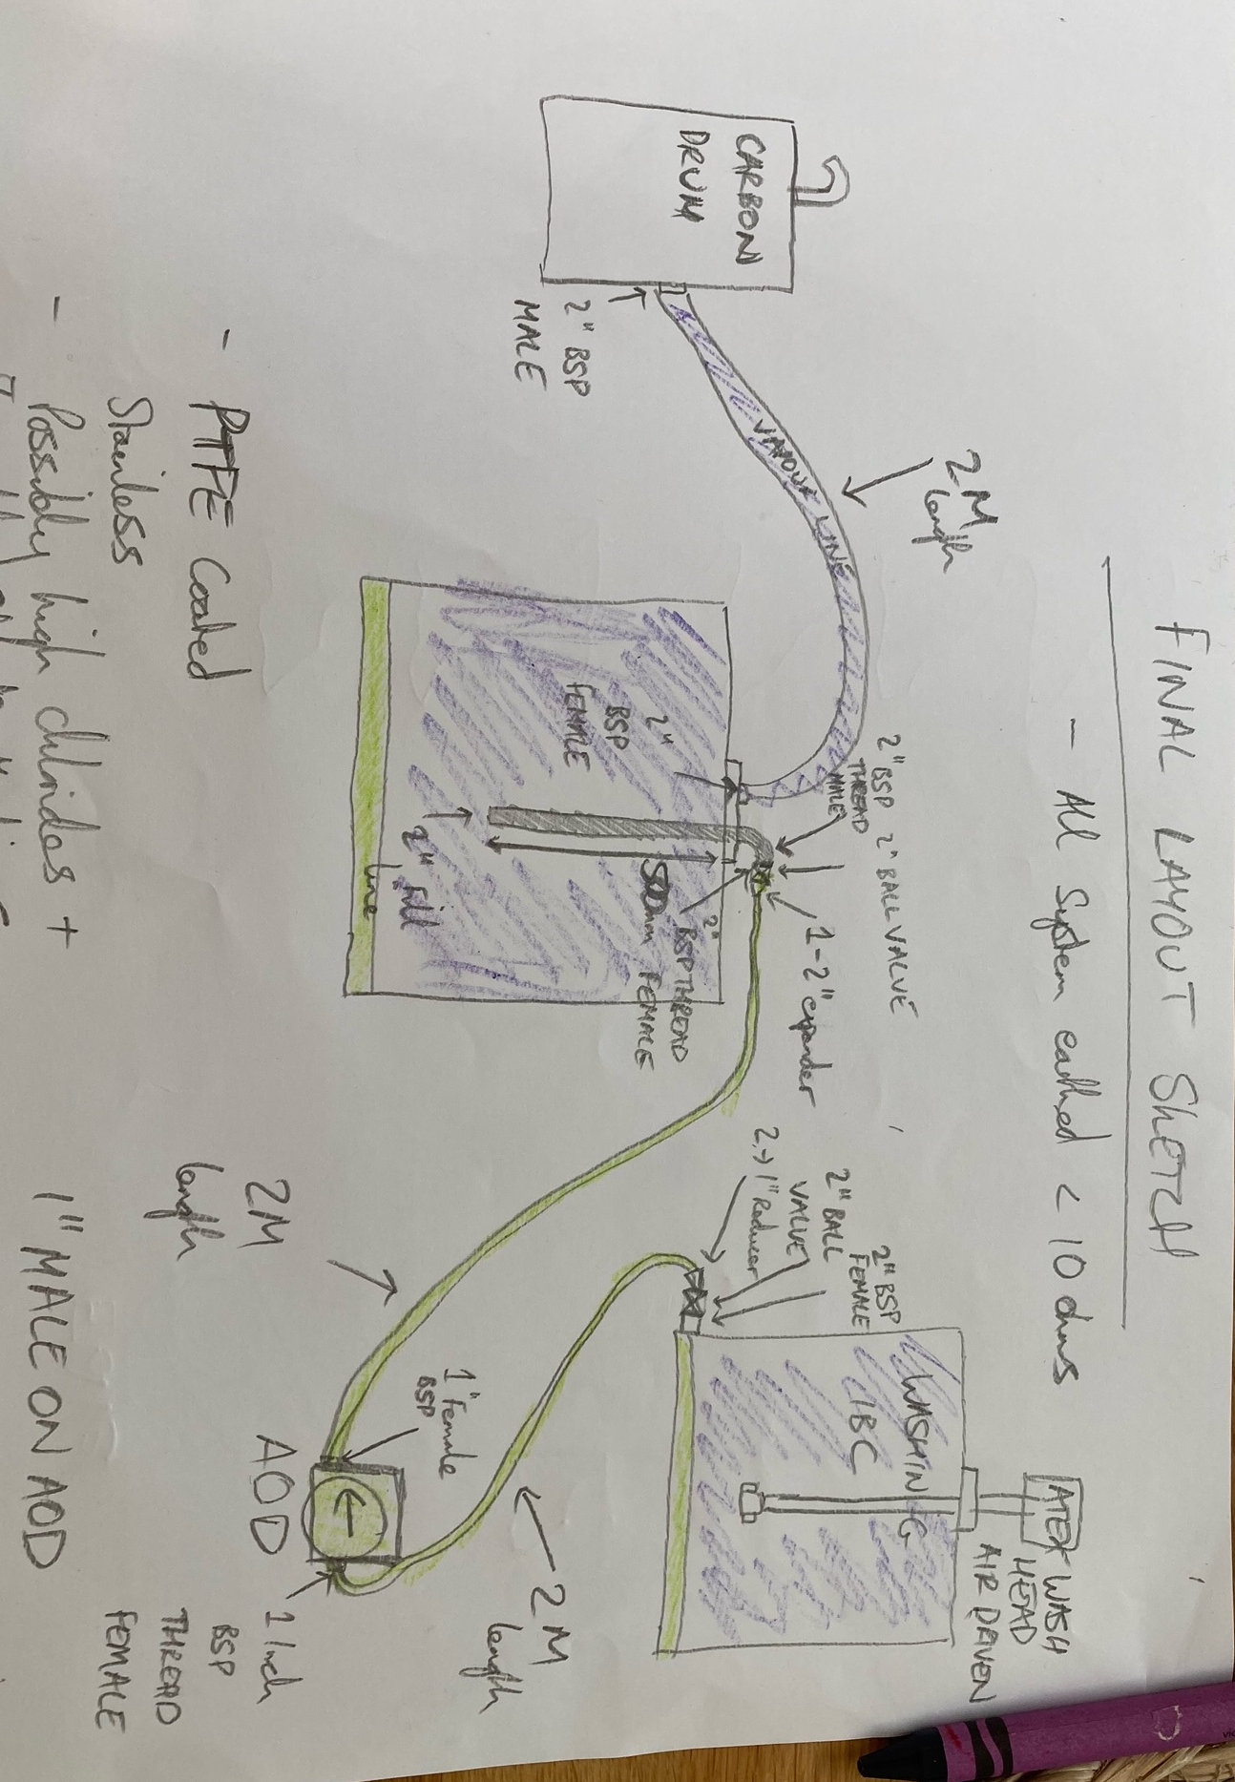
Figure 2 – Process set up Layout sketch
To safely and successfully process materials through the Pre-treatment system, both abatement and earthing systems need to be in-place. This is to comply with DSEAR and COSHH assessments and the site’s environmental permit.
The objective is to ensure all parts within the cabinet are earthed and all odours or vapours displaced in the process are successfully abated through the filtration system.
The containers to be pre-treated are directed by chemists and only materials within the acceptance criteria are processed.
If switching process between different nominally empty containers requiring pre-treatment, a compatibility assessment shall be completed and recorded to ensure there are no adverse chemical reactions in the resulting effluent.
This follows the chemical compatibility and assessment criteria and can be completed in the onsite laboratory or for known compatible materials can be completed as a desktop analysis. E.g. Materials that have been bulked together on a tanker and have already been assessed or materials known to be compatible due to their chemical nature and them being product IBCs E.g. nominally empty Ethanol IBCs and Methanol IBCs.
If there is any doubt over compatibility, a benchtop assessment is completed with samples of the effluents produced. I.e. IBCs will be washed in isolation to produce an effluent; this is then compatibility tested in the laboratory in-line with ‘’LTP-OPLAB 13 – Compatibility testing’’

Batching

Prior to adding to the cabinet, all IBCs are batched to ensure effluent is managed appropriately and no in-compatible materials are mixed. This is recorded on the batching sheet and the compatibility assessments and checked by a chemist.
If there are any doubts, no effluents are mixed without laboratory assessment.

Process steps before addition to cabinet

- Ensure extraction unit is turned on and operational. The fan will slowly ramp up and be heard when operating. Pressure indicators will indicate air flow on ducts. Flow rate should not be adjusted

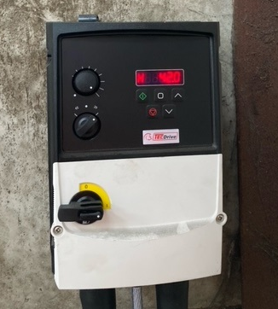

LEV Fan control Unit

- Ensure IBC with water to wash IBCs outside cabinet is sufficiently filled for number of IBCs to wash – This should be mains water only

- Ensure isolation on side of cabinet is reset to allow washing system to be turned on

- Once Panel is switched on, the white ‘’Ready’’ light will be illuminated

- Place VOC Monitor on back wall inside cabinet next to the Newson Gale bond rite equipment. This will act as an alarm if VOCs are building up inside the cabinet and the extraction system which could result in a flammable atmosphere. This will remain in the cabinet during all operations. A second VOC monitor will be placed on the exterior of the cabinet by the system reset panel to alert of any VOCs that may be escaping the cabinet. This is for additional safety controls to ensure only a flammable atmosphere may be present inside the zoned area.

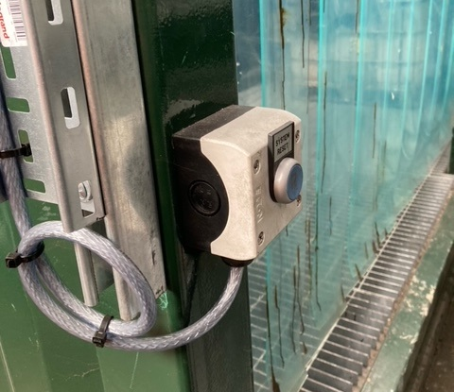
System Reset Panel on front of Cabinet

- Ensure IBC washing panel is switched on. First at the isolator and then on the panel isolation

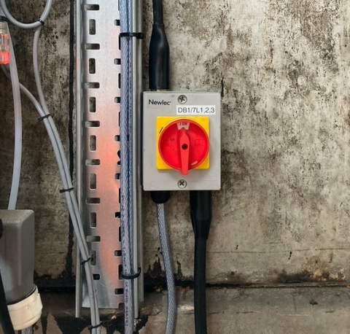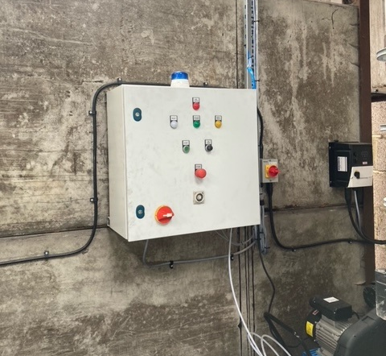
Isolator for Wash Station Control Panel Wash Station Control Panel
- Ensure compressor is switched on (switch on top of compressor)
- Ensure you have anti-sparking tools available if needed for opening drums/IBCs (Brass drum keys)
- Ensure all pipework is connected to air diaphragm pump and all valves are closed (this will be flushed through at the end of previous usage to prevent cross contamination)
- Ensure you have PPE and RPE appropriate for the hazard of products to wash. Standard PPE will be full face RPE with combined respirator cartridge, antistatic chemical resistant overalls and antistatic footwear.
- Ensure receiving IBC and all pipework is attached. Ensure all valves are closed (2’’ Ball Valve on filling elbow and 2’’ valve on Receiving IBC connector).
- Ensure all pipework is earthed to container

Adding IBCs to be cleaned:

- The FLT driver will remain outside the cabinet and will add empty IBCs into the cabinet through the butcher’s curtain. Full PPE and RPE is worn whenever working inside container as well as anti-static footwear and PPE

- Once added, the IBC will be earthed using the Newson Gale bond-rite system inside for the IBC to be washed. The crocodile clip is to be attached to the drum or IBC PRIOR to opening, to remove static and earth the container. The LED on the Newson Gale system will show a green light once the container is earthed. If this does not show green, then immediately cease action as the container is not earthed. Remove the IBC and place back into storage. Investigate by testing the Newson Gale itself and the earth of the system (Unscrew from brackets and test against copper earth cable at back of cabinet). If this shows earth, then replace and repeat. If this does not show earth, then test all other Newson Gale equipment on the same earth. If these show an earth it may be defective equipment so contact Newson Gale or Vaporline to resolve.
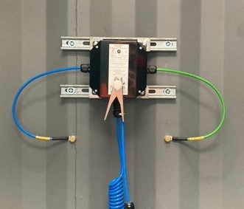

Newson Gale Bond-Rite Equipment to connect to IBCs/drums in container
- Once container to be washed is earthed and the bond-rite is displayed as green, the 2’’ URT fitting can be attached to the outlet of the IBC. This will allow the air pump to pump the residues from the IBC into the receiving IBC, which is already earthed.

- Once container is attached leave 2’’ valve on IBC closed. The lid of the IBC or drum being washed is opened and the wash head placed inside. If the lid is stiff, use a brass (non-sparking) drum key to open it.

- Once the receiving IBC lid has been opened and taken off, the wash head can be pulled down from the concertina wire and placed inside the IBC. The lid around the wash head can now be tightened to create a seal in which to wash the receiving IBC.

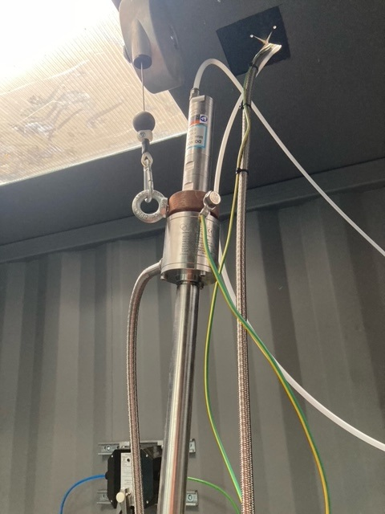
ATEX IBC wash head within cabinet for washing IBCs

- Once this is in place and sealed, the 2’’ valve on the bottom of the IBC & the valves on the receiving pipeline can be opened.

- Prior to this, check that – Vapour line from receiving IBC is attached into carbon drum and that carbon drum is the correct type for application / Check again that all pipework is connected

- Open the 2’’ Valve on the neck of the receiving IBC filling line

- Open the 2’’ Valve on the steel PTFE pipework line on the discharge from the washing IBC line
- Open the 2’’ Valve on the bottom of the IBC

- Ensure there is sufficient capacity in waste IBC for transfer of product. If this IBC has been used previously, ensure that material in the IBC is compatible with proposed product to wash.

- Once all valves have been opened, exit the LEV cabinet via the pedestrian access door & close the pedestrian access door before operating. The panel should only be operated from outside of the container and only 1 person should be using the equipment

Cleaning IBCs:

Note: Reset must be pressed to allow running. This is a safeguard to ensure the operator is outside the cabinet before start.
To run the wash process on the main control panel check that the E-stop is not depressed and press the green ‘’Start’’ button. Upon pressing the start button, you will hear the high-pressure water pump start and the green ‘’Washer running’’ light will show. The panel will automatically start the air diaphragm pump to pump away the washing residues into the receiving waste IBC in the cabinet

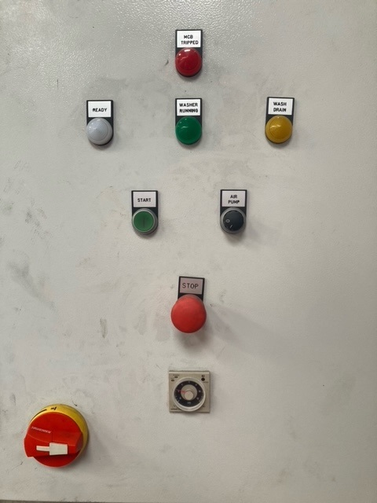
Control Panel for IBC Washing Unit

When operating, there may be a requirement to alter the lengths of the wash cycles. This can be achieved by adjusting the dial by rotation on the front of the control panel to the desired cycle length.

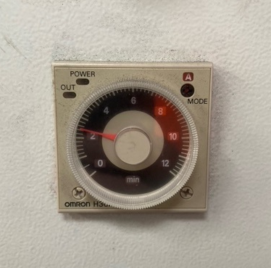
Dial for cycle length adjustment

Upon completion of the wash cycle, the water pump will switch itself off. The green ‘’Washer Running’’ light will turn off and for a short period the ‘’Wash Drain’’ yellow light will be on. This is the air pump removing any liquids from the IBC that has been washed.

Once all these lights have turned off and all pumps are no longer running it is time for the operator to re-enter the cabinet and check that the container has been cleaned.

    - To only run the Air diaphragm pump, turn the switch on the panel to the on position. This will manually turn on the air pump. This may be needed to remove excess residues prior to washing or to remove any pre-treatment chemicals added to the IBCs such as glycols for solvents prior to washing process.
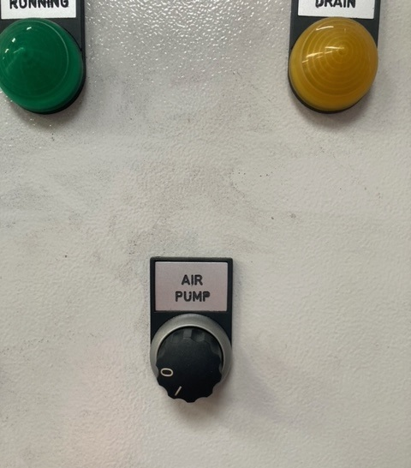

Control panel showing Air Pump Switch
If further drain is required, use manual air pump switch.

To Inspect:

Wearing full PPE (as detailed above), once inside the LEV cabinet we can check the cleanliness of the container. Remove the VOC monitor from the outside of the cabinet as this will need to be used inside if washing flammable products.

Prior to inspecting an IBC, we want to ensure that no product that may remain in the IBC can leak into the cabinet. To do this:

- Close the 2’’ outlet tap on the IBC itself
- Close the 2’’ tap on the pipework that runs from the IBC outlet tap to the air diaphragm pump

At this point the system is sealed so no residues inside the IBC or inside any of the pipework for transferring residues can leak.

Remove the IBC wash head – To do this, unscrew the fitting around the lid and lift the wash head out on the counterbalance wire and safely stow.

Visually inspect the IBC for cleanliness to check all product has been removed

To check the decontamination and removal of a potentially flammable atmosphere place the handheld VOC monitor in the neck of the IBC and check that no VOCs are present.

If no VOCs are present and the IBC is internally clean, the IBC can be marked as ‘’decontaminated’’ and sent to either the plastics granulation plant or the main IBC wash line for a second wash and pressure testing of the bottle and valve to confirm UN certification.

If residues and VOCs are still present. check then re-insert the IBC wash head and seal, open the 2’’ valves from the IBC and the 2’’ valve on the discharge pipework and repeat the decontamination process. Some materials may require longer wash cycles and multiple washes

Failed IBCs:

IBCs that cannot be washed properly shall be removed and used for suitable waste streams for disposal or repackaged for disposal.
IBCs with excess residues should be labelled with ‘’Failed’’ with time and date and reason for failure of inspection and next steps. This would be determined by the chemist running the process based on the chemical nature of the contents within them.

Passed IBCs:

IBCs that pass inspection can be labelled with ‘’decontaminated’’ label with time, date and operator initials (these should be created by a Site Chemist). The previous contents labels are kept on the IBC until they are processed through the main wash plant.

Removal of IBCs from container:

Once IBCs have been washed, they need to be removed from the container for onward processing or testing. To do this:

- Close 2’’ tap on IBC
- Close 2’’ valve on pipework linking to air diaphragm pump
- Disconnect pipework from IBC tap to 2’’ valve on pipework
- Replace 2’’ cap on IBC that has been washed
- Rotate IBC on grating to allow FLT to remove
- Exit cabinet
Once you have exited the cabinet you can instruct FLT driver to remove the washed IBC and inform them of the appropriate location for this based on its status as a decontaminated IBC or requiring further processing.

Once IBC has been removed, another IBC can be placed in the cabinet by FLT operator as directed by chemist and the process repeated.
Prior to commencing a cycle, please ensure that there is sufficient capacity within the waste IBC for the residues to be transferred. A typical wash cycle produces <30L of water plus whatever residual product is in the IBCs.
When the receiving waste washing IBC has 900L of product in then only 1 more washing cycle may be completed. The IBC should then be clearly labelled with the batch number relating to the contents washed into this and this information recorded on the label. This information will then be supplied to the Transfer Station Manager to enable off-site treatment of the waste.

Potential issues and resolution:

IBC wash Head is running but water isn’t coming through:
Check that water IBC outside of cabinet has enough water in it

After completion of a wash cycle the liquids in the IBC being washed are not pumped away:
Check 2’’ valve on IBC is Open
Check 2’’ valve on pipework is open
Check air diaphragm pump independently with water (insert pipework with open valve into bucket and see if water is moved by pump) – If no water moved then likely pipework blocked. This can be dismantled and cleaned to be reused
Visually inspect inside of IBC (wearing PPE) to see if outlet tap is blocked – This may be blocked with solids or sludge that the pump may not move

Water pump is on, but air diaphragm pump and wash head do not work:
Check compressor is turned on or has power available – Likely no air to system

Safety Measures DSEAR/COSHH:

- All Containers and equipment within cabinet is retained at earth and checked as part of start-up process including Newson Gale equipment
- Newson Gale equipment provides visual indication of earth on high-risk components in system. Rest is earth bonded to cabinet on common earth
- Operator wearing anti-static clothing and antistatic footwear and check there is no static build up prior to entering the LEV cabinet.
- Extraction sufficiently specified to ensure air-flow changes in-line with HSG 258
- 2 x handheld VOC monitors used while operating, to alert operators of VOC build up (1 on entrance to cabinet, 1 in corner of cabinet adjacent to Newson Gale equipment)
- Full Face Positive pressure RPE and Chemical resistant and antistatic clothing and footwear worn at all times
- Wash cycles only operated when operator is outside of cabinet to reduce exposure and minimise static risk when washing flammable IBCs
- Chemical compatibility assessments completed on all containers to be washed. Acceptance criteria and benchtop assessment or laboratory testing ensure no materials put for washing that may cause physical or environmental harm
- Specific carbon used within cabinet to reduce vapours from displaced air (as directed by chemists), reducing VOCs and any potentially harmful vapours

Servicing & Maintenance:

The equipment is inspected by Vaporline for COMPEX every 2 years in accordance with their recommendations.
The LEV flow rate is tested every 14 months in line with HSG 258 by Auto Extract Systems who installed the systems in line with HSE requirements.
All equipment is visually checked and inspected as part of weekly checks
Newson Gale Bond-rite systems are checked prior to use. Removed and checked against earth to show resistance <10ohms
LEV system maintained and Carbon in extraction filters changed periodically in line with VOC build up and use (This is subject to accredited monitoring by UKAS lab in accordance with environmental permit)

Print: ................................................................. Sign: ........................... Date...........................

Signed off by:

.................................................................... Director / Manager / Supervisor

