H1 Air impact assessment

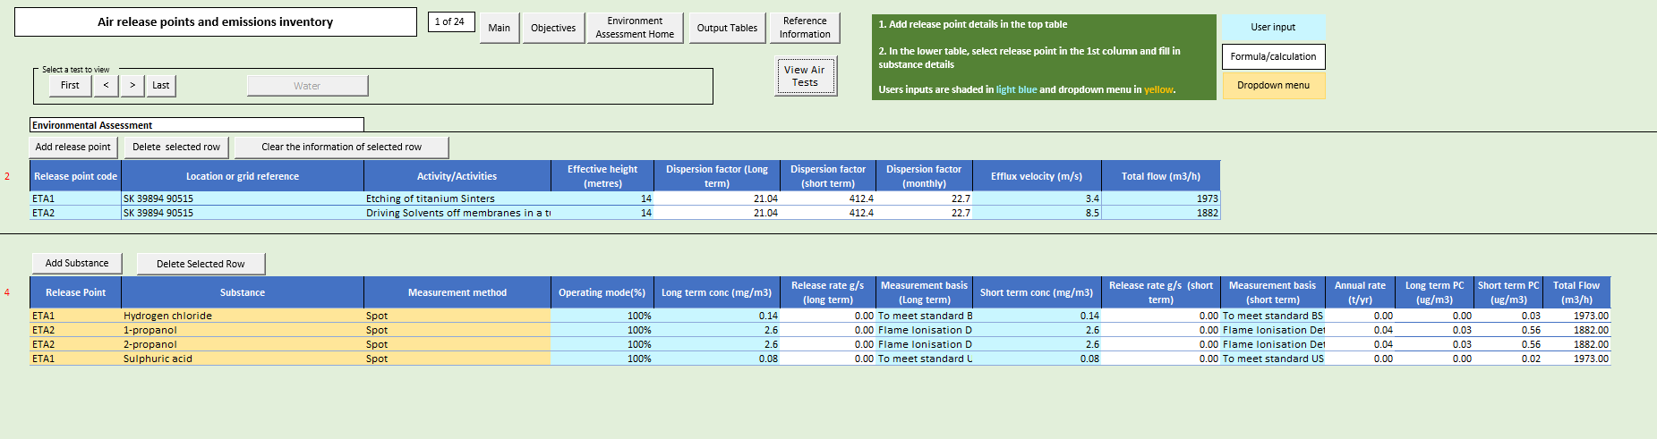

Information taken from Emissions test results from Envirocare on 20th Feb 2024 and 25th-26th July 2024.

