Ridley Pigs LLP The Piggery
Thorpe Salvin WORKSOP
Buildings Plan
Legend
Farmyard Manure Store
Clean water soakaway
Dirty water tank
Feed Bin
Deadstock store
Permit boundary
G Grid IC Inspection Chamber
Clean water drainage
Dirty water drainage

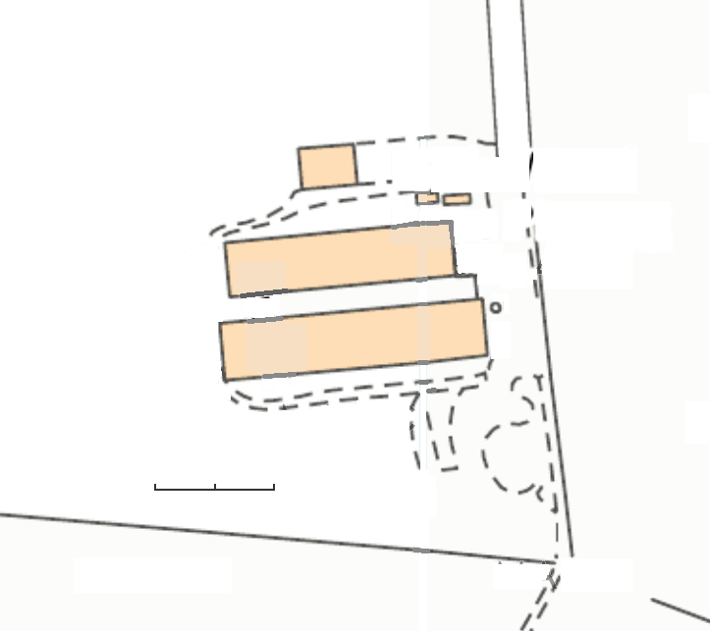
N
G
G
G
G
G
G
IC
scrape
Farm office
Clean Water Tank
House 2
House 1
Bedding Store
m
0
40
20

