Index………………………………………………………………………………………………………………. 1
Issue and revision history………………………………………………………………………………… 1
- Purpose…………………………………………………………………………………………………….. 2
- Scope………………………………………………………………………………………………………… 2
- Authority, Documentation Control………………………………………………………….... 2
- Abbreviations……………………………………………………………………………………………. 2
5.0 Site Operations, production activities and General Management…………….… 3
- 5.1 Purchasing and Goods Received……………………………………………………………… 3
- 5.2 Waste Acceptance, sorting, segregation, and verification……………………….. 3
- 5.3 Material Despatched……………………………………………………..………………………. 3
- 5.4 Waste storage, segregation and handling………………………..……………………… 4
- 5.5 Waste treatment, crushing process……………………………………………………….. 4
- 5.6 Waste treatment Washing and Drying process………………………………………… 4
- 5.7 Waste treatment, Briquetting Process……………………………………………………. 4
- 5.8 Control of Substances…………………………………………………………………………..... 5
- 5.9 Emissions Controls and Monitoring…………..……………………………..…….………. 5
- 5.10 Process Efficiency…………………………………………………………………………………. 5
- 5.11 Waste Minimisation……………………………………………………………………………… 5
- Site, site equipment and maintenance plan ……………………………………………….. 6
- Emergency preparedness…………………………………………………………………………….. 6
- Organisation roles, and responsibilities………………………………………………………. 6
- Handling Environmental Concerns ……………………………………………………………… 6
- Monitoring and evaluation of the EMS…………………………………………………………. 7
10.1 Evaluation of compliance……………………………………………………………………… 7
- Continuous Improvement…………………………………………………………………………… 7

Issue Number | Date | Comments | Author | Approved by
1 | April 2023 | Version 1 | Gary Clarke

- Purpose
This manual sets out the arrangements of the company’s Environmental Management System (EMS), which implements the requirements of standard BS ISO 14001:2015. The sole purpose of the EMS is to continually improve as a business on environmental performance and to ensure the suitability and effectiveness of the EMS.
2.0 Scope
This manual contains site specific information on William Rowland Ltd (WRL) activities, management plans and arrangements. It also acts for training and locating key information. This Environmental Management System Manual (EMSM) shows the organisations capacity to comply with the EMS and any supporting documents.

WRL is based on a new development site located at Tankersley, South Yorkshire. The EMS covers the building and land, shown on the site plan available for viewing in appendix 1.

- Authority, document control, changes to the manual.
This manual will be reviewed annually, if significant changes occur. It is subject to review and potential revisions at any interval if deemed necessary.
This manual if revised, shall be by a competent manager but must be approved before release by the top management. Top management for the purpose of this EMSM, includes Operations Manager, Director, and Managing Director.
The printed version to this manual is located in the Production Managers with an electronic copy located on sharepoint.

- Abbreviations
- EMS - Environmental Management System
- QC - Quality Control
- FPP - Fire Preventative Plan
- EMSM - Environmental Management System Manual
- WRL - William Rowland Ltd
- PPM - Planned Preventative Maintenance
- PPE - Personal Protective Equipment
- SWP - Safe Working Procedure
- RA - Risk Assessments
- NCR - Non-Conforming Register
- LEV - Local Exhaust Ventilation
- KPO - Key Performance Objectives

- Site Operations, Production Activities and General Management
Activities under the control of WRL are assessed to ensure minimum impact to the local wildlife, environment, and neighbours. Activities are planned and supervised by trained personnel and managers to ensure site activities make appropriate use of resources and comply with written procedures that form part of the EMS. The production/operations manager shall ensure staff are aware of risks associated with any activity, this is communicated through the site risk assessment. All staff work under strict supervision until fully trained and competent. As necessary the activities are complemented by additional internal procedures which the quality manager being responsible for drafting and implementing. The procedures display the scope of the activity, main hazards associated with the task, PPE requirements and operational steps that must be followed in order to complete the task safely.

5.1 Purchasing and Goods Received. (Refer to CP8 – Appendix 5)
- Receipt of materials initially goes through radiation monitoring prior to entering site.
- Internal radiation detection procedures are in place. (Refer to SWP-T-033/034/035)
- Received loads are evaluated prior to carrying out the task to ensure safe unloading can take place.
- Unloaded material is at the pre-acceptance stage and is located in a safe storage area for booking in and inspection works.
- Inspection works are scheduled to be completed within thirty days of receipt – material acceptance shall be determined from the findings and is recorded on a segregation report.
5.2 Waste acceptance/rejection, sorting, segregation, and verification
(Refer to CP10/CP8 Appendix 2/5)
- Material received is scheduled for the sorting, segregation and verification process and shall be verified within thirty days of receipt.
- Findings from the segregation and verification report, material acceptance/rejection is determined.
- Material accepted is suitably located and posted to stock awaiting the next process route.
- If rejected - supplier is notified by commercial informing them of the rejection and instructions are sent to the Production Manager for the rejection. These are communicated through email, via a Customer Material Spec (CMS).
- Non-conforming material goes through the rejection process. (Refer to SWP-T-038)
- Non-conforming material is contained suitably and located in the quarantine areas.
- Rejected material is recorded on an internal Works Job Card (WJC)
- Rejected material is recorded Non-Conforming Register (NCR)
5.3 Material despatched.
- Material shall conform with customer specification prior to despatch.
- Material must be suitably contained to enable safe transportation.
- All despatched revert material is recorded on a WJC.
- Quality control (QC) checks are carried out on material prior to despatch.
- All materials that leave site is subject to a radiation scanning and are accompanied with relevant documentation.

5.4 Waste storage, segregation and handling.
- Waste shall be stored in a safe, suitable, and designated area.
- Waste shall be contained correctly and suitable for movement around site and safe transportation.
- All containers will be clearly identifiable with relevant information regarding the contained product.
- Waste is kept a minimum of 3m from the perimeter of the building.
- Waste is handled in accordance with current guidelines.

5.5 Waste treatment - Crushing Process
- Materials shall be analysed and inspected for suitability through the verification process.
- Materials shall be located suitably for the crushing process.
- Chipped material suitably contained and marked for washing and drying.
- Clean up procedure in place to reduce chippings on the floor.
- Continual improvement assessments on the process to reduce release of chippings.

5.6 Waste treatment - Washing and Drying process
- Material located ready for washing/drying.
- Equipment continually monitored for any leaks with regular servicing and Planned Preventative Maintenance (PPM) carried out.
- Spill kits readily available for accidental release.
- Spill procedure in place and recorded on the spill register.
- Finished product suitably contained and located post discharge for either despatch or the next process route.
5.7 Waste Treatment - Briquetting process
- All material shall be fully washed and dried, in spec as per customer requirements prior to feeding the briquetter.
- Equipment monitored for release of product, with resources available for maintenance and servicing requirements.
- Material correctly contained as per CMS and information inputted onto a WJC.

5.8 Control of substances - Washplant waste (Refer to CP2 appendix 3)
Non-Hazardous substances onsite are located in a bunded area North of the building as highlighted with the orange arrow in appendix 1 (site plan). Storage of waste does not exceed a period of one calendar month. The maximum amount of waste stored within a calendar month is < 25,000L.
- Suitable storage containers for substances to prevent escape, ensuring safe transportation around site.
- COSHH assessments carried out on the detergent prior to going into production.
- Full PPE supplied to enable safe handling.
- Inhouse training by experienced members of the production team form other members of staff.
- Internal SWP in place for accidental release/spillage and changing of the wash water from the wash plant tanks. (Refer to SWP-T-031)
- Suitable bunded storage area for wastewater and other wastes onsite. (Inclusive of laboratory waste and waste oils)
- Wastewater arranged for site removal via a licenced waste carrier and sent to a registered site and accompanied with a consignment note.
- Records of waste removal are kept electronically as part of the EMS.

  - Emissions Control and Monitoring

- All equipment is installed and commissioned by a competent person(s).
- All plant and equipment are well maintained and serviced. (This includes LEV testing)
- Any excessive emissions shall be reported to the production/operations manager with the process stopped with immediate effect.
- Daily monitoring by production staff and managers.
- Pre-use checks in place to capture any deficiencies in plant and equipment.

  - Process Efficiency
- Daily auditing of gas, electric and water usage. (This task is completed by maintenance and reported to the Operations Manager)
- Material verified at segregation stage to determine throughput efficiency.
- Process Improvements via continuous Improvement program.

  - Waste Minimisation

WRL intend to reduce waste onsite where possible. Usual streams are waste recycling such as cardboard, wood, hard plastic and scrap metal.

- Full recovery clean downs are part of the process – thus reducing bi-product and waste.
- Internal procedures in place for the processes. (Refer to SWP-T-018, SWP-T-019, SWP-T-020, SWP-T-024, SWP-T-025, SWP-T-026, SWP-T-029, SWP-T-030 & SWP-T-031)
- Compliance checks by management ensuring procedures are being followed.
- Equipment modifications applied where possible to increase efficiency of plant and equipment.
- Regular servicing and maintenance on all plant and equipment reducing and/or preventing spillage and leaks – as per 6.0 & CP6 Appendix 4
- Reuse and recycle where possible.
- Reduction in stopping the production line which leads to less wastewater changeovers and energy usage.
- Training and education to all staff.
- Site infrastructure, site plant/equipment and maintenance plan (Refer to CP12 Appendix 4)

Maintenance, Plant and equipment onsite are continually inspected to prevent failure and breakdown. Planned Preventative Maintenance (PPM) is in place and recorded. Resources are available for reactive maintenance issues. Pre-use inspections on all plant and equipment is conducted by staff, reporting any damage or defects to plant or equipment to the maintenance department.

Plant is operated under PUWER and LOLER requirements.

Regular monitoring through internal auditing of site infrastructure is carried out to prevent failure.

7.0 Emergency preparedness and response (Refer to CP6 Appendix 6)
The operations manager maintains a site emergency environmental plan along with a fire preventative plan (FPP) ensuring appropriate resources and steps are in place to manage the objectives. This site emergency plan takes into consideration the aspects and impacts assessment carried out and the compliance obligations.
In the event of a fire, the emergency plans which include the immediate responses are written in the fire preventative plan. (FFP)

- Organisation Roles, and responsibilities
The operations manager is assigned the responsibility of ensuring the EMSM implements
BS ISO 14001:2015 and the responsibility of reporting on the environmental performance to
other top management and the Environment Agency (EA) at appropriate intervals.

Operations manager will also ensure the following is performed within WRL.

- Communication of the EMS requirements and the importance of conforming to the EMS.
- Ensure resources are available to maintain the EMS.
- Monitor the performance of the EMS annually or if any significant changes occur.
- Review and revise the environmental policy and objectives.
- Promote continual improvement to progress environmental performance with WR.
- Ensure staff are trained and competent.
- Ensure correct PPE is supplied with readily available supplies.

- Handling environmental concerns (Refer to CP2)

The operations manager is responsible for ensuring appropriate action is taken to mitigate or prevent environmental impact. Track record of concerns will be recorded and reviewed by top management and can been done so at any time.

- Audits are carried out by competent managers – such as noise assessments on a monthly basis in accordance with the Noise Impact Assessment.
- Resources will be available for any immediate concerns raised and will be actioned within 24hours of the notification.
- Processes will be stopped to investigate through root cause analysis.
10.0 Monitoring and evaluation of the EMS

The performance and effectiveness of the EMS shall be evaluated and reviewed by top management.

10.1 Evaluation of compliance

The process of compliance shall be carried out on an annual basis by the Operations Manager, reporting to top management. Compliance evaluation can be carried out at more regular intervals and reported separately, if deemed necessary to do so.

The evaluation process can be based on the: -

- Internal auditing
- External auditing
- Non-conformities
- Corrective actions
- Environmental objectives
- KPO’s

- Continuous Improvement

The EMS provides information and the framework for continual improvement of the WRL environmental performance.

12.0 Accident/Incident prevention and management Plan

An accident Management plan is currently being written.

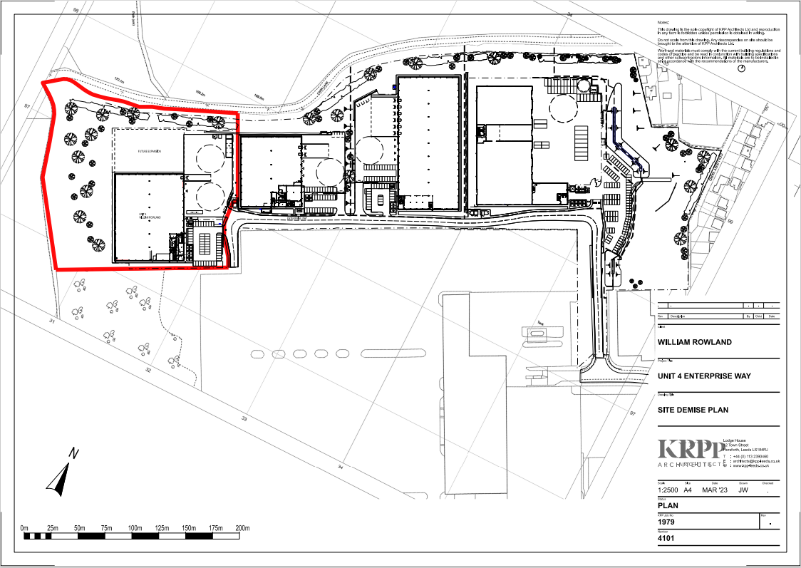

Above – Appendix 1 (Site Plan)
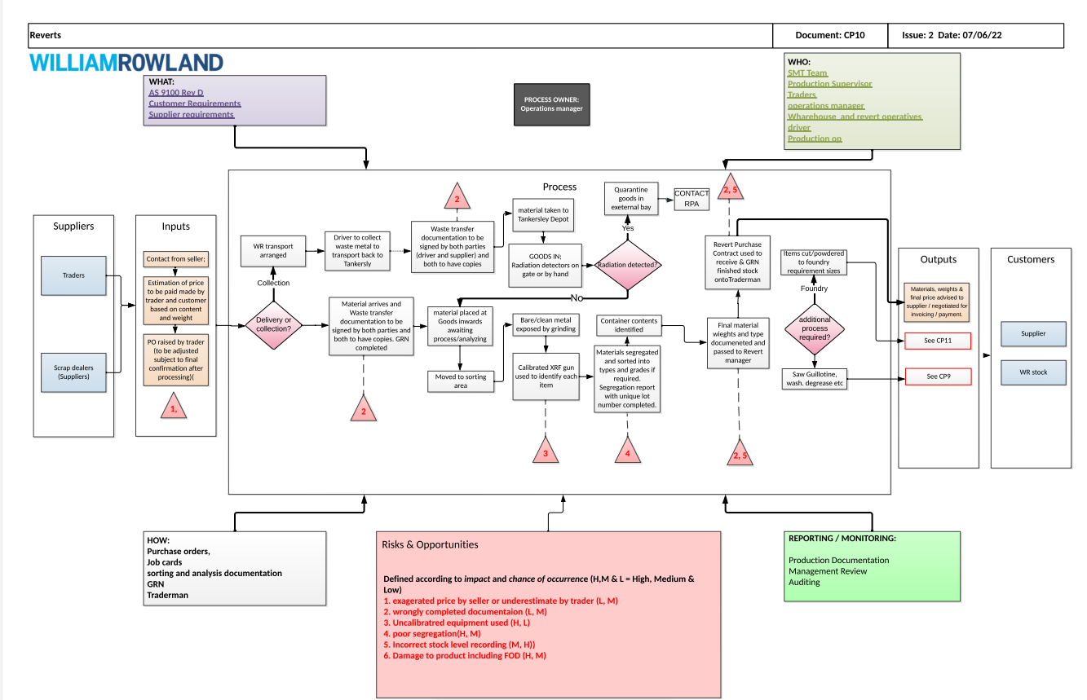
Above - Appendix 2 (CP10)
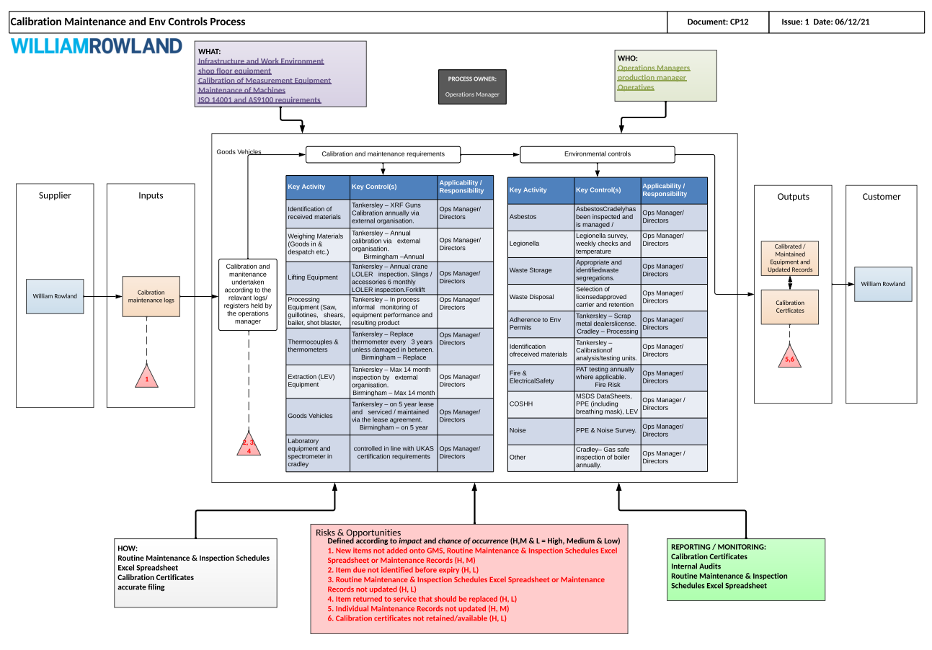
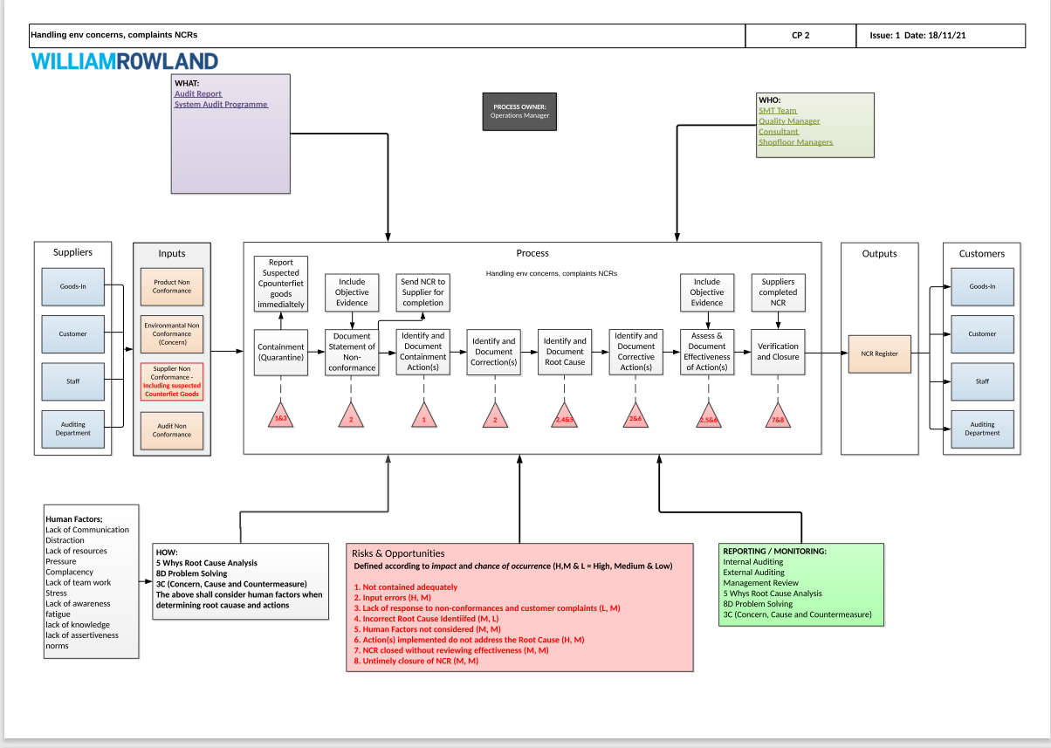
Above Appendix 3 (CP2)
Above - Appendix 4 (CP12)

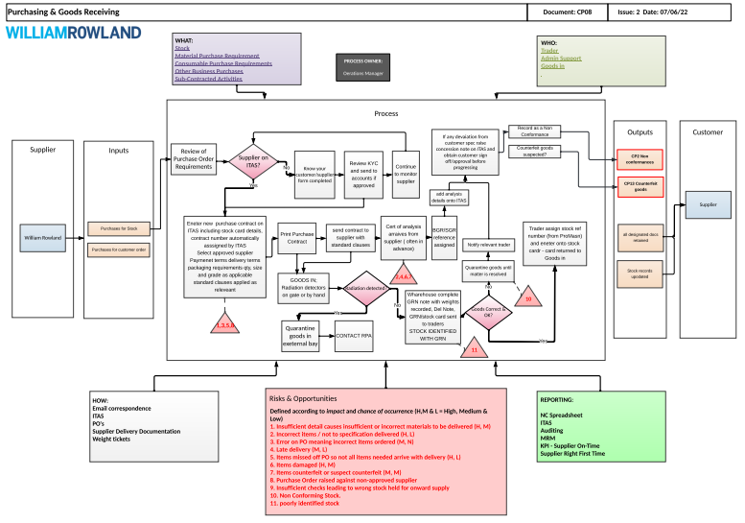

Above - Appendix 5 (CP8)
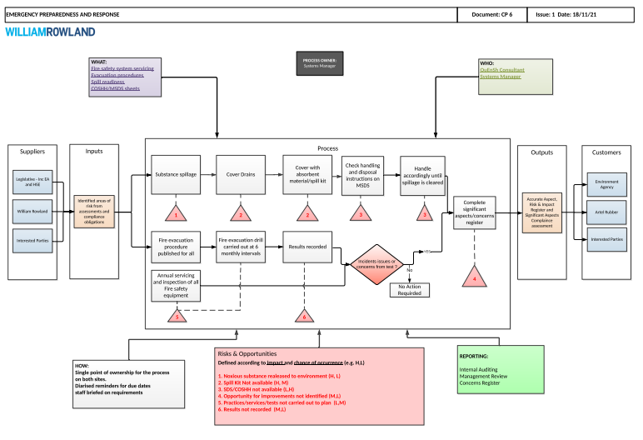

Above – Appendix 6 (CP6)

