CBE Plus Ltd – Environmental Permit Application
Non-Technical Summary
Overview
Capabilities Beyond Engineering Ltd, previously known as CBE+, (referred to as CBEP hereafter) is applying for an environmental installation permit under the ‘Environmental Permitting (England and Wales) Regulations 2016, Schedule 1, Chapter 2, Section 2.3, Part A(1)(a)’. The site process adheres to the regulatory description of “unless falling within Part A(2) of this Section, surface treating metals and plastic materials using an electronic or chemical process where the aggregated volume of the treatment vats is more than 30m3”. The activities carried out on site by CBEP do not meet the criteria set out in Part A(2) of the regulations.
CBEP submitted a permit application pack to the Environment Agency (EA) on 19 June 2024. This application was not ‘duly made’ and returned to CBEP with recommendations from the EA officer. Refer to Appendix 2 ‘EA Not Duly Made Letter’. The application reference for the not ‘duly made’ application pack as stated on the EA letter is ‘EPR/HP3627SH/A001’.
CBEP is located on Enterprise Drive, Williamthorpe Industrial Park, Holmewood, Chesterfield, S42 5UZ (refer to Figure 1 below) and centred on National Grid Reference (NGR) SK 42680 66536 (refer to Figure 2). Hereafter the location of CBEP will be referred to as ‘the site’.
NB The coating operation of CBEP was previously traded as Nitec UK ltd. This name is no longer used for trading.
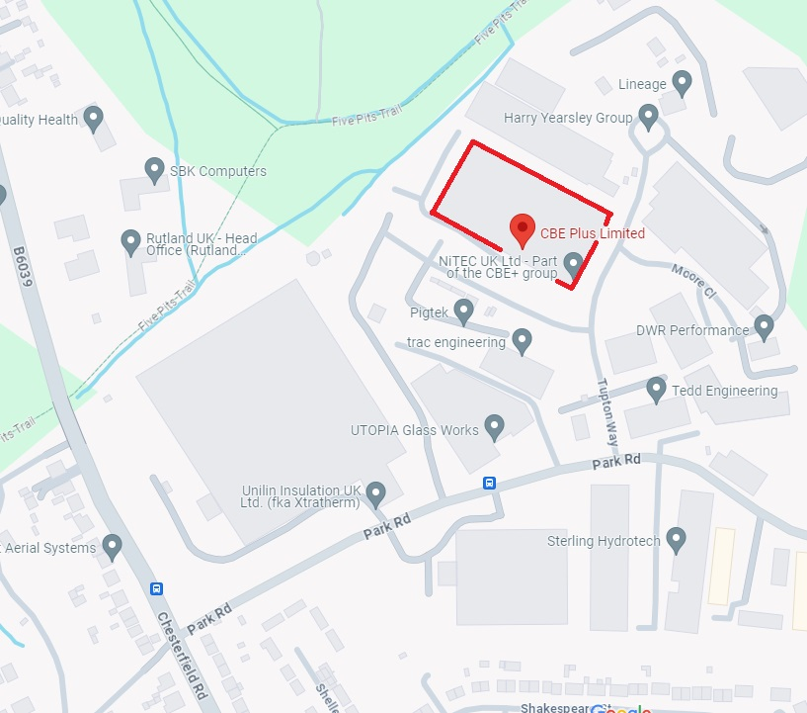
Figure 1 Location of CBEP
CBEP is a multi-disciplinary engineering subcontractor, specialising in:
- Pre-production; including raw material sourcing and design manufacture.
- Machining; including Computer Numerical Control (CNC) milling, CNC turning, gear cutting, and wire Electrical Discharge Machining (EDM).
- Plating; including electroless nickel plating, nickel and polytetrafluoroethylene (PTFE), and diffused nickel plating.
- Finishing; including heat treatment, testing, pressure testing, painting, and assembly.
- Control; including inspection and packaging.
CBEP is an amalgamation of five different previous businesses, all now operating and trading as the Capabilities Beyond Engineering Limited Business Entity:
- BG Engineering Ltd,
- NiTEC UK Ltd, NB CBEP stopped trading under this name in October 2022.
- Pentag Gear and Oilfield Equipment,
- Aerodyn Wire EDM,
- Spire Laboratories Ltd.
All of the above businesses are located at the Enterprise Drive site (as shown in Figure 1) and are one legal entity, Capabilites Beyond Engineering Limited (CBEP).
The permit boundary encloses the building where the activities take place as well as to the rear of the building where the disconnected Combined Heat and Power (CHP) unit is located as well as external storage for waste. Refer to Appendix 4 ‘Permit Boundary’. The site’s emission points (air and water)
The plating processes takes place across 4 existing lines. The total number of vats, including the new, un-commissioned, automated plating line is 37 vats of varying volume, with a total volume of 87,364m³. Refer to Appendix 8 ‘Plating Tank Sizes’.
Due to the activities that take place on site, CBEP have nine emission points to air. These are from:
- Plating line 1 (shown as ‘A2’ on Figure 2).
- Plating line 2 (shown as ‘A3’ on Figure 2).
- Plating line 2a (shown as ‘A4’ on Figure 2).
- Stripping Line (shown as 'A5’ in Figure 2).
- Spray booth (shown as ‘S1’ on Figure 2).
- Plating line 4 (shown as ‘S2’ on Figure 2).
- Laboratory extraction (shown as ‘L1’ on Figure 2).
- New Local Exhaust Vent (LEV) stack (shown as ‘A1’ on Figure 2). The plating line for this stack has not been commissioned and it is therefore not operational/emitting.
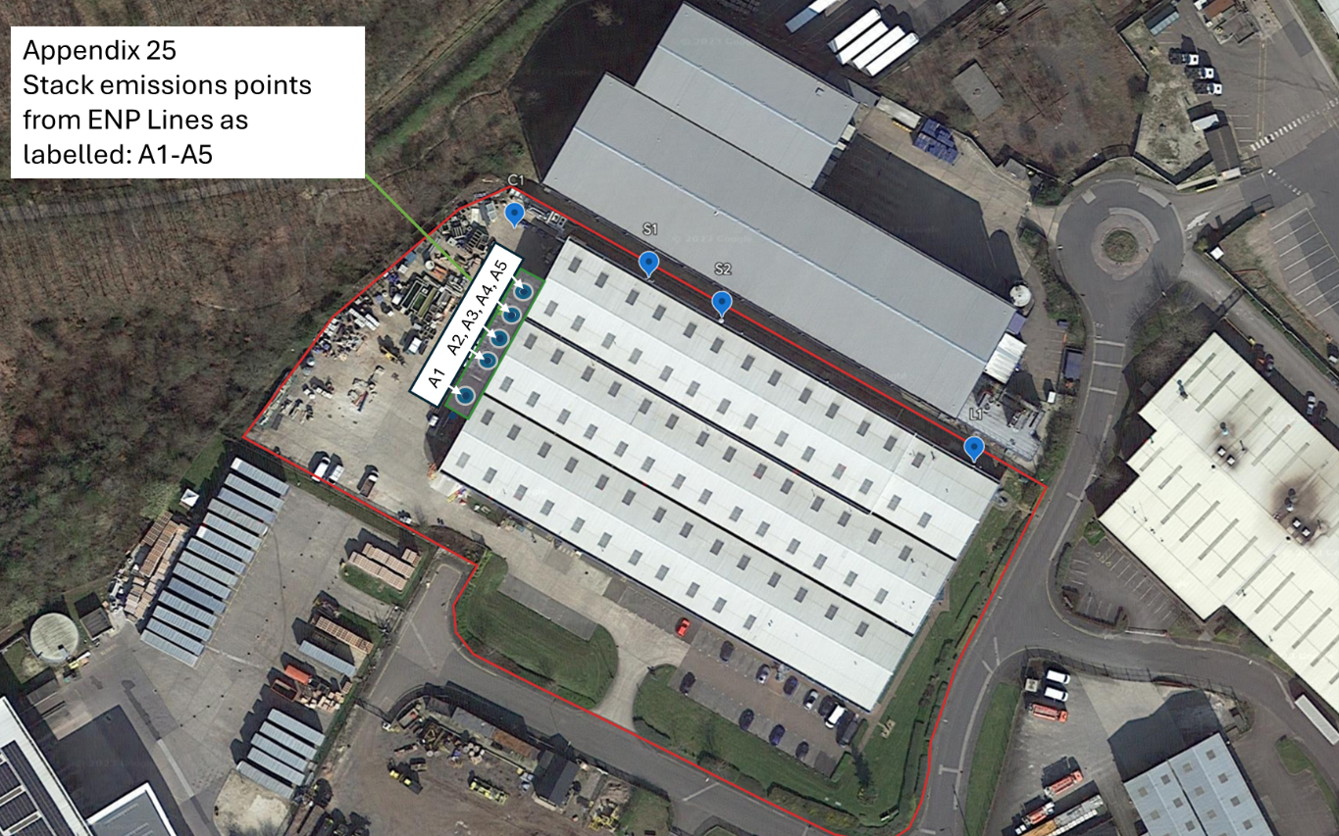
L1
Figure 2 CBEP site map showing air emission points
Chapter V of the ‘Industrial Emissions Directive’ does not apply to the activities that take place on site.
CBEP operates an Effluent Treatment Plant (ETP) on the site. This activity falls under ‘Environmental Permitting (England and Wales) Regulations 2016, Schedule 1, Chapter 5, Section 5.7’. The activity is not covered by Directive 91/271/EEC. CBEP discharges treated effluent to foul sewer under consent from Yorkshire Water Services Ltd (YWS hereafter). The direction number for the site is Y/5032/23D (refer to Appendix 3). The discharge point is located at NGR SK 42623 66520 (refer to Figure 3 below).

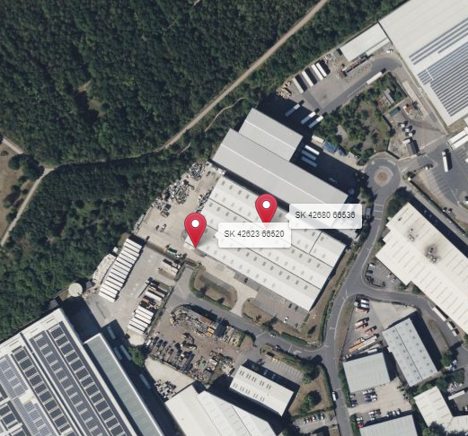
Figure 3 Regulated facility grid locations
A desktop study, using the Department for Environment, Food and Rural Affairs’ (DEFRA’s) MagicMap identified the following sensitive receptors within 5km of the site:
Table 1 List of sensitive receptors
Name | Designation | Location
Williamthorpe | Local Nature Reserve | Adjacent
Pleasley | Local Nature Reserve | East 5km
Rowthorpe Trail | Local Nature Reserve | East 5km
Duckmanton Moor | Site of Special Scientific Interest | North 4km

Refer to Figure 4 below for the location of the site in relation to Williamsthorpe Local Nature Reserve (LNR).
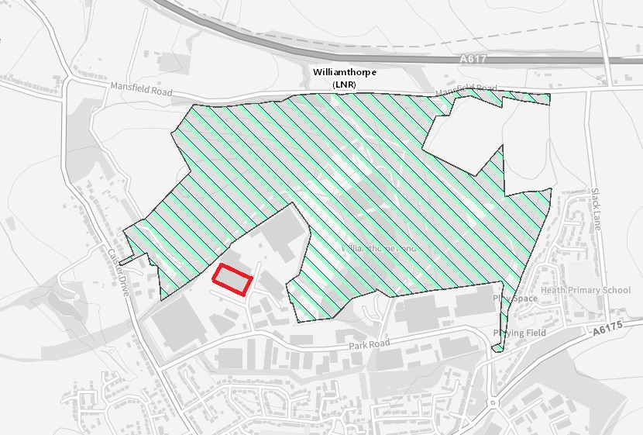
Figure 4 Location of the site to the LNR
None of the following sensitive receptors were found within 5km of the site:
• Areas of Outstanding Natural Beauty (AONB).
• National Nature Reserves (NNRs).
• Ramsar sites.
• Special Areas of Conservation (SACs).
• Special Protection Areas (SPAs).

A desktop review found that the site does not fall within a designated Air Quality Management Area (AQMA).

The site does not lie in a groundwater protection zone. However, the site is located within a nitrate vulnerable zone and within a medium groundwater vulnerability area (refer to Appendix 5 ‘Ground Water Vulnerability’).

An Environmental Risk Assessment (ERA) was carried out to assess the impacts of the activities on site have on the surrounding receptors. Refer to Appendix 7 ‘ERA’.

Site Condition Report (SCR)
CBEP obtained an SCR in March 2020 (refer to Appendix 6 ‘SCR’). CBEP have been surface treating metals since the business moved to the site in 2020 (painting only), with the addition of plating lines in 2022.

CBEP understands that that the SCR is used to establish the condition of the site at the time the environmental permit is issued. The SCR will also be used by the EA, should CBEP surrender the permit in the future, as the legal test for surrender of the permit. This is in accordance with the EA document ‘Regulatory Guidance Note, RGN9: Surrender (b)’.
Chemicals and hazardous waste has been stored within the building at all times whilst CBEP has been operating on site. The building is laid to concrete flooring which would not allow any spills to leak to ground. In addition, CBEP has not suffered any spill incidents on site. Spill kits are located at strategic points within the building as well as outside in the rear yard and next the ramp outside of the roller door near the ETP (refer to Appendix 21 ‘Spill Kit Locations’). Staff are provided with spill kit training and records of the training are kept on file.

The boreholes drilled for the SCR were located outside of the building as the building is an active manufacturing plant, with no access for the drilling of the required boreholes. The boreholes to the outside of the building were located on the northern and western sides. These locations ensured that the samples taken were between the potential source of pollution (the active manufacturing plant) and the potential water receptor (a minor stream or possible drain located immediately beyond the northwest boundary).

The borehole depths range from 1m to 2.8m, not the 10cm to 40cm identified in the EA response letter that accompanied the original application not being ‘duly made’ (refer to Appendix 2 ‘EA Not Duly Made Letter’). The soil testing was targeted on the made ground which fell between those measurements. The made ground on the site was relatively shallow and did not appear to indicate any obvious deep made ground or gross contamination associated with the operation of the site. The made ground comprised of the basal layers of the hardstanding construction around the building.

Soil leachate testing was also undertaken as well as water sampling from three boreholes, as the others were dry.

Deeper boreholes were not undertaken as the method used terminated on shallow mudstone bedrock. This strata is considered relatively impermeable and therefore provides an effective barrier between potential surface contamination and the underlying ‘Secondary A’ aquifer.

CBEP accepts that the SCR document, reference ‘14265 V1.0’ of March 2020 (Appendix 6 ‘SCR’) will be used as a baseline for the site at the point of permit application.

Ciria C736, Containment Systems for the prevention of pollution considerations.

All chemical processes within the CBEP facility are performed in open topped, fully sealed chemically resistant, polypropylene tanks as primary containment. All of these are contained as a minimum over a sealed bund as secondary containment. Some other tanks have a tertiary containment via extra bund or second tank skin are indicated on the Appendix 32 Process Flow diagram plating ops document included within the application. Wet operations are also conducted over the bund to contain any carryover/spillages.
The outside waste storage area is contained via the use for drain covers to prevent any accidental spillage escape to drain/sewer.
The bunded areas are indicated on Appendix 20 Site Map with Bund Drainage and Emissions Points.

Resource Consumption

CBEP has the capacity to plate 35 tonnes of metal per day. Refer to Appendix 12 ‘Raw Materials’ for the raw materials stored and used on site, and the annual throughput for the site. The Safety Data Sheets (SDSs) are saved in a folder ‘CBEP SDS’.

In order to reduce electricity consumption on site, CBEP has installed motion sensors on the office lighting to reduce the possibility of lights being left on unnecessarily. The installation of solar panels is under consideration.

The use of the CHP exhaust gases to heat the plating tanks has been explored by CBEP, though the CHP plant has been disconnected. There is no current plan to reconnect this asset.
The site’s annual electricity consumption for the year ending August 2024 is 1,564,182kWh. Refer to Table 2 for the current annual utility consumption. There has been an increase in the consumption of electricity on site, as the ENP production line relocated to the site in May 2022.

There are two gas meters on site. One for the site itself and one for the disconnected CHP unit. The site’s annual gas consumption for the year ending August 2024 is 170,936kWh (refer to Appendix 14 ‘CBEP Site Gas Report’). The CHP unit’s annual gas consumption for the year ending August 2024 is 1,795kWh (refer to Appendix 13 ‘CHP Gas Report’). The gas supply is currently not connected to site, so there will not be ongoing usage in the short term.
The gas usage will be commuted into electricity usage.

The water usage for the site is currently 5717m³ per year.

Refer to Table 2 below for the current annual utility consumption.

Table 2 Annual utility consumption
Utility name | Consumption | Reporting period
CHP unit (gas) | 1,795kWh | September 2023 to August 2024. NB now disconnected
CBEP site (gas) | 170,936kWh | September 2023 to August 2024
CBEP site (electricity) | 1,564,182kWh | September 2023 to August 2024
CBEP site (water) | 5717m³ | Annual

NB The CHP unit is not currently running having been disconnected from incoming gas supply.

Description of the activities on site
The site consists of a goods in area, administrative offices, a main production area (where the majority of the activities on site take place) and, an external yard. The site benefits from an impermeable surface and a sealed drainage system (refer to Appendix 20 ‘Site Plan Map with Drainage and Emission Points’. This drawing can be zoomed into for further detail).
The operating techniques associated with the activities undertaken on site, as well as the Directly Associated Activities (DAAs), were assessed against Best Available Techniques (BAT) Reference (BREF) Document for the ‘Surface Treatment of Metals and Plastics (August 2006)’. Refer to Appendix 11 ‘BAT Surface Treatments’.
The main production area is divided into sections which contain:
- the laboratory,
- machining,
- pressure test bunker,
- heat treatment,
- nickel plating lines, (+ Copper Plating Line),
- paint booth,
- slurry blaster,
- dry shot blaster,
- ETP,
- wire EDM,
- storage of some waste and degreasers.
A shot blast area is located in a container external to the main production area, as well as a disconnected CHP unit. Some waste streams are stored outside of the main building.
The laboratory
The laboratory is located on the ground floor, in the North east corner of the building. The laboratory conducts various tests, using usual ‘lab smalls’. These are bulked up and disposed of with the other chemicals collected from the main production area. MacDermid Chemicals Ltd is the appointed waste contractor and, collects and disposes of the waste chemicals in accordance with ‘The Waste (England and Wales) Regulations 2011’ and ‘The Hazardous Waste (England and Wales) Regulations 2005’.
The laboratory conducts salt spray testing. The emissions from this process are extracted and passed through the fume cupboards, which then discharge via a stack located on the Northern wall of the building (shown as point ‘L1’ on Figure 2). Refer to Appendix 20 ‘Site Map with Drainage and Emission Points’. The diagram can be zoomed in to for more detail.
Machining
CBEP design and manufacture parts to customer specification. Materials can range from food grade plastics to aerospace alloys.
The following techniques are used:
- CNC milling.
- CNC turning.
- Gear cutting.
- Wire EDM.
These processes do not emit to air.
Waste metal swarf is segregated according to the type of metal machined. The segregated waste metal is stored in appropriate containers within the building. The swarf is collected, and recycled or disposed of by Innovation Alloys in accordance with ‘The Waste (England and Wales) Regulations 2011’.
Waste lubricant used during the machining process is collected in trays at the bottom of the machines and decanted within the building into 205l metal drums. The filled drums are stored inside the building. The waste lubricant is collected, and recycled or disposed of by Pennine Lubricants Limited, the appointed waste management contractor, in accordance with ‘The Waste (England and Wales) Regulations 2011’ and ‘The Hazardous Waste (England and Wales) Regulations 2005’.
Wire EDM
Wire EDM allows for the precise machining of the hardest components and complex geometrics where CNC machining is difficult to achieve the requirements of CBEP customers. EDM is a metal fabrication process whereby a desired shape is obtained by using electrical discharges. Material is removed from the work piece by a series of rapidly recurring current discharges between two electrodes, separated by a dielectric liquid, and subject to an electric voltage.
There are no emissions to air from this process.
The Wire EDM uses non-ionised water for the machining process. The non-ionised water for the process is recirculated and evaporates over time. The non-ionised water is topped up as per the manufacturer’s specifications. There is no waste water produced from this process.
Pressure test bunker
A pressure test bunker is located on the northern side of the manufacturing area. The bunker includes a complex leakage detection system and includes oxygen monitoring, nitrogen extraction and interlocking controls.
The nitrogen extracted during the pressure testing is vented through a grate in the northern wall of the building, directly to atmosphere.
Heat treatment
CBEP can apply heat treatment to some plated components to provide differing properties to the component. This can include:
- heating and normalising,
- hydrogen de-embrittlement,
- increased hardness of Electroless Nickel Plating (ENP),
- interdiffusion.
The oven is located in the centre of the manufacturing area and uses atmospheric air to heat the components. There are no emissions to air from this process and no waste arising from this process.
ENP Line 4
ENP creates a uniform nickel coating to a component. This provides superior corrosion protection, improved surface hardness, wear resistance, conductivity, and shielding. During the ENP process, a nickel salt and hypophosphite solution serves as a bath for the base material. Once the component is in the solution, the base material acts as a catalyst for the deposition of the nickel-phosphorous onto the component.
‘Line 4’ is located within the manufacturing area, along the northern wall. This ENP line is of a smaller scale than the other three plating lines operated by CBEP and is a medium phosphorous process (refer to Appendix 19 ‘Plating Process Asset Locations’. The diagram can be zoomed into for further detail).
The emissions from Plating Line 4 are shown as point ‘S2’ on Figure 2 Appendix 25.
The chemicals used in the plating process (refer to Appendix 12 ‘Raw Materials’) on ‘Line 4’ are stored inside the building on site in Intermediate Bulk Containers (IBCs). The IBCs are stored on bunds.
‘Line 4’ consists of 4 tanks (refer to Appendix 8 ‘Plating Tank Sizes’). The tanks are between 1400m³ and 1540m³ making the aggregated volume of ‘Line 4’ 6020m³.
The emissions from ‘Line 4’ (shown as point ‘S2’ on Figure 2) are vented through a stack located externally to the building on the northern wall. The LEV for this line is also located adjacent to the stack, on the external wall.
The plating chemicals are filtered through 1micron bags in order to recycle and reuse as much of the plating chemical as possible. The filtration system is maintained regularly. The used filtration bags are stored in hazardous waste boxes inside the building. The full containers are exchanged by Innovation Alloys who dispose of them via Tradebe, the appointed waste management. company. The waste filtration bags are collected, transported, and recycled or disposed of in accordance with ‘The Waste (England and Wales) Regulations 2011’ and ‘The Hazardous Waste (England and Wales) Regulations 2005’.
Waste electroless nickel, nitric, and stripper is collected by Innovation Alloys who dispose of them via Tradebe, the appointed waste contactor, and are collected in 25,000l tankers for recycling or disposal. The waste chemicals are collected, transported, and recycled or disposed of in accordance with ‘The Waste (England and Wales) Regulations 2011’ and ‘The Hazardous Waste (England and Wales) Regulations 2005’.
Waste rinses, hydrochloric acid, and caustic cleaners are processed via the ETP. The resultant treated effluent is discharged to sewer under the YWS consent number Y/5032/23D (refer to Appendix 3).

Spray booth
The spray booth is located within the manufacturing area, along the northern wall. CBEP provides water based, oil based and, solvent based paint solutions for manufactured components.
The emissions from the paint booth are vented through a stack located externally to the building on the northern wall (shown at point ‘S1’ on Figure 2).
Waste paint is collected in used paint barrels and stored internally. Innovation Alloys collects and disposes of the waste paint in accordance with ‘The Waste (England and Wales) Regulations 2011’ and ‘The Hazardous Waste (England and Wales) Regulations 2005’.
Solvent Use
Solvent use - total quantity used per year, including spray booth and degreasing: 1475kg for degreaser and 140 litres for spray booth.
The paint contaminated cleaning product (solvent) from this process is collected in barrels (oil barrel size) and stored internally by Innovation Alloys who dispose of them via Tradebe collects and disposes of the waste paint in accordance with ‘The Waste (England and Wales) Regulations 2011’ and ‘The Hazardous Waste (England and Wales) Regulations 2005’.
Innovation Alloys who dispose of them via Tradebe collects and disposes of the waste solvent from the EVT in accordance with ‘The Waste (England and Wales) Regulations 2011’ and ‘The Hazardous Waste (England and Wales) Regulations 2005’.
Slurry/ vapour blaster
Slurry or vapour blaster is used to surface clean components with a mixture of water and an abrasive blast media (slurry) after the machining process.
There are no emissions to air from this process.
The waste slurry is transferred to skips and is collected by Muktubs, the appointed waste contactor. The waste slurry is collected, transported, and recycled or disposed of in accordance with ‘The Waste (England and Wales) Regulations 2011’ and ‘The Hazardous Waste (England and Wales) Regulations 2005’.
Stripping tanks
The stripping tanks are used to clean the components manufactured by CBEP prior to being sent to their customers. This involves the following steps:
- The degrease of the component using a solvent.
- A soak clean in ‘Uniclean 252’ (in raw materials this is a surface treatment) at a temperature of between 60°C and 90°C.
- The immersion of the component in ‘Dekote EN’ at a temperature of between 75°C and 90°C. Regular checks are undertaken at this stage to determine the effectiveness of the stripping.
- The component is washed with cold utilities water.
- The component is washed in hot utilities water.
- The component is either compressed air dried or allowed to dry naturally.
Once these steps are completed the component is oiled for transportation, packaged, and sent to the ‘Goods Out’ area for shipment to CBEP’s customer.
The stripping tanks are located on the main ENP bund, between ENP Plating Line 2A and the degreasing machine.
The emissions from the stripping tanks are vented through a stack located externally to the building on the western wall (shown as point ‘A5’ on Figure 2). The LEV for this line is also located adjacent to the stack, on the external wall (shown as ‘A5’ on Figure 2).
The waste solvents are collected by Innovation Alloys who dispose of them via Tradebe, the waste stripping chemicals are collected by Future Industrial who collect and dispose of the waste chemicals in accordance with ‘The Waste (England and Wales) Regulations 2011’ and ‘The Hazardous Waste (England and Wales) Regulations 2005’.

ENP Line 2 and Line 2a
ENP creates a uniform nickel coating to a component. This provides superior corrosion protection, improved surface hardness, wear resistance, conductivity, and shielding. During the ENP process, a nickel salt and hypophosphite solution serves as a bath for the base material. Once the component is in the solution, the base material acts as a catalyst for the deposition of the nickel-phosphorous onto the component.
‘Line 2’ and ‘Line 2a’ are located in the centre of the manufacturing area, towards the western wall. These ENP lines are identical in nature and run alongside each other. Both lines are a high phosphorous process, and can be used to provide the base for diffused nickel plating.
The chemicals used in the plating process (refer to Appendix 12 ‘Raw Materials’) on ‘Line 2’ and ‘Line 2a’ are stored inside the building on site in Intermediate Bulk Containers (IBCs). The IBCs are stored on bunds.
‘Line 2’ consists of 9 tanks of 4500m³ each (refer to Appendix 8 ‘Plating Tank Sizes’). The aggregated volume of ‘Line 2’ is 40,500m³.
‘Line 2a’ consists of 7 tanks of 4500m³ each (refer to Appendix 8 ‘Plating Tank Sizes’). The aggregated volume of ‘Line 2a’ is 31,500m³.
The emissions from ‘Line 2’ and ‘Line 2a’ are each vented through a stack located externally to the building on the western wall (shown as point ‘A3’ for ‘Line 2’ and point ‘A4’ for ‘Line 2a’ on Figure 2). The LEV for this line is also located adjacent to the stack, on the external wall (shown as ‘A3 & A4’ on Figure 2).
The plating chemicals are filtered through 1micron bags in order to recycle and reuse as much of the plating chemical as possible. The filtration system is maintained regularly. The used filtration bags are stored in hazardous waste boxes inside the building. The full containers are exchanged by Innovation Alloys who dispose of them via Tradebe, the appointed waste management company. The waste filtration bags are collected, transported, and recycled or disposed of in accordance with ‘The Waste (England and Wales) Regulations 2011’ and ‘The Hazardous Waste (England and Wales) Regulations 2005’.
Waste electroless nickel, nitric, and stripper is collected by Innovation Alloys who dispose of them via Tradebe, the appointed waste contactor, and are collected in 25,000l tankers for recycling or disposal. The waste chemicals are collected, transported, and recycled or disposed of in accordance with ‘The Waste (England and Wales) Regulations 2011’ and ‘The Hazardous Waste (England and Wales) Regulations 2005’.
Waste rinses, hydrochloric acid, and caustic cleaners are processed via the ETP. The resultant treated effluent is discharged to sewer under the YWS consent number Y/5032/23D (refer to Appendix 3).
ENP Line 1
ENP creates a uniform nickel coating to a component. This provides superior corrosion protection, improved surface hardness, wear resistance, conductivity, and shielding. During the ENP process, a nickel salt and hypophosphite solution serves as a bath for the base material. Once the component is in the solution, the base material acts as a catalyst for the deposition of the nickel-phosphorous onto the component.
‘Line 1 is able to plate using ENP with Polytetrafluoroethylene (PTFE) - refer to Appendix 19 ‘Plating Process Asset Locations’. The diagram can be zoomed into for further detail.
‘Line 1’ is located in the centre of the manufacturing area, towards the western wall. ‘Line 1’ is a medium phosphorous process. ‘Line 1’ is able to plate using ENP with Polytetrafluoroethylene (PTFE) and diffused nickel plating (refer to Appendix 19 ‘Plating Process Asset Locations’. The diagram can be zoomed into for further detail).
The chemicals used in the plating process (refer to Appendix 12 ‘Raw Materials’) on ‘Line 1’ are stored inside the building on site in Intermediate Bulk Containers (IBCs). The IBCs are stored on bunds.
‘Line 1’ consists of 17 tanks (refer to Appendix 8 ‘Plating Tank Sizes’). The tanks vary in volume between 405m³ and 1013m³, making the aggregated volume of ‘Line 1’ 9344m³.
The emissions from ‘Line 1’ is vented through a stack located externally to the building on the western wall (shown as point ‘A2’ on Figure 2). The LEV for this line is also located adjacent to the stack, on the external wall (shown as ‘A2’ on Figure 2).
The plating chemicals are filtered through 1 micron bags in order to recycle and reuse as much of the plating chemical as possible. The filtration system is maintained regularly. The used filtration bags are stored in hazardous waste boxes inside the building. The full containers are exchanged by Innovation Alloys who dispose of them via Tradebe, the appointed waste management company. The waste filtration bags are collected, transported, and recycled or disposed of in accordance with ‘The Waste (England and Wales) Regulations 2011’ and ‘The Hazardous Waste (England and Wales) Regulations 2005’.
Waste electroless nickel, nitric, and stripper is collected by Innovation Alloys who dispose of them via Tradebe, the appointed waste contactor, and are collected in 25,000l tankers for recycling or disposal. The waste chemicals are collected, transported, and recycled or disposed of in accordance with ‘The Waste (England and Wales) Regulations 2011’ and ‘The Hazardous Waste (England and Wales) Regulations 2005’.
Waste rinses, hydrochloric acid, and caustic cleaners are processed via the ETP. The resultant treated effluent is discharged to sewer under the YWS consent number Y/5032/23D (refer to Appendix 3).
Copper Plating
Copper plating is an electrolytic process that applies a ‘pure’ copper layer on the top of components immersed within it. This layer is used to promote electrical properties including conductivity on the plated product. The copper solution used is a combination of: Copper Sulphate, Cumac Optima (a 3 part solution) Hydrochloric Acid, Sulphuric acid and Copper Sulphate, made up with deionised water. The solution is mixed when required, the constituent parts are stored on the main bund prior to use. The chemicals used and the estimated volumes per tank are detailed in ‘Appendix 32 – Process flow diagrams plating ops.’
The process is performed in two identical tanks with dimensions of 2.0m x 1.97m x 0.5m (3.93 m³ volume each) that stand side by side – these have been designed specifically to accommodate radio aerials used in the rail industry. The plating tanks are not directly extracted and sit on a polypropylene bund that surrounds the two tanks and is designed to ‘overflow’ onto the main ENP concrete bund – there is enough height to ensure any fluid would drain in this way with a channel to direct any spillage in the desired direction. There are no preparation tanks or rinse tanks associated with this process, only the two process tanks themselves. The copper tanks are located to the North side of the main bund, between the Vapour Blaster and the EVT Vapour Degreaser.
The process is an electrolytically driven process, initiated by passing an electrical current through electrodes connected to copper pellets that are immersed in the solution along with the part being plated. The tank is not directly heated.
Waste Copper solution is pumped into an IBC and collected and by Innovation Alloys who dispose of them via Tradebe, the appointed waste contactor,. The waste chemicals are collected, transported, and recycled or disposed of in accordance with ‘The Waste (England and Wales) Regulations 2011’ and ‘The Hazardous Waste (England and Wales) Regulations 2005’.

Air emissions
The CBEP site has nine emissions points to air. These stacks are from the following processes and activities that take place on site:
- Plating Line 1
- Plating Line 2
- Plating Line 2A
- Plating Line 4
- Spray Booth 1
- Laboratory Extraction
- CHP Unit - disconnected
All of the emission points have sample ports installed to adhere to British Standard ‘EN15259: Air quality – Measurement of stationary source emissions - Requirements for measurement sections and sites and for the measurement objective, plan and report’.
Emission points testing was carried out on the 20th January 2020 on equivalent processes at the previous location, by EMS before transferring the process lines to Enterprise Drive in 2022. Report attached Appendix 23
An H1 Risk Assessment has been completed. Using estimated figures, based on measured figures from the same operations under the previous location and water emissions from the current site. (refer to H1 Tool v9.2 - WQDisabled).
Waste sources from the plating process
The plating chemicals are filtered through 1micron bags in order to recycle and reuse as much of the plating chemical as possible. The filtration system is maintained regularly. The used filtration bags are stored in hazardous waste boxes inside the building. The full containers are exchanged by Innovation Alloys who dispose of them via Tradebe, the appointed waste management company. The waste filtration bags are collected, transported, and recycled or disposed of in accordance with ‘The Waste (England and Wales) Regulations 2011’ and ‘The Hazardous Waste (England and Wales) Regulations 2005’.
Waste electroless nickel solution, nitric, and stripper is collected by Innovation Alloys who dispose of them via Tradebe, the appointed waste contactor, and tanked off site for recycling or disposal. The waste chemicals are collected, transported, and recycled or disposed of in accordance with ‘The Waste (England and Wales) Regulations 2011’ and ‘The Hazardous Waste (England and Wales) Regulations 2005’.
Waste rinses, hydrochloric acid, and caustic cleaners are processed via the ETP. The resultant treated effluent is discharged to sewer on the YWS consent.
Dry shot blast unit
Dry shot blast is used to surface clean components with blast media after the machining process.
The unit is external to the site’s building where the majority of the site’s activity takes place. The unit is a 6m long modified, weatherproofed container. The container has a steel plate lined floor and rubber lined walls, with safety interlocking doors to prevent blasting, if they are left open.
The container holds a dust collector that consists of a dry filter unit. The dust laden air enters the dust collector through an inlet spigot located in the side of the casing. Large particles drop out of the airstream in the pre-separation section, due to the drop in air speed. Air is then drawn upwards though the filter bags where the finer particles are collected on the outside of the elements. Clean air is drawn into the eye of the backward inclined centrifugal fan, mounted in the fan chamber at the top of the unit. The fine dust deposited on the outside of the bag is dislodged, after shutdown of the fan, by a shaking mechanism activated by a motor mounted on the side of the casing.
The emissions to air from this process are vented directly to atmosphere after the dust collector unit.
The used dust collection bags are collected by Ward’s and transported, recycled or disposed of in accordance with ‘The Waste (England and Wales) Regulations 2011’ and ‘The Hazardous Waste (England and Wales) Regulations 2005’.
The old sand used in the blast cleaning process is placed in a small skip and removed by Muck Grab Services. The waste sand is collected, transported, and recycled or disposed of in accordance with ‘The Waste (England and Wales) Regulations 2011’ and ‘The Hazardous Waste (England and Wales) Regulations 2005’.
Refer to Appendix 16 ‘Dry Shot Blast Unit’ for the full specification.

Effluent Treatment Plant (ETP)
CBEP operates an ETP on site under consent number Y/5032/23D (refer to Appendix 3) issued by YWS. This allows the site to discharge trade effluent to sewer. The consent was varied on the 29th of September 2023. Discharge to sewer takes place daily in accordance with the YWS consent.
Waste rinses from the plating process, hydrochloric acid, and caustic cleaners are directed to the ETP to discharge to foul sewer under this consent. The effluent is treated prior to the permitted discharge. The effluent is tested to ensure that parameters set out in the YWS consent are met. The discharge is not considered hazardous.
The ETP is located within the main production area along the southern wall of the building (refer to Figure 5 ETP sewer connection location and sample point, below). the shortest distance between the boundary of the site and the nearest foul sewer is approximately 20m, with an NGR SK 42743 66468.
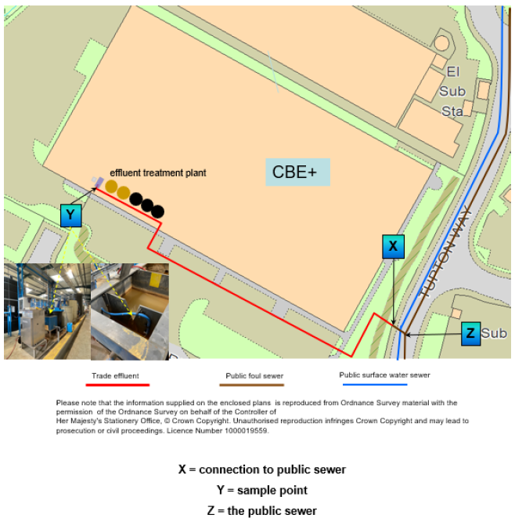
Figure 5 ETP sewer connection location and sample point
The trade effluent consent stipulates the following conditions:
- The quantity and rate of discharge from the site will be measured continuously.
- A continuous record of the pH of the effluent will be provided at the approved measuring point (refer to Figure 3, point Y).
- Records to be kept by CBEP, for a period of six years, of the nature and quantities of any chemicals used to ensure compliance with the consent issued by YWS.
- The equipment used to measure the parameters set out in the consent form are independently tested and calibrated.
- The quantity of effluent discharged will not exceed 35m³ in any period of 24 hours.
- The rate of effluent discharged will not exceed 0.4l per second.
Below is Table 3 which lists the conditions stipulated in the consent from YWS and the latest result results of testing undertaken by CBEP on 11 September 2024 (refer to Appendix 17 ‘ETP Discharge Log’). The temperature and pH are measured continuously and records are kept on the systems’ computer. Zinc and cyanide are not measured as these materials are not used on site.

Table 3 Conditions set out in consent Y/5032/23D and results from last test
Parameter | Condition | Unit of measure | Time period | 11.09.2024 test results
Temperature | 43.3 | Degrees Celsius | At the time of discharge | Continuous reading stored on system computer
Acidity/ alkalinity | No less than 6/ no more than 10.5 | pH | Approved measuring point | Continuous reading stored on system computer
Settled Chemical Oxygen Demand (COD) | 3000 | mg/l | At any one time | 136mg/l
Settleable solids | 250 | mg/l | At any one time | 56mg/l
Total copper (Cu) | 1 | mg/l | At any one time | 0.156mg/l
Total load of copper (Cu) | 0.0150 | kg | In a 24 hour period | 0.0005kg
Total cyanide (CN) | 2 | mg/l | At any one time | Not used on site
Total nickel (Ni) | 4 | mg/l | At any one time | 1.21mg/l
Total load of nickel (Ni) | 0.0600 | kg | In a 24 hour period | 0.0036kg
Total zinc (Zn) | 1 | mg/l | At any one time | Not used on site

The use of the onsite ETP has reduced the associated costs for the removal of effluent from the site via tanker and allows for the treatment of effluent on site. The ETP recycles water within the site process (refer to Appendix 22 ETP Process), reducing the volume of effluent discharge to foul sewer. Refer to Appendix 18 ‘ETP Specification’. The specification document contains flow diagrams of the effluent treatment process.
In order to ensure compliance with the permitted limits of the discharge consent, CBEP monitors the daily flow rate. The ETP is fitted with a flow meter which records the total flow and maximum flow rate for the current and previous day. In addition, a second flow meter records the instantaneous flow rate, which can be monitored via a web-based logging platform accessible to permitted and trained employees.
The effluent from the plating tanks can become acidic or alkali depending on the process being used during ENP. CBEP treats the waste liquids to ensure the aqueous waste is safe before discharging to the sewer under the consent granted by YWS. Waste liquids resulting from the plating process include rinse water, spent cleaners, spent acids, and spent electroless nickel solution.
The ETP is able to manage an increased throughput of effluent, by utilising a separate clarifier system to clarify and thicken solids for removal prior to the de-watering process.
Waste rinses, hydrochloric acid, and caustic cleaners are mixed in the treatment tank following the procedure outlined in CBEP document ‘SOPEFF004 – Treating Waste HCL, Cleaner and Rinses’ found in the ETP folder.
A sumpless pump system automatically transfers the wastewater directly from the ENP lines to the designated holding tanks in the ETP area.
The rinse water is collected in a 15,000l equalisation tank and a programmable pump is used to transfer the waste to the treatment tank.
Spent alkaline concentrates are collected in a 10,000l tank and spent acid concentrates are collected in a separate 10,000l tank.
Spent electroless-nickel waste is collected in a 12,000l tank.
The 7,500l neutralization tank adjusts the pH to the optimum value, adding a precipitant and a coagulant to precipitate metals, and then adds a flocculant to enhance settling of the effluent. A neutralisation tank is used to process effluent and automatically calculates and provide the correct dosage to ensure the effluent pH is within the acceptable limits of the discharge consent. The filling of the neutralisation tank is described in detail in CBEP document ‘SOPEFF003 – Filling the Effluent Treatment Tank’ found in the ETP folder.
The flocculated waste is then pumped to a 11,500l clarifier tank with built-in thickener to settle the solids. The clarified, treated water overflows into a 7,500l final pH neutralization unit. Once the treated effluent is at the correct pH, it is pumped into a 20m³ transfer tank, prior to being pumped to the discharge point into foul sewer. The transfer tank allows for the controlled discharge of treated effluent to the foul sewer line in accordance with the YWS discharge consent limit of 0.4l/s. Refer to CBEP document ‘SOPEFF007 – Discharging to V-Notch’ found in the ETP folder.
Fully automated chemical feed systems ensure proper treatment and optimise chemical usage to achieve the conditions set out in the discharge consent, prior to discharge to foul sewer.
Filling of the polymer (flocculant) tank is detailed in CBEP document ‘SOPEFF004 – Treating Waste HCL, Cleaner and Rinses’ found in the ETP folder. The addition of a coagulant binds with the metals present in the waste liquid. Flocculants promote the clumping together of the polymer-bound metals in the liquid waste. The flocculant is more dense than the liquid and separates from the liquid waste in the clarifier tank.
Refer to Appendix 17 ‘ETP Discharge Log’ for samples of monthly testing undertaken by CBEP in accordance with the consent granted by YWS.
Copper and nickel require measuring and monitoring as part of the consent issued by YWS. When reviewed against the ‘Substances confirmed as hazardous or non-hazardous pollutants following public consultation’ document via the weblink in Part B6 of this application, the following was found, shown in Table 4:
Table 4 Effluent substances pollutants
Substance | Findings
Copper | All iterations are non-hazardous pollutants
Nickel | A non-hazardous pollutant

The integrated system also includes a 25l per minute Reverse Osmosis (RO) system to provide high quality water for the ENP process. This means the waste-water can be partly recycled and used within the processes on the site. Mains water is collected in a covered 1,900l tank prior to treatment.
Waste sources from the ETP
A filter press is used to separate the solid matter (filter cake) from the liquid treated effluent. The filter cake, which contains nickel and other metals that has been precipitated during the effluent treatment process, is packaged in impermeable sacks and industrial clingfilm. The filter cake packages are stored outside of the building in the waste yard, on an impermeable surface that benefits from sealed drainage. The packages are stored on top of pallets to provide visibility for any leaks and for ease of movement for disposal.
The filter cake is collected by Innovation Alloys who dispose of them via Tradebe, the appointed waste contactor. The filter cake is collected, transported, and recycled or disposed of in accordance with ‘The Waste (England and Wales) Regulations 2011’ and ‘The Hazardous Waste (England and Wales) Regulations 2005’.
Waste held internally
CBEP has hazardous waste boxes placed at strategic points throughout the manufacturing area. These boxes are in place to hold filtration bags from the plating process, waste solvents, degreasers, and spent nascent.
These waste streams are segregated, stored correctly and collected in accordance with ‘The Waste (England and Wales) Regulations 2011’ and ‘The Hazardous Waste (England and Wales) Regulations 2005’.

Waste
Various waste streams are produced by CBEP whilst undertaking their business activities. Refer to Table 5 (below) for details of the waste produced on site:
Table 5 Waste types produced by CBEP
Waste type | Container | Classification | Waste management company
General | Skip | 20 03 01 | Ward’s
Cardboard | Skip | 20 01 01 | Ward’s
Plastic | Skip | 15 01 02 | Ward’s
Food | Skip | 20 01 08 | Ward’s
Waste Electrical and Electronic Equipment (WEEE) | Skip | 20 01 36 | Innovation Alloys
Batteries | Skip | 16 06 01/16 06 02 | Innovation Alloys
Wood | Skip | 20 01 38 | Ward’s
Metal (swarf, filings, off cuts etc) | Plastic stillages | 12 01 01/12 01 03 | Innovation Alloys
Lubricants, oils | IBC | 13 01 09 | Pennine Lubricants
Paint | Used paint cans | 08 01 11 | Innovation Alloys
Solvents | Hazardous waste boxes | 14 06 02 | Tradebe
Degreasers | Hazardous waste boxes | 14 06 03 | Tradebe
Nascent | Hazardous waste boxes | TBC | Tradebe
Chemicals | IBCs | 11 01 11 / 11 01 98 / 11 01 05 / 11 01 07 / 11 01 98 / 11 02 05 | Tradebe
Liquids (contaminated) | IBCs | 06 01 05/ 11 01 11 | Tradebe
Filter cake | Plastic wrapped | 11 01 09 | Tradebe
Filter bags (1micron) | Hazardous waste boxes | 15 02 02 | Tradebe
Filter bags (dry shot blast) | Skip | 15 02 03 | Innovation Alloys
Vapour Blaster Slurry | Skip | 15 02 03 | Muktubs

All waste is produced on site by CBEP is managed in accordance with the waste hierarchy as part of the ‘Waste Framework Directive (Directive 2008/98/EC)’.
Environment Management System
CBEP operates its own effective, written management system that will identify and reduce the risk of pollution arising from the site from the permitted activities. The environmental management system will take into account resilience to climate change and follow the guidance on the Gov.uk website.
Image showing document arrangement: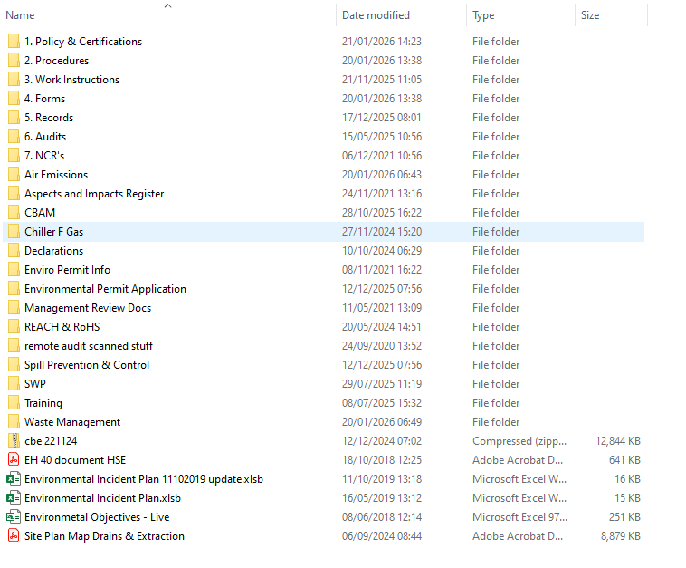
Preventative Maintenance Programme
CBEP operates a Planned Preventative Maintenance (PPM) programme on all plant on the site. This covers the following plant:
- Vapour blaster
- Degreaser
- ETP
- Paint heater
- Line 4
- Aeron’s for all plating lines
- Carbolite oven
- Nitec oven 2
- Nitec oven 4
- Nitec oven 5
- Pentag boring and turning machine
- Hodge Clemco Sand blaster
- DSBC880 Sand blaster
- Shot blaster
- Vapormat 1010
- Mazak350 lathe
- Okuma MB40000 Horizontal Mill
Refer to folder ‘PPM’ for details of the maintenance programme for the associated plant.

