CBE Plus – Environmental Permit Application
Appendix 4 – Permit boundary
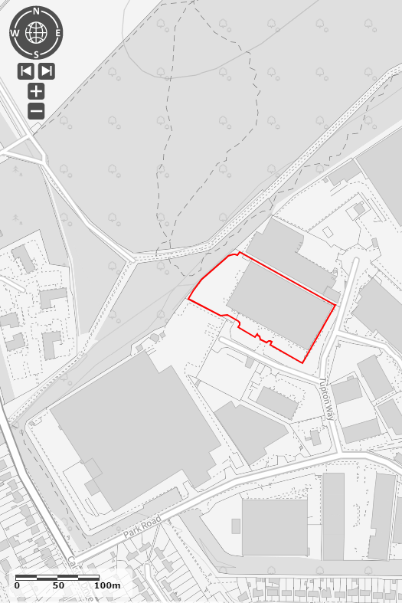
Figure 1 Permit boundary
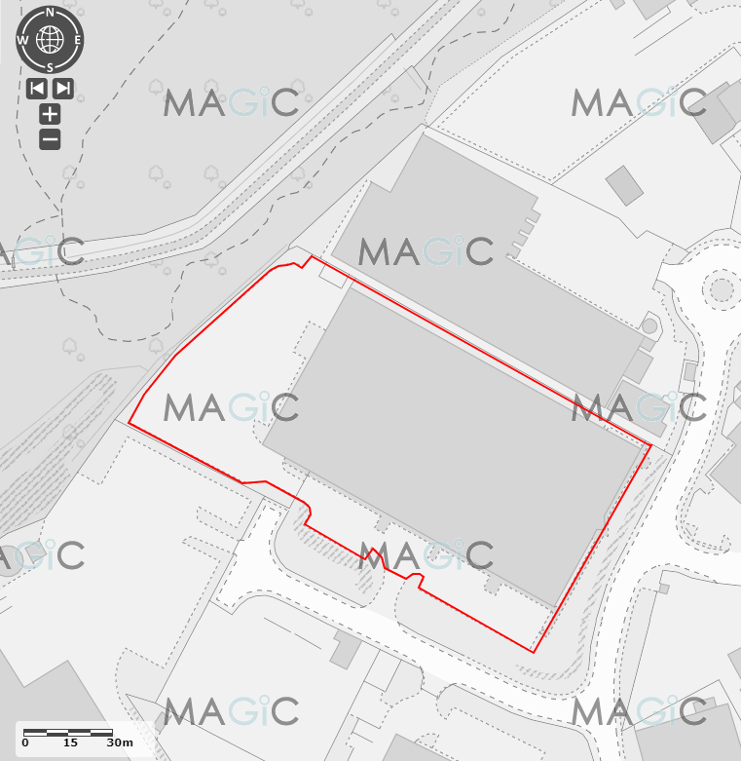
Figure 2 Permit boundary closeup

