sopeff00X – Troubleshooting issues with the effluent
cbeplus.com



Document Control
Publication Date: | 10/01/2024
Author: | Haneef Rashid
Version number: | 1
Comments: | Document created

Background

An effluent is an industrial wastewater treatment plant. We use it treat our waste liquids to ensure it’s safe before discharging to a sewage works.
During the plating process we generate a lot of waste liquids that include, rinse water, spent cleaners, spent acids & spent electroless nickel solution.
We must treat these waste products by through a process of metals removal and neutralisation.

Treatment process won’t start
To start the treatment process from the main menu, click on batch treatment then select “start treatment” as shown in Figure 1. If the treatment process does not start then return to the main menu, select batch treatment and ensure that:
- All the lights highlighted Figure 2 are green. If they are not, identify which light(s) are white and adjust where required to obtain a green light.
- The batch treatment process is in auto.
- Ensure that the fill level is made in the polymer tank.
- Ensure that all chemical pumps are set to auto.
- Ensure that the mixer is set to auto
If all the lights are showing as green but the treatment process still won’t start then reset the treatment process and restart the treatment process as shown in Figure 1.
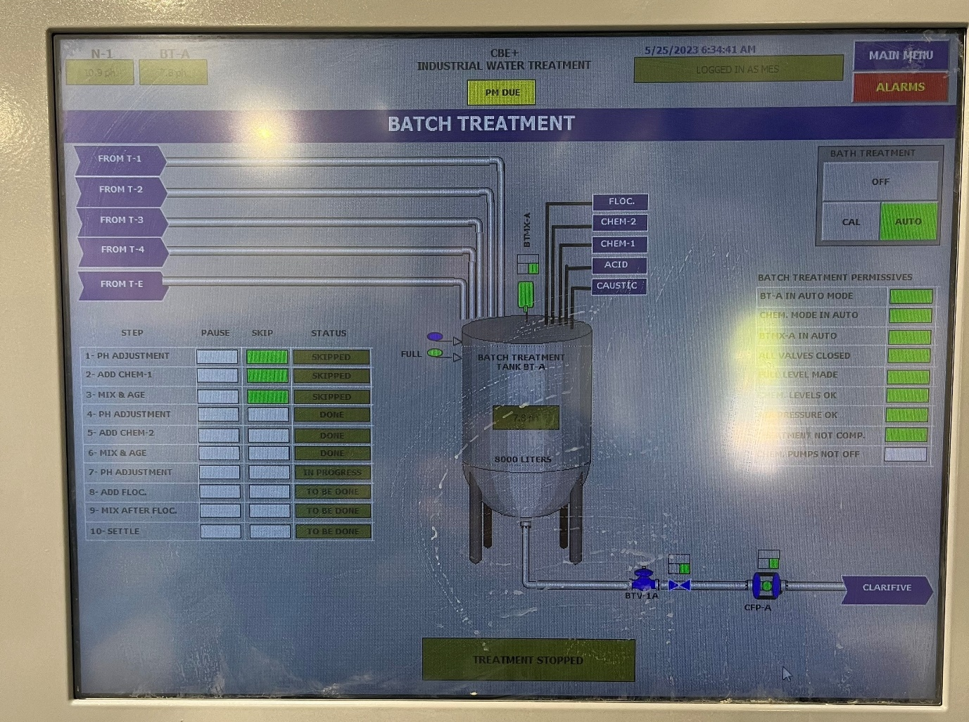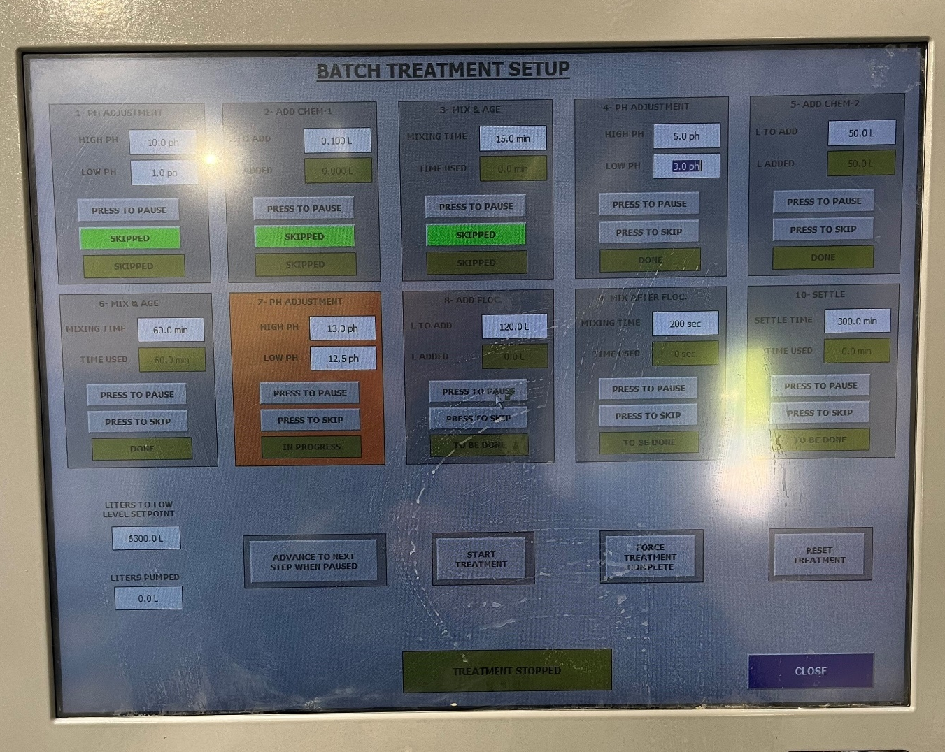
Figure 1

Figure 2

Treatment process stopped during cycle

Chemical pumps cut off
When dosing large amounts Caustic, Sulphuric acid, Ferric Chloride and Polymer it is common that the chemical pumps will automatically switch from “auto” to “off”. The pumps automatically switch off as a safety feature to avoid the pumps running away.
However, all the pumps need to be switch to auto for treatment to continue. As shown in Figure 3 all the boxes within the batch treatment menu must be green for the treatment process to start and for it to continue.
If at any point one the chemical pumps cut out it will show as the bottom box will be white and not green. Even if a step does not involve any chemicals dosing the process will not continue onto the next step without the pumps being reset.
Figure 3

If the treatment process has stopped and the chemical pumps are showing as off, then press on the chemicals being dosed into the batch treatment tank as shown in Figure 4.
Figure 4

Ensure that the pumps highlighted in Figure 5 are all in “auto”. Once they are all in “auto” then the treatment should automatically resume the treatment process.
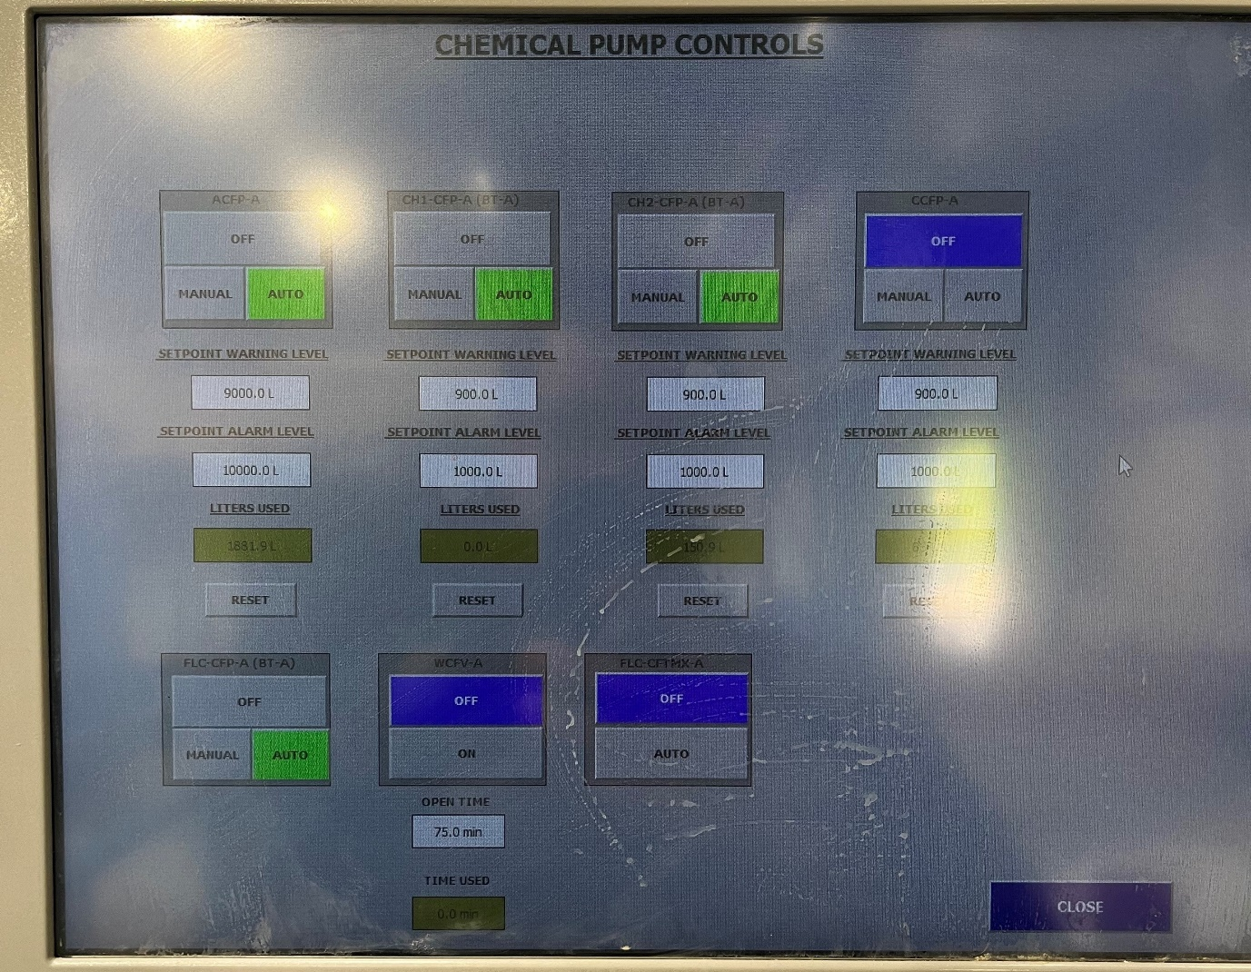
Figure 5
If the treatment process does not resume then reset the setpoint levels for each pump as shown in Figure 6.

Figure 6

Training Confirmation

I have read and understood the above SOPEFF00X – “Troubleshooting issues with effluent” and will abide by the procedure and will ensure any concerns or rectifications required to the procedure are raised through the necessary authority (team leader, manager etc)

Signed……………………………………………………………. Print name……………………………………………………..

Date………………………………………………………………..

The above signed document will be retained by HR as part of the employee training documentary evidence.

Trainers name & signature ……………………………………………………………………………………..

