sopeff007 – discharging into the v-notch
cbeplus.com



Document Control
Publication Date: | 8/01/2024
Author: | Haneef Rashid
Version number: | 1
Comments: | Document created

Background

Trade effluent is liquid waste, other than domestic sewage or rainwater run-off that comes from a business. Our trade effluent must be treated before being discharged to the sewage works. Our trade effluent may be analysed at any time by the water authority who manage the sewage works (Yorkshire Water) to ensure that our trade effluent is within the limits of our consent. It is the responsibility of the company and the person discharging to ensure that the trade effluent meets the limits outlined within the consent. Any breach of consent may result in, a warning, a fine, criminal prosecution.

Our current discharge consent is the following:

- The temperature of the effluent shall not exceed 43.3 degrees Celsius at the time of discharge.
- The pH value of the effluent shall not be less than 6 nor more than 10.5 at the approved measuring point.
- Settled Chemical Oxygen Demand shall not exceed 3000 milligrams per litre.
- Settleable Solids shall not exceed 250 milligrams per litre.
- Total Copper (as Cu) shall not exceed 1 milligram per litre.
- Total load of Copper (as Cu) discharged in twenty-four hours shall not exceed 0.015 kilograms.
- Total Cyanide (as CN) shall not exceed 2 milligrams per litre.
- Total Nickel (as Ni) shall not exceed 4 milligrams per litre.
- Total load of Nickel (as Ni) discharged in twenty-four hours shall not exceed 0.06 kilograms.
- Total Zinc (as Zn) shall not exceed 1 milligram per litre.
- Maximum flow rate will not exceed 0.4 L/s and 35 m³ over a given 24-hour period.

Our treatment process

Once treated the effluent is pumped from the treatment tank over to the clarifier to aid in separation of the floc from the treated water. The treated effluent the overflows from the clarifier into a neutralization tank. The neutralization tank is to ensure that the pH of the effluent does not exceed the pH outlined in our consent. It is then pumped into a transfer tank which transfers the treated effluent to a 20m³ holding tank (Tank E) which allows for a controlled discharge of treated effluent without exceeding 0.4 L/s.

Discharging

To start discharging from the holding tank (Tank E) then go to main menu - > Clock. You will then see the clock menu as shown in Figure 1. From the clock menu you can turn the discharge on or off and set times for discharging. The pumps will turn on and off automatically to discharge within the times set if the switches are green.

Times can be altered by clicking on the start/stop boxes and typing the times in.

The current time and date is shown in the top right corner and can be edited by selecting “setting date and time” in the bottom right corner.

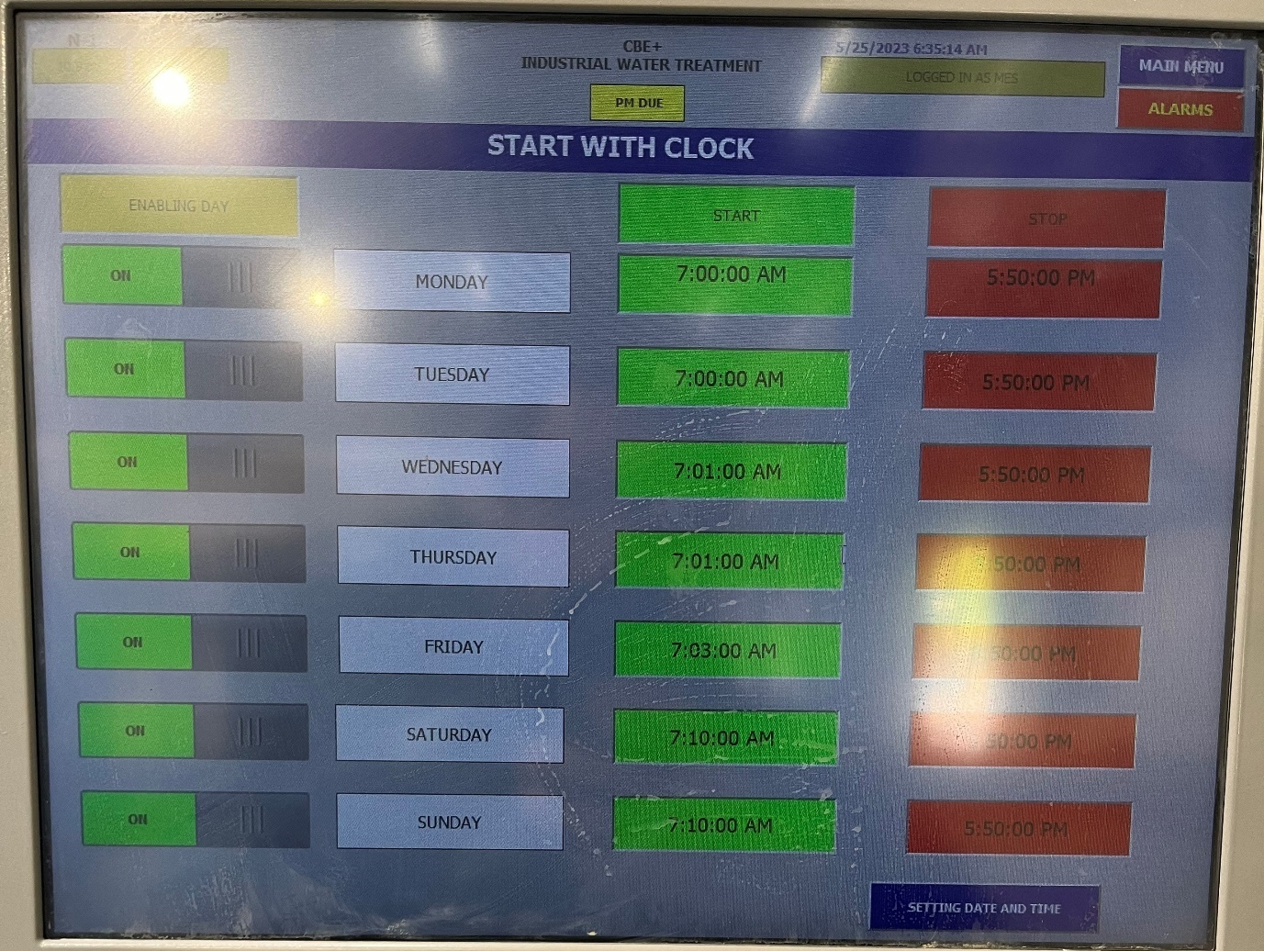
v
Figure 1

Once the tank has started to discharge into the v-notch it’s important to ensure that the flow rate does not exceed 0.4 L/s as outlined within our consent. The flow rate is controlled by the discharge pump air pressure which can be turned up to increase flow rate and turned down to decrease the flow rate. It is also controlled by the ball valves from the holding tank to the v-notch. Opening any of the ball valves will increase the flow and closing them will restrict the flow.

The maximum flow rate for a given day can be seen at any time on the Siemens flow meter shown in Figure 2.
The siemens box will also show the total flow discharged as shown in Figure 3.
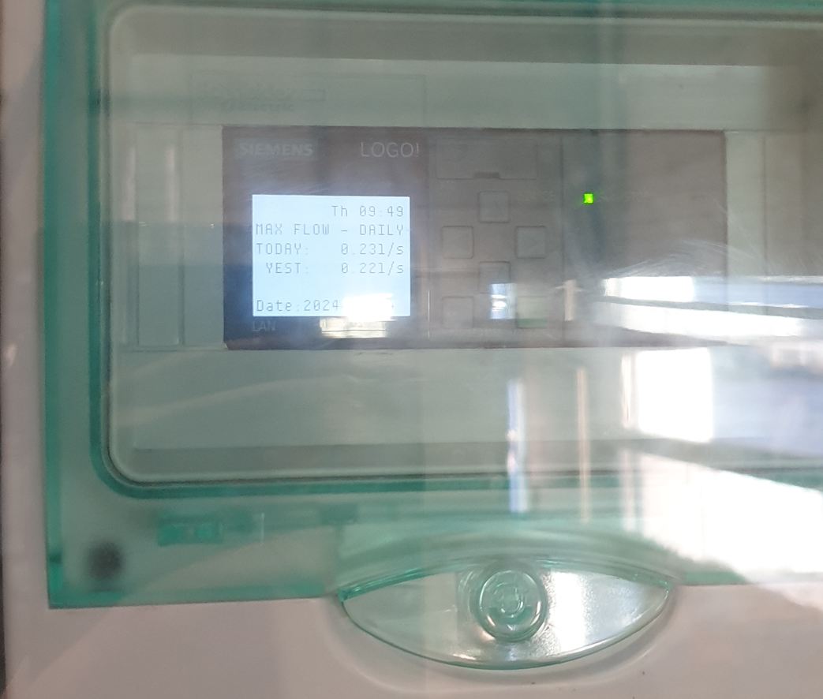
Figure 2

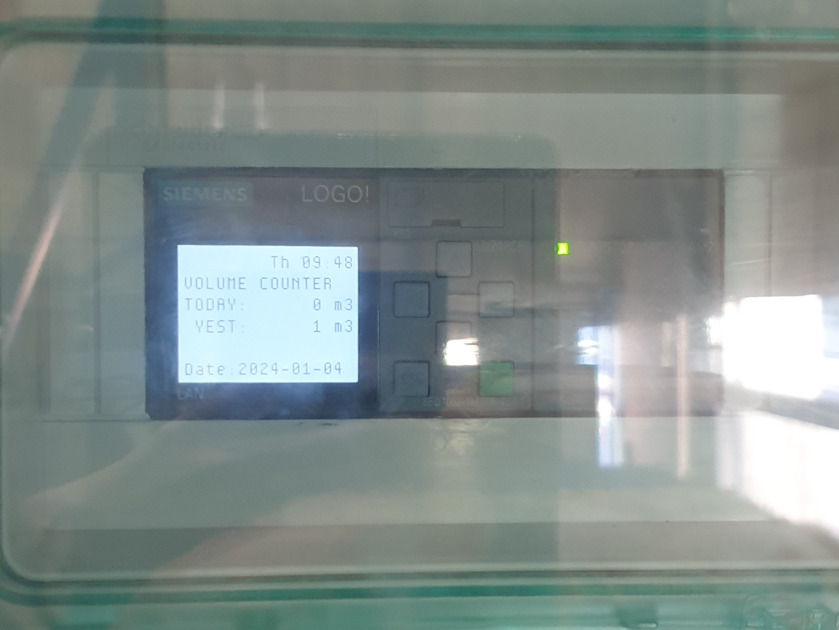
Figure 3

While discharging samples will be automatically collected by the sample bottles every 1m³ to create a composite sample for that day. It is required to store this sample for 48 hours as Yorkshire Water may need to test the composite sample.
Samples are collected into bottles show in Figure 4. They fill up from left to right 1 bottle per day. When the sampling unit reaches the bottle furthest to the right the next bottle will be the furthest to the left. One key point to note is that the sampling unit will only move onto the next bottle if you discharge at least 1m3 that day. If you do not discharge that day the sampling unit will not move on to the next bottle.

The bottles should be emptied 48 hours after the sample is collected. Yorkshire water will only take a sample of the water discharging on the day they come in and a sample from the previous day. They should be checked regularly to ensure that the sampling unit is sampling into a empty bottle a the start of the day.
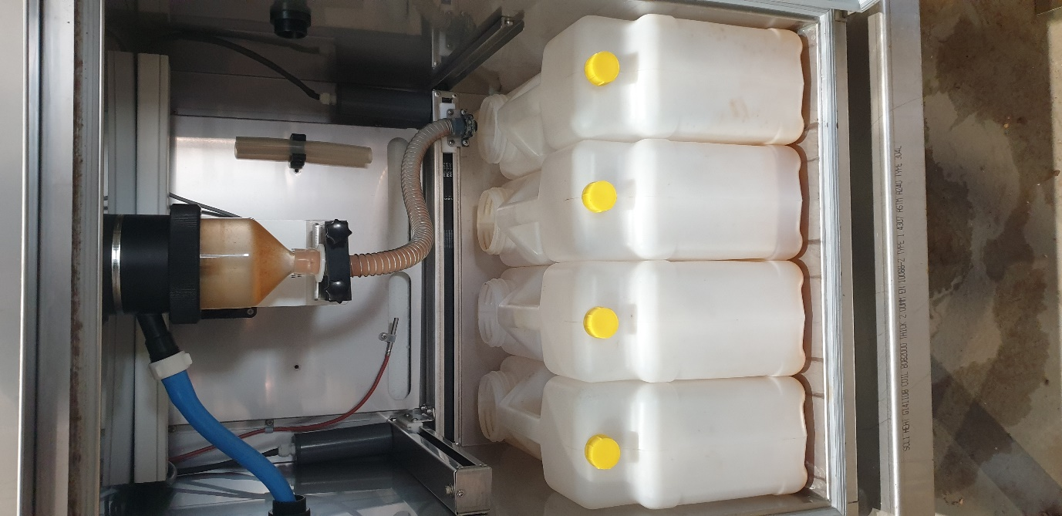
Figure 4

Training Confirmation

I have read and understood the above SOPEFF007 – “Discharging to V-Notch” and will abide by the procedure and will ensure any concerns or rectifications required to the procedure are raised through the necessary authority (team leader, manager etc)

Signed……………………………………………………………. Print name……………………………………………………..

Date………………………………………………………………..

The above signed document will be retained by HR as part of the employee training documentary evidence.

Trainers name & signature ……………………………………………………………………………………..

