sopeff004 – Treating waste HCl and Cleaner
cbeplus.com



Document Control
Publication Date: | 4/01/2024
Author: | Haneef Rashid
Version number: | 1
Comments: | Document created

Background

An effluent is an industrial wastewater treatment plant. We use it treat our waste liquids to ensure it’s safe before discharging to a sewage works.
During the plating process we generate a lot of waste liquids that include, rinse water, spent cleaners, spent acids & spent electroless nickel solution.
We must treat these waste products by through a process of neutralization and metals removal.

Filling the wastewater treatment tank

To treat waste acid and alkaline then follow the outlined below:

- Follow the instructions outlined in SOPEEFF003 to fill the batch tank with roughly 400L Acid, 1000L of cleaner (alkaline waste) and the rest with rinses (these values may change due to the strength of the cleaner and acid wastes, an ideal starting point is a mixed pH of 3, so adjust the waste mixture accordingly depending on the strength of the cleaner and acid). When filling the treatment tank, It is important not to add cleaner and acid at the same time. Instead add approx. 1000L of rinses followed by 500L of acid, then 3500L of rinses followed by 1000L of cleaner, then fill the rest of the tank with rinses. This is to ensure that you don’t get a reaction between the acid and alkaline waste streams. DO NOT pump acid and alkaline into the tank at the same time.
- Once the treatment tank is filled then allow to mix for at least 10 minutes to ensure that the mixture is homogenous. By mixing it allows the pH probe to obtain an accurate reading.
- From the main menu go into batch treatment Figure 1.

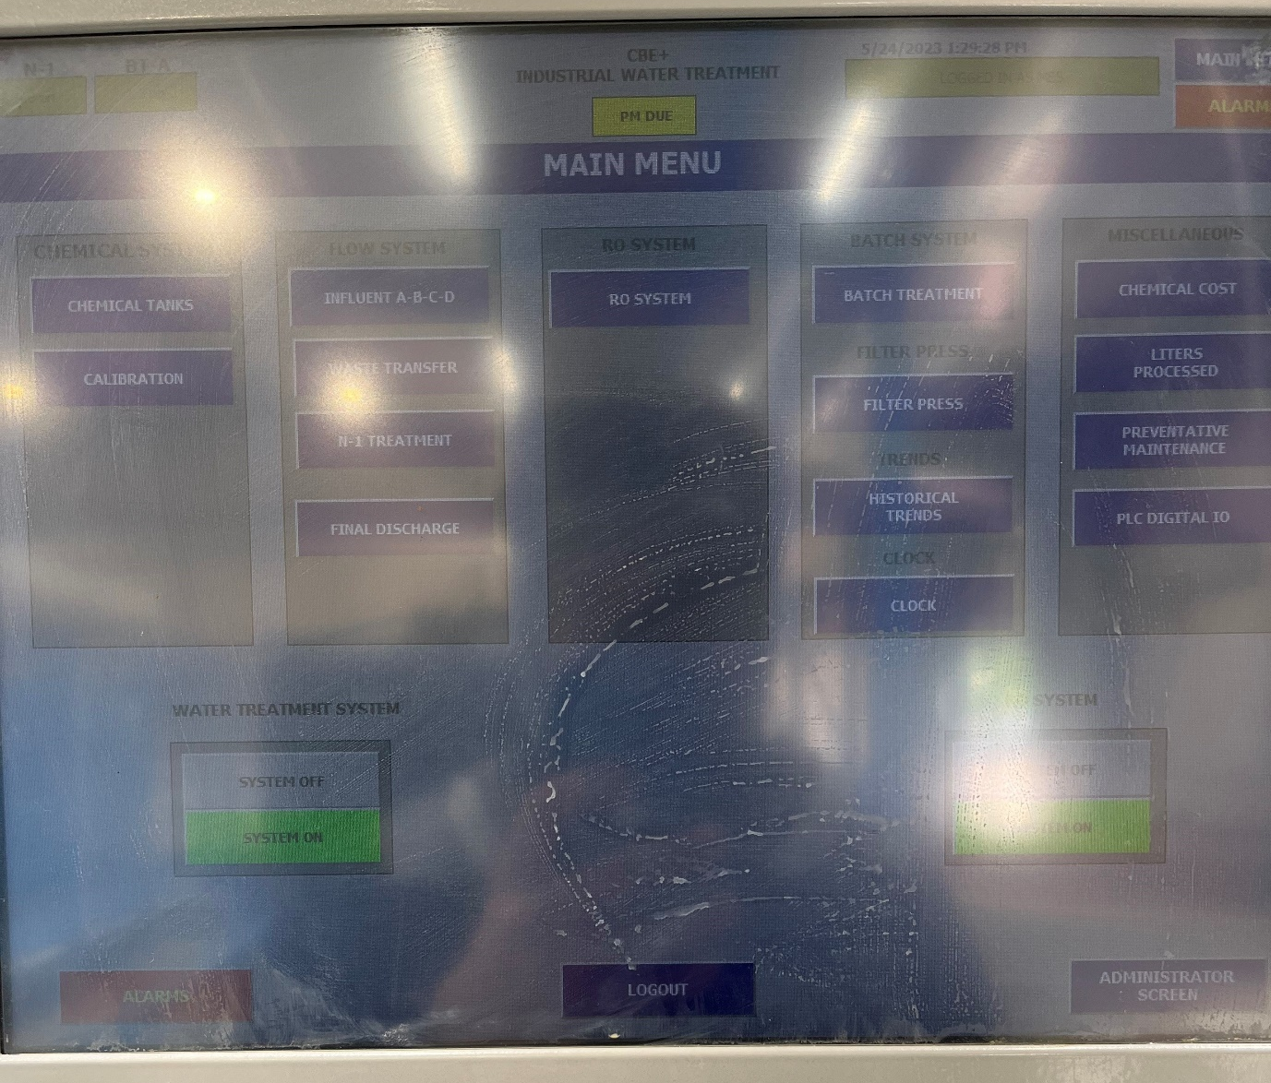
Figure 1
- From the batch treatment menu select the batch treatment tank (Figure 2).

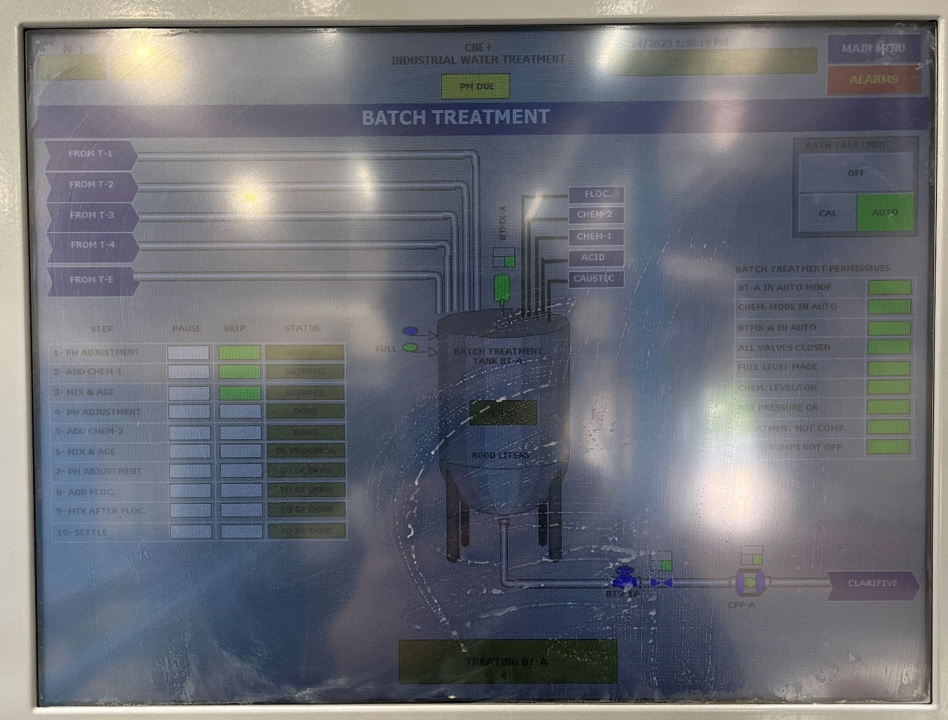
Figure 2
- From the batch treatment menu, the process should already be set out. The first 3 steps of the process are not needed and are permanently skipped. Typically, the steps are as follows.
  - Adjust pH to between 3-5
  - Add 40L of ferric chloride.
  - Mix for 60 mins (while adding approx. 50 kg of lime or equivalent of liquid lime during this mixing step)
  - Allow to mix for a further 60 minutes.
  - Adjust the pH to between 11.5 and 12.5 using caustic soda liquor.
  - Add 100-200L of flocculant depending on the dilution of the polymer (you may need to manually adjust this volume while dosing in to achieve the require flocculation).
  - Mix for 200s.
  - Leave to stand for as long as possible to help compact the filter cake (typically overnight but at least 2-4 hours).
- Any adjustments to the flocculant volume etc can be made by pressing on the white text boxes and typing the values in manually (Figure 3). Manual jar tests may be required to determine how much flocculant, lime, ferric chloride to add.
- When conducting a jar test to determine the amount of flocculant, polymer and lime to add use a sample volume of 500ml. to scale up addition you will need to multiply the jar test result by 15000.
- Once you are happy with the process selected then you can start the treatment process by selecting start treatment Figure 4.
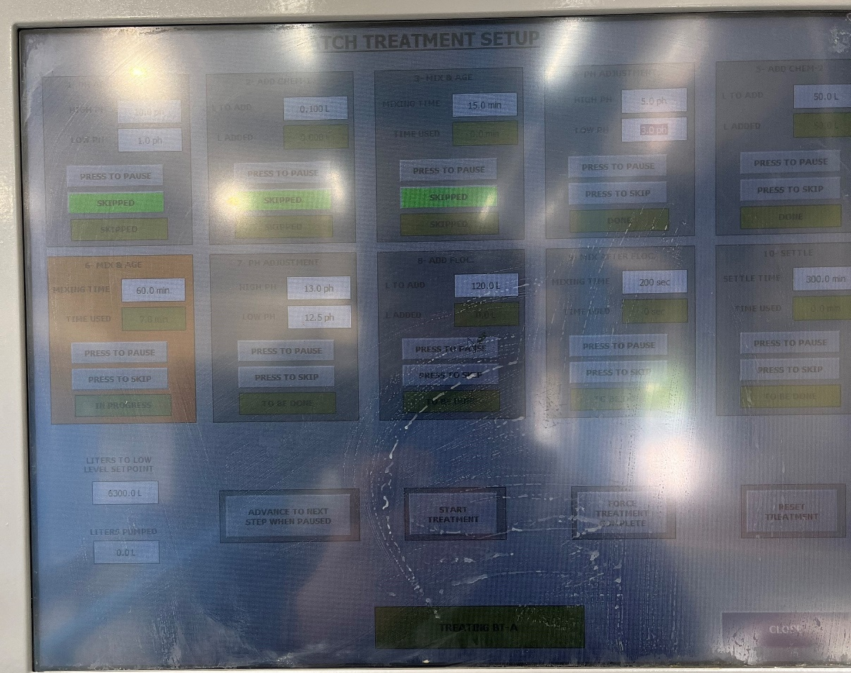
Figure 3
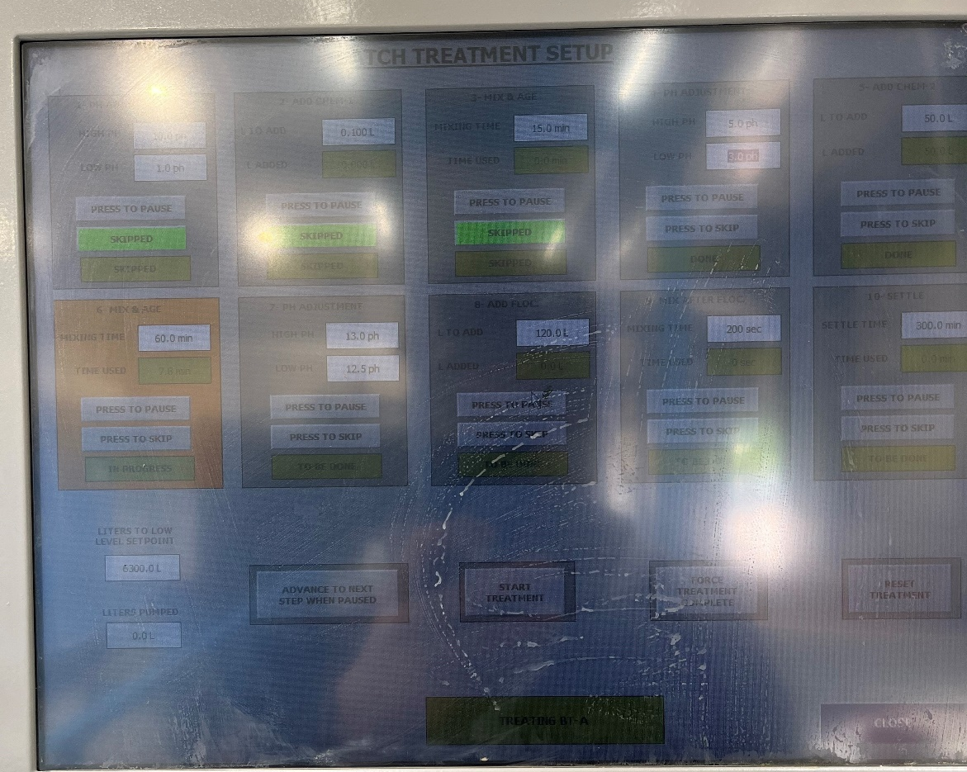
Figure 4

- If the pH needs to be adjusted the pump will kick in immediately after pressing start if it doesn’t and there is no change of pH required in the first 2 minutes the control panel will move onto the next step.
- The control panel shouldn’t require any additional manual input however if there is a large pH adjustment, or large amount of flocculant that needs to be added the pumps will turn themselves off to prevent runaway or damage to the pumps. To reset the pumps, you need to select the pumps that lead into the treatment tank by pressing the location shown in Figure 5.
Figure 5
- Ensure that all the pumps showed in Figure 6 are turned to auto and the procedure should continue. If any of the pumps are not in automatic it will be highlighted in the batch treatment menu by a green bar shown in Figure 7 and the treatment procedure will pause, even if those pumps are not in use.
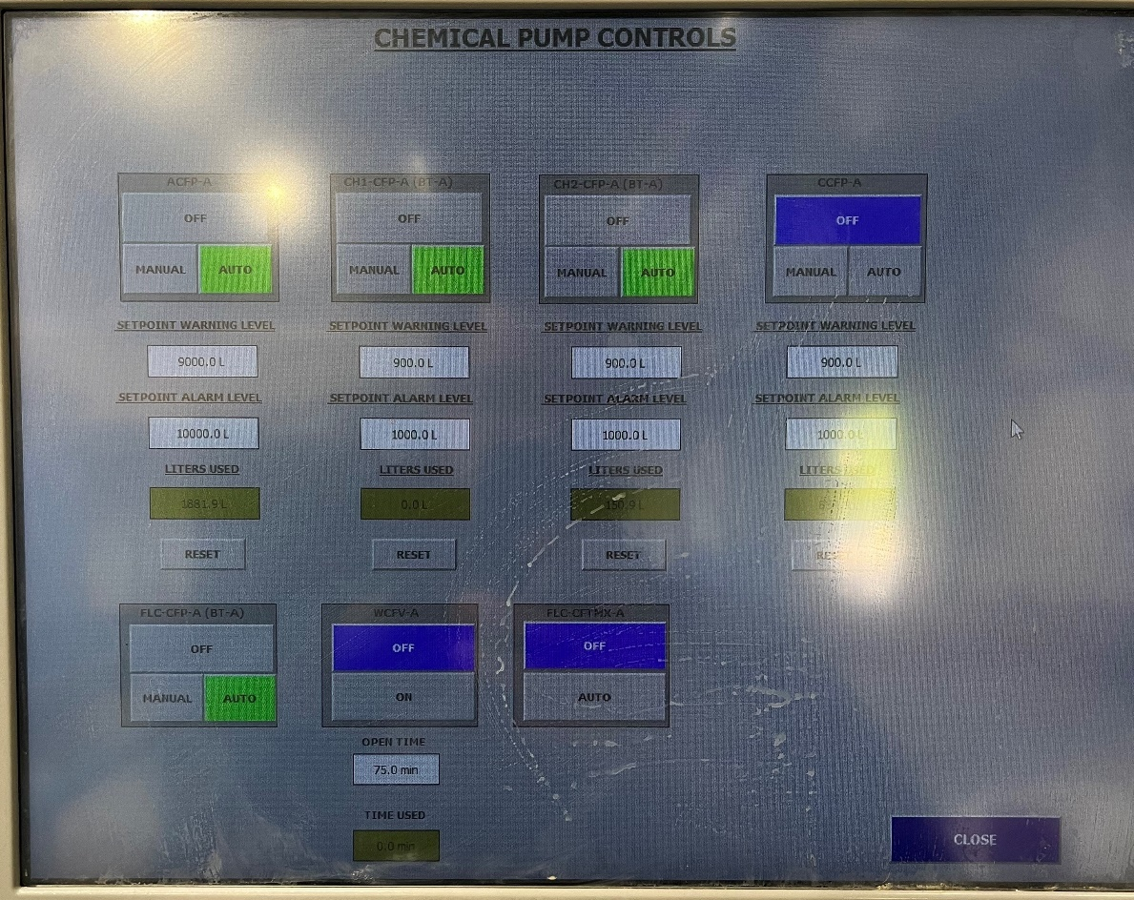
Figure 6

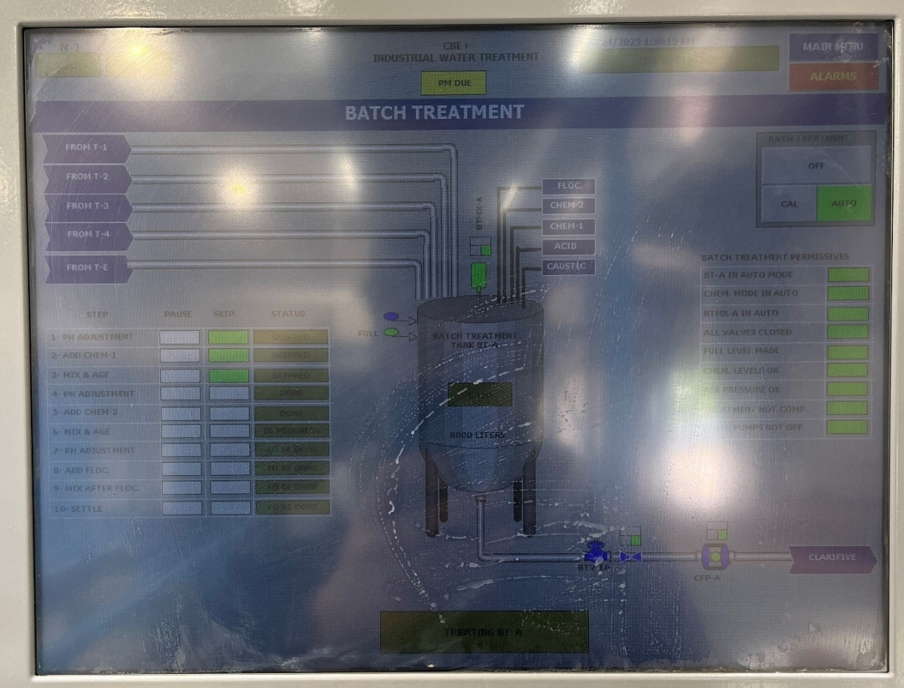
Figure 7
- The process should continue automatically until completion and begin to discharge the treated wastewater into the clarifier. You should check for the following before.
  - That the treated batch is <4 ppm of nickel
  - That the treated batch is <3000 ppm of C.O.D
  - There is enough room in the clarifier so that no sludge or debris will be decanted with the effluent.
  - There is enough room in the discharge holding tank (tank e)
- Ensure that the treatment tank is empty before filling again. This is to make sure there isn’t a build-up of sludge in the bottom on the treatment tank which may cause a blockage. To make sure that the tank is empty you may have to turn the pump, which empties the treatment tank, to manual in the batch treatment controls as shown in Figure 8 & Figure 9. Turn the pump back to auto once the batch tank is empty.
- Once the treatment tank is empty you can refill the treatment tank by following SOPEFF003.

Figure 8

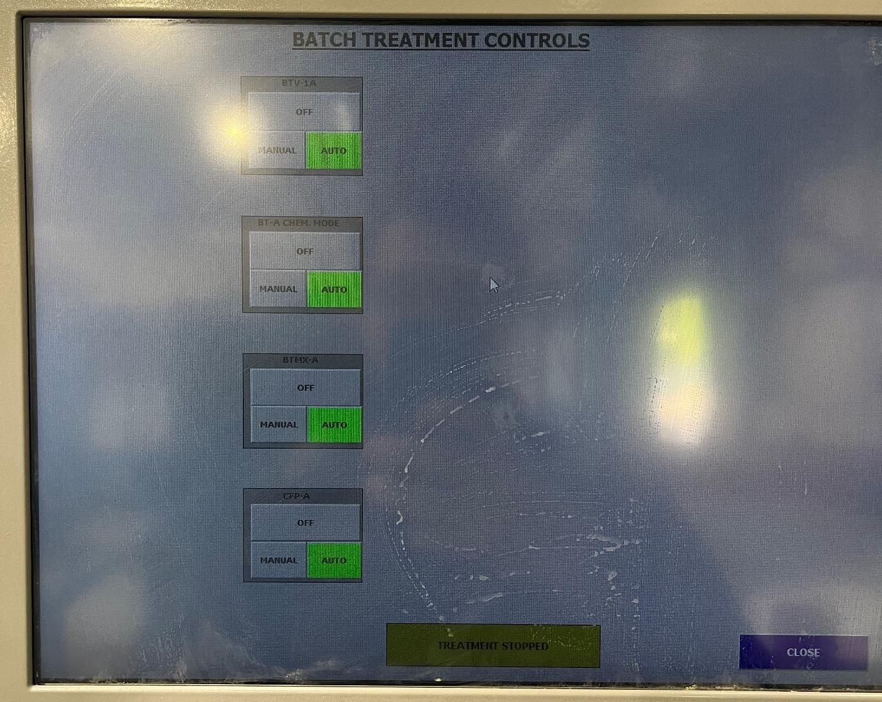
Figure 9

Training Confirmation

I have read and understood the above SOPEFF004 – “treating waste HCl and Cleaner” and will abide by the procedure and will ensure any concerns or rectifications required to the procedure are raised through the necessary authority (team leader, manager etc)

Signed……………………………………………………………. Print name……………………………………………………..

Date………………………………………………………………..

The above signed document will be retained by HR as part of the employee training documentary evidence.

Trainers name & signature ……………………………………………………………………………………..

