sopeff003 – Filling the treatment Tank
cbeplus.com



Document Control
Publication Date: | 4/01/2024
Author: | Haneef Rashid
Version number: | 1
Comments: | Document created

Background

An effluent is an industrial wastewater treatment plant. We use it treat our waste liquids to ensure it’s safe before discharging to a sewage works.
During the plating process we generate a lot of waste liquids that include, rinse water, spent cleaners, spent acids & spent electroless nickel solution.
We must treat these waste products by through a process of neutralization and metals removal.
We currently have 4 holding tanks
  - T1 – Rinses (25,000L)
  - T2 – Alkaline (10,000L)
  - T3 – Acid (10,000L)
  - T4 – Electroless nickel solution (12,000L)

Filling the wastewater treatment tank

Fill the batch tank follow the instructions outlined below:

- Go to the main control panel on the effluent.
- Ensure that the batch treatment tank is empty.
- Select waste transfer from the main menu Figure 1.
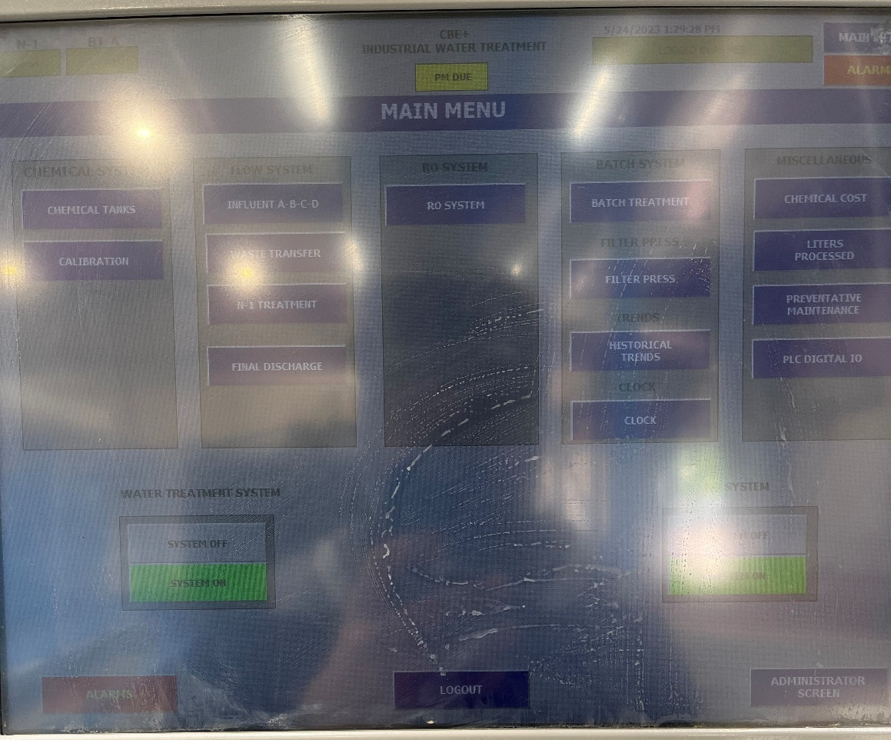
Figure 1
- The waste transfer menu will show 4 tanks (Figure 2)
  - T1 – Rinses
  - T2 – Alkaline
  - T3 – Acid
  - T4 – Electroless nickel solution

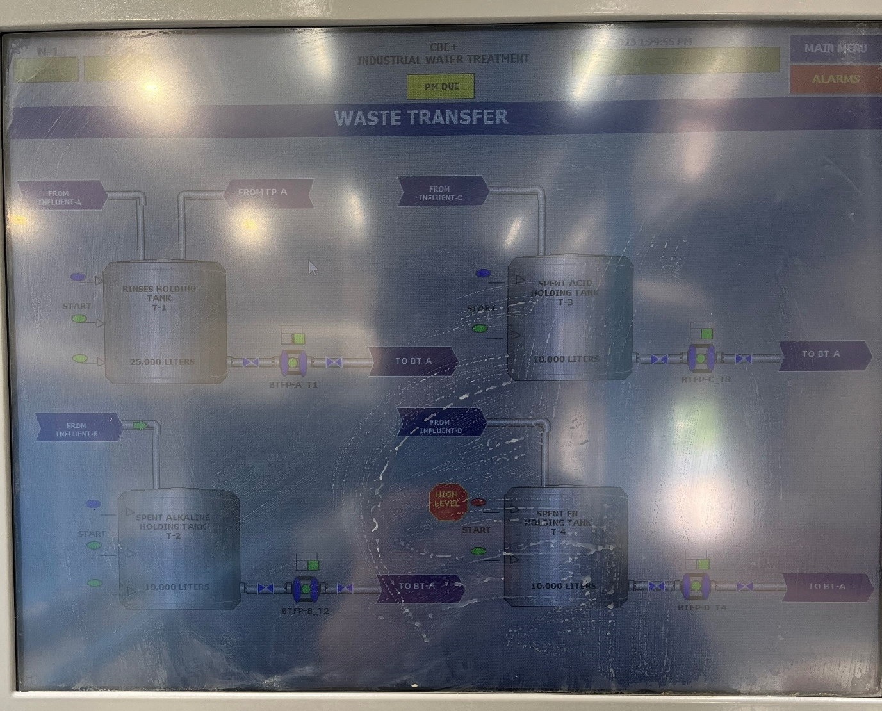
Figure 2
- To operate the waste transfer controls press on 1 of the pumps shown in (Figure 2).
- Ensure that all the pumps are in green and on auto.
- Select how much of each waste stream you would like to pump into the treatment tank by pressing on the white boxes shown in Figure 3
  - T1 – Rinses
  - T2 – Alkaline
  - T3 – Acid
  - T4 – Electroless nickel solution
  - TE- Treated water holding tank (only used if there is an issue with the treated batch)
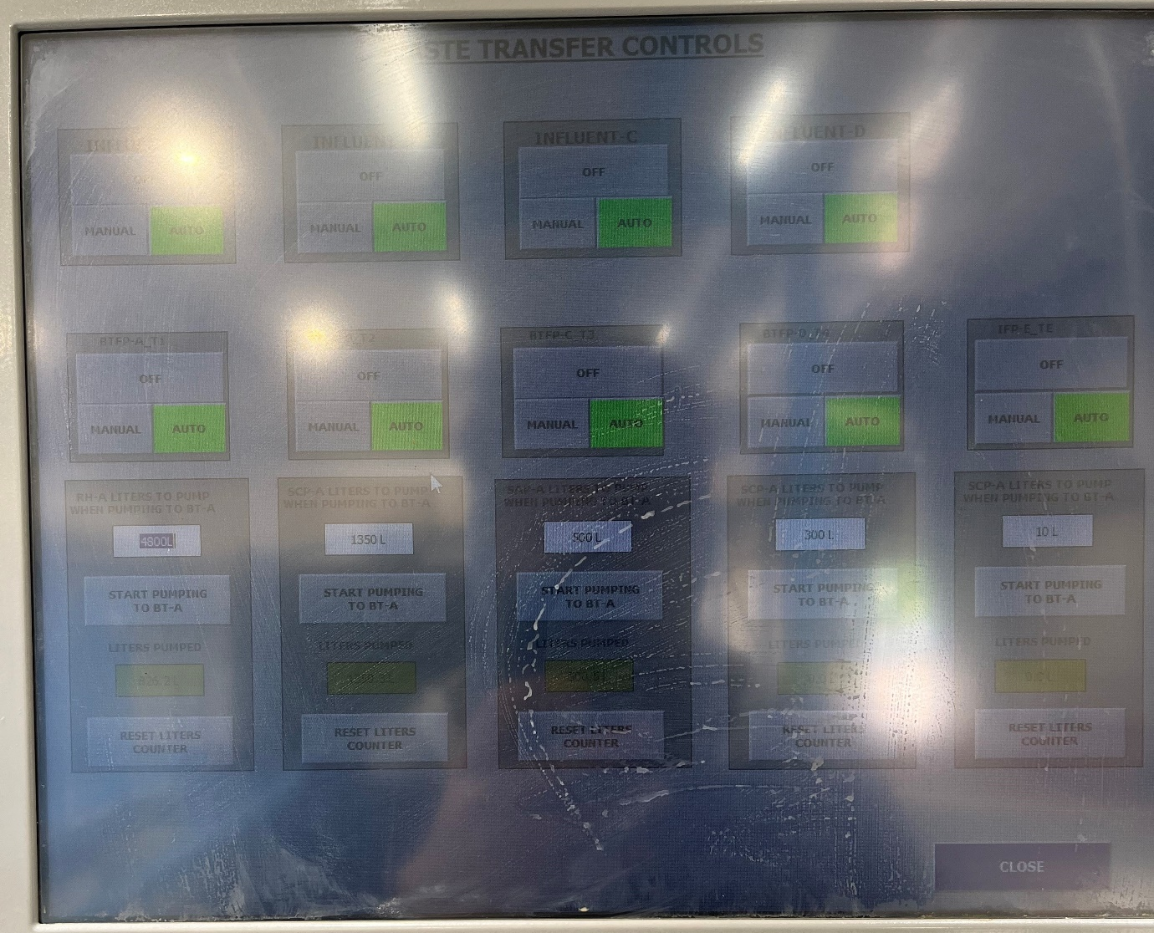
Figure 3

- Once you are happy with the values in litres then open the orange ball valves to all the required holding tanks Figure 4.

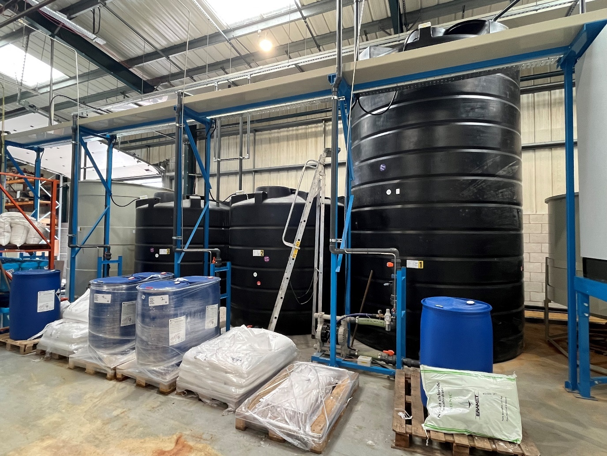
Tank 4 – EN
Tank 2 – Alkaline
Tank 1 – Rinses
Tank 3 – Acid
Figure 4
- When the ball valves are open you can start pumping in the required amount of each solution by pressing start pumping on the required pumps (Figure 5). If treating acid and alkaline it’s important to separate the 2 by a large volume of rinses. Do not pump in acid and alkaline at the same time.
Figure 5

- If the pumps do not start when you press start pumping then the system may think that the previous treatment has not finished and this must be reset by going to the main menu, selecting batch treatment, then the image of the batch tank and finally reset treatment Figure 6.
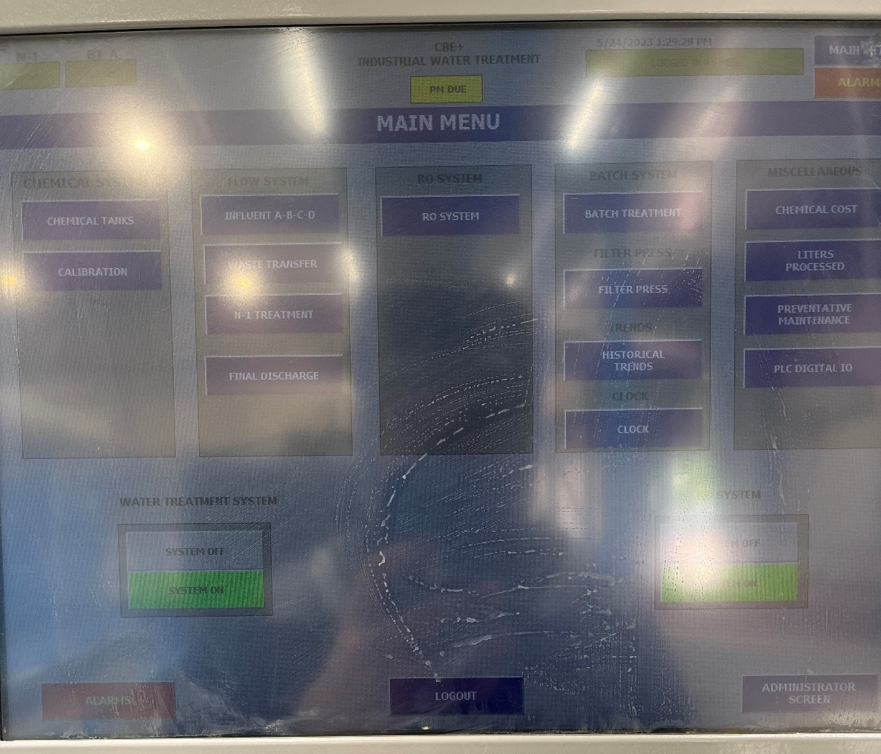
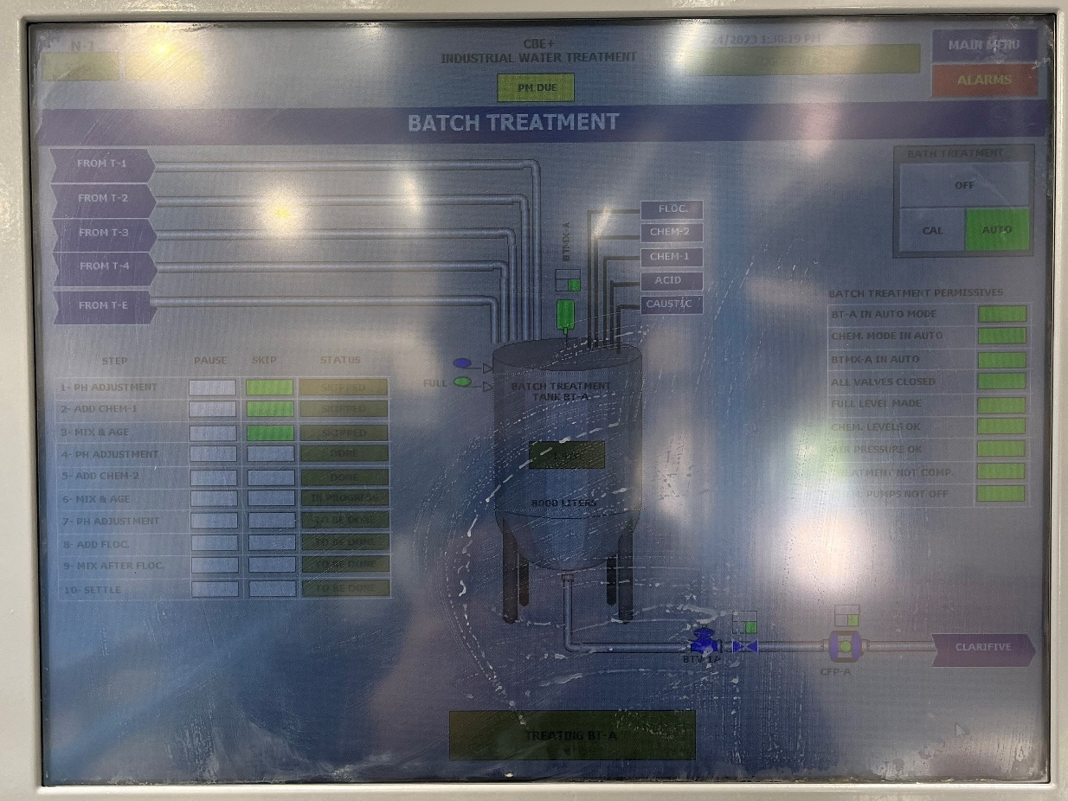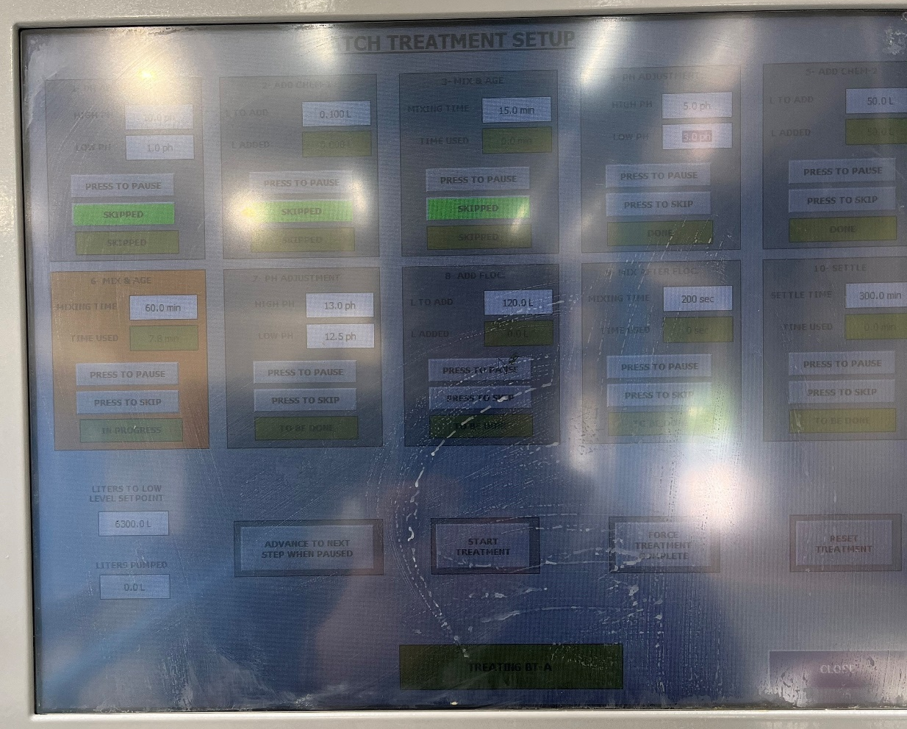
Figure 6
- Allow the treatment tank to fill up with the desired volumes. It take approx. 15-20mins to fill the treatment tank. The pumps will stop when the batch tank is full or the desired volume has been added to the batch tank.
- IMPORTANT - Immediately after the pumps have stopped pumping turn the orange ball valves to the close position to stop the holding tanks from siphoning over.

Training Confirmation

I have read and understood the above SOPEFF003 – “Filling the wastewater treatment tank” and will abide by the procedure and will ensure any concerns or rectifications required to the procedure are raised through the necessary authority (team leader, manager etc)

Signed……………………………………………………………. Print name……………………………………………………..

Date………………………………………………………………..

The above signed document will be retained by HR as part of the employee training documentary evidence.

Trainers name & signature ……………………………………………………………………………………..

