sopeff002 – Emptying the Filter press
cbeplus.com



Document Control
Publication Date: | 4/01/2024
Author: | Haneef Rashid
Version number: | 1
Comments: | Document created

Background

A Filter press s a large press that helps to separate solid from liquid. In the effluent it is used to separate “filter cake” from the treated effluent. The solid filter cake contains nickel and other metals that have been precipitated out during the treatment process.

Filling the filter press

To remove filter cake from the filter press then closely repeat the instructions outlined below:

- Go to the main control panel on the effluent.
- From the main menu select filter press (Figure 1). If any other menu is showing you can always return the main menu by closing any windows and selecting main menu in the top right corner.
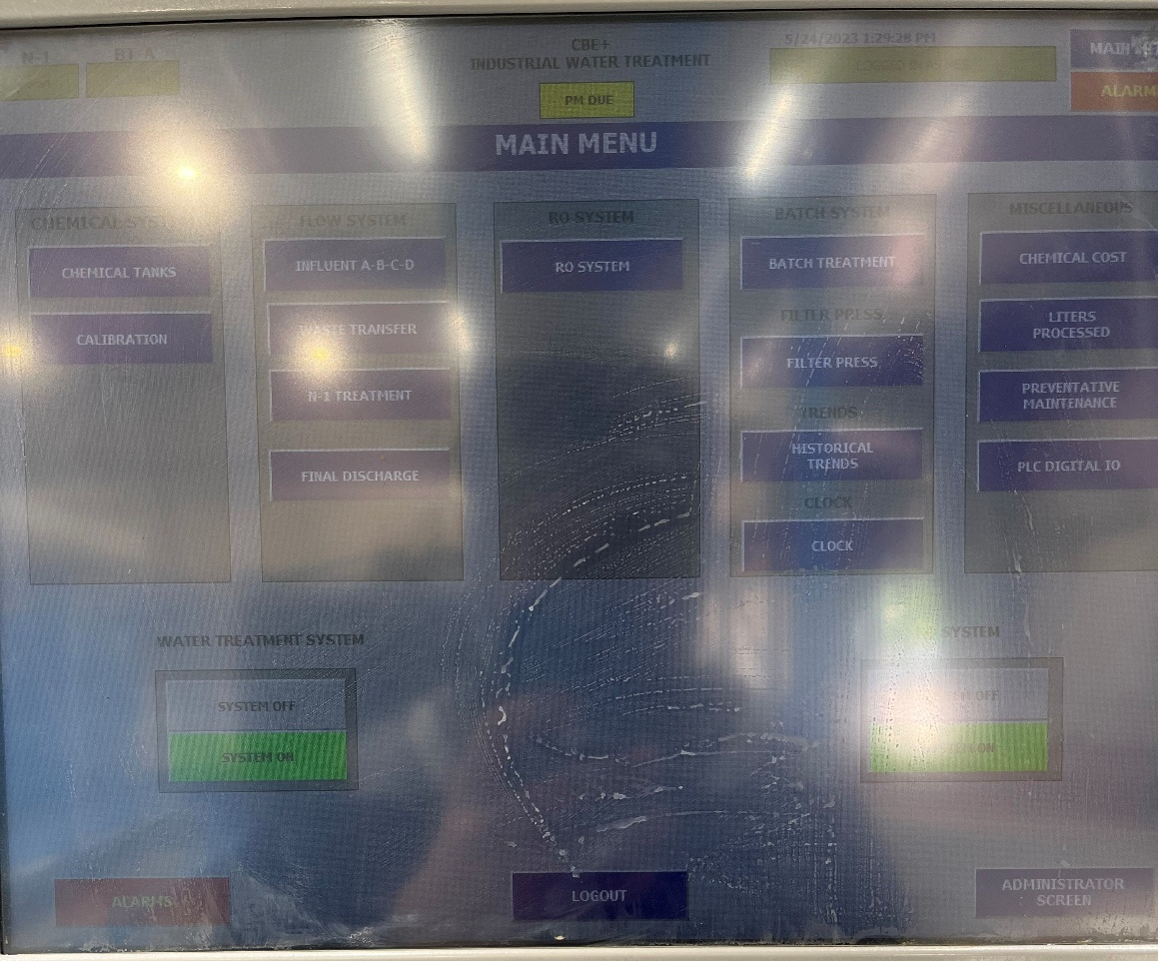
Figure 1
- From the filter press menu select The press manager by pressing on the green box above the image of the filter press (Figure 2).
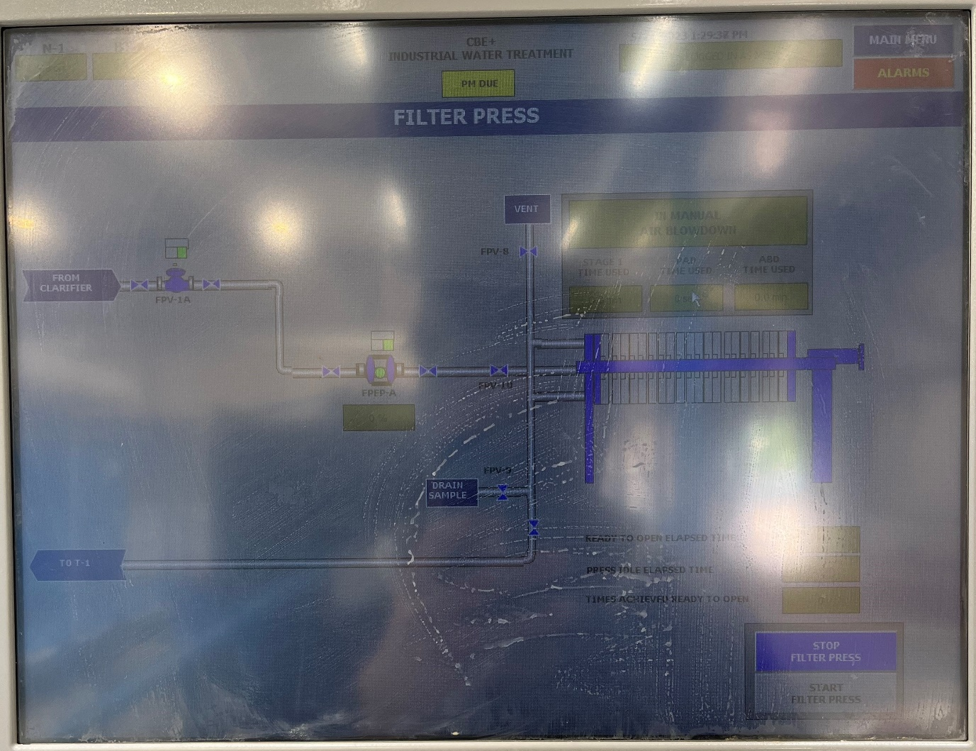
Figure 2
- From the press manager turn the manual air blow down off by press manual air blow down (Figure 3).
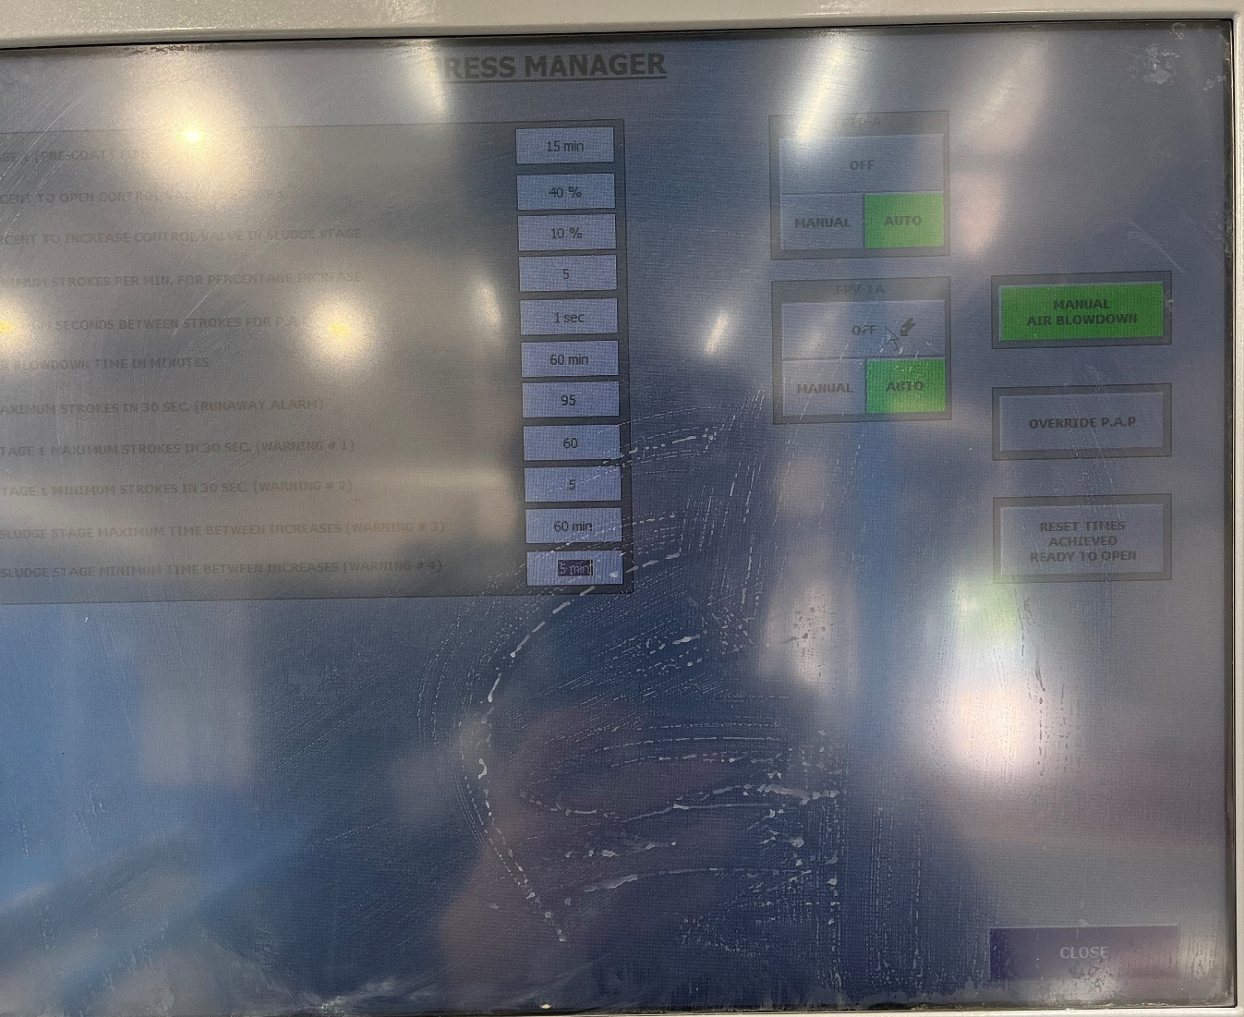
Figure 3
- Once the blowdown is turned off then go to the filter press operation terminal located at the end of the filter press (Figure 4).
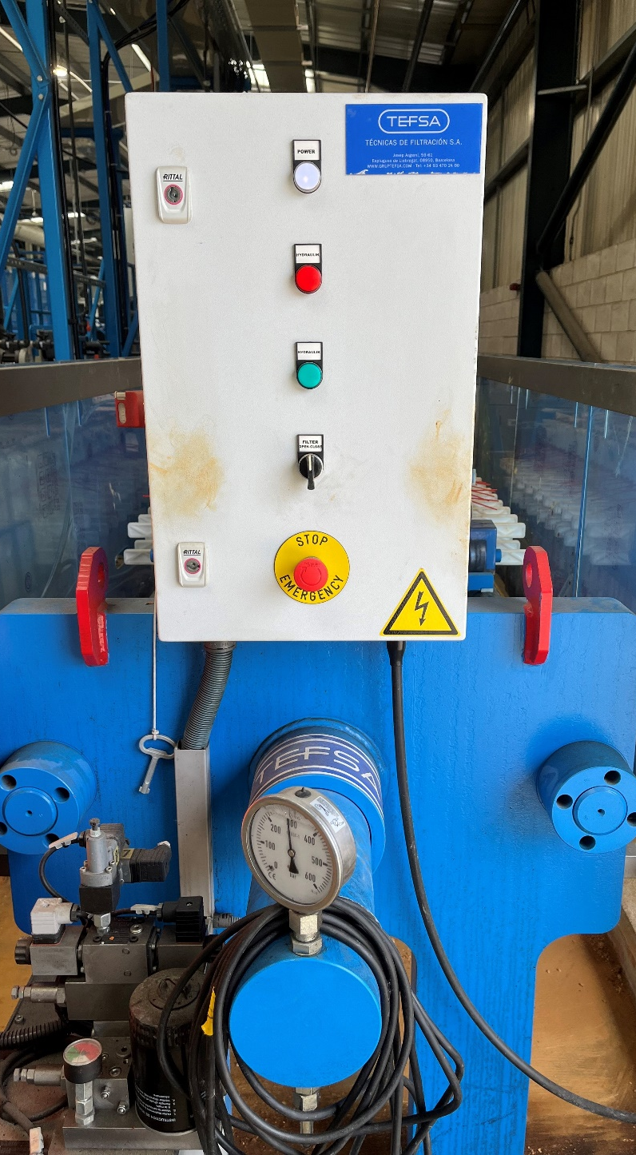.
Figure 4
- Open the filter press by turning the dial on the filter press to open Figure 4. The press will then fully open automatically. (If water is seen running from the slats when you open the press then the filter cake was not dry enough and needed longer with the manual air blowdown on before being emptied).
- Once the filter press is fully open separate the slats within the filter press 1-1. Shake and scrape the filter cake off of each slat into the collection tray below the filter press Figure 5. You should remove the filter cake form both sides of the slats
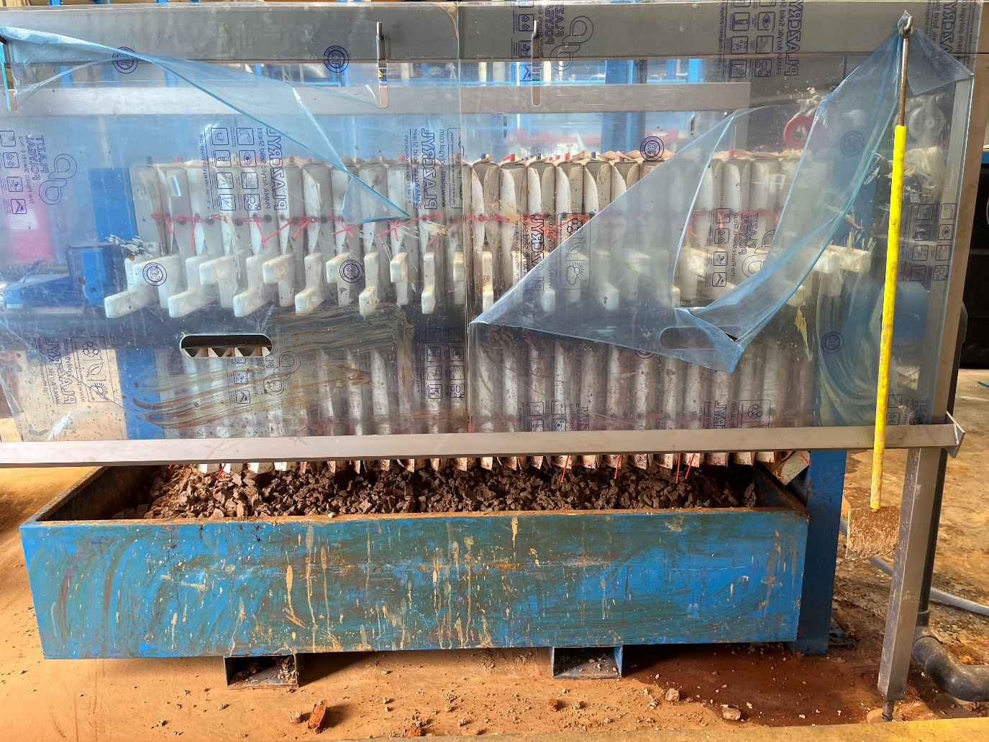
Scaping tool
Collection tray
Figure 5
- Once the press is empty close the press back up by turning the dial on the filter press terminal to close and pressing the 2 buttons either side of the terminal. The press will slowly close and will require both buttons being pressed to fully close. The press will stop closing once the plates feel its maximum pressure.
Figure 6

- Once the press is empty then you empty the clarifier using the press following SOPEFF001.

Training Confirmation

I have read and understood the above SOPEFF002 – Emptying Filter Press and will abide by the procedure and will ensure any concerns or rectifications required to the procedure are raised through the necessary authority (team leader, manager etc)

Signed……………………………………………………………. Print name……………………………………………………..

Date………………………………………………………………..

The above signed document will be retained by HR as part of the employee training documentary evidence.

Trainers name & signature ……………………………………………………………………………………..

