sopeff001 – Filling the Filter press
cbeplus.com



Document Control
Publication Date: | 4/01/2024
Author: | Haneef Rashid
Version number: | 1
Comments: | Document created

Background

A Filter press s a large press that helps to separate solid from liquid. In the effluent it is used to separate “filter cake” from the treated effluent. The solid filter cake contains nickel and other metals that have been precipitated out during the treatment process.

Filling the filter press

To remove filter cake from the clarifier using the filter press then closely repeat the instructions outlined below:

- Go to the main control panel on the effluent.
- From the main menu select filter press (Figure 1). If any other menu is showing you can always return the main menu by closing any windows and selecting main menu in the top right corner.
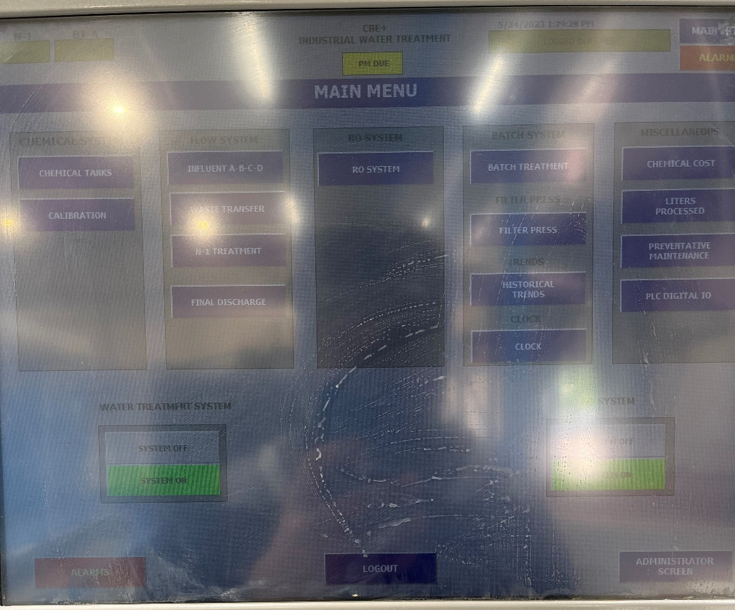
Figure 1
- From the filter press menu select “start filter press” Figure 2.
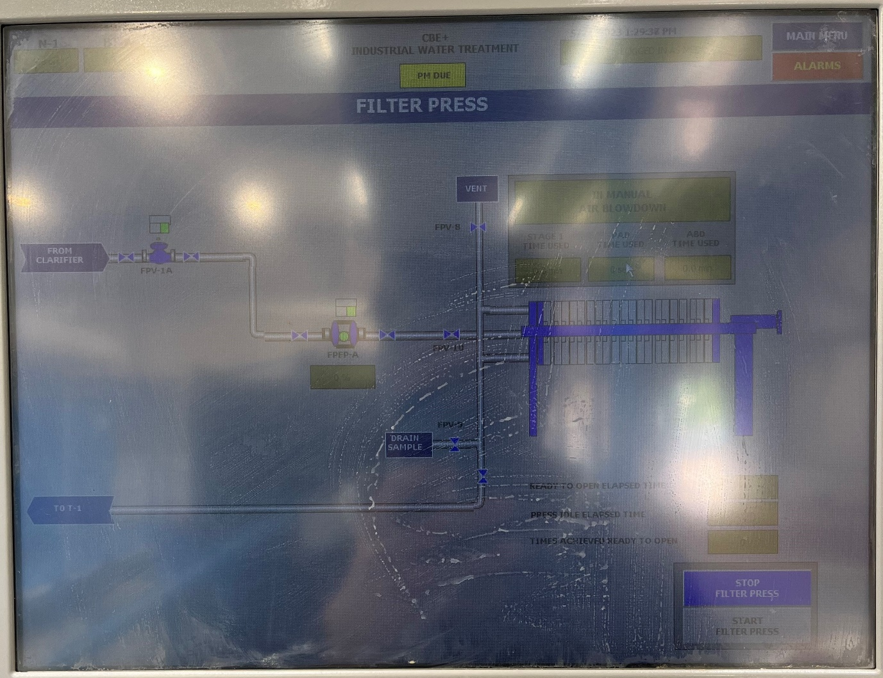
Figure 2
- You will hear a pump kick in and the level of the clarifier will begin to lower. The pump will be pulsing very quickly (5-10 pumps a second).

- Once the pump slows down to a rate of roughly 0.5-1 pump per second then select “stop filter press” (Figure 3).

Figure 3

- Once the filter press has been turned off open the press manager by clicking on the larger green box above the image of the filter press (Figure 4).

Figure 4
- From the press manager select manual air blowdown (Figure 5).
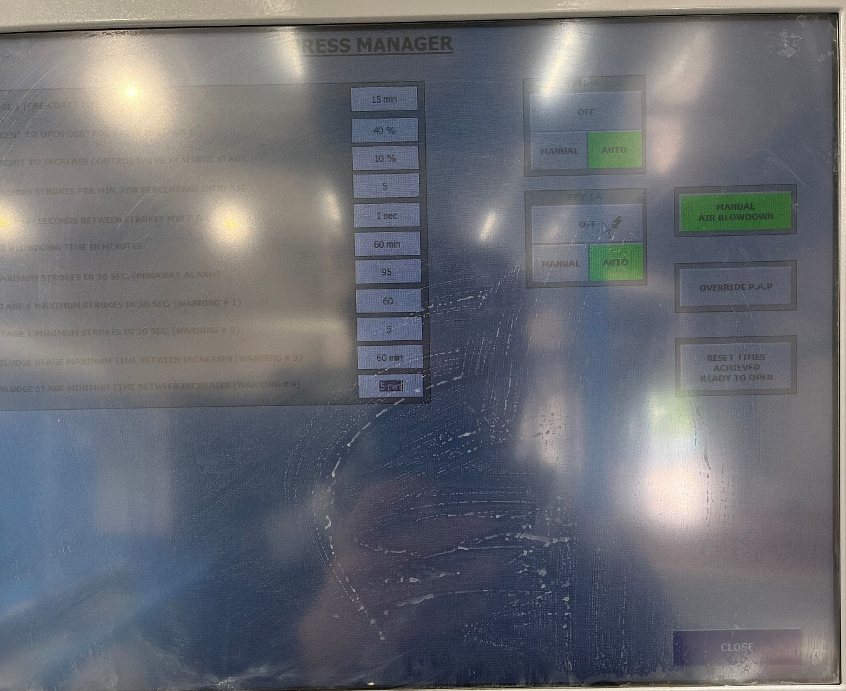
Figure 5

- The blow down will dry the filter cake. There may be some excess water added to the neutralization tank on the effluent.

- To remove more filter cake from the clarifier repeat steps 1-8 over the course of shift. It’s best to wait at least 10-15 minuets between pumping more filter cake to avoid blockages within the system and to allow the bulk of the water to be removed from the filter cake before adding more to the press.

- Leave to dry for at least 2.5-3 hours before emptying.

Training Confirmation

I have read and understood the above SOPLAB003 – “Using a pH meter” and will abide by the procedure and will ensure any concerns or rectifications required to the procedure are raised through the necessary authority (team leader, manager etc)

Signed……………………………………………………………. Print name……………………………………………………..

Date………………………………………………………………..

The above signed document will be retained by HR as part of the employee training documentary evidence.

Trainers name & signature ……………………………………………………………………………………..

