1.0 Scope

This procedure details the requirements for monitoring & maintaining the effluent plant

2.0 Responsibility

The Chemical Manager is responsible for compliance with this procedure.

3.0 Records

Document Ref Location Retention

Effluent Analysis Records -- Laboratory 3 years

4.0 Procedural Notes

1. Due to company limitations, monitoring of the effluent is restricted to the relevant trace metals – Nickel, Copper, Chromium and also Cyanide and pH, using indicator papers & pH meters.

Additional to internal monitoring, a regular sample is collected by the Water Authority for full analysis.

- PROCESS CONTROL – EFFLUENT PLANT ANALYSIS TO FOULSEWER

- The temperature of the effluent shall not exceed 43.3 Degrees Centigrade at the time of discharge
- The PH value of the effluent shall not be less than 6 or more than 10.5 at the measuring point.
- Settled Chemical Oxygen demand shall not exceed 1.5mg/L
- Total Copper (Cu) shall not exceed 1 mg/L
- Total load of Copper (Cu) discharged in 24 hours shall not exceed 0.03 kg
- Total Nickel (Ni) shall not exceed 4mg/L
- Total load of Nickel (Ni) discharged in 24 hours shall not exceed 0.06 Kg.
- Settleable solids shall not exceed 250 mg/L

- PROCESS CONTROL – EFFLUENT FILTER PRESS AND DISCHARGE CHECKS

- The V-Notch must be checked every day when discharging Effluent Discharge.
- Ensure the hydraulic ram is fully operational. To check this, ensure that the hydraulic ram arm is under compression when the pump is engaged.
- Obtain a reading on a Nickel test strip or analysis kit on the fluid.
- A reading of under 4mg/L is acceptable on the test Kit, if in doubt of the readings seek help via the Chemical Manager.
- Readings higher than 4ppm will need to be assessed by the Chemical manager
- If readings over 4ppm are evident, then stop all operations on the Discharge and contact the Chemical Manager for advice.
- The V-Notch MUST be checked every day with a Nickel test strip or KIT.
- Contamination from spills or otherwise to the effluent will require the containment of the batch and possible handling in accordance with cross contaminated fluids waste removal. Always seek the advice of the Chemical Manager.
- Testing methods are covered in APP 1 of this procedure.

App1
App1 Cont.

Effluent Emergency procedure
1.The Effluent should only be running if an operator is on site.
2.If any issues arise the operator should stop the effluent and contact the Chemistry manager or senior management (Lee Marriott, Steve Whitehead).
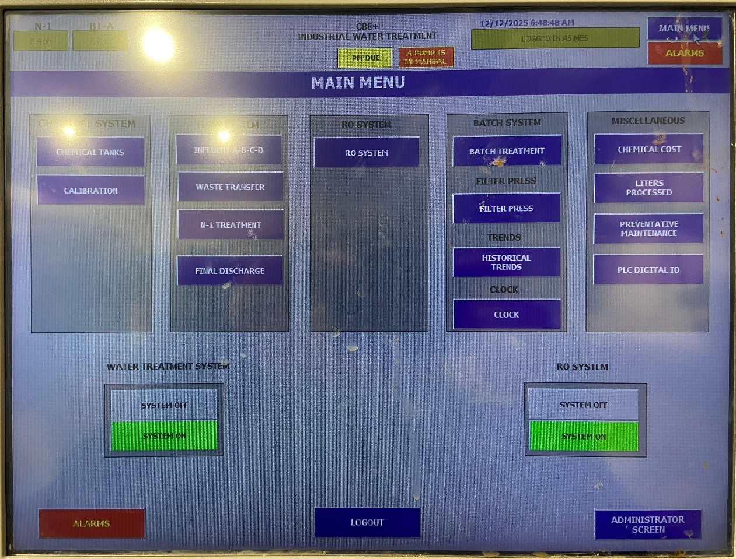
To stop all effluent systems, press system off

NO EFFLUENT SHOULD BE DISCHARGED IF IT IS OVER CONCENT LIMITS, THIS IS BOTH UNLAWFUL AND MAY HAVE CONSIDERBALE COST IN FINES AND WILL RESULT IN DISCIPLINARY PROCDURE

Sample taken from batch awaiting disposal

Sample analysed for consent parameters

Results compared with consent limits

Hold for re-treatment and ensure plant operation satisfactory
No
Satisfactory?

Yes

Set flow rates

Continue discharge to foul sewer

Revision History

DATE | REASON FOR CHANGE | AUTHOR
05/06/13 | Reformat of document | PA
08/08/2025 | Update | AS

