SCOPE

This procedure defines the training and recording system operated by Capabilities Beyond Engineering UK Ltd and is designed to satisfy and exceed the requirements stipulated in ISO9001:2015 sections 6.1,6.2,6.3 and the requirements of ISO14001:2015 section 7.1, 7.2 and the requirements of AS9100 section 6.2.1, 6.2.2.

CIRCULATION

Controlled and backed up Network Drives on Company Server.

1.0 POLICY

1.1 It is the policy of Capabilities Beyond Engineering UK Ltd to ensure the individual training needs of staff are reviewed and records maintained.

2.0 PROCEDURE

- All new employees irrespective of their employment status within the group companies will receive induction training by the Production Health and safety representative or HSE Manager and will be included to the master training matrix. A record of their induction, signed by them and their trainer will be kept on file.

- It is the responsibility of each Departmental Head to ensure the staff that report to them are suitably qualified to carry out the tasks for which they have been employed. All subsequent training will be identified by the Departmental Head on an ongoing basis and will include as a minimum, the Company Quality Policy, plus any quality control procedures relevant to the individuals job.

- In the event that specialist equipment is installed/introduced i.e. Overhead cranes, fork lift trucks etc, at least one person will attend a suitable training course. Other personnel may be trained in house by the ‘trained person’ by working under their supervision until deemed competent.

- Training on the location of the Management System documents will be undertaken by the Management Representative and recorded in the training file.

- Changes to the system will be conveyed to the staff by internal memo, newsletter or company communications Whatsapp Group.

3.0 RECORDS

3.1 The Staff Training Record for each employee will be maintained by the HR administrator and stored on a controlled and backed up network drive.

The record will include:-

- Employee’s Name.

- Job Title.

c) Details of all Training Carried out including reference by Title/Number
to any External Training Course or Quality Control Procedures etc.

d) The Name/Organisation responsible for carrying out the Training.

e) The result of Training i.e. ‘Satisfactory’ or ‘Further Training Required’,
this will be signed by the nominated authority and the Trainee.

- The date of the Assessment/Result.

- Any certificates supplied by external bodies or Capabilities Beyond Engineering Ltd UK achieved or held

3.2 Staff training records will be retained for a minimum period of 12 months following termination of employment.

3.3 Training records shall be recorded on the relevant training matrix (Precision or ENP as appropriate) as shown in Appendix 1 of this procedure for easy and quick reference. NB these document are embedded within the company QMS.

3.4 Shortcuts to the relevant parts of the Management Systems will be placed on computer terminals within the production area and employees shall be trained on their location.

Appendix 1

QD11 Extract Precision Machining
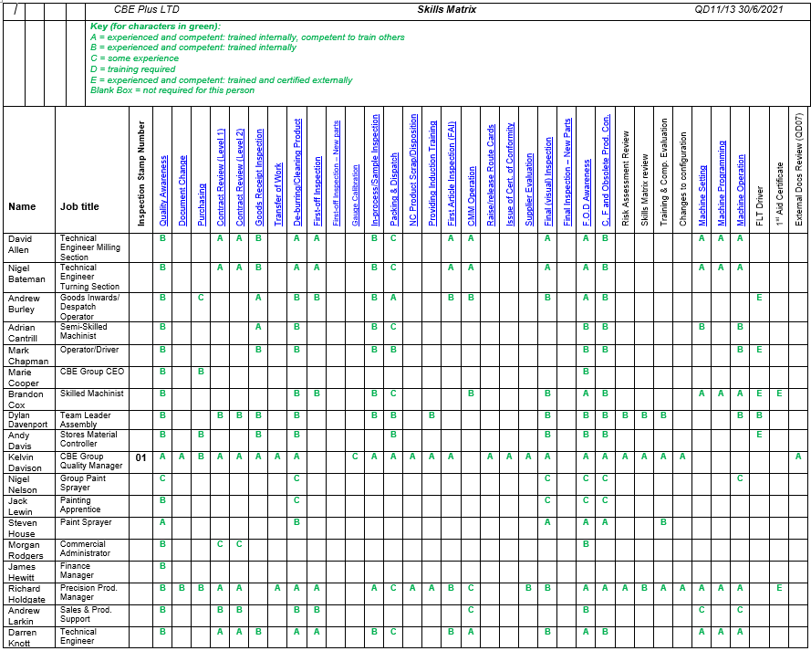

Master Training Matrix Extract – ENP

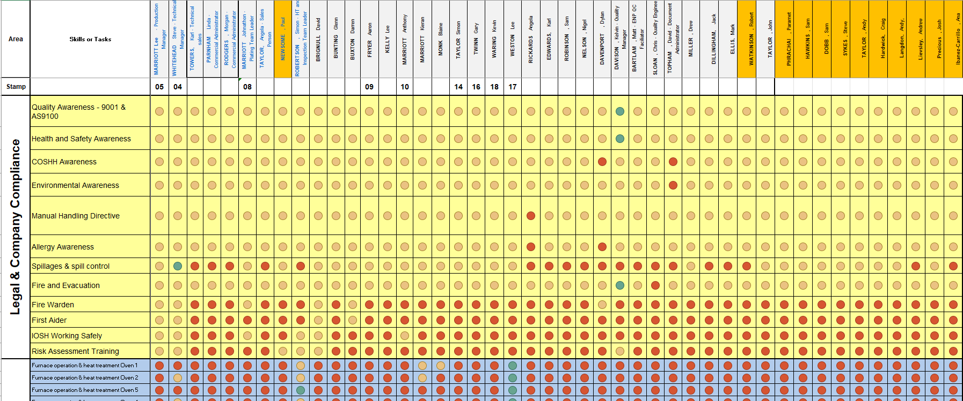

Revision History

DATE | REASON FOR CHANGE | AUTHOR
30/05/13 | Reformat of document | PA
14/10/14 | Inclusion of sections of AS9100. Clarify document locations and controlled / uncontrolled specifications | PA
17/07/2018 | References made to updated standards | GG

