FO43/v3 – Capabilities Beyond Engineering Organisational and Process Charts
This organisational chart shows the level of responsibility for Health, Safety and Environment within the organisation and not scaled tov levels of seniority within the organisation.
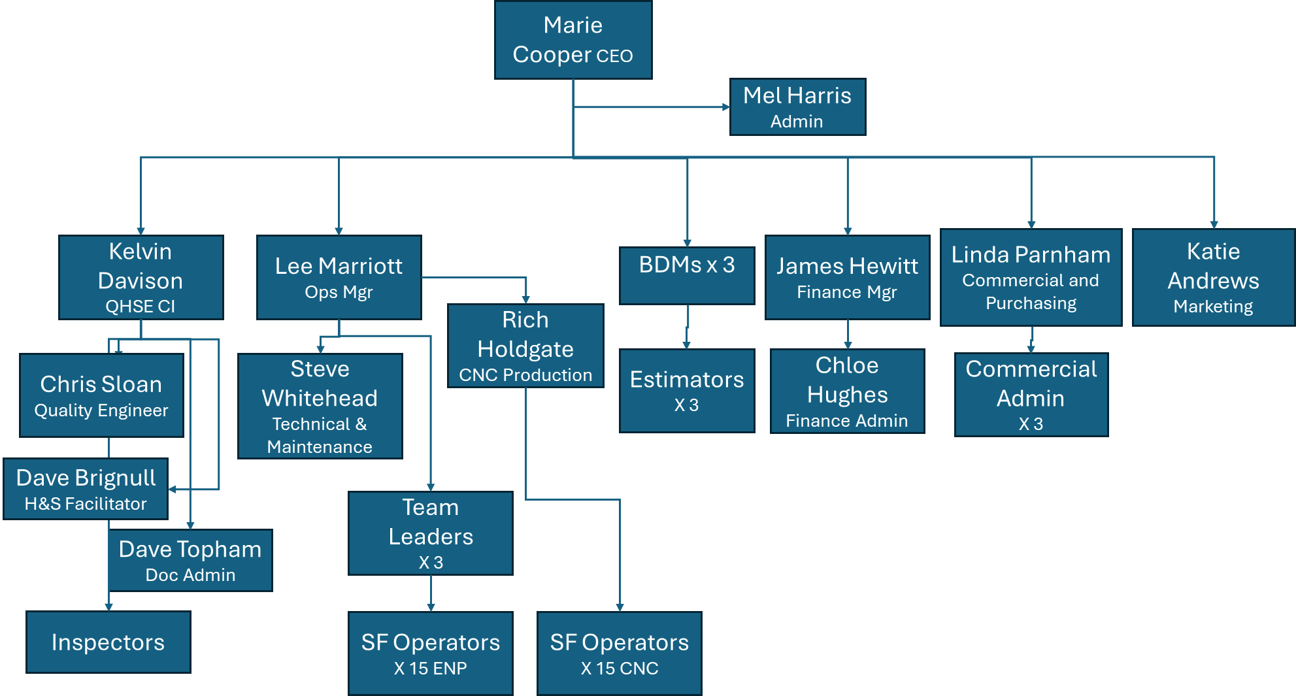
This diagram shows the processes within Nitec that fall within the scope of the organisation and reflect the context of the business and the process of continual improvement.

