CBE+
Enterprise Drive
Holmewood
Chesterfield
S42 5UZ
5th July 2021
For the attention of Steve Whitehead – Technical Manager

Based on our recent conversation and your recent email, please find below our quotation for complete plug-in and play containerised blast booth.

The system includes a 6m long modified, weatherproofed container that you are considering siting internally. This being the case, you can utilise the whole container as the work chamber and site the blast, recovery and extraction equipment adjacent the booth. The container is however weatherproofed and therefore can be sited externally as well. If this option is preferred, then there will be required a partition to the rear of the container to house the blast machine and recovery system and therefore this will reduce the work chamber from 6m down to 3.8m.

The booth has a steel plate lined floor for protection, rubber lined walls, LED lighting and the main doors are safety interlocked to prevent blasting should they be left open.

Equipment includes blast machine c/w accessories and PPE, sweep-in vacuum recovery system and a 3000 cfm dust extraction system we have quoted for an IND200P system. The recovery system vacuum unit will consume approx. 100 cfm of compressed air. However, as you only switch this on when sweeping up, the demand is alternate to the blast operation and not compounded.

Our quotation, which prices both for an internally and/or an externally sited booth, is an installed and commissioned price carried out by our own install team. Only carriage at cost to site and VAT is extra, with CBE+‘s only responsibility being to connect mains power to the control panels, compressed air connection to the manifold and add the abrasive.

Should you wish to move forward with our proposal, we will provide a site survey and produce layout drawings, for your approval.

We trust everything makes sense Steve and await your valued feedback. In the meantime, please don’t hesitate to contact me should you require any further assistance.

Thank you and kind regards,

Derek Bridger
Hodge Clemco Ltd
07793 587 928

SPECIFICATION FOR A 6m CONTAINERISED BLAST BOOTH FACILITY FOR CBE+

Ref: DAB/EN21367

Proposal for the supply of:

1.0 General

The equipment offered will basically comprise of a containerised blast room, recovery system and dust extraction system.

2.0 Booth Unit (Internally sited)

The booth unit will be a free standing unit with dimensions of 2.4m wide x 2.4m high x 6m long nominally, based on a new shipping container. The whole container can either be utilised as the blast room work chamber if citing internally, or can be cited externally, but this means a plant room is required at the rear of the booth, thus reducing the work chamber to approx 3.8m long. Double doors will be fitted at one end. All doors will be fitted with safety interlocks to prevent blasting if a door is open. Rubber curtains will be included to protect the walls of the room from the abrasive ricochet. Lighting will be included.

2.1 Air Inlet Ducts and Extract Points

Air will enter through the air inlet points at the front of the room and extracted at the rear of the room.

2.2 Rubber Lining

The walls and doors of the booth will be fully lined with 3mm thick commercial quality shotblast rubber curtains. The curtains will be suspended from fabricated hanger brackets fixed to the booth supporting steelwork.

2.3 Lighting

LED lighting is included

2.4 Safety Features

Main doors are safety interlocked to prevent blasting should they be left open.

2.5 Work Chamber Floor

The floor of the work chamber will be steel plate lined for protection against erosion from the blast.

3.0 Booth Ventilation System

The dust extraction system will comprise of a freestanding dry bag collector located adjacent to the booth.

3.1 Dust Collector

The dust collector consists of a dry filter unit whereby dust laden air enters the unit through an inlet spigot located in the side of the casing. Large particles drop out of the airstream in
the pre-separation section, due to the drop in air speed. Air is then drawn upwards though the filter bags where the finer particles are collected on the outside of the elements. Clean air is drawn into the eye of the backward inclined centrifugal fan, mounted in the fan chamber at the top of the unit. The fine dust deposited on the outside of the bag is dislodged, after shutdown of the fan, by a shaking mechanism activated by a motor mounted on the side of the casing.

Dust is deposited in a quick release bin which is removed for emptying by lifting a locking lever.

An attenuator is included as standard, which totally encloses the fan motor and discharge.

Model Z50 dust collector is included. The unit is rated at 3000 cfm giving approximately 3 complete air changes per minute inside the booth and a linear air flow of 43ft/minute down the length of the room. The collector has a filter area of 50m² giving a filter speed of 5ft/minute.

Electrical requirements: 7.5kW/415v/3ph/50Hz

4.0 Blast Machine and Operator Protective Equipment

The 2452SGV (2040NCSGV if siting externally) blast cleaning machine is a high production single chamber 45º cone direct pressure unit. The unit is mounted on wheels and is joined directly to the outlet of the storage hopper, forming a totally enclosed feed system into the dish of the blast machine. The blast machine also incorporates:

a) A RMS 100 remote control system, including 10m of recova air control lines and deadman handle which enables the operator to turn the blast machine on and off from the nozzle. The deadman handle is spring loaded to act as fail-safe control stopping the blast cycle should the nozzle be dropped etc.

b) Water separator/air filter.

c) Urethane coated automatic pressure sealing pop up valve with external sleeve giving reduced wear properties, greater reliability and quicker response times.
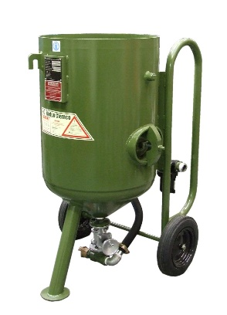
d) Pressure regulator

e) Enlarged 230mm x 165mm inspection cover for easy access.

f) Pop up valve umbrella fitted in the dished end of the blast machine designed to relieve pressure on the pop up valve from the head of abrasive in the storage hopper and hence give better and quicker sealing of the pressure vessel.

4.1 Blast Hose, Nozzle Holder, Couplings and Nozzle

A 10m length of 1” i.d. x 1.1/2” o.d. static dissipating Clemco blast hose complete with quick couplings and nozzle holder. The blast hose is tough, static dissipating and kink free and complies with all the latest international standards.

a) Nozzle Holders: The nozzle holder is manufactured from tough lightweight nylon to reduce operator fatigue. A coarse female thread matches the range of Clemco blast nozzles. Internal grip rings secure the blast hose for a safe fit whilst retaining screws provide extra holding power without penetrating the hose wear tube. Nozzle holders are supplied complete with replaceable nozzle gaskets to ensure good seal between blast hose, nozzle holder and nozzle.

b) Blast Hose Couplings: To connect the blast hose to the blast machine a universal quarter turn nyloc quick coupling is employed. The coupling is attached to the blast hose in the same manner as the nozzle holder and gives a simple and leak proof connection without the need for hand tools. A safety spring lock pin is employed which automatically engages with two sets of holes in the coupling flange for extra safety. The couplings are supplied with replaceable gaskets to ensure a good seal.

c) Nozzle: A 3/8” orifice Boron Carbide lined nozzle will be supplied. The blasting nozzles are designed to maintain maximum blasting velocity, uniform abrasive distribution and high work rate over a long operating life.

4.2 Operator Protective Equipment

Apollo Helmet - CE Marked

APH600CE air fed helmet designed to be used in conjunction with the CPF20 breathing air filter. The main benefits are:

60” sq. of optical quality lens area, giving improved visibility for operator comfort, productivity and safety.

Tabbed tear off perforated outer lens pack, enabling operator to clear vision whilst wearing helmet.

Acoustically designed to meet respiratory protective equipment controls, (EN 271) providing a safe environment for operator.

Heavy duty nylon cape with muffler lining

Kink proof and crush proof breathing air hose along with fixed airflow regulator.

CPF 20

The CPF breathing air filter is designed to reduce pollutants in air supplied to air fed helmets. As an important part of Clemco operator safety range of products, this filter removes mists (including oil mist) water vapour and particulate down to 0.5 microns in size from a suitable
supply of compressed air that is FREE from CARBON MONOXIDE, in accordance with BS 4275 and OSHA regulations 1910.19 and 1910.34

5.0 Media Recovery Equipment

Abrasive recovery will be accomplished using an IND 200P pneumatic sweep-in abrasive recovery unit. The complete system comprises a pneumatically operated suction filter unit, a vacuum silo, a small sweep-in floor hopper and suction nozzle and all necessary connecting hoses.

5.1 Suction Filter Units

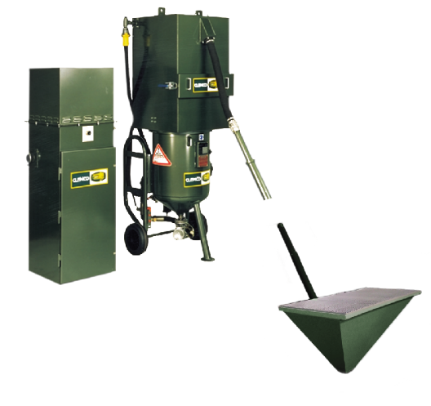
The freestanding suction filter unit incorporates a series of vacuum inducing air jets, which provides the vacuum power for the system. Dust is drawn from the vacuum silo and into the cartridge of the suction filter unit. Dust is dislodged from the cartridge by an adjustable reverse pulse of air. Dust dislodged from the cartridge is deposited in a removable dust tray. The unit will be fitted with an air dryer on the inlet and a pressure regulator to control recovery when using light abrasives.

5.2 Vacuum Silo/Storage Hopper

The vacuum silo/storage hopper is mounted over the 2040SGV blast cleaning machine and receives all spent media, debris and dust from the floor hopper. Reusable media is separated from the dust and passes through the angled sieve to screen out large particles. Good media is deposited in the storage hopper for automatic refill of the blast machine and the dust is passed into the filter cartridge.

5.3 Floor Hopper

A small floor hopper will be used to recover the spent abrasive swept or blown into it.

6.0 Services Requirements

Compressed air:

Blast Machine = 161 cfm @ 80 psi
Blast Helmet = 6 cfm
Rec unit = Up to 100 cfm (alternate use with blast)

Electrics:

Dust Collector = 415v/3ph/50Hz – 7.5 kW

7.0 Installation and Commissioning

Installation and commissioning is by Hodge Clemco engineers and fitters and all labour, hotel and living expenses are included. Installation costs are on the basis that the premises provide normal working conditions with lifting equipment, lighting, power for hand tools and also canteen and toilet facilities. Any expenses extra to the above incurred due to circumstances beyond the control of
Hodge Clemco Ltd are chargeable. Installation will be carried out during normal working hours, 9 a.m. to 5 p.m. Monday to Friday, excluding bank holidays.

8.0 Paint Finish

The equipment will be finished in Hodge Clemco ‘spruce green’ gloss metallic. We also offer a range of different paint finishes and colours to suit our clients’ requirements. Special paint finishes are available for a small additional cost.

9.0 Electrical Wiring

Electrical inter-wiring will be carried out by Hodge Clemco electricians and the cost is included in the price quoted. Mains wiring into the control panel from the customer’s supply is excluded.

10.0 Delivery

The price quoted excludes delivery to site. It is the customer’s responsibility to unload the consignment and store it safely at the final erection site.

11.0 Operator Instruction

Basic initial operator instruction is included during the commissioning of the equipment. Fully certified on-site training courses are available, for which a price is shown on the price page.

