Technical Competence Management for 10 tankered trade import sites
June 2023
Background
Following the OPRA guidance, YW have calculated that the recommended TCM hours is 20% of operational hours. This equates to 33.6 hours per week. However, *REDACTED DATA* Consequently, YW is confident in its ability to continue operating to a high standard.
Additionally, whilst YW have applied for a maximum volume of 500,000m³ per annum across all the sites, this figure was applied for to allow for future growth. Currently, the maximum volume imported to any one site is 30,000m³. If or when this figure increases substantially, YW will work with local EA officers to agree a suitable amount of time for a TCM to be present on site.
Yorkshire Water proposal
Yorkshire Water is proposing that a TCM will attend each site for *REDACTED DATA*. The site will only be operational if the TCM hours can be covered for that week. It is likely each TCM will attend two sites which are in close proximity to each other to minimise travel time between sites if an incident required their presence on site. Please see further details below:
Site Group | Sites | Travel time between sites
1 | Old Whittington and Woodhouse Mill | 9.6 miles (approx. 25 minutes)
2 | Blackburn Meadows and Sandall | 22.3 miles (approx. 35 minutes)
3 | Deighton and Esholt | 15.5 miles (approx. 35 minutes)
4 | Knostrop and Naburn | 27.2 miles (approx. 33 minutes)
5 | Hull and Whitby | 64.2 miles (approx. 1 hour 49 minutes)

The following TCM’s will cover the proposed 15 hours at each site:
TCM Name
Kevin Spink
Mark Threlfall
Daniel Tilford
John Bullivant
Kelly Neild

Date of birth and contact information
TCM | Date of birth | Contact information | Site Group
Kevin Spink | REDACTED DATA | REDACTED DATA | 1
Mark Threlfall | REDACTED DATA | REDACTED DATA | 3
Daniel Tilford | REDACTED DATA | REDACTED DATA | 4
John Bullivant | REDACTED DATA | REDACTED DATA | 2
Kelly Neild | REDACTED DATA | REDACTED DATA | 5

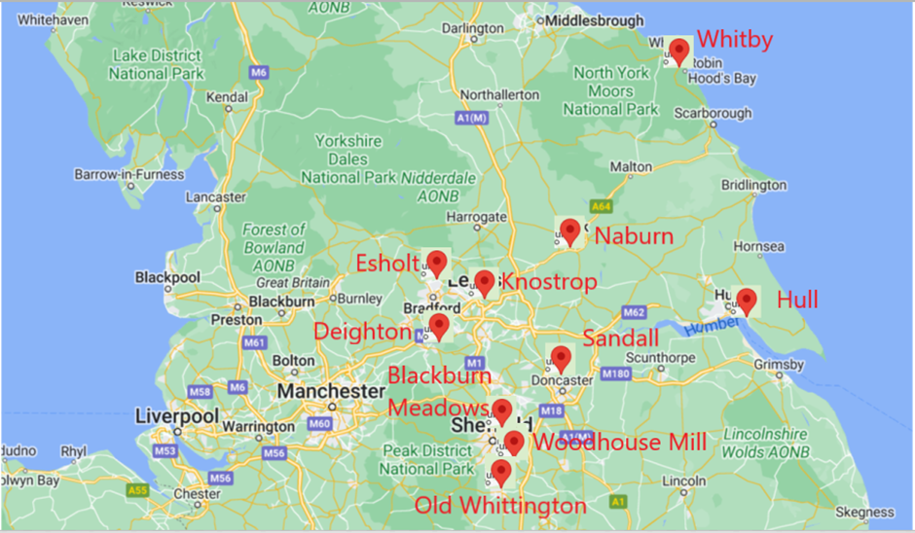
Figure 1 - Map of YW Tankered Trade Import Sites
Site name | Site Address | Site Contact | Tankered Trade Site Group
Aldwarke WwTW | Aldwarke Wwtw  Aldwarke Lane  Rotherham  South Yorkshire  S65 3SR | John Bullivant
Blackburn Meadows WwTW | Alsing road,  Sheffield,  S9 1HF | John Bullivant | 2
Caldervale WwTW | Caldervale Wwtw  Calder Vale Road  Wakefield  West Yorkshire  WF1 5PJ | Danny Tilford
Deighton WwTW | Ashgrove Road, Bradley, Huddersfield, HD2 1FE | Mark Threllfall | 3
Esholt WwTW | Ainsbury House  Esholt  Bradford  West Yorkshire  BD10 0TW | Mark Threllfall | 3
Huddersfield Energy and Recycling Facility | Upper Brighouse WwTW Cooper Bridge Road Mirfield West Yorkshire WF14 0BS | Mark Threllfall
Hull WwTW | Hull Waste Water Treatment Works  Hull Road  Kingston Upon Hull  HU12 8EY | Kelly Neild | 5
Knostrop WwTW | Knostrop Sewage Treatment Works  Knowsthorpe Lane  Leeds  LS9 0PJ | Danny Tilford | 4
Leeming Bar WwTW | Leeming Bar W W T W  Northallerton Road  Leeming Bar  North Yorkshire  DL7 9LQ | Kelly Neild
Lundwood WwTW | Lundwood Wwtw  Lund Lane  Barnsley  South Yorkshire  S71 5PA | John Bullivant
Mitchell Laithes WwTW | Mitchell Laithes Wastewater Treatment Works  Long Lane  Dewsbury  WF12 8LL | Mark Threllfall
Naburn WwTW | Naburn S T W  Naburn Lane  Naburn  York  North Yorkshire  YO19 4RN | Danny Tilford | 4
Old Whittington WwTW | Old Whittington W W T W  Station Lane  Chesterfield  Derbyshire  S41 9HY | Kevin Spink | 1
Sandall WwTW | Sandall W W T W  Wheatley Hall Road  Doncaster  South Yorkshire  DN2 4NU | John Bullivant | 2
Staverley WwTW | Staveley Waste Water Treatment Works, Hague Lane, Renishaw, Rotherham, South Yorkshire, S139HR | Kelly Neild
Whitby WwTW | Stainsacre Lane Whitby YO22 4NW | Kelly Neild | 5
Woodhouse Mill WwTW | Woodhouse Mill W W T W  Retford Road  Sheffield  South Yorkshire  S13 9WD | Kevin Spink | 1

