Background

Shale is the secondary raw material used for the manufacture of cement clinker at Hope Works. It comprises up to 20% of the total material used in raw meal manufacture. Shale contains the largest proportion of sulphur compounds within the raw materials used and these have a direct impact on the emissions of sulphur dioxide from the kilns. The correct amount of sulphur is also required to ensure stable process conditions and clinker quality within the kiln system. As a result, to ensure stability of the kilns, together with the emissions of sulphur dioxide, it is vital to control the input of sulphur compounds from within the shale.

Control Philosophy

The sulphur content within the shale is very variable. The upper 15m of Hope’s shale reserve is classed as low to medium sulphur shale, containing SO3 levels typically <3%. The next 13m depth of reserve is classed as med/high sulphur shale with an SO3 content ranging typically between 3-7%. Below this point, we classify the shale at ultra-high sulphur with an SO3 content above 7%. The blends of high, medium and low sulphur shales used for raw mix have to be monitored continually and adjusted as the SO3 content of the different shales vary.

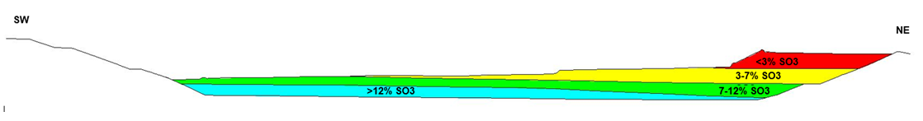

Control Methodology

A weekly quarries development meeting takes place that considers shale operations, shale chemistry and current raw mix quality. An operational programme of shale blends for the week will be agreed, taking into consideration the current SO3 levels in the available shale, operational activities, and available additional secondary materials (e.g. Pulverised Fuel Ash).

A weekly technical meeting takes place to review kiln process conditions and operational performance to set targets for raw mix including SO3 limits based on clinker production and monitoring kiln SO2 emissions. The technical meeting will also consider the other available secondary materials including volumes, chemistry, and operational conditions to agree a typical feed rate.

Raw meal samples are taken hourly and analysed by the laboratory. The resultant SO3 content of the raw meal is displayed continually on the site’s Process Information system. Actions are taken during operation to control the SO3 levels if they deviate from target.

Quarry management monitor the raw meal SO3 results on a daily basis and instruct the shale extraction operators to modify the shale blends by adjusting the ratios of low/med or high sulphur shale sulphur shale input to maintain the raw meal SO3 target.

Representative samples of shale being crushed are collected from the shale quarry on a daily basis and analysed by the laboratory. These results are displayed on the AQCNet quality information system, and this provides supporting data to inform of changes in the SO3 content of the shales being extracted. Consideration will be given to any unexpected chemistry data and this will be fed back into the quarries development reviews.

Furthermore, the shale extraction team are instructed only to feed low sulphur shale at the start of each day as part of the blending process. This is to avoid a sudden spike of high SO3 raw meal being produced which could cause process instability and elevate the SO2 levels in the kiln exhaust gas.

Kiln exhaust gas emissions, including SO2, are continually monitored, levels and this information is displayed on the environmental screen in the Control Room.

If additional secondary raw materials are being used for raw meal production, such as Pulverised Fly Ash, then the effect of this on the overall SO3 content of raw meal will need to be monitored. The amounts of such materials available, together with a review of the kiln process as a whole, is conducted weekly at a technical review meeting. All this information is then considered when reviewing the raw meal SO3 target.

This process is summarised in the flow diagram below. 