# Site Plan 2025-01-01 V1

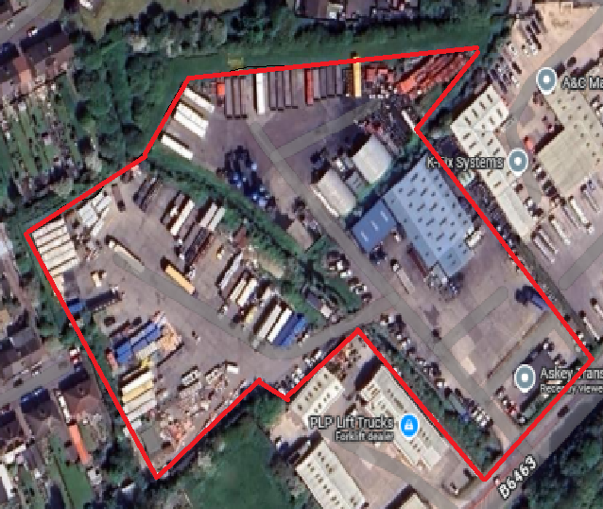

## Key:

Askey Site Outline

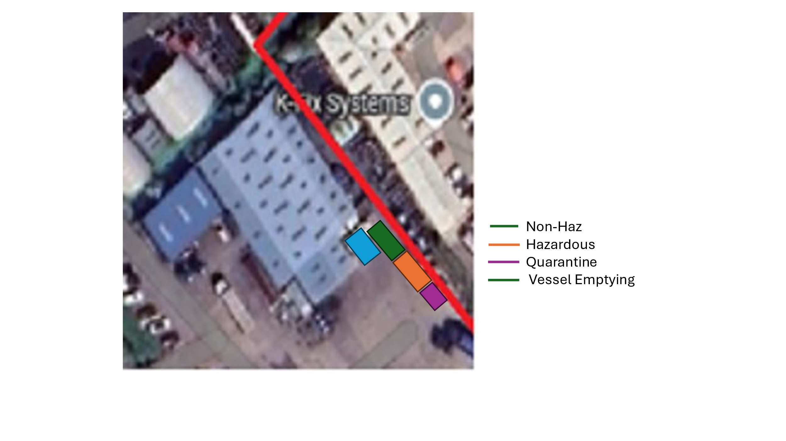Proposed Operational Area

# Magic Maps