Form EPA: Application for an environmental permit - Part A about you

Application for an environmental permit Part A - About you

**You will need to fill** in **this** part **A if you** are **applying for a new permit, applying to change an existing permit or surrender your permit, or want to transfer an existing permit to yourself. Please check that** this **is the latest version of the** form **available from our website.**

**You can apply online for Waste standard rules environmental permits, bespoke waste permits and bespoke Medium combustion plant permits**

**Apply online for an environmental permit.**

**Please read through this form** and **the guidance notes that came with it.**

**The form can be:**

1. **saved onto a computer and then filled in. Please note that the form follows a logic that means questions will open** or **stay closed depending on a previous answer. So you may not be able to enter text in some boxes.**
2. **printed off and filled** in **by hand. Please write clearly in the answer spaces.**

**Note:** if you believe including information on a public register would not be in the interests of national security you must enclose a letter telling us that you have told the Secretary of State. We will not include the information in the public register unless directed otherwise.



It will take less than one hour to fill in this part of the application form.

Where you see the term 'document reference' on the form, give the document references and send the documents with the application form when you've completed it.

**Contents**

1. **Aboutyou**
2. **Applications from an individual**
3. **Applications from an organisation of individuals or charity**
4. **Applications from public bodies**
5. **Applications from companies or corporate bodies**
6. **Your address**
7. **Contact details**
8. **How to contact us**
9. **Where to send your application**

**Appendix 1** - **Date of birth information for installation and waste activities (applications for a new permit or transferring a permit) only**

1. **Aboutyou**

Are you applying as an individual, an organisation of individuals (for example, a partnership), a company (this includes Limited Liability Partnerships) or a public body?

An individual

An organisation of individuals (for example, a partnership)

A public body

A registered company or other corporate body

D Now go to section 2 and if you are applying for a new permit or transferring a permit for an installation or waste activity please also fill in Appendix 1

lill Now go to section 3 and if you are applying for a new permit or transferring a permit for an installation or waste activity please also fill in Appendix 1

D Now go to section 4

D Now go to section 5 and if you are applying for a new permit or transferring a permit for an installation or waste activity please also fill in Appendix 1

1. **Applications from an individual 2a Please give us the following details** Name

Title (Mr, Mrs, Miss and so on) First name

Last name

Now go to section 6

EPA Version 14, August 2020 page 1 of?

**Form EPA: Application for an environmental permit - Part A about you**

## Applications from an organisation of individuals or charity

3a Type of organisation

For example, a charity, a partnership, a group of individuals or a

club 1

3b Details of the organisation or charity

If you are an organisation of individuals, please give the details of the main representative below. If relevant, provide details of other members (please include their title Mr, Mrs and so on) on a separate sheet and tell us the document reference you have given this sheet

Contact name

Title (Mr, Mrs, Miss and so on) First name

Last name

Now go to question 3c or section 6

3c Details of charity Full name of charity

This should be the full name of the legal entity not any trading name.

3d Company registration number

If you are registered with Companies House please tell us your registration number

3e Charity Commission number

If you are registered with the Charity Commission please tell us your registration number

Now go to section 6

## Applications from public bodies

4a Type of public body

For example, NHS trust, local authority, English county council 4b Name of the public body

4c Please give us the following details of the executive An officer of the public body authorised to sign on your behalf Name

Title (Mr, Mrs, Miss and so on) First name

Last name Position

Now go to section 6

## Applications from companies or corporate bodies

**r=l 1.,;.11**

Sa Name of the company Arundel Motors Ltd

Sb Company registration number 00292195

Date of registration (DD/MM/YYYY)

19/09/1934

If you are applying as a corporate organisation that is not a limited company, please provide evidence of your status and tell us below the reference you have given the document containing this evidence.

Document reference

EPA Version 14, August 2020 page 2 of7

**Form EPA: Application for an environmental permit - Part A about you**

# Applications from companies or corporate bodies, continued

Sc Please give details of the directors

If relevant, provide details of other directors and company secretary, if there is one, on a separate sheet and tell us the reference you have given this sheet.

Document reference

Details of company secretary (if relevant) and director/s

Title (Mr, Mrs, Miss and so on) Mr

First name Robert

Last name Askey

Title (Mr, Mrs, Miss and so on) First name

Last name

Now go to section 6

# Your address

6a Your main (registered office) address

For companies this is the address on record at Companies House. Contact name

Title (Mr, Mrs, Miss and so on)

First name Last name Address

Postcode

Contact numbers, including the area code Phone

Fax Mobile Email

Robert Askey

1Monksbridge Road

Dinnington Sheffield,

South Yorkshire 1S25

01909 560768

07970 259 080

1darren@askeytransport

For an organisation of individuals every partner needs to give us their details, including their title Mr, Mrs and so on. So, if necessary, continue on a separate sheet and tell us below the reference you have given the sheet.

Document reference

6b Main UK business address (if different from above) Contact name

Title (Mr, Mrs, Miss and so on)

First name Last name Address

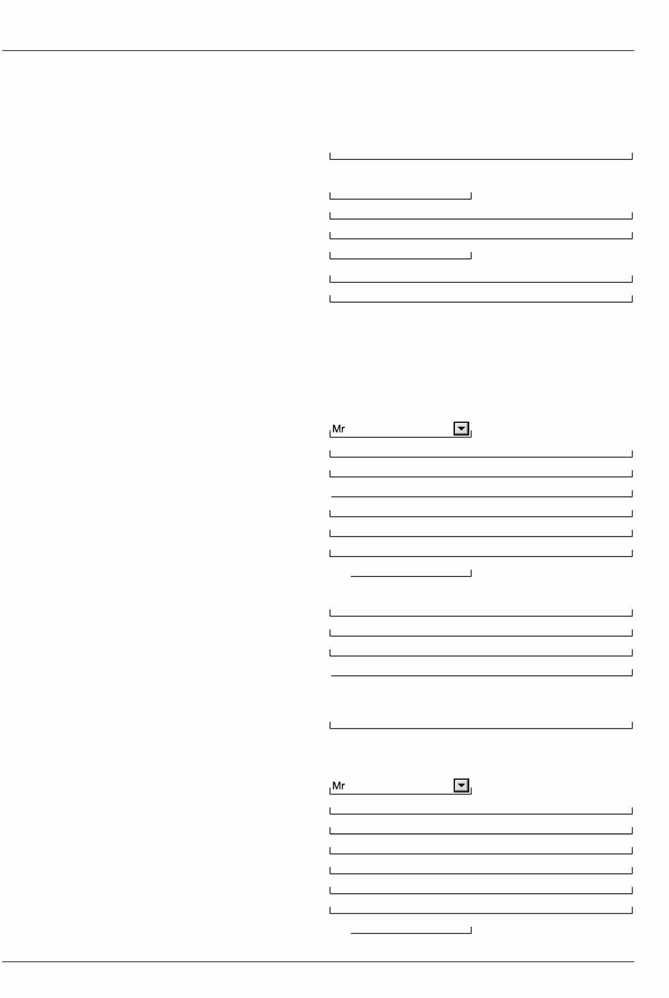

Postcode

EPA Version 14, August 2020

Robert Askey

Monksbridge Rd Dinington Sheffield

South Yorkshire 1S24 3 QS

page 3 of7

**Form EPA: Application for an environmental permit - Part A about you**

1. Your address, continued Contact numbers, including the area code Phone

Fax Mobile Email

Now go to section 7

1. Contact details

### 7a Who can we contact about your application?

01909 560768

07970 259 080

It will help us if there is someone we can contact if we have any questions about your application. The person you name should have the authority to act on your behalf.

Please add a second contact on a separate sheet if this person is not always available. Document reference of this separate sheet

This can be someone acting as a consultant or an 'agent' for you. Contact name

Title (Mr, Mrs, Miss and so on)

First name Last name Address

Postcode

Contact numbers, including the area code Phone

Fax Mobile Email

John **Shadiack** CPL Products

1 lmmingham Works

1southern Rd, Western Access Rd lmmingham

1DN40 2QR

01469 571700

07826 872486

[1john.shadlock@activated-carbon.corn](mailto:1john.shadlock@activated-carbon.corn)

### 7b Who can we contact about your operation (if different from question 7a)?

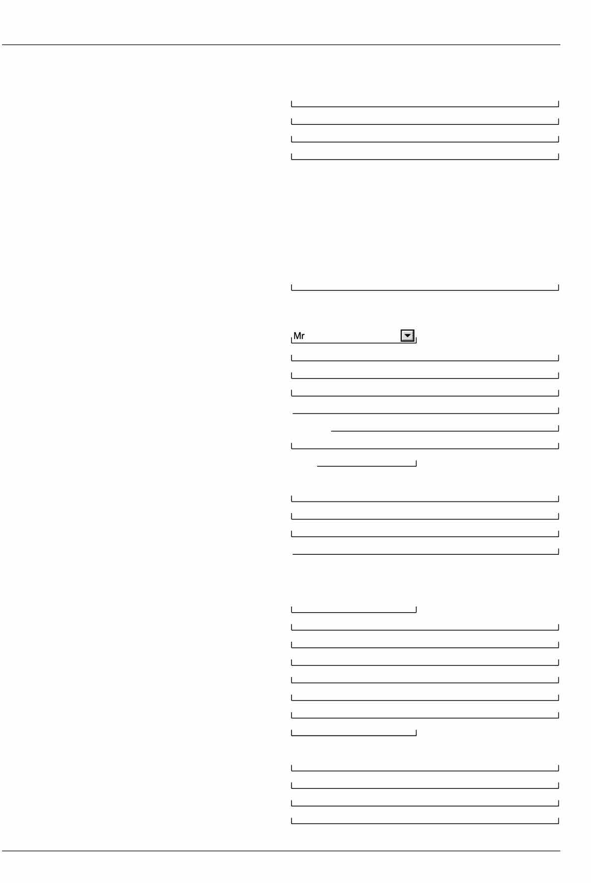

Contact name

Title (Mr, Mrs, Miss and so on) First name

Last name Address

Postcode

Contact numbers, including the area code Phone

Fax Mobile Email

EPA Version 14, August 2020 page 4 of7

**Form EPA: Application for an environmental permit - Part A about you**

# Contact details, continued

## 7c Who can we contact about your billing or invoice?

#### Note: Please provide the name and address that all invoices should be sent to for your subsistence fees.

*As in question 7a As in question 7b*

*Please give details below if different from question 7a or 7b. Contact name*

*Title (Mr, Mrs, Miss and so on) First name*

*Last name Address*

*i2I*

□

*Postcode*

*Contact numbers, including the area code Phone*

*Fax Mobile Email*

# How to contact us

*If you need help filling in this form, please contact the person who sent it to you or contact us as shown below. General enquiries: 03708 506 506 (Monday to Friday, 8am to 6pm)*

*Textphone: 03702 422 549 (Monday to Friday, 8am to 6pm) Email:* [*enquiries@environment-agency.gov.uk*](mailto:enquiries@environment-agency.gov.uk)



EPA Version 14, August 2020

page 5 of7

*Website:* [*www.gov.uk/government/organisations/environment-agency*](http://www.gov.uk/government/organisations/environment-agency)

*If you are happy with our service, please tell us. It helps us to identify good practice and encourages our staff. If you're not happy with our service, please tell us how we can improve it. More information on how to do this is available at:* [*www.gov.uk/government/organisations/environment-agency/about/complaints-procedure.*](http://www.gov.uk/government/organisations/environment-agency/about/complaints-procedure)

**Please tell us if you need information in a different language or format (for example, in large print) so we can keep in touch with you more easily.**

# Where to send your application

*For how many copies to send see the guidance note on part A. For water discharges by email to* [*PSC-WaterQuality@environment-agency.gov.uk*](mailto:PSC-WaterQuality@environment-agency.gov.uk) *For waste and installations by email to* [*PSC@environment-agency.gov.uk*](mailto:PSC@environment-agency.gov.uk)

*For flood risk activity permits send 1 copy only to* [*enquiries@environment-agency.gov.uk*](mailto:enquiries@environment-agency.gov.uk) *or to the local Environment Agency office for where the work is proposed to be carried out.*

*Or*

*Permitting Support, NPS Sheffield Quadrant 2*

*99 Parkway Avenue Parkway Business Park Sheffield*

*S9 4WF*

**Form EPA: Application for an environmental permit - Part A about you**

**Feedback**

(You don't have to answer this part of the form, but it will help us improve our forms if you do.)

We want to make our forms easy to fill in and our guidance notes easy to understand. Please use the space below to give us any comments you may have about this form or the guidance notes that came with it.

How long did it take you to fill in this form?

We will use your feedback to improve our forms and guidance notes, and to tell the Government how regulations could be made simpler.

Would you like a reply to your feedback?

Yes please □

No thank you □



**For Environment Agency use only**

Date received (DD/MM/YYYY)

Payment received?

No □

Our reference number

Yes □ Amount received

£

EPA Version 14, August 2020 page 6 of?

## Appendix 1 - Date of birth information for installation and waste activities (applications for a new permit or transferring a permit) only



Form EPA: Application for an environmental permit - Part A about you

### Date of birth information in this appendix will not be put onto our Public Register

#### Are you applyingas an individual, an organisation of individuals (for example, a partnership) or a company (this includes Limited Liability Partnerships)?

An individual

An organisation of individuals (for example, a partnership) A registered company or other corporate body

### Applications from an individual

Please give us the following details Name

Date of birth (DD/MM/YY)

D Nowgo to2

□ Nowgo to3

� Nowgo to4



### Applications from an organisation of individuals or charity

#### Details of the organisation or charity



EPA Version 14, August 2020

page 7 of7

If you are an organisation of individuals, please give the date of birth details of the main representative below. If relevant, provide details of other members on a separate sheet and tell us the document reference you have given this sheet.

Name

Date of birth (DD/MM/YY) Document reference

### Applications from companies or corporate bodies

Name of the company 1Arundel



Motors Ltd

Please give the date of birth details for all directors and company secretary if there is one. If relevant, provide those details of other directors on a separate sheet and tell us the document reference you have given this sheet.



Details of company secretary (if relevant)and director/s Name

Date of birth (DD/MM/YY) Name



Robert Askey 01/06/71

Garry Green 06/11/61

Jean Green 129/10/39

AML/CPL/DIR/240424

Date of birth (DD/MM/YY) Name

Date of birth (DD/MM/YY) Document reference