The following response was sent to Liz Topping on 14 March 2024. It relates to a request for information relating to Application reference: EPR/DP3092ZJ/V005/S006, Facility: Woodhouse Mill WwTW, Retford Road, Woodhouse Mill, Sheffield, S13 9WD.
1) Application fee
a) Variation application fee
I know Sarah confirmed in her e-mail dated 26/01/2024 that you needed to pay a further £1760 following her triage questions to you. I have checked and we have not received this payment yet. Also I can confirm that a habitat assessment fee (charging reference 1.19.2 for £779) is not required for this application as there are no nearby qualifying habitat sites. Therefore you owe us £981 for the variation application. The charges are summarised below (and you have paid £17,869 so far).
£13,984 application fee for S5.4 A(1) (b) (i)
£2,379 Application fee for a Minor variation fee to remove activity R2
£1,246 Odour management plan
£1,241 Emission management plan
Please can you let me know the date and reference of this payment once made.

Thank you for confirming the habitats fee is not required. Unfortunately the payment had already been approved and was paid at the point of receiving this RFI. YW Accounts Team tell me this was made on 31 January 2024. This was made with reference pscappyyorksSW119 with a fee of £3,159 (habitats assessment £779 and R2 removal £2,379).

If I could request a refund for the habitats fee in line with the refund discussed in 1b. Thank you.

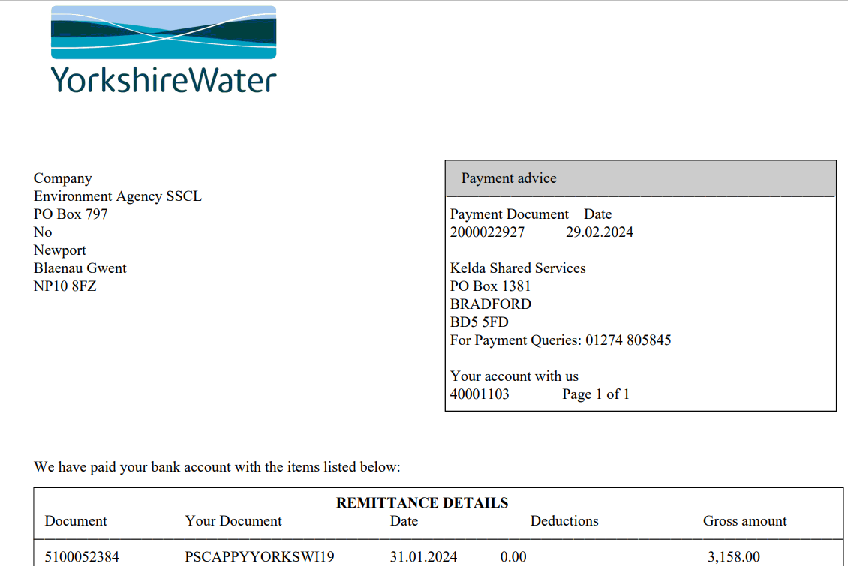

b) Partial surrender application fee
You have paid £6084 for the partial surrender on 29/06/2023 (under charging reference 1.16.19), however it has been agreed this partial surrender is a low risk surrender which is charged at 20% of the new permit activity under charging reference 1.16.19. The main permit activity charge is £10,141 and so 20% of this figure is £2028.20. I will request that £4055.80 is refunded.
Note: The two applications need to be dealt with separately so I still need you to make the payment for the variation application and I can sort out the refund for the partial surrender separately.

Thank you for confirming the low risk application has been accepted. We originally discussed in communication with Phil Dixon that we should pay the full amount for any surrender and then refunds would be discussed accordingly hence the over payment.
2) Site name
What site name do you want to use for this permit application? Application form C2 says Woodhouse Mill Wastewater Treatment Works but it may be confusing to use this name as this will be the name of the UWWTD permit for this site. We could call the site Woodhouse Mill sludge treatment and tankered waste facility or Woodhouse Mill Sludge Treatment Facility, please confirm.

I agree. The STW references the existing permit name. Please use Woodhouse Mill Sludge Treatment Facility.
3) Wet weight
In your supporting information (table C3: 1a-1 types of activities) you have stated the … total digester treatment capacity combined 270 tonnes per day⁷ (at 6% dry solids), 16.2 tonnes dry solids (TDS) per day.
a) Can you confirm what is the maximum wet weight in tonnes per day is for the treatment capacity?

270 t/d
b) Can you confirm what is the maximum wet weight in tonnes per day is for the annual throughput?

98,550 t/yr
4) Emission points
I’ve noticed that some of the emission point NGR’s provided in the supporting information table C3:2-1 & 2-2 do not match the location on the site location plans submitted. Can you please double check these NGR’s, the current NGR given for emission point S2 is just outside of the installation boundary. If you think the NGR’s are correct in your current application you may need to update your site plans to reflect this.
Emission point | NGR given in application | NGR I think it should be to match location on site plans
A1 | SK 43462 85890 | SK 43459 85886
A2 | SK 43465 85885 | SK 43463 85878
A3 | SK 43425 85905 | SK 43421 85901
S2 | SK 43355 85958 | SK 43355 85954

For the permit application we used gridreferencefinder.com to select the grid references that were provided. However, this is not ortho-corrected data so, depending on the position the photography was taken from, changes in ground height and perspective have the potential to slightly distort the position of features compared to their true position.
Therefore, following your request we have used the Ordnance Survey website mapping as an alternative (https://explore.osmaps.com/). We have reviewed the drawing and have provided the following updated grid references using the “Standard” mapping layer on the OS website. Note that we have not used the aerial photography layer as this is also differs slightly compared to “standard” base mapping.

Emission point | Updated NGR
A1 | SK 43459 85888
A2 | SK 43463 85881
A3 | SK 43418 85900
S2 | SK 43356 85958

These grid references are slightly different again to those suggested by the Environment Agency in Q4. The location of the emissions points is as shown on Woodhouse Mill Figure 3 Site Layout Plan_Rev_B - Principal Emissions Points.
5) Head of works waste activity discharge point
a) Please complete application C4 for your waste operation at this site, link to form is as follows: Application for an environmental permit Part C4 – Varying a bespoke waste operation permit - GOV.UK (www.gov.uk). As this waste operation is changing, we need you to complete this form to confirm the throughputs for the remaining head of work wastes.
b) Please confirm the maximum annual throughput wet weight in tonnes per day for this waste activity?
b) Please supply a site plan showing the head of works discharge point, sample point and any storage facilities for this waste activity, please ensure you use appropriate references on the site plan that corresponds with the other emission points already supplied for this application.
c) Please supply a description of how this waste activity is discharged at the wastewater works and detail any storage information. For example, are buffer tanks used here, how long wastes are stored, the volumes stored, if there is any abatement or pre-treatment, if it’s an impermeable surface with a sealed drainage system etc.

There is a separate application currently being determined by NPS in relation to the Head of Works permit application at Woodhouse Mill WwTW. The application is wholly separate to the IED-AD application. Please note though that we’ve been advised by Sarah Raymond that waste water sludges are excluded from permitting as it falls under controlled waste regulations, therefore we were advised that the EWC codes for sludges would not be featured on the head of works permit. That’s a separate conversation to this IED-AD application though.
We do not propose to provide any details requested by Q5 but would welcome further discussion and engagement with the Environment Agency on this issue if deemed necessary.
6) Uncontaminated site surface water from roof and non-operational areas
You have supplied a drainage plan for the site but this does not give a discharge point reference or NGR for the site surface water from roof and non-operational areas.
a) Please supply a site plan to show this location labelled, please ensure you use appropriate references on the site plan that corresponds with the other emission points already supplied for this application.
b) Please supply the NGR’s for these discharge point(s).

Figure 3 has been updated to add emissions points to water W1 and W2 as shown. These discharges comprise only clean, uncontaminated rainwater runoff from roadways, which is discharged to final treated effluent tanks (FSTs) prior to discharge to the river. Note that YW is committed to re-route these discharge points back to the WwTW inlet and therefore these emissions points will be removed.
The grid references for W1 and W2 are provided below.
Emission point | NGR
W1 | SK 43321 86016
W2 | SK 43355 85958

In relation to roofwater, there are 4 buildings within the installation boundary. These are: thickener building, centrifuge building, boilerhouse building and the building containing emissions point S2 (i.e. the top water and return liquors sump). YW is committed to establishing the discharge route for roofwater from these buildings and will provide this information to the EA during the permit determination period. Please see attached Woodhouse Mill Figure 3 Site Layout Plan_Rev_B - Principal Emissions Points

