Royal Hallamshire Hospital – Site Condition Report Summary

The Site
Royal Hallamshire Hospital (RHH) (hereafter ‘the site’) is located on Glossop Road, Broomhill, S10 2JF in Sheffield, South Yorkshire. Sheffield Teaching Hospital NHS Foundation Trust (STH hereafter) is a public body that manages RHH.
The site is located approximately 1km from Sheffield city centre, and the surrounding area of the site is made up of the hospital, university buildings, schools, hotels, businesses and residential properties.
The boundary of the site can be found in Figure 1, and ‘RHH B2.5a Site Plan main boundary’. Within the site boundary, there are 12 boilers and four standby generators in the Boiler House of RHH (shown in brown in Figure 2), one standby generator in Weston Park (shown in green in Figure 1), and one standby generator in the Jessop Wing (shown in pink in Figure 1). There are no generators or boilers in Charles Clifford (shown in orange in Figure 1). Four of the standby generators at RHH were removed and replaced with four new standby generators, three of which were commissioned in May 2024 and one commissioned in July 2024. Therefore, this application excludes the generators that are to be replaced and includes the new standby generators that were commissioned in May 2024 and July 2024. In total, this application includes 12 boilers and six standby generators. 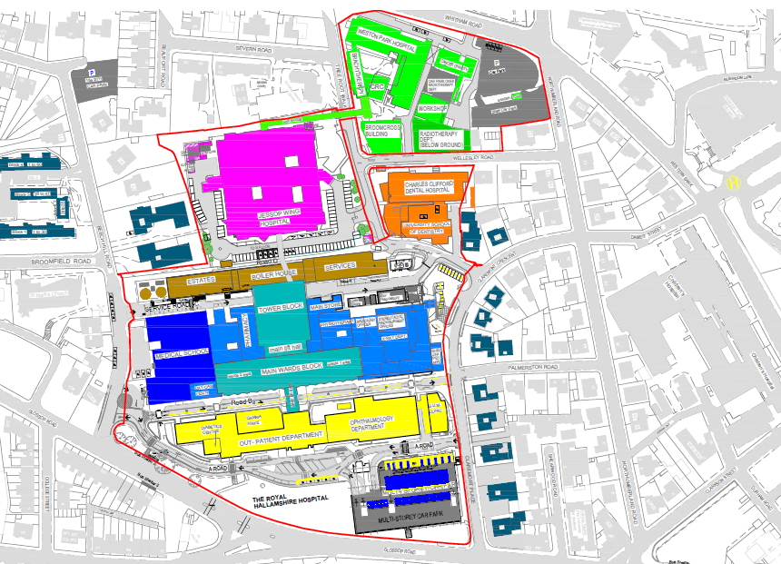
Figure 1 Site plan
The site is not located within 5km of a Special Protection Area (SPA), Special Area of Conservation (SAC), Ramsar site, Area of Outstanding Natural Beauty. The nearest SPA (Peak District Moors) and SAC (South Pennine Moors) are approximately 6km south west. The site is located within the Sheffield City Council Air Quality Management Area (AQMA) and is within 5km of four Sites of Scientific Interest (SSSI).
As part of this desktop assessment, an Enviro-Insight report was purchased from GroundSure to provide a desktop-based study on the site area (refer to ‘RHH B2.5b GroundSure report’). The report details all present records for current and historical land-use, specifically to clarify the susceptibility of the site and surrounding area to potential ground-polluting incidents, and any presence of potential ground-polluting sources.

Summary of Groundsure Report
The Groundsure study highlighted the findings, shown in Table 1, in relation to the RHH site, as well as its surroundings. The historical use of the site, since 1974, is a hospital.

Table 1 Summary of Findings
Findings | Location
- 33 counts of historical industrial land uses including: Hospital, Unspecified Tanks and Unspecified Ground Workings | Located within 500m radius of the site
- 3 counts of historical energy features: Electricity Substation | Located on site
- 5 counts of historical tanks | Located on site
- 4 counts of recent industrial land uses: Charles Clifford Dental Hospital, Electricity Sub Station, Weston Park Hospital and RHH | Located on site
- 15 counts of radioactive substance authorization: RHH, University of Sheffield, and Medical School. | Located on site
- The site lies on a ‘Secondary A’ bedrock aquifer | N/A
- The site lies on a ‘Medium Vulnerability’ secondary superficial aquifer | N/A
- The site does not lie on a groundwater source protection zone | N/A
- The following environmental designations have been identified within a 2.2km radius of the site
- Sites of Special Scientific Interest  - Ramsar Sites  - Special Areas of Conservation  - Special Protection Areas  - National Nature Reserves  - Local Nature Reserves  - Ancient Woodland  - Designated Ancient Woodland  - Biosphere Reserves  - Nitrate Sensitive Areas  - Priority Habitat Inventory | 1 count (Neepsend Railway Cutting)  0 counts  0 counts  0 counts  0 counts  6 counts – the closest is Sunnybank 655m south east of the site.  1 count – the closest is Smith Wood 1481m south west of the site.  0 counts  0 counts  0 counts  1 count – the closest is deciduous woodland located 97m south east of the site.

Assessment
The boilers and generators associated with this Installation application are all stored internally (see Figures 2, 3, 4 and 5), in locked rooms.
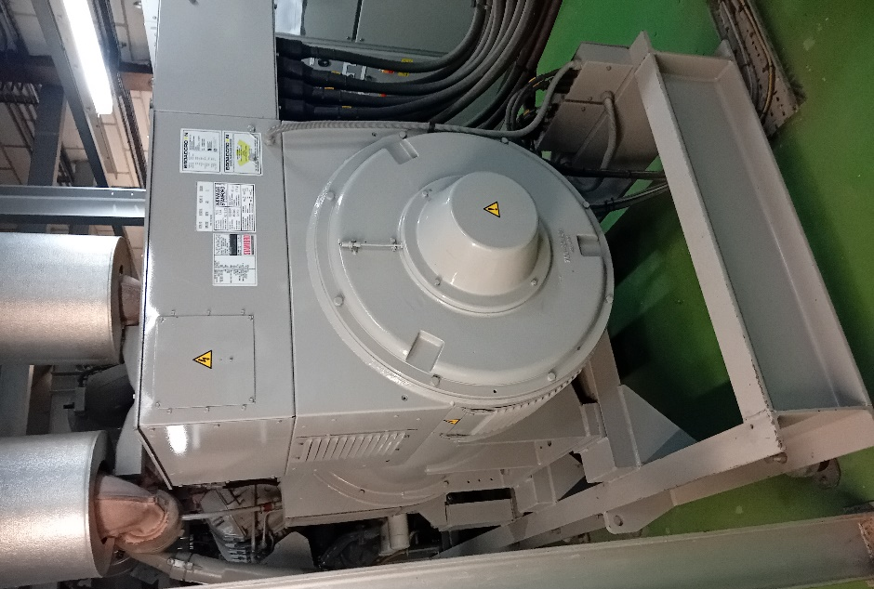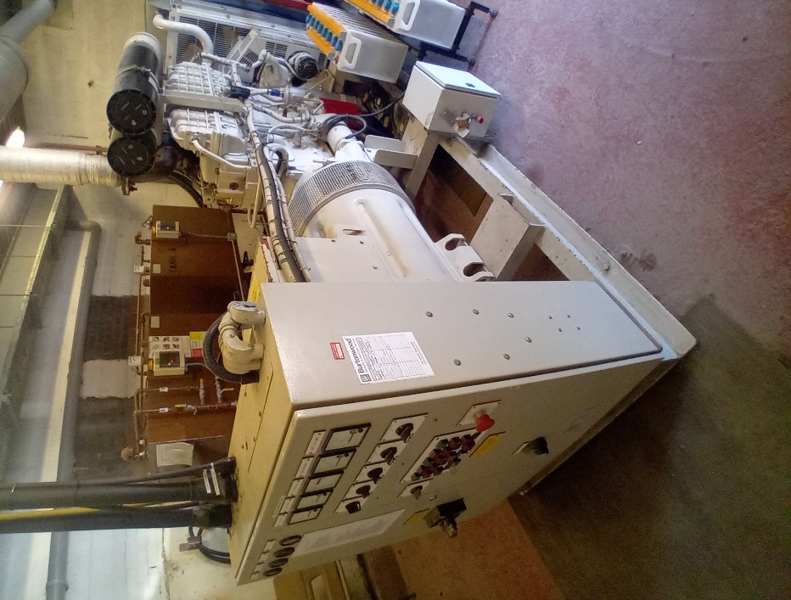
Figure 2 Jessop Park standby diesel generator | Figure 3 Weston Park standby diesel generator

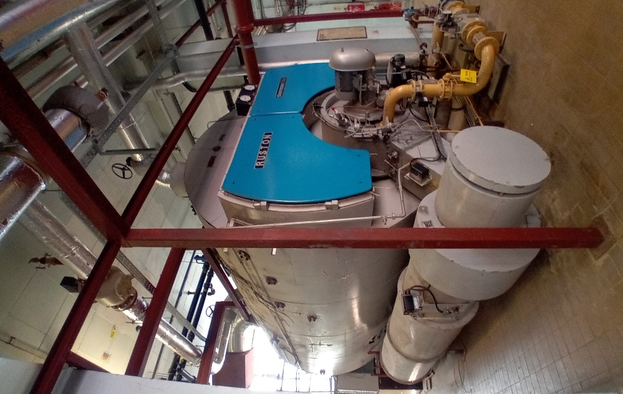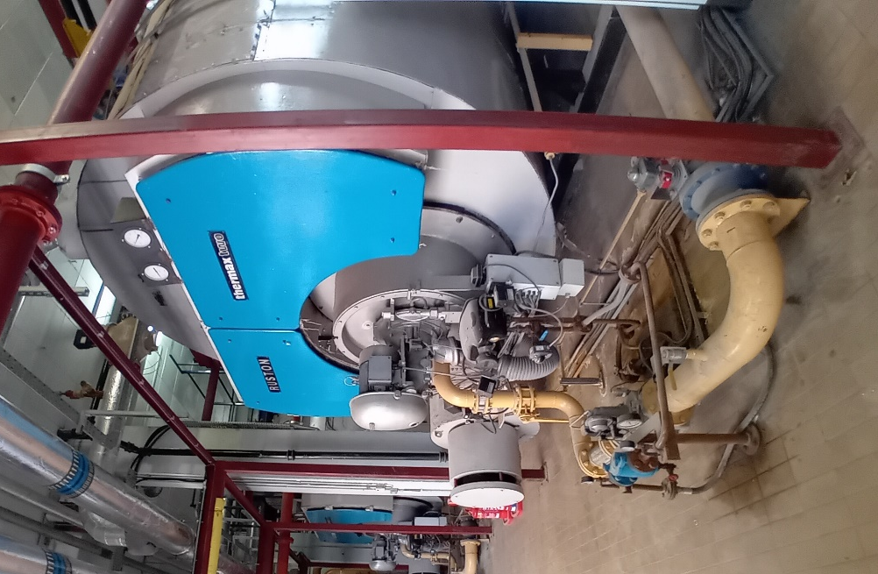
Figure 4 Three RHH Boiler House dual-fuelled boilers
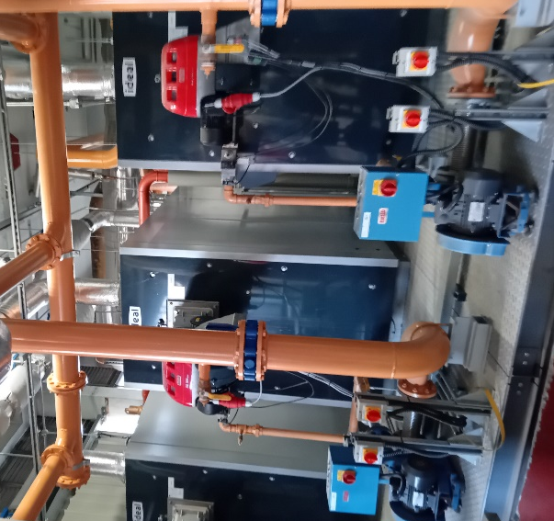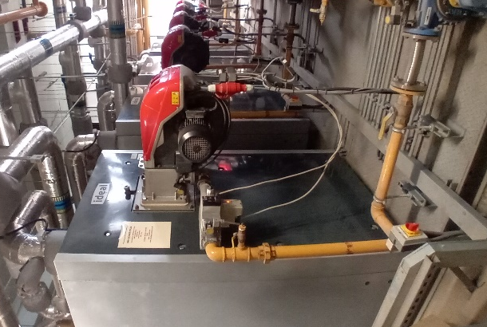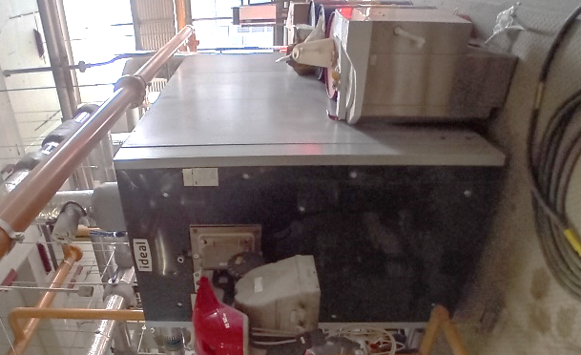
Figure 5 Nine RHH Boiler House natural gas boilers
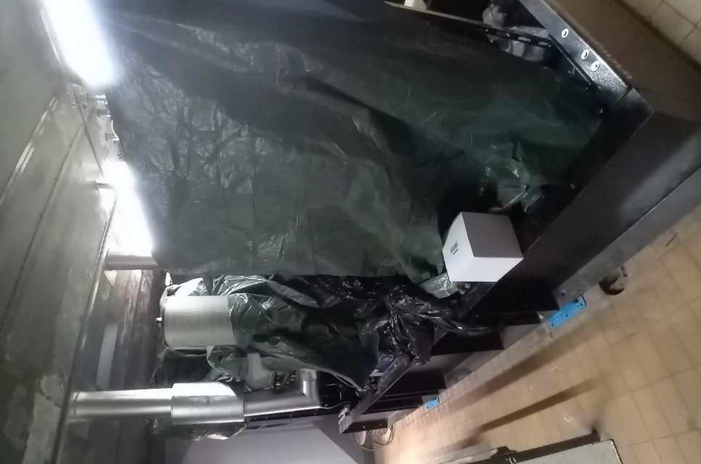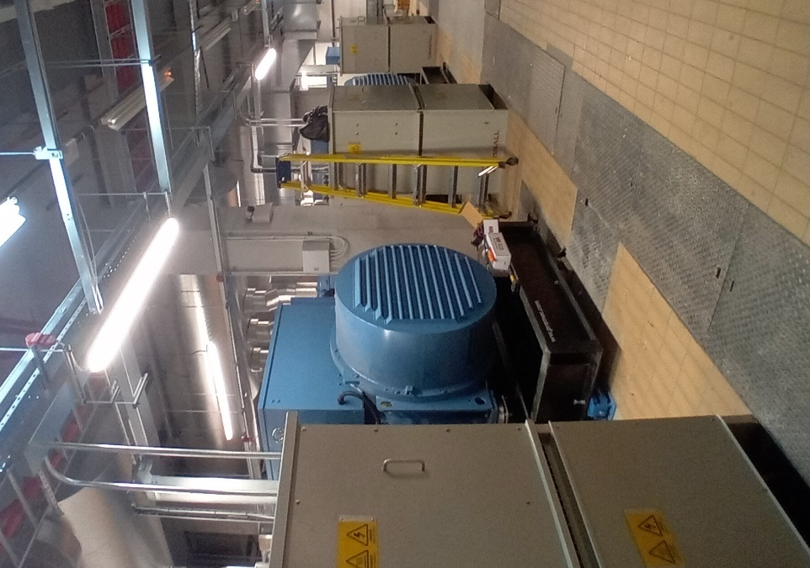
Figure 6 Four RHH Standby generators (not commissioned at the time the photo was taken)
At the Jessop Wing, diesel is delivered by a tanker, which is stored in a tank which feeds the standby generator (see Figure 7). At Weston Park, diesel is delivered in barrels and stored on bunds, before being fed into the standby generator when required (see Figure 8). At RHH, diesel is delivered via tanker which is stored in large external tanks(see Figure 9 for examples), and then fed into internal day tanks. This will be used to feed the new standby generators and the dual-fueled boilers where required.
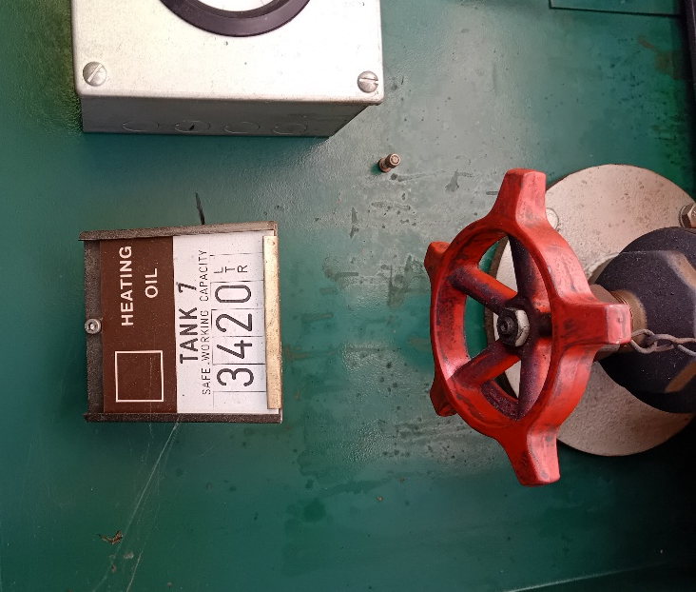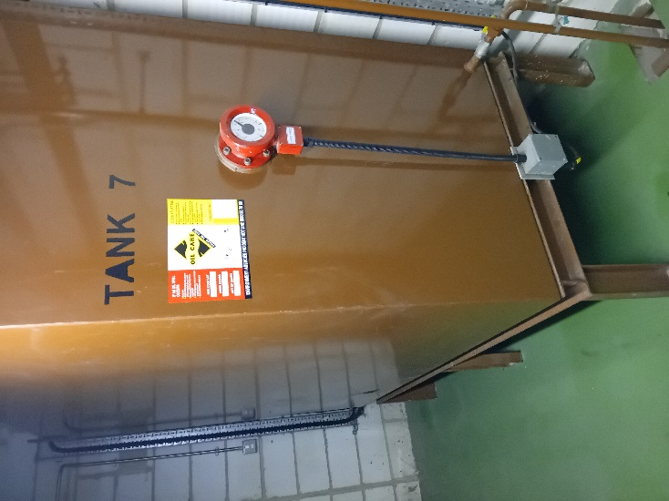
Figure 7 Jessop Wing diesel tank
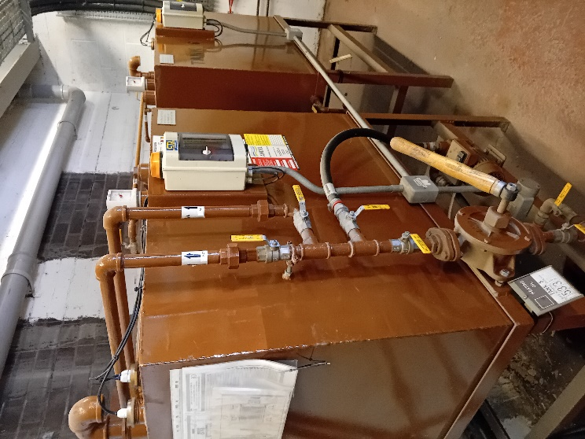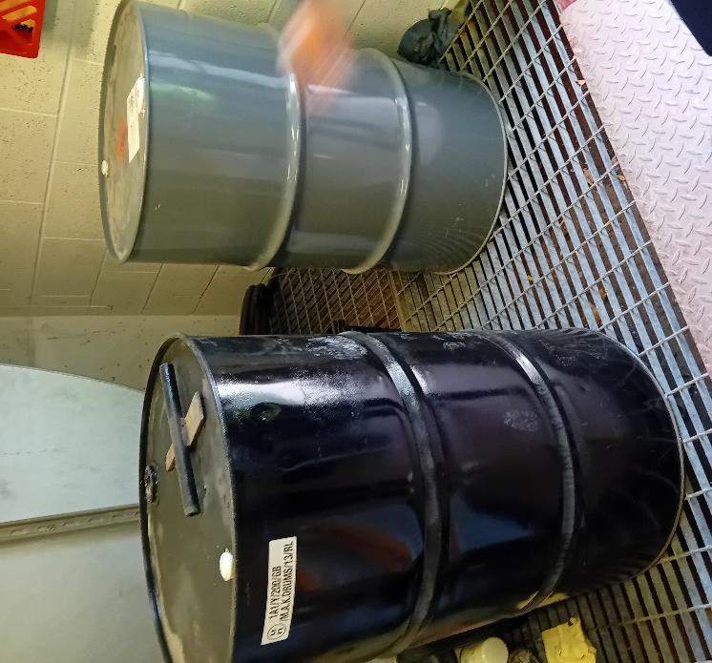
Figure 8 Weston Park diesel tanks and barrels
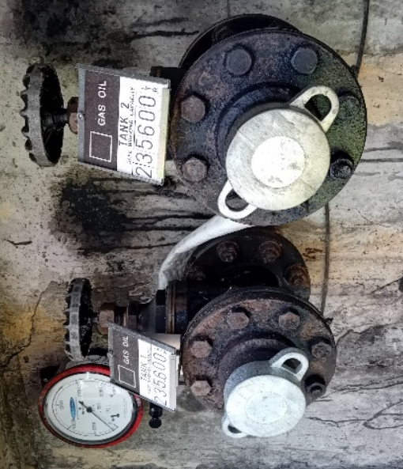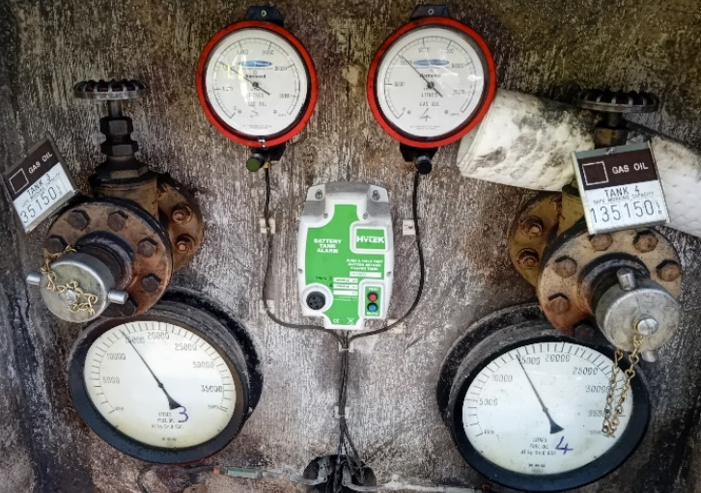
Figure 9 RHH standby generator and dual fuel-boilers diesel tank inlet
The diesel storage tanks for RHH are inspected annually (see ‘RHH B2 Inspection Reports’ for the December 2023 reports). Tank 3 and Tank 4 were identified as having holes in the bunds due to cabling, however, this issue has been remediated, as can be seen in Figure 10.
There are spill kits located next to the standby generators and diesel tanks (see Figure 11). Spill kit training is provided to relevant staff (see ‘RHH B2 Spill Kit Training Log’ for the most recent training record).
Generators and internal diesel tanks are stored internally on hardstanding.
There are two oil interceptors which are inspected every six months; one in the entry to the main goods yard, and one in the multi-storey car park (see ‘RHH B2 SCR’).

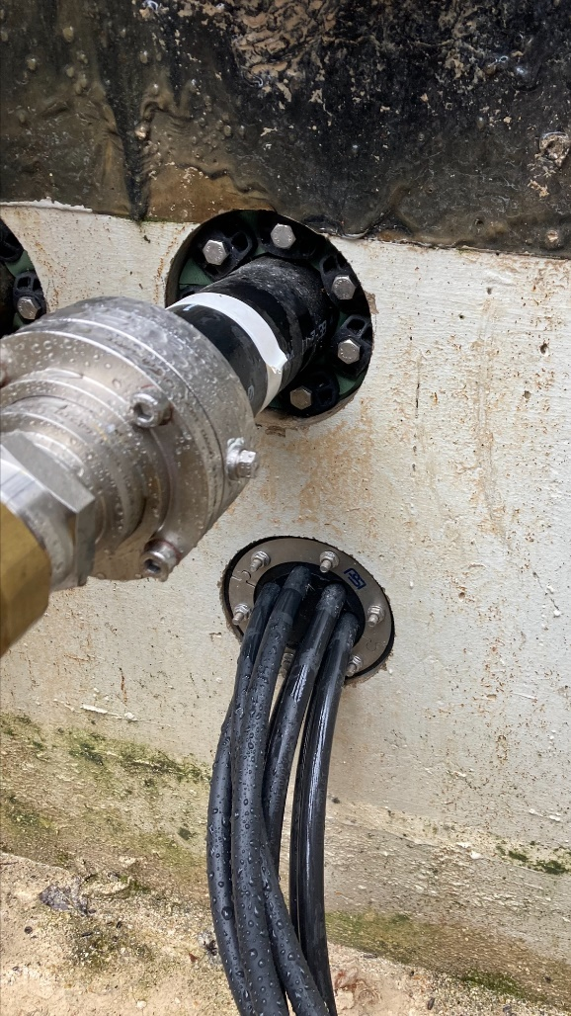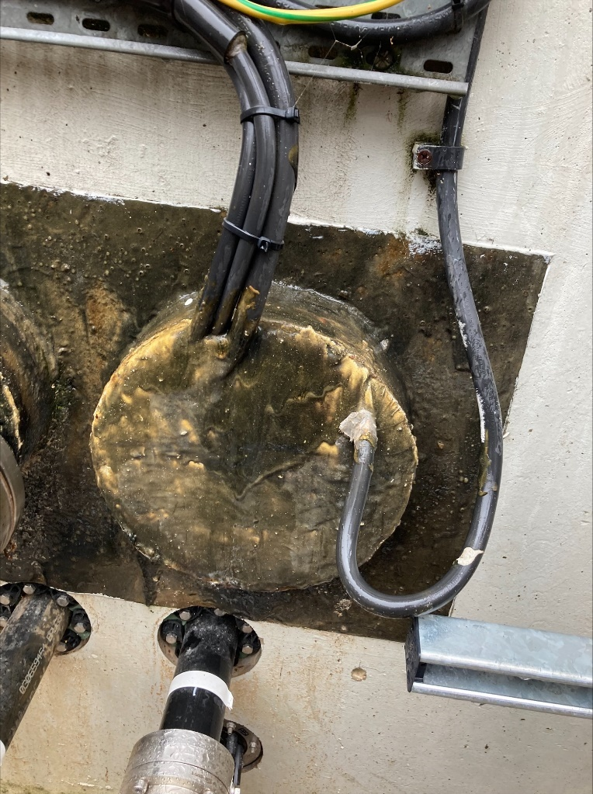
Figure 10 Remediation of holes in bunds for Tank 3 and Tank 4
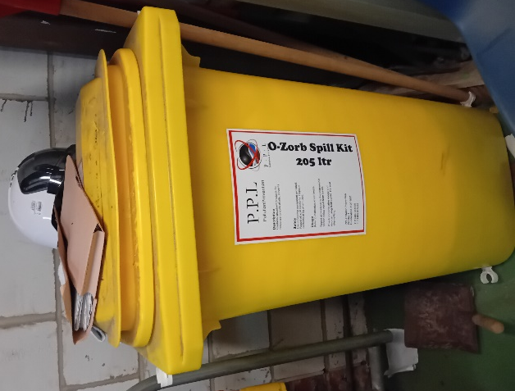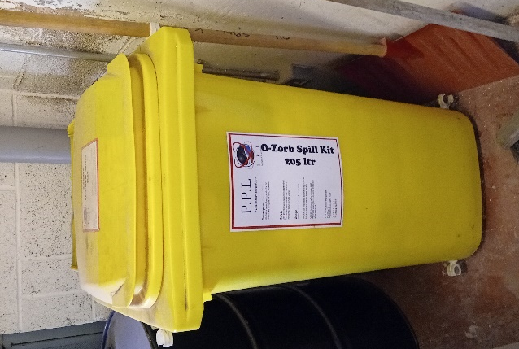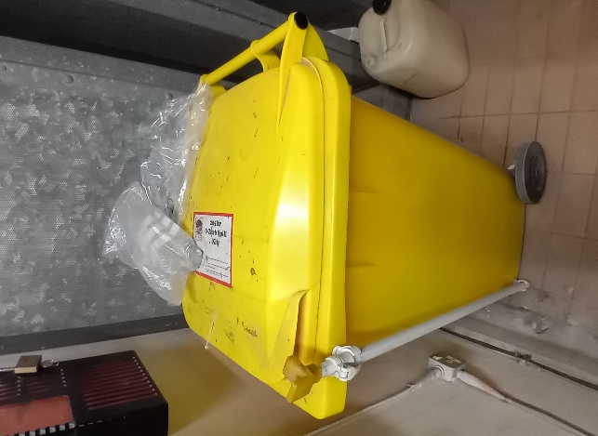
Figure 11 Spill kits for Jessop Wing, Weston Park and the new RHH generators
The site has its own environmental management system in place (refer to ‘RHH B2.3d EMS Manual’). The generators and boilers on site are managed through an online Planned Preventative Maintenance (PPM) system called Concerto, which generates job cards for the operative, as and when servicing and checks are required.
Overall, the risk of land contamination associated with the generators and boilers on site is low.

