Non-technical Summary for Royal Hallamshire Hospital Installation Permit Application
Royal Hallamshire Hospital (RHH) (hereafter ‘the site’) is located on Glossop Road, Broomhill, S10 2JF in Sheffield. Sheffield Teaching Hospital NHS Foundation Trust (STH hereafter) is a public body that manages RHH.

Permit Type
STH is applying for an installation permit for a combustion activity: Section 1.1 Part A(1)(a), under the Environmental Permitting (England and Wales) Regulations 2016 (refer to Figure 1). This is due to the total capacity of the combustion plant on site, which can operate at the same time, being 51.633MWth.
Figure 1 Environmental Permitting Regulations (EPR) permit: Section 1.1 Part A(1)(a)

The Installation
The boundary of the site can be found in Figure 2, and ‘RHH B2.5a Site Plan main boundary’. Within the site boundary, there are 12 boilers and four standby generators in the Boiler House of RHH (shown in brown in Figure 2), one standby generator in Weston Park (shown in green in Figure 2), and one standby generator in the Jessop Wing (shown in pink in Figure 2). There are no generators or boilers in Charles Clifford (shown in orange in Figure 2). Four of the standby generators at RHH were removed and replaced with four new standby generators, three of which were commissioned in May 2024 and one commissioned in July 2024. Therefore, this application excludes the generators that are to be replaced and includes the new standby generators that were commissioned in May 2024 and July 2024. In total, this application includes 12 boilers and six standby generators.
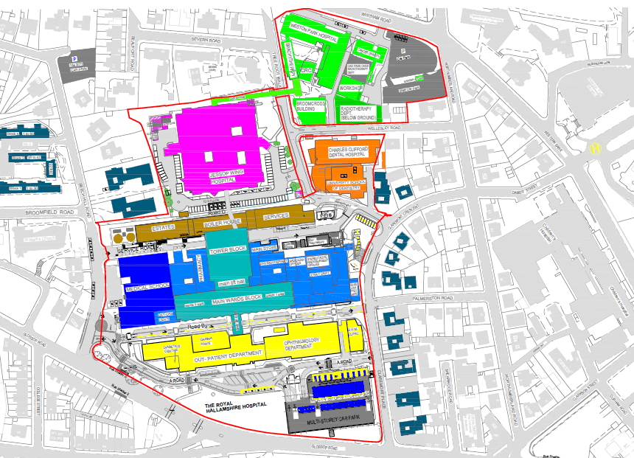
Figure 2 Site plan
The 12 boilers in the Boiler House of RHH are used to power the hospital and also supply power to the Charles Clifford, Weston Park and Jessop Wing. The three Ruston boilers are dual-fuelled, running primarily on natural gas, however, are also able to run on diesel (gas oil) in the event that the supply of gas to the site is lost (Figure 3). See Figure 4 for the the nine Ideal boilers at RHH. The standby generators in Jessop Wing (Figure 5), Weston Park (Figure 6), and Royal Hampshire Hospital (Figure 7), are only used in emergencies if there is a failure in the national grid supply; this is crucial due to the critical healthcare services they provide.
The data sheets for the generators and Ideal boilers can be found in ‘RHH Data Sheets’. Data sheets for the Ruston boilers were not available due to their age.

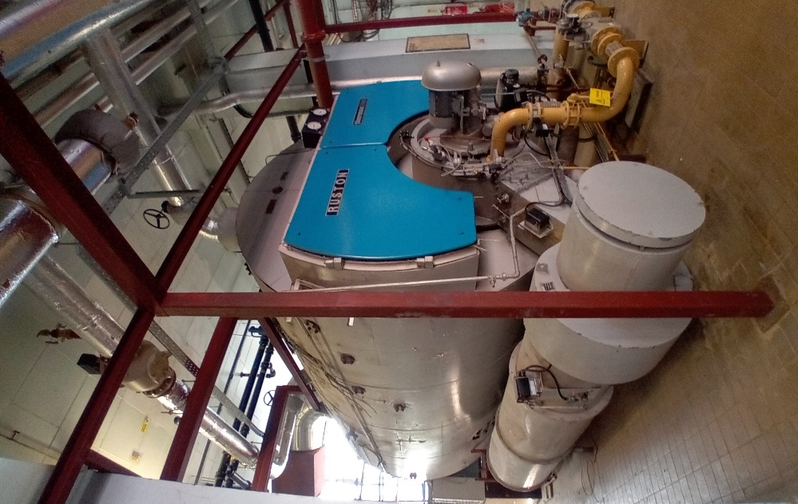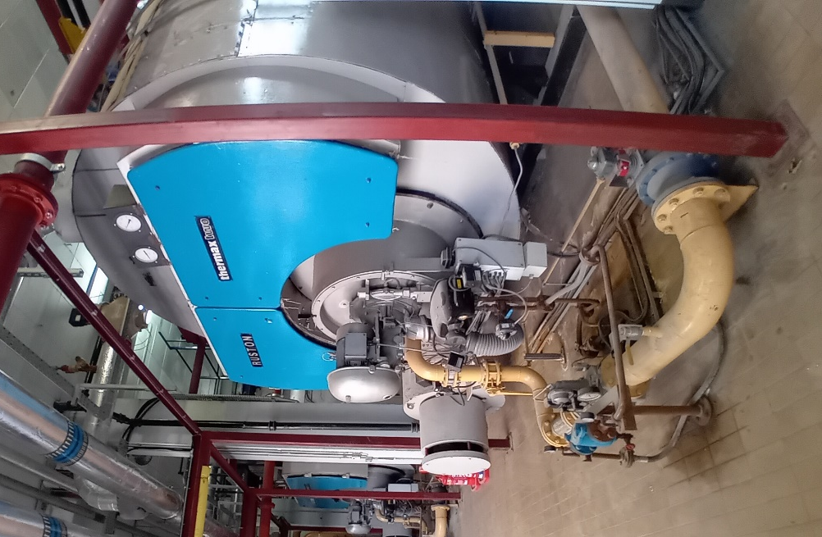
Figure 3 Three RHH Boiler House dual-fuelled boilers
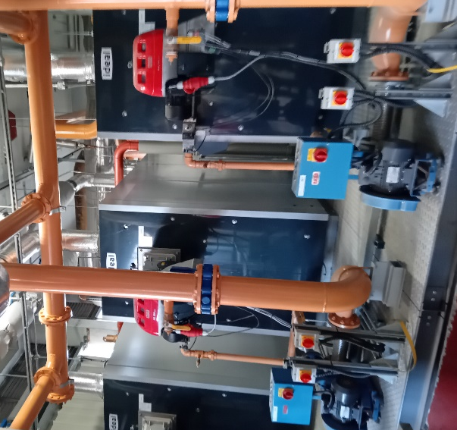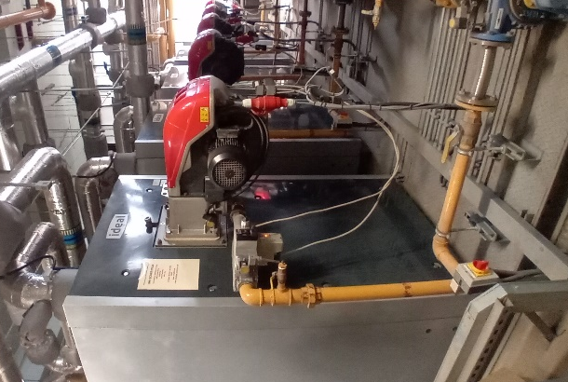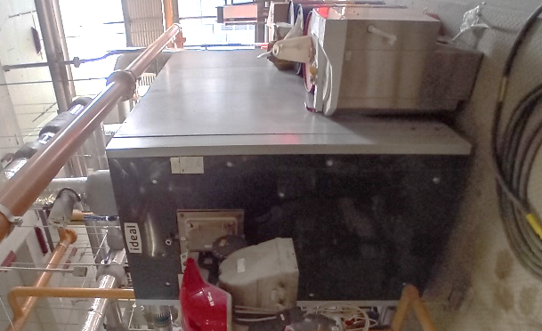
Figure 4 Nine RHH Boiler House natural gas boilers

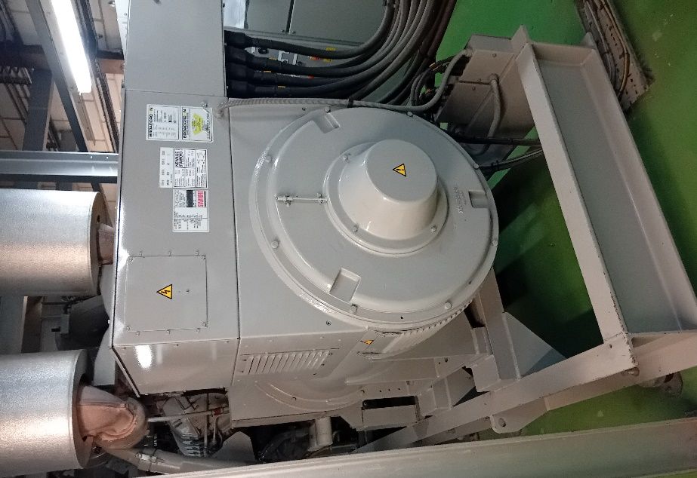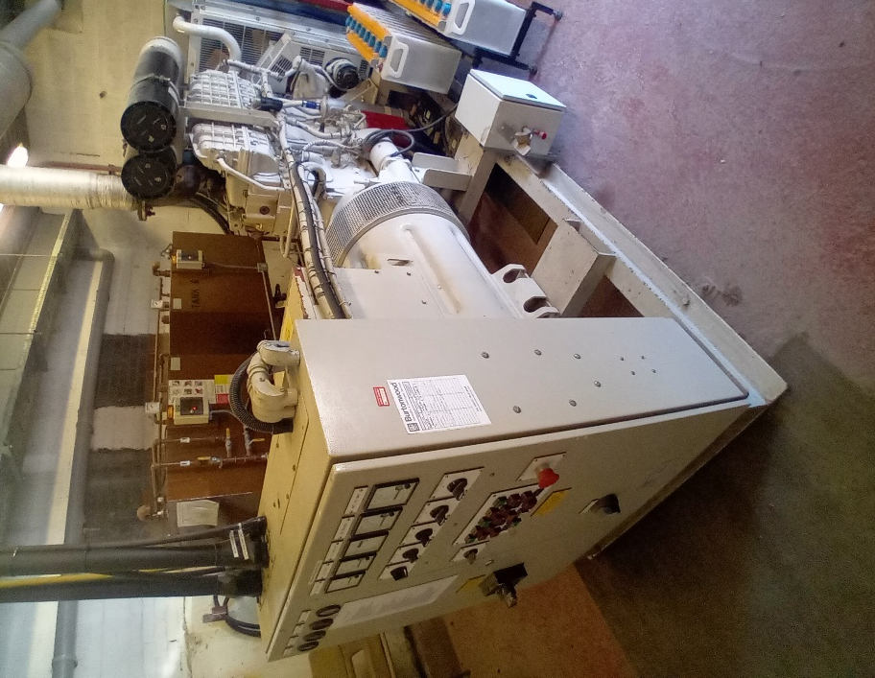
Figure 5 Jessop Park standby diesel generator | Figure 6 Weston Park standby diesel generator

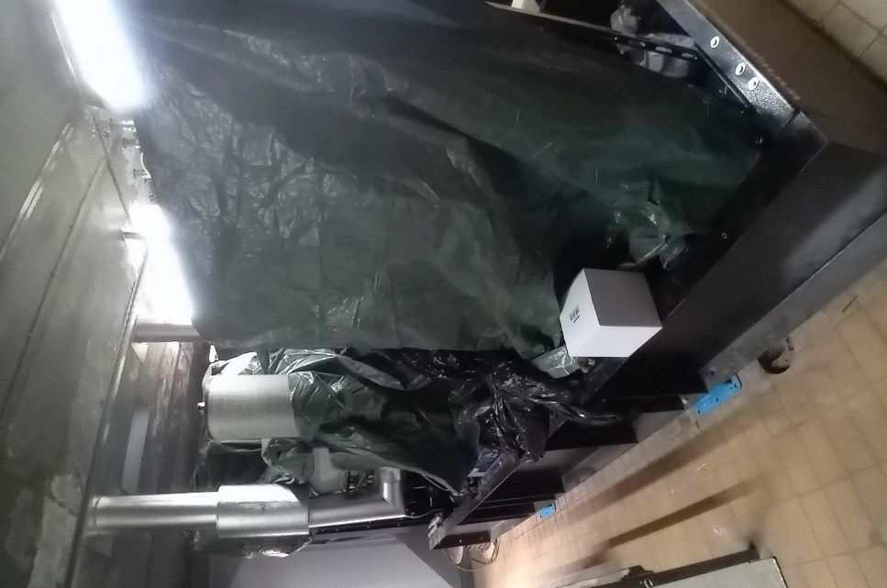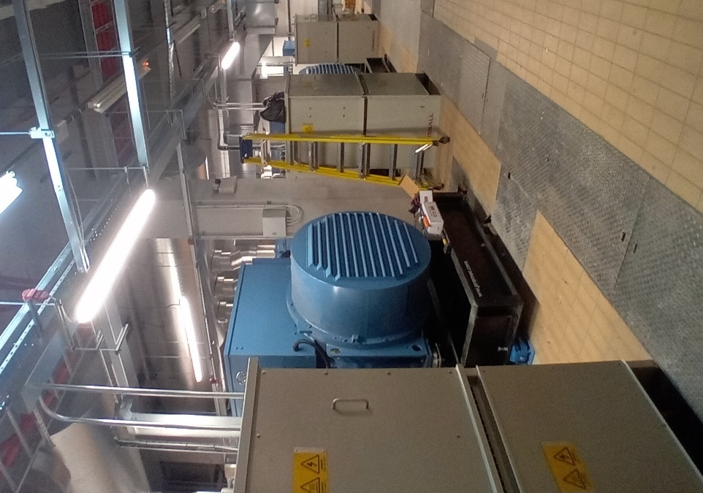
Figure 7 Four RHH Standby generators
See ‘RHH B2.5 MCP-generator-list’ for a breakdown of the manufacturer, MWth, fuel type, annual running hours and installation dates for each boiler and generator covered in this application. It has not been possible to ascertain the exact installation date. An accurate reading for the average load could not be acquired. The six standby generators are assumed to have a 100% average load.
There are six stacks for the boilers. The six lower ground floor Ideal boilers share three stacks. Three Ruston boilers and three ground floor Ideal boilers share three stacks (e.g. one Ruston and one Ideal boiler share a stack).

The four standby generators at RHH, the Jessop Wing generator, and the Weston Park generator each have a stack.

See Figure 8 and Table 1 for locations of the stacks.

Table 1 Grid references for stacks

Stack | Grid Reference
Weston Park standby generator stack (one generator) | SK 33736 87174
Jessop Wing standby generator stack (one generator) | SK 33682 87001
RHH boiler house stacks (centre) (nine Ruston boilers, three Ideal boilers) | SK 33764 86991
RHH standby generators stacks (centre) (four generators) | SK 33742 86954
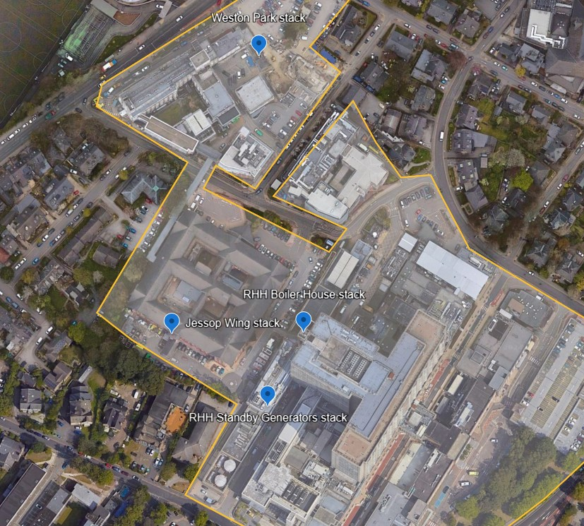
Figure 8 Location of stacks

See Figure 9 for the Jessop Wing standby generator stack, estimated at 3m from the roof, and Figure 10 for the Weston Park standby generator estimated at 2m from the roof. See Figure 11 for the RHH generators stacks, estimated at 6m from the roof, and Figure 11 for six RHH boilers stacks estimated at 4m from the roof.

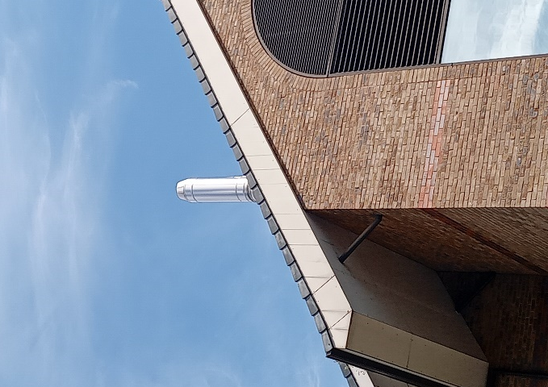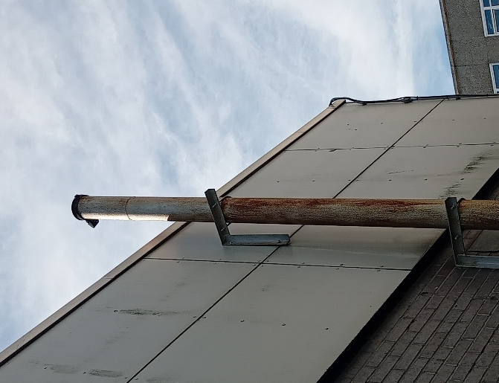
Figure 9 Jessop Wing stack | Figure 10 Weston Park stack

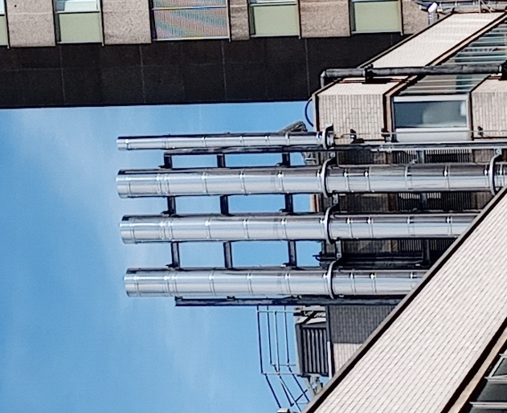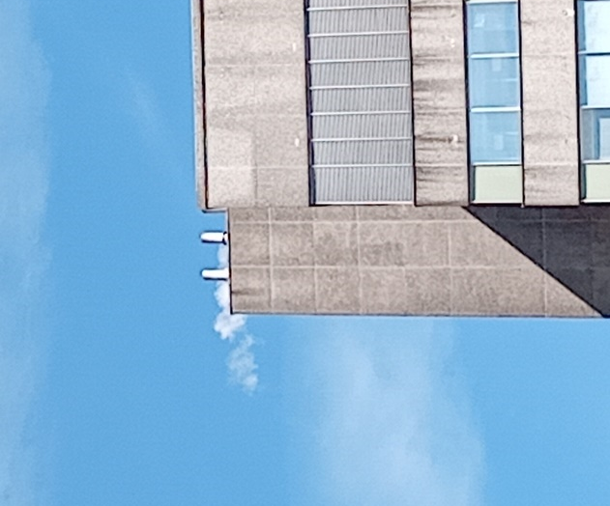
Figure 11 RHH generator stacks | Figure 12 RHH Boiler House stacks

Three Ruston boilers run for approximately 200 hours, the nine Ideal boilers run for approximately 1,500 hours, and the six standby generators run for less than 50 hours, only for testing.

The testing of the standby generators is carried out in line with the ‘Health Technical Memorandum 06-01 Electrical services supply and distribution’. All standby generator plant is tested online with the building load every month. The duration of the online test is at least one hour, but preferably two hours. The method of initiating the start of such a test will depend on the healthcare organisation’s electrical distribution strategy and should include testing of the interlock/changeover arrangements. A longer test is run annually to establish the generator engine’s mechanical performance. The period of the test is around three to four hours.
The site has its own environmental management system in place (refer to ‘RHH B2.3d EMS Manual’). The generators and boilers on site are managed through an online Planned Preventative Maintenance (PPM) system called Concerto, which generates job cards for the operative, as and when servicing and checks are required.
Sheffield Teaching Hospital has an existing permit for the RHH ref: EPR MB3435DZ) and Weston Park (ref: EPR/MB3435DZ) for the use of radioactive material and disposal of radioactive wastes from their premises. The hospital adhere to ‘Health Technical Memorandum 06-01 Electrical services supply and distribution’ and ‘Health Technical Memorandum 07-02 – making energy work in healthcare’.

The Surrounding Area
The site is located approximately 1km from Sheffield city centre, and the surrounding area of the site is made up of buildings associated with the hospital, university buildings, schools, hotels, businesses and residential properties.
The site is not located within 5km of a Special Protection Area (SPA), Special Area of Conservation (SAC), Ramsar site, Area of Outstanding Natural Beauty. The nearest SPA (Peak District Moors) and SAC (South Pennine Moors) are approximately 6km south west. The site is located within the Sheffield City Council Air Quality Management Area (AQMA), and is within 5km of four Sites of Scientific Interest (SSSI).
The site is located with a flood zone 1 (see ‘RHH Flood Map for Planning’), which means an area with the lowest probability of flooding.
Figure 13 shows the key sensitive receptors located within close proximity to the site boundary. Table 2 lists these key sensitive receptors and also ecological receptors within 5km of the site. The ecological receptors in Table 2 are not mapped out in Figure 13 due to their distance to the site
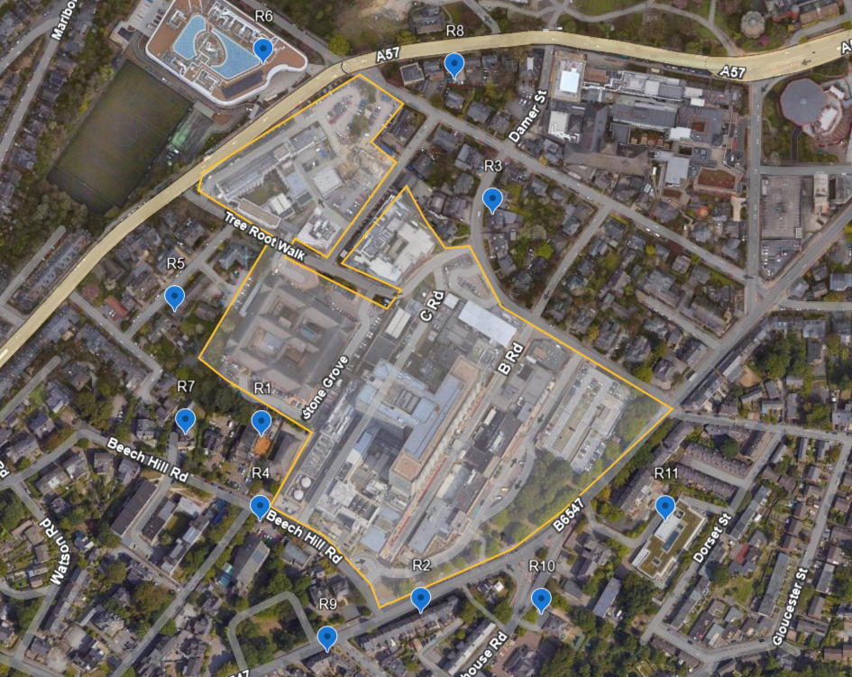
Figure 13 Key sensitive receptors
Table 2 List of key sensitive receptors
Reference | Receptor | Approximate Distance to site boundary
R1 | Sunshine Nursery | 10m
R2 | Residential properties - Glossop Road | 15m
R3 | University building | 20m
R4 | Church of St Mark – church | 25m
R5 | Residential properties – Severn Road | 25m
R6 | University building | 30m
R7 | Residential properties – Beech Hill Road | 40m
R8 | Residential properties - Northumberland Rd | 40m
R9 | Residential properties – Glossop Road | 50m
R10 | Fairmount Nursery | 60m
R11 | University building – Claremont Crescent | 60m
 | Neepsend Railway Cutting (SSSI) | 2.2km
 | Neepsend Brickworks (SSSI) | 2.3km
 | Stannington Ruffs (SSSI) | 3.7km
 | Wadsley Fossil Forest (SSS) | 4.7km

Emissions to Air
A stack emissions test report has been produced for each of the nine Ideal boilers, two of the three dual-fuelled Ruston boilers, the Jessop Wing and Weston Park generators, and two of the four new generators.
The stack emissions results can be found in ‘RHH Stack Emission Results’.

One of the three dual-fuelled Ruston boilers could not be tested (Rushton 4 in ‘RHH B2.5 MCP -generator-list’). Therefore, the average emissions results of the two other dual-fuelled boilers have been inputted into the H1 risk assessment (‘H1 Tool v9.2’) as they have the same manufacturer, estimated annual running time and MWth.

One of the Ideal boilers (Ideal Boiler 1 in the ‘RHH B2.5 MCP -generator – list) was not able to be tested for velocity and flow, therefore, these results have been inputted into the H1 risk assessment (‘H1 Tool v9.2’) using an average of the other eight boilers.

The generators at the RHH were excluded from the H1 risk assessment (‘H1 Tool v9.2’) . One of the RHH generators (Pramack GSW665M in the ‘B2.5 MCP – generator- list’) is only tested every quarter and was not available to be tested when emission samples were being taken. One of the RHH generators was not able to be tested due to time restraints for the operation of the engine. The two other two RHH generators were tested for concentrations of CO and NO2, however, safety restrictions meant that volumetric flow and velocity could not be monitored. Therefore the data associated with these generators was not able to be inputted into the H1 risk assessment.

H1 Risk Assessment
Operating modes were calculated as follows: (running hours/8760) X 100.
- Jessop Wing, Weston Park and RHH generators operating mode = 50/8760 X 100 = 0.6%
- Ruston boilers operating mode = 200/8760 X 100 = 2%
- Ideal boilers operating mode = 1,500/8760 X100 = 17%.

Stack heights were calculated as follows.

According to the ‘H1 Software Tool User Guide V9.0 Final’, “The effective height of release could be considered as zero where the point of discharge:
- is less than 3m above the ground or building on which it is located, or;
- is greater than 3m above the ground or building on which it is located, but less than the height of any building within a distance 5L from the point of discharge (where L is the lesser of the building height and the maximum projected width between two points the same height in the building).

When the effective height of release is more than 3 metres above the ground or building, but less
than 2.5 times the building’s height, estimate it by following these steps.
- Take the actual height of release.
- Subtract the height of the tallest building within a distance 5 times L (this can be the building where the emissions are coming from, if it’s the tallest).
- Multiply the figure that’s left by 1.66.”

The Weston Park stack is less than 3m above the building on which it is located. The Jessop Wing stack, and RHH generator stacks are greater than 3m above the building on which they are located but less than the height of a building nearby (the RHH – 76m tall). Therefore, the effective height for these stacks is 0m.

The RHH boiler stacks are 4m above the building where they are located. The height of the release is 80m and the height of the tallest building in the area is the building the emissions are coming from (76m). The effective height for the RHH boiler stacks was calculated as followed: (80m-76m)x 1.66 = 6.64m.

The emissions results, as discussed in section 4, were input into the H1 Risk assessment (‘H1 Tool v9.2’.
The H1 risk assessment (‘H1 Tool v9.2’) showed that sulphur dioxide screened out and passed Test 1, whilst carbon monoxide (CO) and nitrogen oxides (NO2) did not screen out and therefore failed Test 1. As a result, Test 2 had to be carried out for CO and NO2 which involves considering the background concentrations in the area. CO background levels were not available for the area, therefore, this was left blank. A background concentration for NO2 of 12.72 ugm3 was taken from DEFRA’s 2023 ‘Ambient Air Quality Map’, for coordinates 433451,386971 (west of the site) to account for the prevailing winds from the west. Emissions of CO and NOX failed and did not screen out of Test 2 (see Figure 14), therefore, air dispersion modelling is required to determine if the emissions are likely to have a significant impact on the environment.
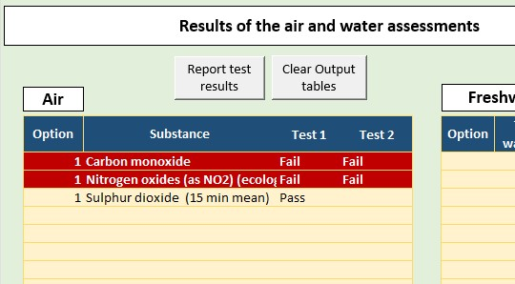
Figure 14 H1 risk assessment output table

Air Dispersion Modelling Results

A ‘Detailed Disperion Modelling Assessment’ of emissions to air from the boilers and generators on site was produced by Industrial Compliance Solutions Ltd, in May 2025. The assessment can be found in ‘RHH B2 Air Dispersion Modelling’. The dispersion modelling demonstrated that, assuming the maximum emission period for NOx, the predicted environmental concentrations at human receptor locations were not significant, and consequently emissions to air are not expected to have caused adverse effects upon the health of the local population.
The assessment did not conclude any significant effects to either ecological or human receptors. It should be noted that the results in Section 5 of ‘RHH B2 Air Disperion Modelling’ represent the impacts derived from assuming the maximum emission period for the NOx. Therefore, these results are showing the worst-case scenario at the Royal Hallamshire Hospital site for the period January 2019 to December 2023.

Best Available Techniques (BAT)

Each unit on a site is <15MWth, making it an Industrial Emissions Directive (IED) Chapter II combustion activity. There is no BAT reference document for Chapter II combustion activities, however, the BAT assessment for large combustion plant (‘RHH B3 .3a BAT Document for Large Combustion Plants’) has been carried out (‘RHH B3.3a BAT Assessment - Installation Permit’), and the minimum emissions limit values from the MCP Directive have been used for the H1 risk assessment.

Site Condition Report
A Site Condition Report was created for the site to assess the risk of land contamination (see ‘RHH B2.5b Site Condition Report’). This report used information from GroundSure report (see ‘RHH B2.5b GroundSure report ’) and also sets out the measures in place on-site to prevent the risk of land contamination. The associated H5 form has been completed (see ‘RHH H5 form’).

Environmental Risk Assessment
An environmental risk assessment (‘RHH B2.6 Environmental Risk Assessment’) has been carried out setting out the risk of different aspects associated with the boilers and generators on site, and associated control measures in place.

Cogeneration or District Heating
The STH has not considered the installation of any combined heat and power systems, however, STH is considering a partnership with a local District Energy Network (Veolia) to supply heat to the Central Campus site. Although discussions are ongoing, this is not likely to come into realisation for a few years yet, as some of the boilers are less than 10 years old.

