NEPTUNE CONTRACT SERVICES LTD.

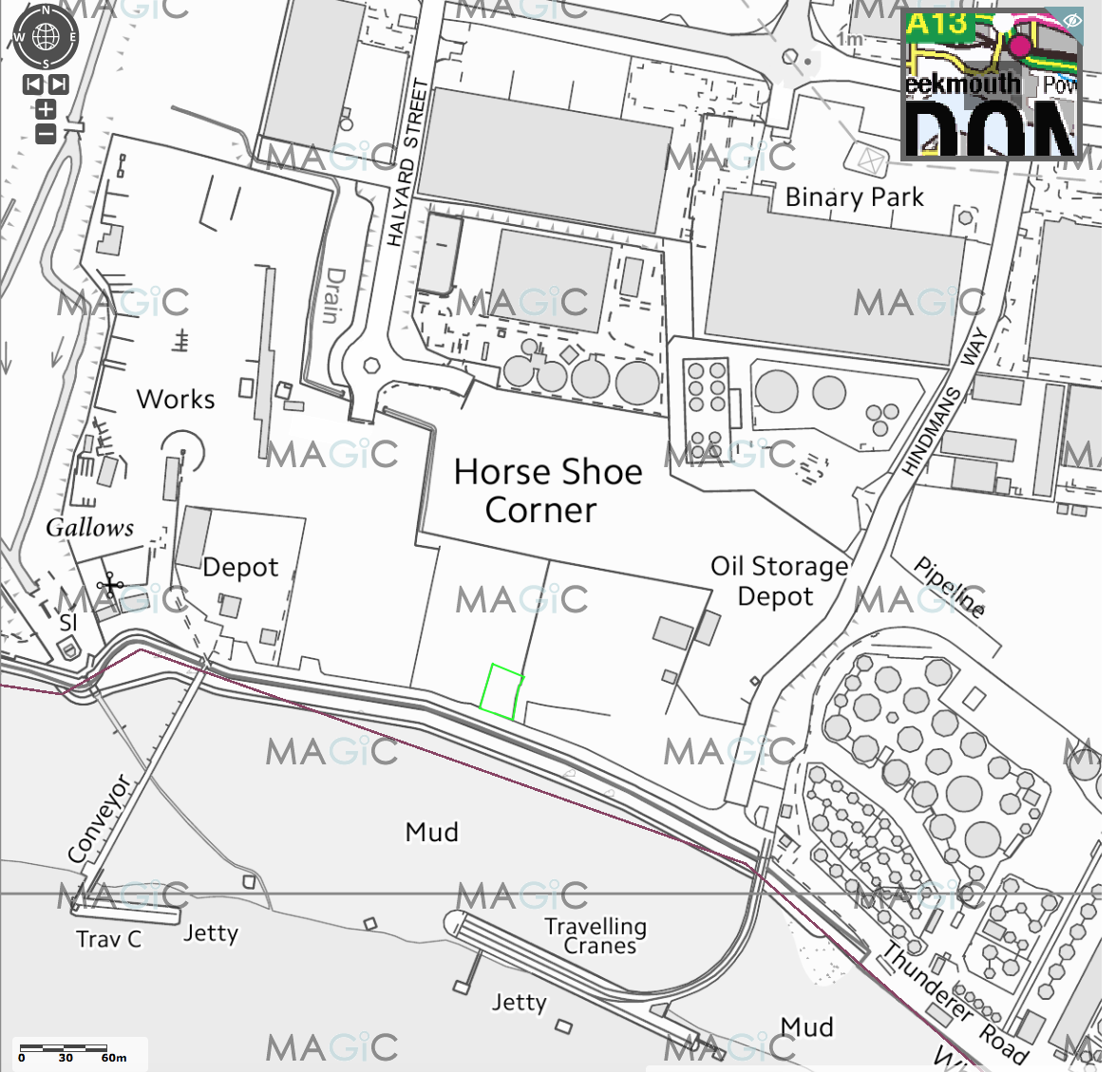

HAZARDOUS WASTE TREATMENT FACILITY
THUNDERER ROAD
OFF CHEQUERS LANE
DAGENHAM
RM9 6PU

SITE CONDITION REPORT

MARCH 2018
1.0 SITE DETAILS

Name of the applicant | Neptune Contract Services Ltd.
Activity address | Thunderer Road, Chequers Lane, Dagenham RM9 6PU
National grid reference | TQ 48354 82141 [centre of site]

Document reference and dates for Site Condition Report at permit application and surrender | NCS/PartB2/5b  Site Condition Report: dated 20 February 2018  The operator also encloses a copy of the environmental setting sourced from the EA website for the site that shows receptors as document reference NCS/PartB2/6i.  The operator also encloses a copy of the Magicmap for the site that shows receptors as NCS/PartB2/6ii.  A review of the British Geological Survey for the site confirms that the site has superficial geology of Tidal River Deposits [to approx. 10m] overlying bedrock of Thanet Sands.  The operator also encloses a copy of the British Geological Survey information for the site as Appendix B.  This document forms part of an application for a bespoke environmental permit for physical treatment by screening only of hazardous construction and demolition wastes.

Document references for site plans (including location and boundaries) | Document reference – NCS/Part B2/5a/i; location  Document reference – NCS/Part B2/5a/ii; layout  Document reference – NCS/PartB2/5a/iii; infrastructure  Document reference – NCS/PartB2/5a/iv; site monitoring

2.0 Condition of the land at permit issue

Environmental setting including:  - geology  - hydrogeology  - surface waters | Topography: the site is set back 10m from the river Thames flood defences and essentially flat land at approx. 4mAOD [height of Thames flood defences] rising to approx. 5mAOD at the southern boundary to the site and rising to 6m AOD at the northern extent of the site.  A review of publicly available information of conditions close to the site records that ’historic map evidence indicates centuries of land reclamation and draining of the marshes from the early post-medieval period, followed by rapid riverside industrial development from the early-20th century (c 1916) onwards. It is predicted that most of the made ground deposits within the site date to the 20th century development’.  Geology: The site lies within the Thames floodplain with superficial geology of Tidal River Deposits [to approx. 10m] overlying bedrock of Thanet Sands. This is shown in Appendix B. Specific borehole records provided on BGS website provides additional information of the local geology for purposes of informatives.  Hydrogeology: the site is considered on EA website as a moderately productive aquifer with high vulnerability [NCS/PartB2/6i], however, the site is outside a groundwater protection zone [for potable water supplies], as shown in Appendix A.  Surface waters: the Agency’s Flood Zone maps show the site as being located in an area of flooding, however, the site is protected from flooding by EA flood defences.  The closest surface waters are river Thames [high water level] 0.015km S and open drains 0.2km N and 0.35km W of the site respectively.  General: The site has been used since c1990 for the storage and processing of inert and non-hazardous soils and aggregates for recycling and storage of associated vehicles, plant & equipment.  Part of the site is impermeably surfaced and part of the site infrastructure was constructed of made ground and subsequently hardstanding made of crushed concrete and hardcore to provide a site surface to operate from.  Aerial photos of 1999, courtesy of Google Earth, show the site being used for the described purposes of soils, aggregates and general materials handling. The operator maintains records of photographic aerial evidence of 1996, 2008 and 2015.  Prior to 1996 there is less knowledge of the site’s use other than a 1996 planning application to regularise the current operation of crushing and screening.  Immediately prior to the application for the environmental permit the site has been vacant.  There are four surface water abstraction licences [surface water] approx. 0.25km SW and 0.5km E of the site, however, none are used for potable domestic water uses.  There are no known ground water abstraction points within 5km of the site.  At the site there are no reported breaches of the site infrastructure, see below, or pollution incidents arising from previous activities: source EA website.
Pollution history including:  - pollution incidents that may have affected land  - historical land-uses and associated contaminants  - any visual/olfactory evidence of existing contamination  - evidence of damage to pollution prevention measures | The land is owned by the operator.  Prior to the application for the environmental permit the site has been used since c1990 for the storage and processing of inert and non-hazardous soils and aggregates for recycling and storage of associated vehicles, plant & equipment.  There have been no visual observations of any historic pollution generated from the previous owner/operator during a site walk-over.
Evidence of historic contamination, for example, historical site investigation, assessment, remediation and verification reports (where available) | A walk-over visual review of the application site confirms that part of the site is formed by concrete and part by hardstanding. The site will be impermeably surfaced prior to commencement of site activities.  There have been no visual observations of any historic pollution generated from the previous owner/operator during a site walk-over.  No intrusive ground condition survey was undertaken and is not required by the permit application.
Baseline soil and groundwater reference data | See above.
Supporting information | EA environmental setting: Document reference: NCS/PartB2/6i Magicmap environmental setting: Document reference: NCS/PartB2/6ii  British Geological Survey: Document reference: NCS/SCR/Appendix A [hydrogeology]  British Geological Survey: Document reference: NCS/SCR/Appendix B [geology]  Planning history: Document reference: NCS/SCR/Appendix C  Site history: Aerial photos [1996, 2003, 2008, 2015]; Document reference: NCS/SCR/Appendix D; held by operator  Plans: see section 1 above.

3.0 Permitted activities

Permitted activities | Bespoke environmental permit application is for the physical treatment by screening only of hazardous construction and demolition waste soils to produce soil substitutes and aggregates.
Non-permitted activities undertaken | None.
Document references for:  - plan showing activity layout; and  - environmental risk assessment. | NCS/PartB2/5a/i site location drawing.  NCS/PartB2/5a/ii site layout drawing.  NCS/PartB2/5a/iii site infrastructure drawing.  NCS/PartB2/5a/iv site monitoring drawing.  NCS/PartB2/6 environmental risk assessment [desktop site specific ERA based on Agency’s GRA for SR permits].

- 4.0 Changes to the activity

- Have there been any changes to the activity boundary?

- Have there been any changes to the permitted activities?

- Have any ‘dangerous substances’ not identified in the Application Site Condition Report been used or produced as a result of the permitted activities?

- Checklist of supporting information

- 5.0 Measures taken to protect land

- Use records that you collected during the life of the permit to summarise whether pollution prevention measures worked. If you can’t, you need to collect land and/or groundwater data to assess whether the land has deteriorated.

- Checklist of supporting information

- 6.0 Pollution incidents that may have had an impact on land, and their remediation

- Summarise any pollution incidents that may have damaged the land. Describe how you investigated and remedied each one. If you can’t, you need to collect land and /or groundwater reference data to assess whether the land has deteriorated while you’ve been there.

- Checklist of supporting information | - .

- 7.0 Soil gas and water quality monitoring (where undertaken)

- Provide details of any soil gas and/or water monitoring you did. Include a summary of the findings. Say whether it shows that the land deteriorated as a result of the permitted activities. If it did, outline how you investigated and remedied this.

- Checklist of supporting information

- 8.0 Decommissioning and removal of pollution risk

- Describe how the site was decommissioned. Demonstrate that all sources of pollution risk have been removed. Describe whether the decommissioning had any impact on the land. Outline how you investigated and remedied this.

- Checklist of supporting information

- 9.0 Reference data and remediation (where relevant)

- Say whether you had to collect land and/or groundwater data. Or say that you didn’t need to because the information from sections 3, 4, 5 and 6 of the Surrender Site Condition Report shows that the land has not deteriorated.

- If you did collect land and/or groundwater reference data, summarise what this entailed, and what your data found. Say whether the data shows that the condition of the land has deteriorated, or whether the land at the site is in a “satisfactory state”. If it isn’t, summarise what you did to remedy this. Confirm that the land is now in a “satisfactory state” at surrender.

- Checklist of supporting information

- 10.0 Statement of site condition

