NEPTUNE CONTRACT SERVICES LIMITED
ENVIRONMENTAL MANAGEMENT SYSTEM
Emergency Operating Procedures
Reference: EMS-OP-02
NEPTUNE CONTRACT SERVICES Ltd.
HUNDERER ROAD
DAGENHAM
RM9 6PU

Document Control Sheet

Version Reference | Date | Reason for Change | Issued by

CONTENTS
1 Introduction 1
1.1 Roles and Responsibilities 1
1.2 Purpose 1
1.3 Scope 1
2 Emergency Procedures 2
2.1 Fire Response 2
2.2 Spillage 2
2.3 Vandalism or unauthorised entry 4
2.4 Flood Warning and Evacuation Plan 5

- Introduction
  - Roles and Responsibilities
The TCM has responsibility for ensuring these procedures are adhered to. The TCM is specifically responsible for:
- Ensuring the adequate training of staff and contractors working on site regarding the content of these procedures;
- Ensuring the adequate provision of resources such as spill kits and personal protective equipment (PPE);
- Ensuring the provision and maintenance of hand held fine extinguishers at the site is adequate.
  - Purpose
The purpose of these procedures is to guide staff and contractors in the actions to be taken in the event of an emergency.
  - Scope
These Emergency Procedures are based on the Accident Management Plan set out in EMS-OP-01.
The scope of these procedures does not extend to health and safety related accidents such as personal injuries at work. These are covered by the company Health & Safety procedures.
The contact list of emergency numbers in Appendix B will be retained in the Site Office and updated as required by the TCM.
- Emergency Procedures
  - Fire Response
The Fire Plan is as follows:
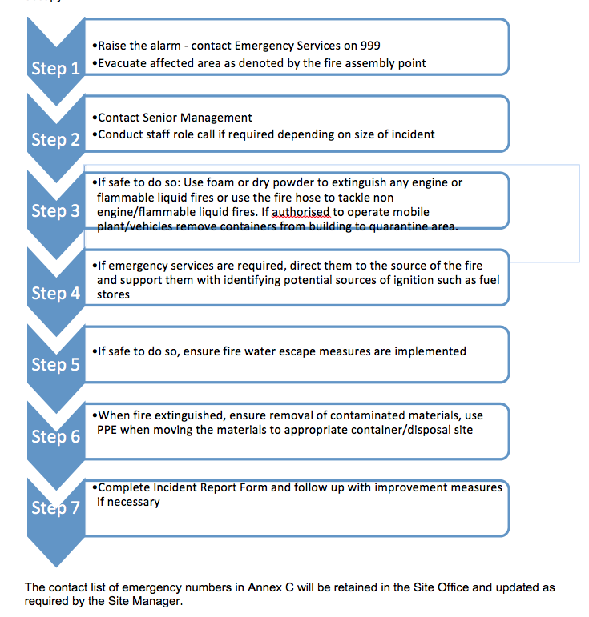
  - Spillage
    - Potential causes of a spill
Minor spillages may be caused by:
- Machinery and fuel/oil leaks from vehicles
- Spillages or leaks from the diesel tank

    - Prevention of Spillages
Spillages and impacts from spillages will be prevented by:
- Controlling vehicle manoeuvring will be controlled
- Regular maintenance of plant and machinery
- Diesel tank to be double skinned and bunded
- Spill kits maintained in site office

    - Minor Spillage Procedure
A minor spillage is one that usually presents little or no risk to person or property, and is small enough to be safely cleaned up using the emergency spill kit. The procedure is:

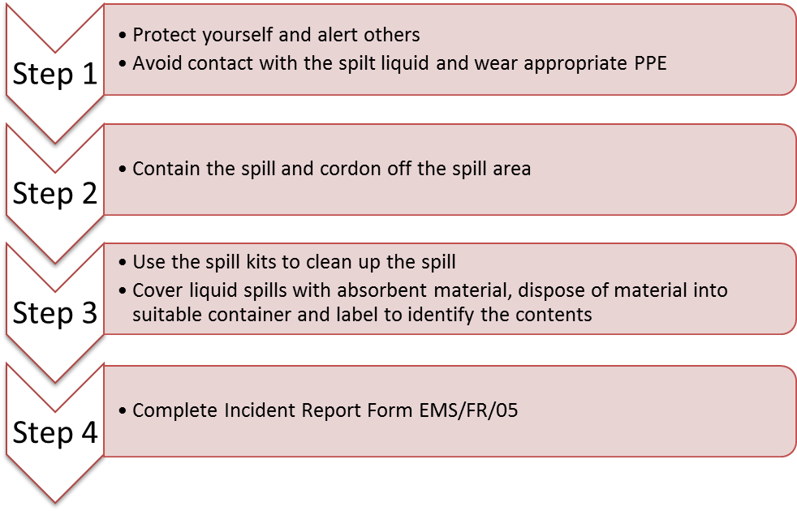

    - Spill Kits
Spill kits will be maintained at the facility in order to respond to any spill incident. The spill kits will include:
- absorbent granules or sand;
- protective overalls;
- chemical/oil resistant gloves;
- chemical/oil resistant goggles; and
- a broom and shovel.

    - Major Spillage Procedure
A major spill is one that cannot be contained safely with the material on site and threatens safety to life and or the environment. The procedure is:
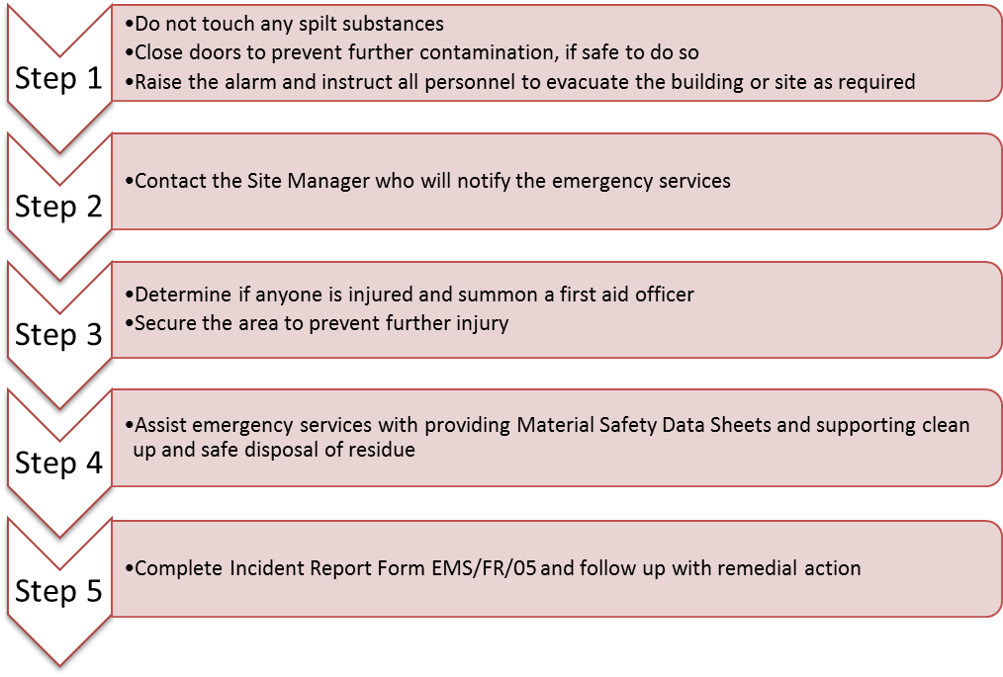

  - Vandalism or unauthorised entry
The site may be subject to unauthorised entry and vandalism which may pose a risk to environmental protection as well as health and safety.
If a staff member identifies evidence of unauthorised entry or vandalism they will:
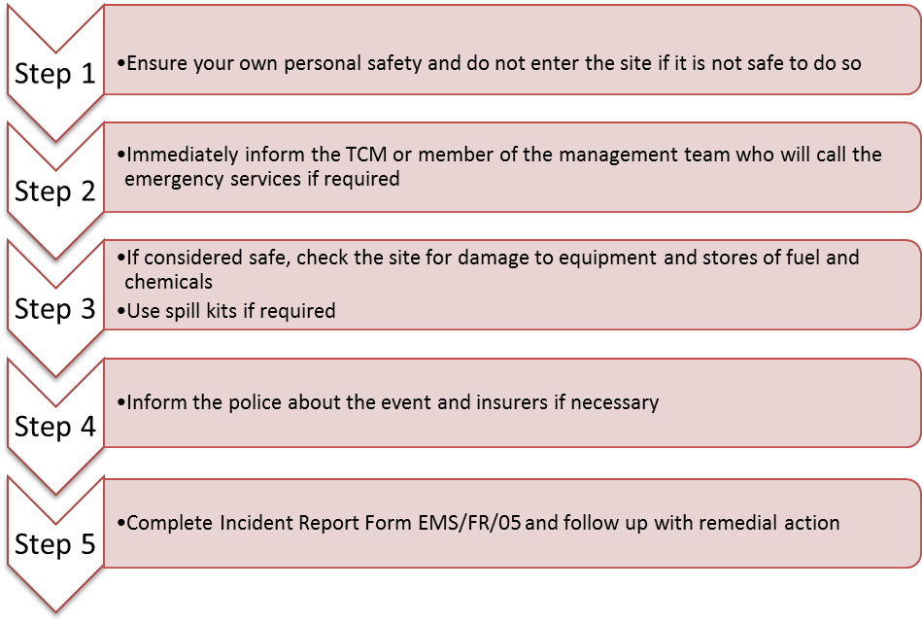

  - Flood Warning and Evacuation Plan
    - Potential causes of a flooding
The site is located within an area not defended from flooding.
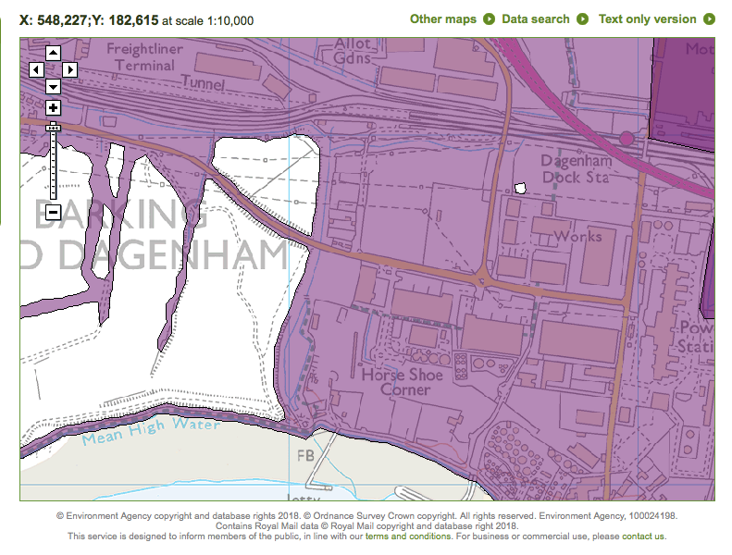
    - Flood Warning
The Site Manager will register with the Environment Agency for flood warnings
In the event of receiving a flood warning, the procedure is:
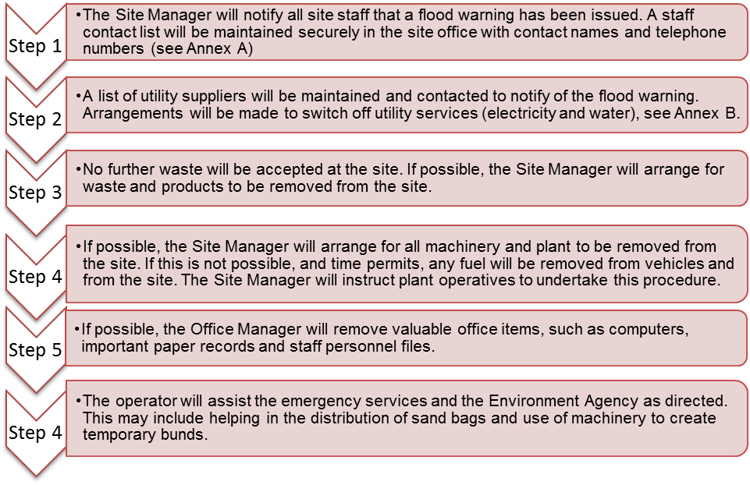
A copy of this procedure will be kept in the Site Office and Mess Facilities. All staff will be trained in this procedure.

Annex A: Emergency Contacts Register
SITE DETAILS: NEPTUNE CONTRACT SERVICES LTD.
Location: Thunderer Road, Dagenham

Postcode: RM9 6PU
Site Access Grid Reference: TQ 48342 82132
SITE CONTACTS | Name |  | Office Hours (specify) | Out of hours
Owner: operator | Neptune Contract Services Ltd. |  | 0208-596-9880 | 07966 195105‬
Director: | Mr. F. Fitzpatrick |  | 0208-596-9880 | 07966 195105‬
Site Manager: | Mr. F. Fitzpatrick |  | 0208-596-9880 | 07966 195105‬
Site Supervisor/Competent Person: | Mr. C. Benn |  | 0208-596-9880 | 07787 117449‬
Security Contact: | Mr. F. Fitzpatrick |  | 0208-596-9880 | 07966 195105‬
Landowner / Agent: | M. Long & Daughters Ltd. |  | 0208-596-9880 | 07966 195105‬
EMERGENCY SERVICES |  |  | Office Hours | Out of hours
Emergency |  |  | 999 | 999
Medical: Barking Hospital, Upney Lane, Barking IG11 9LX |  |  | 0203-644-2301
Police: |  |  | 999 | 999
Fire: Dagenham Fire Station, 151, Frizlands Lane, Dagenham RM10 7HD Barking Fire Station, Alfreds Way, Barking IG11 0BB |  |  | 999/0203-215-3000  0208-555-1200 | 999/01296-744400  0208-555-1200
REGULATORS |  |  | Office Hours | Out of hours
Health and Safety Executive (HSE) |  |  | 0151 922 9235 | 0151 922 9235
Local Authority: Barking & Dagenham Council |  |  | 0203-215-3000 | 0203-215-3000
Environment Agency (Local) |  |  | 03708 506 506 | 03708 506 506
EA (24 hour emergency hotline) |  |  | 0800 80 70 60 | 0800 80 70 60
Natural England |  |  | 0845 600 3078 | 0845 600 3078
UTILITY / KEY SERVICES |  | Name | Office Hours | Out of hours
Water undertaker: |  | Thames Water | 0800 316 9800 | 0800 316 9800
Sewerage undertaker: |  | N/A
Gas supplier: |  | N/A
Electricity supplier: |  | N/A
Oil supplier: |  | N/A
Fuel supplier: |  | N/A
Chemical supplier: |  | N/A
Oil spill contractor: |  | N/A
Maintenance contractor: |  | In-house
Electrician: |  | In-house
Plumber: |  | In-house
Locksmith: |  | In-house
Joiner: |  | In-house
OTHER KEY CONTACTS |  | Name | Office Hours | Out of hours
Head Office: |  | N/A
Adjacent landowners:
Neighbours:
Neighbours:
Specialist advisors:

Annex B: Staff Contact and Training Register
Name | Job Title | Contact Telephone Number | Training Received (Insert Date) | Signature | In the Event of a Flood Warning, staff member has been notified (Date/Time and initial)

