

**Odour Management Plan for Waste**

**Transfer Operations**

GAP GROUP LIMITED

GAP Group Limited

Dock Road

Tilbury

Thurrock

Essex

RM18 7EQ

**Contents**

**1.1 Introduction**

**1.2 Structure of the odour management plan**

**1.3 Objectives**

**2.1 Liquid waste transfer operations**

**2.2 Conceptual Model**

**2.3 Source Material**

**2.4 Waste Acceptance**

**2.5 Process**

**2.6 Releases**

**2.7 Odour Release Point Inventory**

**2.9 Storage**

**2.10 Chemical Additives**

**2.11 Frequency**

**2.12 Alternative options**

**3.1 Internal Odour Assessment and Monitoring**

**3.2 Daily checks**

**3.3 Cleansing**

**3.4 Maintenance**

**4.1 Dispersion**

**4.2 Site Location**

**4.3 Dispersal Control**

**4.5 Other Sources of odour**

**5.1 Responsibilities**

**5.2 Procedures when odours arrive**

**5.3 Response to Complaints**

**5.4 Abnormal meteorological conditions**

**5.6 Breakdown of Process Equipment and Plant**

**5.7 Staffing Issues**

**5.8 Review**

**Appendix**

**Appendix A Proposed Discharge Connection**

**Appendix B Odour Complaint Form**

**Appendix C Odour Report Form**

**Appendix D Odour Diary**

**1.0 Operations and odour management plan**

**1.1 Introduction**

The structure of this OMP has been revised on the basis of the Environment Agency Guidance

available at the website and can be seen in the CONTENTS listing that follows here:

<https://www.gov.uk/government/publications/environmental-permitting-h4-odour-management>

This OMP is aimed at assisting the site management and staff in effectively managing potential odour releases associated with the operations at the site and minimisation of the risk of abnormal operational conditions, which could result in increased risk of odour generation at the site.

This type of operation has been carried out across the country by a number of operators without the requirement for an environmental permit, however a change in case law has resulted in an environmental permit being required due to the manual screening of the waste.

**1.2 Structure of the Odour Management Plan**

The structure of the OMP is laid out in accordance with EA guidance and considers:

* Operations and odour management plan
* Process and emissions
* Prevention
* Dispersion and Receptors
* Procedures

**1.3 Objectives** This odour management plan is designed to:

• employ appropriate methods, including monitoring and contingencies, to control and minimise odour pollution;

• prevent unacceptable odour pollution at all times;

• reduce the risk of odour releasing incidents or accidents by anticipating them and planning accordingly.

The OMP will consider sources, releases and impacts, and use these to identify cost effective opportunities for odour management.

**2.0 Process and Emissions**

**2.1 Liquid waste transfer and storage operations**

GAP GROUP Limited’s Welfare Division operates a fleet of tankers designed to facilitate the emptying of septic tanks and portable toilets from the construction industry throughout the country.

GAP wish to transfer the waste direct to the foul sewer at their site at - Dock Road, Tilbury, Thurrock, Essex, RM18 7EQ, instead of transferring it at waste water treatment works. The process of transferring the waste to the foul sewer requires the waste to be passed over a metal screen to collect any foreign bodies such as tools and mobile phones.

This is also the case for liquids entering storage tanks in preparation to be released to the foul sewer at a controlled flow.

The act of screening of the waste liquid and storage requires the activity to be permitted and as a result an odour management plan being created as part of the bespoke permit application is required. This activity is common place at sewage treatment works, which accept tankered liquid wastes.

The transfer of septic tank waste has the potential to generate malodours from process. This OMP makes an assessment of likely sources of odour generation and sets out good site practice and mitigation that is employed to minimise where reasonably practicable any odour emitted from site.

The likelihood and frequency of exposure to odour arising from the facility is determined by combination of the magnitude of release, the prevailing meteorological conditions, and the distance and direction of receptors in relation to the facility. Each of these factors are discussed in the following sections.

The site operate in during the following periods -

Mon – Fri 07:30 – 17:00

Sat 08:00 – 12:00 (only in exceptional circumstances)

Sun Closed

The site will only accept one or two loads per day as a result operations are limited to a very small percentage of operating times. In addition, the depot itself is open for same hours and busy through out the day offering a wealth of plant and equipment hire solutions.

**2.2 Conceptual Model**

The conceptual model for pollutant linkages identified for the release of odours from the

Waste transfer facility is identified in Figure 1 below

|  |  |  |  |
| --- | --- | --- | --- |
| **SOURCE** | **PATHWAY** | | **RECEPTOR** |
|  |  | |  |
|  |  | |  |
| Release of odours during  waste transfer to foul sewer. | Airborne transportation. | | Nearby sensitive receptors  identified in section 7. |
| **HAZARD** | | Nuisance to local population | |

**2.3 Source Material**

The site will operate a waste transfer and treatment operation through the transfer of septic tank and portable toilet waste from road tanker via a screen to the foul sewer or a to a storage tank prior to release to the foul sewer.

In order to understand the odour potential of the different waste streams that enter the process, a feedstock inventory has been provided for the various waste types.

Table 1 below provides an assessment of each waste type by source of material, identifying the typical and abnormal compositions of those waste types and providing an overall odour potential of that feedstock based upon the likelihood of abnormal conditions being encountered at site.

**Table 1 - Assessment of Odour Potential from source material**

|  |  |  |  |  |  |
| --- | --- | --- | --- | --- | --- |
| **Waste Type** | **Waste Source** | **Typical Composition** | **Abnormal Composition** | **Likelihood** | **Odour Potential** |
| 20 03 04 - septic tank sludge | Construction site and sites requiring temporary toilet facilities | Mixtures of water and wastes from toilet blocks | Unlikely septic tanks only serve toilet blocks. Waste can be up to two weeks old. | Waste can regularly be up to two weeks old. | High |
| 16 10 02 - aqueous liquid wastes other than those mentioned in 16 10 01 | Construction site and sites requiring temporary toilet facilities | Mixtures of wastes from portable toilets and sanitising chemicals | Unlikely septic tanks only serve. Waste can be up to two weeks old. | Waste can regularly be up to two weeks old. | Medium |
| 20 03 06 Waste from sewage cleaning | Construction site and sites requiring temporary toilet facilities | Mixtures of water and wastes from toilet blocks | Unlikely septic tanks only serve toilet blocks. Waste can be up to two weeks old. | Waste can regularly be up to two weeks old. | Medium |
| 20 03 99 Municipal wastes not otherwise specified | Construction site and sites requiring temporary toilet facilities | Mixtures of wastes from portable toilets and sanitising chemicals | Unlikely septic tanks only serve. Waste can be up to two weeks old. | Waste can regularly be up to two weeks old. | Medium |

**2.4 Waste Acceptance and storage**

The facility is very limited in the waste that it will accept due to the nature of the work that company completes and the wastes that the site is designed to handle. The Environmental Permit will also be limited to only two EWC codes:

* 20 03 04 - septic tank sludge
* 16 10 02 – portable toilet waste
* 20 03 06 Waste from sewage cleaning
* 20 03 99 Municipal wastes not otherwise specified – Domestic portaloos.

GAP will collect the waste from the customer and transfer it at the site ensuring consistency and adhering to waste acceptance criteria.

All waste will be checked before being collected and if it is now in line with the above waste streams it will be transferred to a permitted waste facility that can accept the waste stream.

Furthermore, only GAP will use the facility ensuring total control of both the waste collection and transfer process.

The maximum length that waste is stored on the site is 1 month.

**2.5 Process**

The process is simple whereby a tanker that has collected either septic tank sludge or portable toilet waste discharges it foul sewer or it is stored in a sealed tank prior to release to the foul sewer at a controlled rate.

The tanker is a sealed unit and is coupled via a flexible hose to a coupling that connects to the foul sewer or the storage tank meaning no waste liquid is exposed throughout the transfer process. This is the industry standard at waste water treatment works.

The discharge point contains a metal screen that is designed to prevent items that had been dropped into portable toilets such as tools and mobile phones entering the foul sewer. This screen is cleared on a daily basis and any solids are collected and placed inside black bags, which are in turn stored within a sealed skip.

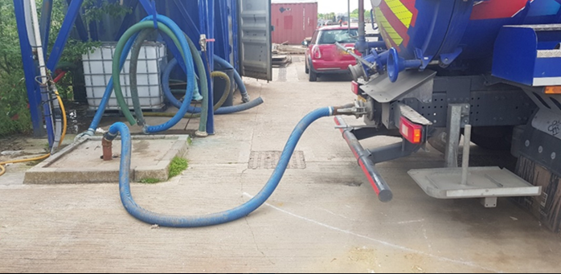The process is enclosed as opposed to pumping the liquid waste from a tanker to an open manhole to the foul sewer.*Image of purpose built discharge point*

*Image of grid used to capture foreign items from the direct discharge point (not this is located within the covered chamber)*

**Treatment via dewatering**

The second process is the dewatering of liquid and sludge wastes before the de-watered liquid is discharged to the foul sewer.

Waste liquids or sludge’s are transferred from the tanker via a sealed hose connector to the first of two sealed tanks. This allows no contact between the waste material and the air.

The liquid / sludge passes through screen via gravity within the first sealed container. The remailing liquid is then pumped again via sealed hoses to a second tank. Once within the second sealed container the liquid settles under gravity allowing the suspended solids to remain and the resulting liquid to be discharged to the foul sewer.

The process of discharging to the foul sewer will be the same as with the first site process of direct tanker discharge to the foul sewer where by the liquid is pumped via a sealed flexible pipe.

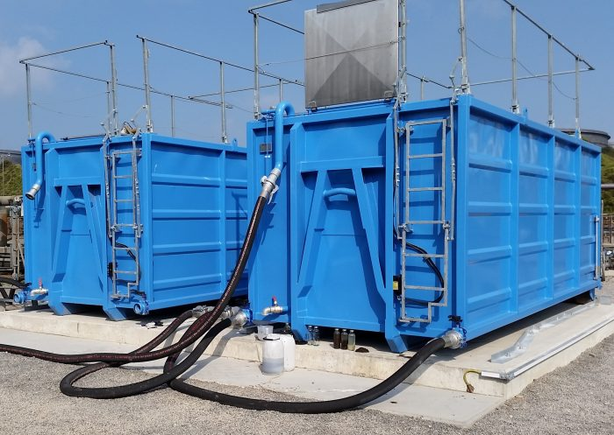

*Dewatering units*

**2.6 Contingency Planning**

Should the above process controls fail at any point during the transfer and a spill was to occur, the tanker pump would be switched off and the transfer stopped.

Any liquid would be contained on the impermeable concrete pad forming part of sealed drainage system and immediate hosed to the foul sewer via open manholes. If in the event of the discharge point was damaged receipt of tankers shall not recommence until a full review of this Odour Management Plan has been conducted and process controls (including critical limits) amended as required.

The company uses a network of permitted waste management sites that tankers could be diverted to until the site was ready to accept waste again.

**2.7 Releases**

Key measures for management of releases includes reducing evaporation and, if needed, containment and abatement. The whole process is carried out in a controlled manner to assist with minimising odour releases.

The process involves connecting the tanker to a purpose built discharge point or to the screening tank via a flexible hose, meaning there are no release points and the process is fully enclosed. This is the same transfer system that is used at sewage treatment works for accepting tankered liquid wastes.

As a result, there will be no evaporation of liquids that can be a key creation of odour. There are no point source discharges of odour due to the use of the of the purpose built connection (Appendix A) points and as a result exposure is low. Releases may occur when the screen is cleaned within the chamber from the direct discharge point.

**2.8 Odour Release Point Inventory**

All identified odour release points have been collated into the table below for quick reference. The inventory assists in identifying the physical locations that require management.

The process’s giving rise to odours can be split into two three areas -

**Direct Discharge to foul sewer**

The first process is the direct discharge of liquids to the foul sewer.

|  |  |
| --- | --- |
| **Odour Release Point & Description** | **Location and Process** |
| Transfer of tankered waste | Coupling on tanker and discharge point |
| Transfer of waste to foul sewer | Coupling on tank and discharge point |
| Transfer of tankered waste | Coupling on tanker and first storage tank |
| Cleaning of the screen | Discharge point |
| Storage of removed debris from screen | Enclosed skip |

**Treatment via dewatering**

The second process is the dewatering of liquid and sludge wastes before the de-watered liquid is discharged to the foul sewer.

|  |  |
| --- | --- |
| **Odour Release Point & Description** | **Location and Process** |
| Transfer of tankered waste | Coupling on tanker and first container |
| Transfer of waste between tanks | Between both tanks |
| Transfer of waste to foul sewer | Coupling on tank and discharge point |
| Tank observation points | Top of both tanks |
| Tank cleaning | Observation point on the top of both tanks |

**Housekeeping**

Housekeeping is classed cleaning of the wider site.

|  |  |
| --- | --- |
| **Odour Release Point & Description** | **Location and Process** |
| Cleaning of drains | All site drains |
| Cleaning of silt traps and interceptor | Specific location of silt traps and interceptor |
| Cleaning of site surfaces | All site surfaces |

**2.11 Frequency**

There discharges to the foul sewer each day will not be constant. As a result, the frequency of potential odour releases is very limited.

The time of the time of the discharges will be within the sites opening hours.

**2.12 Alternative to proposed transfer system**

The system that is proposed for the transfer of liquid waste from the tanker to the foul sewer uses the same connectors and equipment as those found on sewage treatment works that accept tankered effluent. This is the industry standard method for of transfer.

There are no other available techniques facilitating the transfer of liquids from tankers where the discharge remaining free from contacting the air.

As a result, this method was deemed the most suitable and least likely to result in odour complaints.

**3.0 Prevention**

**3.1 Internal Odour Assessment and Monitoring**

GAP will carry out odour checks at 4 points around the perimeter of the site on a daily basis (shown in figure 3.3) when transfers are taking place. Monitoring is undertaken at various times to build in an element of random checks.

In the event that a perimeter odour at 3 on a scale of 1-5, 3 being classed as a strong odour or above is recorded, then off site odour checks will be carried out in the prevailing wind direction and details recorded in the site diary. Office staff and other visiting staff are encouraged to check odour to reduce the risk of site staff becoming normalised to the tankered waste.

Odour scales used for assessment of odours

0 - No odour

1 - Slight odour

2 - Moderate odour

3 - Strong odour

4 - Very strong odour

5 - Overpowering odour

If an odour of 3 or above is identified, then the source of the odour must be identified immediately. The following steps are taken –

* Odour Report form completed and an odour of 3 or greater recorded.
* Site manager notified
* Odour source identified
* Source of odour removed or cleaned (i.e.) spill cleaned up or inspection hatch closed
* Technically Competent Manager Notified
* If the Odour was recorded outside of the site boundary the Environment Agency will be notified with 24 hours.

If the source of the odour is broken or damaged equipment any waste within the equipment will be removed via either discharge to foul sewer or tinkering off site. Or in the case of a container it would be hook-loaded from site to be tipped at a suitable permitted waste facility.

The equipment will then be repaired and inspected before use.

If the source of the odour is a certain load of waste from a certain location / producer this waste will not be accepted at the site again.

**Figure 3.0 Internal odour monitoring points**

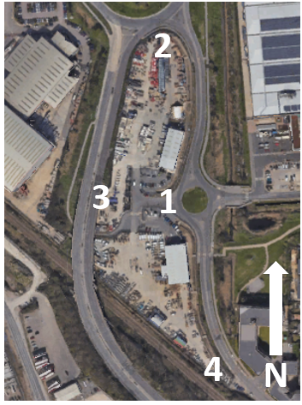

**3.2 Daily Checks**

A Daily Checklist will be implemented which is to be carried out daily and available to the Environment Agency on inspection. The checklist will be filled in daily by the site manager or other appropriate person in order to monitor the site cleanliness and weather conditions which may affect odour controls. The monitoring will take place on a daily basis and is designed to reduce the potential for odour. This checklist will be kept in the site office and will be produced upon the request of the Environment Agency.

**3.3 Cleaning**

The site will have operate a strict cleansing regime of the permitted area to ensure that any residues from the transfer of the liquids are not allowed to remain exposed to the air, this will include –

* Cleansing of the discharge point via hosing.
* Flushing of the hose used for the transfer of liquids from the tanker to the discharge point.
* Hosing of the transfer area to the foul sewer.
* The grid collecting the solids is cleared and hosed down on a daily basis.
* Ensuring the sealed skip containing the collected solids is cleansed at each exchange.

Cleaning the treatment tanks is carried out in the following steps.

* Primary screening tank when full is removed from site via hook-loader and taken to a suitably permitted waste facility and emptied.
* The settled solids tank is again removed from site via hook-loader and taken to a suitably permitted waste facility and emptied.
* When returned to site they valves are closed to prevent any liquid release.
* Via an access hatch on the roof of the tank clean water is sprayed into the tank to removed remaining solids from screens to ensure the containers perform at their optimum levels. After the spraying has stopped the lids are closed and secured.
* The valves are then opened allowing the water to drain to the foul sewer.

The containers are then ready to use again with minimum onsite cleaning and opening of the containers.

**3.4 Maintenance**

The site will have operate a strict maintenance regime of the equipment integral to the transfer of liquid waste permitted area and those making up the permitted area to ensure that and failure or damage of equipment does not give rise to odour. This will include –

* Checking all coupling points on the discharge point and tankers are functional and free from leaks.
* Checking all coupling points on the tank for leaks.
* Checking the hose used for the transfer of liquids from the tanker to the discharge point is free from splits, holes and damage.
* All curbing is intact to prevent any runoff from the pad spreading across the site.
* All drain lids are fitting correctly and free from damage.
* The solids skip is shutting correctly.

**4.0 Dispersion and Receptors**

**4.1 Dispersion**

The following section identifies the prevailing weather conditions on site, in particular the wind direction in order to predict the path of likely aerial dispersion of odours generated on site. By

constant monitoring and even forecasting of poor dispersion conditions, GAP can trigger contingency measures to temporarily cease operations.

Information on wind direction has been derived from the Willy Weather based upon the last five years. This data is illustrated by the wind rose in Figure 2. Wind data is collected daily as part of the routine monitoring on site. 16-point wind directions are provided below, note that calm days are also included to provide a complete data record.

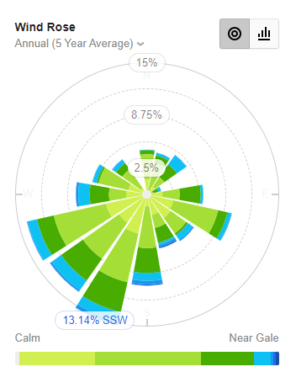

|  |  |
| --- | --- |
| **Direction** | **Percentage** |
| N | 4.40 |
| NNE | 4.21 |
| NE | 4.75 |
| ENE | 1.41 |
| E | 5.51 |
| ESE | 8.51 |
| SE | 5.61 |
| SSE | 5.41 |
| S | 8.94 |
| SSW | 13.14 |
| SW | 11.68 |
| WSW | 12.10 |
| W | 7.00 |
| WNW | 5.51 |
| NW | 4.22 |
| NNW | 0.00 |

*Wind rose for Port of Shoeburyness Observing Station taken for the last five years*

The predominant wind blows from the South West towards receptors to the east

North-east of the Site. This area is less populated by light industry within the immediate vicinity of the site and housing further from the site with and parts of the area giving way to farmland.

**4.2 Site Location**

The site is located to the north eastern edge of the Tilbury Docks. The site is flanked the west by the dockland industries, commercial properties to the north east and residential to the east, southeast.

In the local vicinity there are a large number of permitted waste management facilities –

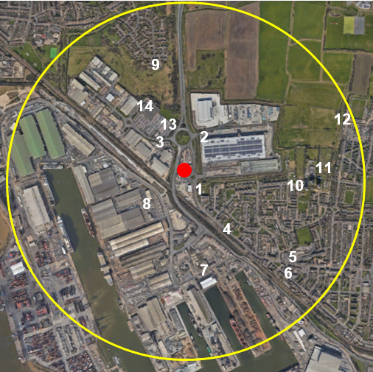

**Receptors**

|  |  |  |  |  |
| --- | --- | --- | --- | --- |
| **Ref** | **Receptor** | **Description** | **Direction from site boundary (m)** | **Approximate distance from Site Boundary (m)** |
| 1 | Dwellings | Housing on Dock Road | 170 | SE |
| 2 | Light Industry | Amazon Distribution | 145 | NE |
| 3 | Light Industry | Industrial Estate | 60 | W |
| 4 | Food outlet | Restaurant Dock Road | 530 | SE |
| 5 | School | Lansdowne Primary School | 750 | SE |
| 6 | Gym | UK Fitness Club | 825 | SE |
| 7 | Docks | Tilbury Docks | 600 | S |
| 8 | Light Industry | Industrial Estate | 270 | SE |
| 9 | Dwellings | Housing on Salix Road | 645 | NW |
| 10 | School | Olive A P Academy | 745 | E |
| 11 | Allotments | Community Allotments | 815 | E |
| 12 | Football Stadium | Grays Athletic | 995 | NE |
| 13 | Food | McDonalds | 270 | NW |
| 14 | Supermarket | Asda | 370 | NW |

Within 1,000m of the site there are the following –

* Hospitality
* Leisure
* Dwellings

Based upon the guidance document - H4 Odour Management How to comply with your environmental permit states the following ‘Some receptors are more sensitive than others. Domestic residences, or a pub with a beer garden are more likely to be sensitive than an industrial complex’.

The above insinuates that the within 1,000m of the site that there are sensitive receptors, however these receptors are out of the prevailing wind direction.

**Site location and prevailing wind direction**

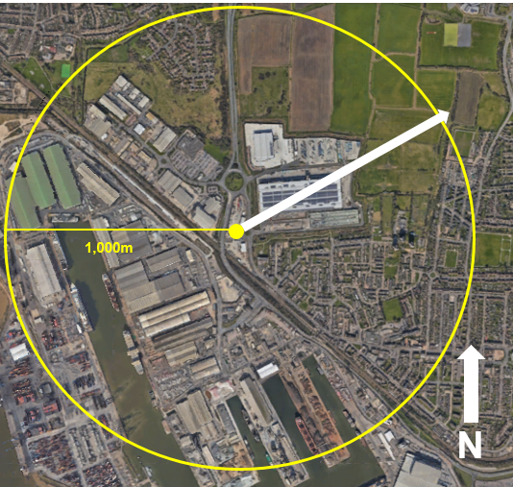

**4.3 Dispersal Control**

There are no sensitive receptors in various directions from the site. Given the varying directions to non-sensitive receptors it will not be practicably possible to restrict activities by wind direction. As the receptors are a mix of commercial properties operating around the clock it would also not be possible to restrict activities by time.

**4.4 Other Sources of Odour**

The Avonmouth Industrial Estate has a variety of different industries located upon it with a variety of sites that will produced their own distinct odours, including:

* Asphalt and concrete production
* Waste management (namely skips hire and wood recycling
* Dockside storage
* Agriculture

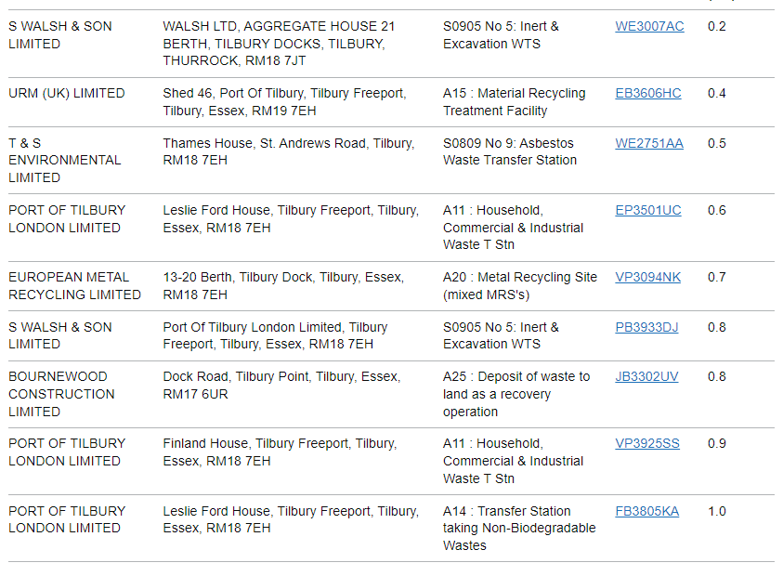**Permitted Waste Facilities**

**5.0 Procedures**

**5.1 Responsibilities**

The overall responsibility for the site shall remain with the Companies’ Managing Director.

Day to day operational responsibility for the transfer to foul sewer process is maintained by the site’s competent persons or COTC holders (Certificate of Technical Competence Holder’s in the event of an odour complaint the Odour Complaint Form as shown in Appendix B will be used and if complaint is validated the cause investigated and remedied

**5.2 Procedures when Odours Arise**

There is an internal odour report form (see Appendix C) and an external complaints procedure (as outlined below and in Appendix B) to ensure any odour issues are dealt with quickly and effectively.

**5.3 External Complaints Procedure**

Any complaints relating to the odour of the site will be taken seriously and channelled through a senior member of staff. Staff taking note of the complaint will use the appropriate Odour Complaint Form (see Appendix B).

Once the complaint is taken, the Site Manager will investigate the complaint and the site activities and respond to the complainant in writing outlining any findings and actions taken to mitigate the source of odours. Any complaints, investigations and mitigating actions will be recorded in the site diary.

The complaints procedure, including a survey of the complaints to date will be re-assessed by the Operations Manager and the Managing Director on a yearly basis, unless the number of complaints

warrants additional reviews. It should be pointed out there have been no substantiated odour complaints by the Environment Agency for the last 2 years at this site.

**5.4 Response to Complaints**

The receipt of a single odour complaint during normal operations is treated as an exceedance of control levels. The primary response will be as detailed in accordance with the site’s complaints procedure. An investigation shall be initiated into the cause of the complaint; this will involve as necessary:

* An olfactory survey as outlined below;
* An examination of the site activities at the time of the complaint;
* An examination of the meteorological conditions at the time of the complaint; and
* A review of the effectiveness of operational and odour control procedures. If the complaint is validated it will be treated as an exceedance of the control level. The outcome of the investigation will determine the corrective actions to be implemented.

**5.5 Abnormal Meteorological Conditions**

In the event that meteorological conditions prevent delivery or dispatch vehicles, or staff arriving on site, emergency contingency plans will need to be followed to ensure the site can be remotely managed until the site can return to operation under normal conditions. The site manager and staff operatives will undertake daily weather checks to ensure that any abnormal weather conditions can be foreseen as much as possible and contingency arrangements can be put in place prior to any problem occurring on site. In the event that the site has to be closed due to severe weather conditions deliveries will be diverted to an alternative suitably authorised site for either recovery or disposal.

The site has access to advanced weather forecasts and warnings via the Met Office and also an onsite weather station that measures wind speed and direction. This information can inform site staff when the wind direction will be in the direction of sensitive receptors and if as result opening access ports can be halted in these circumstances.

**5.6 Breakdown of Process Equipment and Plant**

In the event that there is a breakdown of equipment or plant that cannot be repaired within 24 hours, hire equipment will be brought in. The wider group of companies behind GAP has significant resources and will be able to ensure relevant plant can be sourced.

**5.7 Staffing Issues**

The general manager ensures holidays are properly covered by staff from the wider group of companies. In terms of illness if a member of staff was not able to attend work on a particular day

the site will manage but if that person or several staff at the same time were to be off for a longer period, staff can be sourced from the wider group of companies.

**5.8 Odour Management Plane Review**

The odour management plan will be reviewed annually and the version and review date modified accordingly, however if any of the following occur the odour management plan will be updated accordingly -

* Change to the permitted activities of the site.
* Change to the infrastructure and technology used to facilitate the transfer of liquid waste.
* Receipt of substantiated external odour complaints.
* Recording of odour internally that are likely to give rise to external complaints.
* A request made by the Environment Agency.

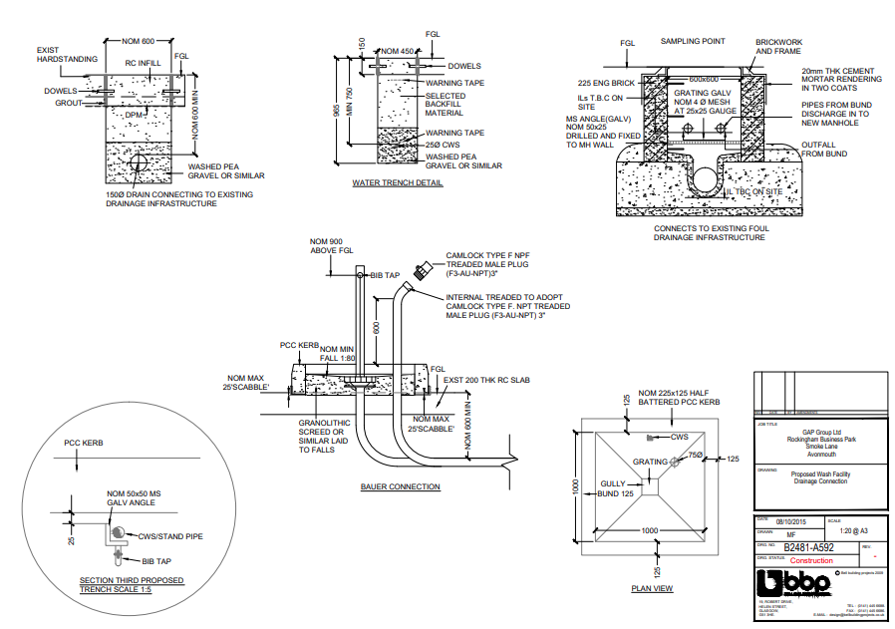**Appendix A – Proposed Discharge Connection**

**Appendix B**

**Appendix C**

**Appendix D**

Odour intensity scale

0 - No odour

1 - Slight odour

2 - Moderate odour

3 - Strong odour

4 - Very strong odour

5 - Overpowering odour