Notice of request for more information
The Environmental Permitting (England & Wales) Regulations 2016

Angus Energy Weald Basin No.3 Limited
Westpoint 4 Redheughs Rigg South Gyle
Edinburgh Scotland EH12 9DQ
Application number: EPR/BL9763IN/V005
The Environment Agency, in exercise of its powers under paragraph 4 of Part 1 of Schedule 5 of the above Regulations, requires you to provide the information detailed in the attached schedule. The information is required in order to determine your application for a permit duly made on 10/03/2021.
Send the information to either the email or postal address below by 15 June 2021. If we do not receive this information by the date specified then we may treat your application as having been withdrawn or it may be refused. If this happens you may lose your application fee.
Email address: psc@environment-agency.gov.uk.

Postal address:
Permitting and Support Centre Quadrant 2
99 Parkway Avenue Parkway Business Park Sheffield
S9 4WF

Name | Date
Eleanor Blackeby | 18/05/21
Authorised on behalf of the Environment Agency

Notes
These notes do not form part of this notice.
Please note that we charge £1,200 where we have to send a third or subsequent information notice in relation to the same issue. We consider this to be the first notice on the issues covered in this notice.
The notes in italics that appear after questions in the attached schedule do not form part of the notice. The notes are intended to assist you in providing a full response.

Schedule

Supplementary Hydrogeological Risk Assessment (SLR Ltd, 422.07154.00002, Rev 6, August 2020) (Supplementary HRA)
- Provide evidence to support the statement that Brockham’s current reservoir pressure is 50% and that restoration to 65% to 80% of original pressure is in line with ‘good oilfield practice’.
It should be noted that when referring to reservoir pressure we are referring to the oil zone of the reservoir. The pressure in the water zone, where the injection well is completed, will be approximately constant regardless of proposed or past operational activities. The oil zone, whilst in communication with the water zone below is not affected quickly by the higher pressure because permeability is low and the water cannot expand significantly because it is incompressible. There has been a movement of water into the oil zone over the last 30 years but this has been limited.
However water injected into the water zone will find its way upward into the oil zone more swiftly and will tend to equalise the pressure in the oil zone with the water zone. Given the extent of the aquifer c.600 mmbbls or 95 million m³ (reference most recent mapping and central case reservoir assumptions from Xodus and Tracs reports), the proposed injection activities of 150 bbls/day or 24m³ will never appreciably affect the pressure of the aquifer. The proof of this and the safety of the formation from overpressure, is confirmed in our answer to questions 3 & 5 below.

As regards pressure in the oil zone, this can, of course, only be measured from the production well. The previous estimate of reservoir pressure was based on the original oil reservoir pressure of 930 psi at 630m BRT from BP original well test of 1987 and the net volume of 68,480 m3 or 428,000 barrels removed from an original estimated Original Oil in Place figure of 2.79mmbbls STOIIP (reference Xodus). The reservoir pressure estimate was therefore a function of the mass balance in the reservoir [see Q 4]. On this basis, as stated, we would have expected the pressure to be about 50%.
It has proven to be impossible to obtain steady and consistent direct downhole pressure readings because the well has been shut in for such lengthy periods of time that it now needs to be flowed to remove accumulated waxy oil and other blockages which lead to inconsistent fluid flow and fluid density. Once production strings are in place it is then not possible, without the considerable expense of removing and then putting back the production strings, to obtain regular direct downhole pressure readings.

However, following pumping of the well to clear the annulus, it is reasonable (and a commonplace substitute), to use echometer readings on the annulus to determine the level of fluid therein after it has been allowed to rise again fully, and so derive a calculated downhole pressure figure. The last such echometer reading (June 2021) indicated a calculated downhole oil reservoir pressure of 470 psi. This is approximately 50% of original pressure and accords well with our approximations from mass balance calculations of fluid removed and injected over 30 years.

With regard to best practice in water injection, the voidage replacement ratio affects the ultimate recovery from the field. However, it is recognised that this effect is variable as in the OGA publication “Recovery Factor Benchmarking September 2017” which paper considers a higher voidage replacement ratio to be generally beneficial.

The paper “International Reservoir Management Strategies for Development of Water Injection Planning Project Proceedings of the 2016 International Conference on Industrial Engineering and Operations Management Detroit, Michigan, USA, September 23-25, 2016” provides a good study into optimisation of voidage replacement ratios and concludes that a VRR of 0.75 appears to achieve the best results. Recognising uncertainty, we have proposed up to 0.8.

- Provide supporting documents for all relevant procedures and monitoring systems referenced as ‘robust procedures’ in section 2.2.
Section 2.1 of procedure BRO-ANGPR-O0004-3 has been amended.

Section 2.2 sets out the ‘robust procedures’ in place to ensure the compatibility and management of water to be injected. Comments are made about monitoring frequencies and checks but no detail is provided. For example, we need to know how brine compatibility checks be documented and made available for inspection. You should provide information about the location and frequency of independent salinity checks and how they will be undertaken.
- Explain how you will monitor bottom hole pressure in the BRX 3 re-injection well and your frequency of monitoring.
Section 2.2 of the HRA states that bottom hole pressure will be monitored periodically to verify execution of the plan. You will need to confirm the frequency of your periodic monitoring of bottom hole pressure so the Environment Agency can be satisfied that this monitoring will be carried out because it is a mitigation measure for the re-injection of produced water.
The monitoring sheets in Appendix 5 state well head pressure on annuli and tubing are monitored at 30minute intervals during injection. This is also stated in the Water Injection Procedure. There is no information in the HRA that confirms how and when the bottom hole pressure will be monitored and frequency of this monitoring in order to verify the bottom hole pressure will not exceed 80% of the initial reservoir pressure.

As regards monitoring of the water zone of the reservoir, it would be feasible to run pressure gauges at bottom in the injection well. However, since we know the density of the fluid injected into the well and its depth the bottom hole pressure can easily and accurately be calculated by measuring the surface pressure. This can be done more frequently than a bottom hole pressure survey and so provides more useful information. We would propose that the calculations be made monthly.

To measure the oil reservoir pressure, observations must be made in the production well. As stated in the answer to question 1, this can be achieved by periodic echometer monitoring of the level in the annulus and then, knowing the fluid in the well and the level supported, it is possible to calculate the bottom hole pressure. This is a reasonable measure of bottom hole oil reservoir pressure which would otherwise be unreasonably expensive to measure directly. In addition to regular monitoring of well head pressure, this echometer monitoring of downhole pressure will be done once a month during pauses in production.

- Provide references for the data used in section 2.3.2 and accompanying Figure 2-2 and review this section of the document for discrepancies between the text and the data shown in Figure 2-2.
Section 2.3.2 discusses the formation pressure and barriers to fluid flow. The evidence in Figure 2-2 allegedly based on Oil and Gas Authority (OGA) data, shows a net loss of fluid despite previous reinjection activities. The net fluid loss figure of 68,480 m³ described in the text does not accord with the graph trend line, which seems to suggest around 40,000 m³. There is a caveat regarding compressibility and other effects, but no guide as to how much these would affect the accuracy of the figures.

Figure1 shows the total volume removed from the reservoir and the volume injected: the volume removed minus the volume injected equals the net volume removed. We found a discrepancy between the previously reported numbers and the PPRS number. Therefore, we have used the PPRS numbers and corrected the graph as well. The corrected numbers do not make a material difference.

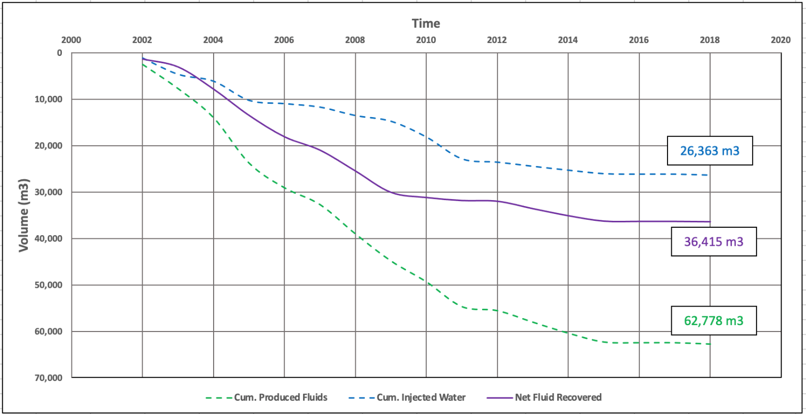
Figure 1 : Total volumes produced and injected in the reservoir

- Confirm what evidence was used to describe the surrounding formation pressures in comparison to the reservoir pressures discussed in the final paragraph of section 2.3.2.
This section describes how the lowering of pressure in the reservoir means there that there must be an inherent inward pressure gradient from surrounding rock formations. We consider that this argument could be ignoring the possibility that the initial pressure was many times greater than surrounding formations and thus could be lowered, without necessarily reversing a gradient. We acknowledge this is probably unlikely in this scenario, but we consider that the report should have discussed this point and provided suitable evidence to dismiss it as appropriate. Likewise, this would support (or indeed refute) whether 80% restoration of initial reservoir pressure would or would not result in a net loss of fluid from the reservoir.

The initial reservoir pressure was measured directly in the BP well test conducted in 1989 before the field had had any production. The pressure measured was 930psia at a depth of 630mBRT in the oil reservoir (reference BP well test report July 1989). The pressure in the water zone of the reservoir was also measured by a well test at the same time. The pressure measured was 948 psia at a depth of 647m BRT just below the oil water contact. This proves that the water and oil zones were in equilibrium before production commenced. The injection point in well 3 is at a depth of 704m TVD. Corrected to this depth the original pressure at this point was around 1145psia. The pressure presently is about (1096psia measured in 2021) reflecting a very small pressure difference which may be observational error or reflects the small movement of water into the oil reservoir.

What is perhaps of greater importance is that the pressure at the wellhead of the injection well should never exceed the pressure at which, considering the density of brine in the well, the bottom hole pressure would exceed the fracture pressure of the formation.

The fracture gradient of the formation which is the point at which the formation will start to break down was observed directly during past drilling operations at Brockham and nearby wells. The data are consistent and show that the fracture pressure of the formation at a depth of 700m (the depth of the injection point in the Brockham 3 well) is around 140 Bar or 2060 psi which is around 1200 psi above the normal hydrostatic gradient. However, the Hydraulic Impedance Test from BP 1989 report indicates a formation breakdown pressure closer to 1635 psi. Therefore, we decided to use a conservative WHIP no more than 350 psi.

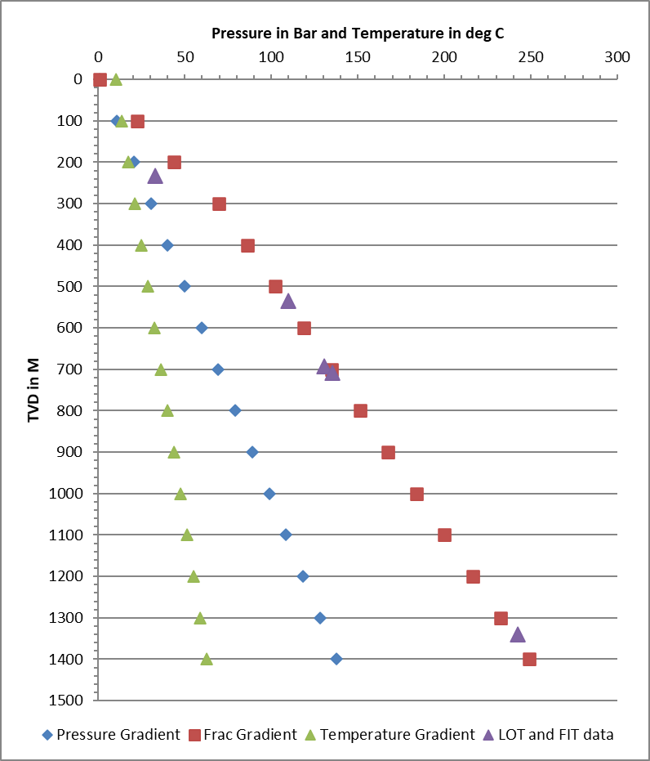
Figure 2: Fracture gradient data from Brockham and nearby wells.

- Provide an evaluation of the results of the 2021 Cement Bond Log in your hydrogeological risk assessment.
The findings of the 2021 CBL are considered by the Environment Agency to be an important component of this variation, yet they have been omitted from this supplementary HRA. The 2021 CBL report identified less than ‘good’ cement sections adjacent to water-bearing strata, when measured depths of the CBL are compared to published geological logs for BR-X1. This should be outlined, discussed and evaluated in your HRA.

Figure 3 below shows the various aquifers present in the well in the context of the casing strings run to protect and isolate them. The three aquifers of particular interest because they contain fresh water are the Upper and Lower Tunbridge Sands and the Ashdown Sands. These are behind the 7” casing which was cemented to surface and the 9 5/8th inch casing also cemented to surface. So, these aquifers are protected from the wellbore contents by two steel casing strings and two cement barriers.

The Purbeck Limestone aquifer is present below the 9 5/8” casing but is behind the 7” casing and the cement barrier around it. The cement bond logs run in the 7” casing are shown in figure 4 below. The main obvious conclusions from the cement bond logs and the reports are that there are two good cement sections above the reservoir. These sections of good bond show excellent consistency between the three cement bond logs run in 1987, 2003 and 2021 despite the differences in the tools used.

There can therefore be assurance that there can be no movement of water upwards from the reservoir to the Purbeck aquifer and beyond. There is also the fundamental fact that since the oil reservoir remains below the pressure in the aquifers above there can be no flow from the oil reservoirs to the aquifer as fluid flow cannot go from low pressure towards higher pressure.

Lastly, there is no communication from the reservoir to shallower formations as the reservoir is being sealed by an impermeable layer, the Purbeck Anhydrite.

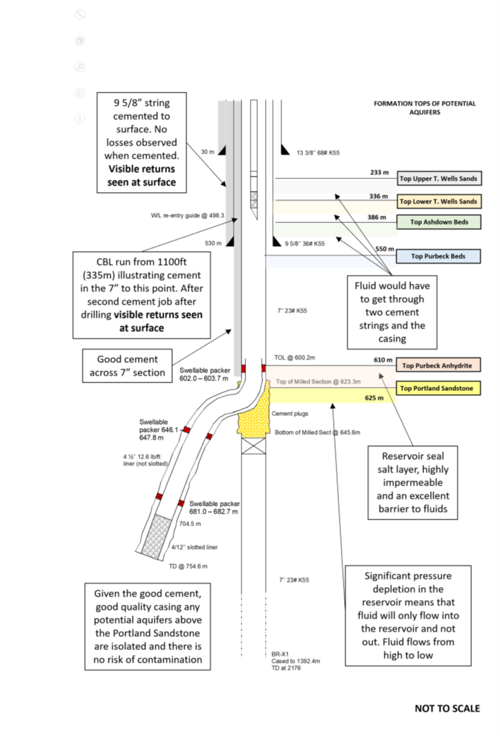

Figure 3: Summary of barriers present in the water injection well

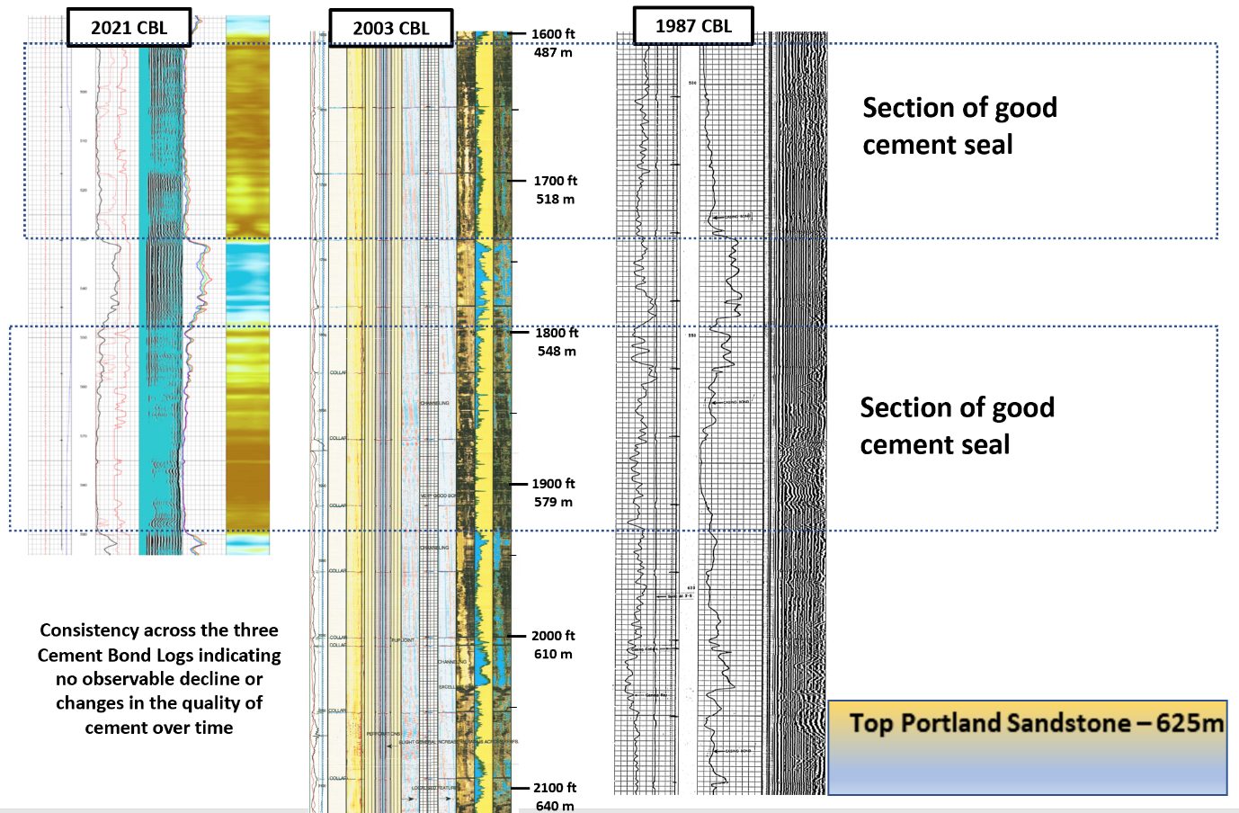
Figure 4: Comparison of CBL logs

- Provide additional data and explanation justify the absence of groundwater monitoring as outlined in section 2.5.
The absence of groundwater monitoring is only acceptable if we are satisfied with operational procedures and both current and future well integrity. Direction back to the original HRA is not sufficient as the HRA was identified as being weak in this respect. Further justification is required.
Section 2.5 has been updated.
- Provide additional data and explanation upon which the statements regarding well integrity are based in sections 2.5 and section 3. This should include evidence that the logs were independently verified and substantiated.
Section 3.0 provides a brief summary and conclusions based on the previous sections of the report. It summaries the evidence that SLR have accumulated to address the 3 aspects that have prevented reinjection activities being permitted at Brockham. It should be noted that although the comments on the potability of some of the nearer surface aquifers are reasonable, this does not mean that a reinjection activity is permissible without due regard to the risks of potentially polluting discharges to groundwater.
The report states “…the pressure containment integrity of the well has been checked with independent verification of the logs and observations”. We require evidence of this.

The pressure containment integrity of the well has been checked with independent verification of the logs and pressure testing of all the components of the well during the latest workover. The new completion (injection tubing) that was installed in the well includes a packer, which isolates the injection tubing from the annulus between the injection tubing and the 7’’ casing. The injected fluid will be enclosed in the tubing, which was tested at 2500 psi while setting the packer. The 7’’ casing was pressure tested at 100 psi (pressure measure at surface).

Figure 5 presents the pressure test chart signed by the driller, tool pusher and drilling supervisor (DSV), who are competent independent contractors with many years of experience. This eliminates any possibility of discharge from inside the well to near surface aquifers. In addition, the tubing hanger seals and the hold down bolts were pressure tested to 200 and 1000 psi for 5 and 10 minutes respectively (Figure 6). Figure 7 shows the gate valves on top of the injection tubing being tested to 250 and 500 psi for 5 and 10 minutes, respectively.

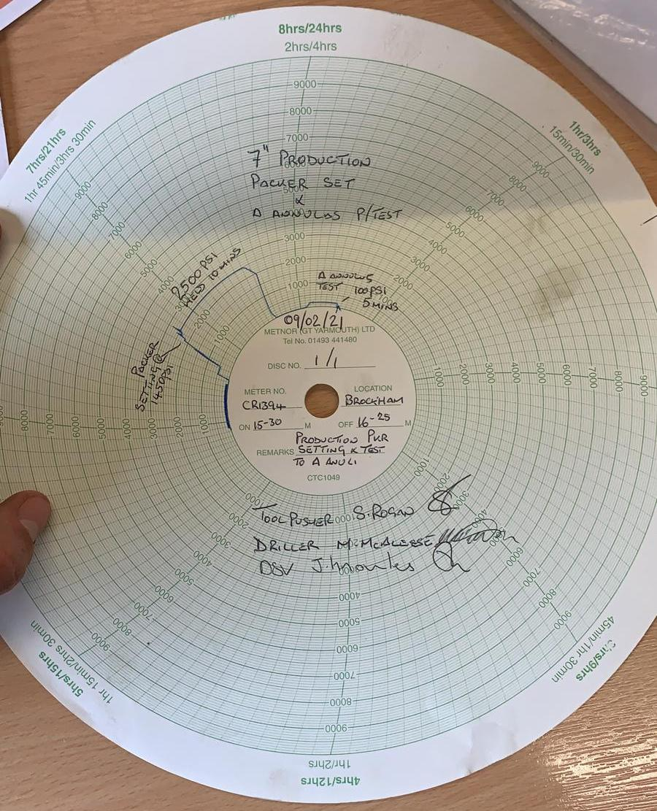

Figure 5: Pressure test chart of tubing and annulus

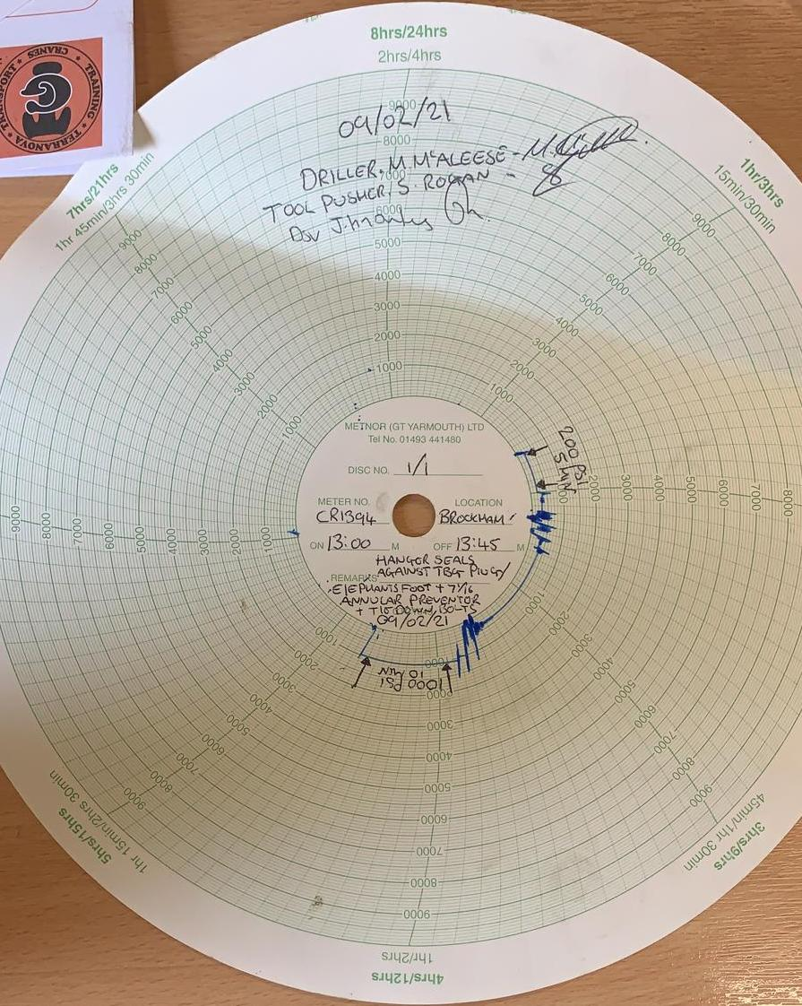

Figure 6: Pressure test chart of tubing hanger seals and hold down bolts
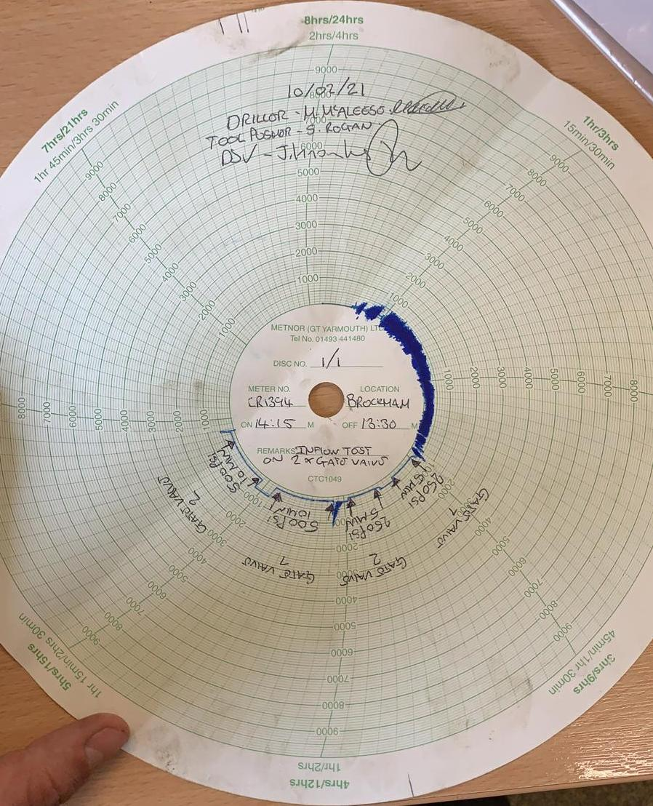

Figure 7: Pressure test chart of gate valves

As per EA’s request, a CBL was run earlier this year to evaluate the state and quality of the cement outside the 7’’ casing. The findings of the CBL were examined by an independent competent consultant from Oilfield International, who also compared the results with past CBLs to evaluate if there is any degradation of the cement and quality of the bond. The competent person concluded that ‘’Between the top of the liner at 597 m and the 9/5/8” casing shoe both logs are identical showing no change in the cement bond. Through this section there is an aggregate of over 126m of good to excellent bond including consistent sections of around 40m’’. This confirms that there is no possibility of any leak behind the casing and any fluid migration to shallower aquifers. The shallower aquifers horizons are also isolated from the 9-5/8’’ which is cemented to surface.

Appendix 04 – Additional Well Integrity Report (ANGS-BRO-RP-HRA-001)
- Provide source citations and additional explanation to support the data presented in Appendix 04 – Additional Well Integrity Report (ANGS-BRO-RP-HRA-001).
This report should cite sources or append reports from which the data originates. Without this information some of the tables (for example tables 2 and 3) lack context which prevents full understanding. For example table 3 shows the pressure was rechecked at the end of a specified period. It is not specified what exactly the maximum acceptable loss was.

Citations have been added to the report

- Brockham 1 - Drilling Completion Report page 13 (Table 4)
- 101008proterep.pdf, page 25 (Section 6)
- Brockham X3 End of Well Report, page 177-179 (Table 1)
- ANGUS BROCKHAM BRX3 Wellhead Integrity Report Mar 2020.xls (Table 2 and 3)

Appendix 05 – Monitoring Sheets
- Provide further description of the relevance of the SECE and Gauge Programme sheets in Appendix 05 – Monitoring Sheets.
Most of the pre-set values in these templates can only be taken in good faith as their original source is not quoted. Some of the sheets would have benefitted from a fuller description of what they record, though we acknowledge some are self-explanatory others are less obvious, such as ‘SECE’ and ‘Gauge Programme Sheet’.

BR3 SECE Equipment Testing and Gauge Programme Excel Spreadsheet and the Wells Integrity Monitoring and Surveillance Excel Spreadsheet has been added to the Schedule 5 response.

We have the maintenance and inspection spreadsheets for the ‘Safety and Environmental Critical Equipment’ and related instrumentation regime from the ‘Oil and Gas UK Well Life Cycle and Integrity Guidelines Issue 4, March 2017 and included as an example of good industry practice in ISO 16530-1-2017.

Appendix 08 – Operational Procedures and PID’s: Brockham Oil Production Facility – General Description (BRO-ANGPR-O0001-1)
- Provide the capacity of tank BRO-PW-T-01 as referenced in section 3.

Section 3 updated to state capacity of BRO-PW-T-01 as 400 bbls (63.6m3)

- Clarify what is meant by “discharged on site surface or water course” in section 9.3.

Section 9.3 has been updated to state that all water/fluids contained in the bunds must be removed as hazardous/non-hazardous waste and tankered off site to by a licenced waste carrier to a permitted waste facility.
- Provide the missing unit for the discharge to Tanner’s Brook which is described as “20m3/”.
Section 9.4 references the maximum discharge volume to Tanners Brook as 20m3/day.
- Provide reference to a formal site surface drainage procedure rather than including a brief summary of drainage procedures within this document.
Section 9.1 has been updated and references procedure ‘BRO-ANGPR-O0024-2 Onsite Surface Water Monitoring and Discharge’ A copy of the procedure has been submitted with the Schedule 5 response.

- Review the aim and accuracy of this document (BRO-ANGPR-O0001-1) to ensure it does not contradict with approved site operating techniques.
This document has been reviewed and amended
The purpose of document BRO-ANGPR-O0001-1 is unclear. It reads as a series of brief aims rather than being a procedure or instruction document. It lacks the detail required to inform a site operative of the actions required to achieve the stated aims. Some aspects overlap with activities controlled by the existing Environmental Permit such as surface water disposal and emissions monitoring. In other places there appears to be some contradiction with approved site operating techniques.

Appendix 08 – Water Injection Procedure (BRO-ANGPR-O0003-2)
- Confirm the accuracy of documents references BRO-ANGPR-A0040 and BRO-OR- ANGQ004 referred to in section 1 as we are unable to locate them.
The procedure has been corrected. The correct referencing for the procedures are:
BRO-ANGPR-O0040 – Brockham Water Transfer Procedure
BRO-ANGPR-O0004 – Brockham Water Acceptance and Unloading Procedure
- Confirm the maximum instantaneous rate for produced water re-injection in litres per second.
The maximum instantaneous rate is 1.35 litres per second. The procedure has been amended to reflect this.
The flow capacity of the pump is given as 80 litres per minute in BR-ANGPR-O0003-2 and a maximum limit of 150bbls will be re-injected over any 24-hour period. The Water Injection Procedure goes on to state that the 150bbls maximum limit will be reviewed after each injection to reduce or increase quantity after viewing trends.
Please note there will be a maximum daily discharge volume and instantaneous flow rate limit for produced water re-injection on any issued permit. If you wanted to increase your produced water re-injection quantities, you would still need to comply with the permit limits for maximum daily discharge volume and instantaneous flow rate.

Appendix 08 – Water Acceptance and Unloading Procedure (BRO-ANGPR-O0004-2)
- Correct the typographical error on the second sentence of section 2.1 (“This is do as follows”) to ensure correct understanding.

This has been amended.
- Provide detail about where information should be recorded and how this information will be stored for future inspection in all relevant parts of the document.
The procedure has been updated to show that the reporting of information should be carried out in accordance with ‘BRO-ANGS-05-Data Reporting’. This procedure has been submitted with this Schedule 5 response.
- Provide reference to a list of approved chemicals for any biocides added to the produced water.

Section 2.14 Biocide has been added to the procedure.

It states: DAE Biocide 25 is the only approved biocide to be used at Brockham Well site. Check the label on the IBC to confirm that the biocide is DAE Biocide 25 before transferring.

The MSDS is included in Appendix 9 of the Supplementary HRA.

Appendix 08 – Surface Water Monitoring and Discharge (BRO-ANGPR-O0024-1)
- Confirm whether bund water will be used to top up the produced water tank for reinjection. If so, include the relevant procedures and explain how bund water will be treated prior to reinjection to comply with the relevant regulations and ensure this water is clean and uncontaminated prior to reinjection. If bund water is not to be used, the Supplementary HRA should be amended to remove reference to this in section 2.2 and ensure their application does not suggest using bund water in other supporting documentation.

The bund water will be removed off-site for disposal.

Section 2.2 of the Supplementary HRA states: “It is planned to use produced water from BRX2, supplemented by similar and compatible brines from other producing fields within the Weald Basin as well as minor volumes of surface water falling in the containment bunds on the Brockham site.”
We note that section 3.2 of BRO-ANGPR-O0024-1 describes the bund water being discharged (‘under some circumstances’) to the ditch. The procedure does not explain what these circumstances are, how the bund is emptied to and when this water is sampled prior to discharge to the drainage ditch. There is no mention of this being treated and used to top up the produced water tank for reinjection.
The document has been updated to state that the bund water will be removed off-site for disposal
Document BRO-ANGPR-O0024-1 states that all cellar fluids will be transferred to the slops tank or removed as hazardous waste as this is primary containment. This contradicts Section 6.2.1 of HRA Rev 5 which states that any contaminated surface water from the bunded area or well cellars will be re-injected into the Portland Beds via well BRX3.
We are seeking clarity and consistency across documents.

The supplementary HRA supersedes the HRA Rev 5. All fluids from the bunded area and/or well cellars will be removed off-site for disposal. Supplementary HRA and associated documents amended to reflect this.

- Confirm the construction details of the well cellars and provide a diagram showing the well cellar construction. This should include:
  - Explain how you carry out the well cellar integrity reviews and frequency of inspection.
  - Confirm when the well cellar(s) integrity was last tested and how this testing was carried out to verify the well cellars are watertight.
This information is needed because the well cellars are one of the main containment areas on site and is a key mitigation measure for preventing the loss of contaminants to ground and subsoil. The HRA Rev 5 states that well cellar integrity will be regularly reviewed by visual inspection and remedial works undertaken as required. However there is no information confirming how these reviews are carried out, the frequency of inspection and when the well cellars integrity was last tested for example through a leakage test.

BRO-ANGPR-O0046-1 Hydrostatic Integrity Cellar Test has been added to the Schedule 5 response.

The well cellars were constructed prior to Angus Energy’s operatorship of the Brockham Well Site by the previous operators and were not provided with records of the construction details.

Angus Energy carry out annual hydrostatic integrity well cellar tests. The tests are carried out in accordance with operating procedure BRO-ANGPR-O0046-1 which has now been incorporated in the Supplementary HRA.

The last well cellar tests were carried out in September 2020 and results recorded as per procedure BRO-ANGS-05-M-Data Recording. The results of the tests showed that there was no compromise to the integrity of the well cellars.

Appendix 08 – Transfer of Water from Production Tank (BRO-MR131) to Produced Water Tank (BRO0PW-T-01) (BRO-ANGPR-O0040)
- Provide detail about where information should be recorded and how this information will be stored for future inspection in all relevant parts of the document.

The procedure has been updated to show that data should be reported as shown in the Data Reporting Procedure – BRO-ANGS-05-M-Data Reporting.

Appendix 08 – Data Reporting Procedure (BRO-ANGS-05-M-Data Reporting)
- Include references to BRO-ANGS-05-M-Data Reporting in other procedural documents for completeness.
Procedure has been reviewed and updated.
It appears that this document was produced to address lack of clear direction on data reporting in other procedural documents. This is a useful document, but reference to this in other procedural documents would be useful.

