**Pollution Prevention Response Plan**

**LGW16**

**Digital Realty Crawley Unit 2**



**Pollution Prevention Response Plan**

**Digital Realty Crawley**

|  |  |
| --- | --- |
| **Contract /Site:** | **Digital Realty –** Digital Realty, Unit 2, Connect Way, Manor Royal, Crawley. RH10 9BD |
| **Nature of Business:** | **Maintenance of Data Centre facilities** |
| **Scope of Services:** | **Electrical, mechanical and fabric planned and reactive maintenance delivered through a resident site team and specialist sub-contractors** |

|  |  |  |  |
| --- | --- | --- | --- |
| **Date of Plan:** | 26th March 2020 | **Revision:** | Rev C |
| **Approved by:** |  | **Review Date:** | March 2021 |

Table of contents

1.0 Scope 3

2.0 Emergency Contact Details 3

3.0 Site Drainage Plans 4

4.0 Chemical, product and waste inventory 7

5.0 Emergency Procedures 7

5.1 Chemical Spill 7

5.2 Fuel / Oil Spill 8

6.0 General Information 9

7.0 Distribution and Revision 10

8.0 Attachments 11

8.1 Drainage Schematic **Error! Bookmark not defined.**

8.2 LGW16 Drainage plan Ground Floor **Error! Bookmark not defined.**

8.3 LGW16 Drainage plan Roof **Error! Bookmark not defined.**

# 1.0 Scope

This document contains the pollution prevention response plan, for the scope of services that are currently provided at **Digital Realty, Unit 2 connect way Crawley**. The procedures contained within this document should be followed in the event of a chemical and/or fuel oil spillage on site. The person responsible for updating and reviewing this plan is the Data Centre Manager.

# 2.0 Emergency Contact Details

External contacts: include external support services relevant to the risks posed.

|  |  |
| --- | --- |
| On site Security: | **014835 45550** |
| Emergency Services: | **999** |
| Local Police: | **0845 125 222** |
| Doctor: | **Crawley Hospital – 01293 600300** |
| Sewer provider: | **Thames Water – 0800 316 9800** |
| Water supplier: | **Thames Water – 0800 316 9800** |
| Gas supplier: | **No gas connected to site** |
| Electricity supplier: | **UKPN 01473202832** |
| Waste management contractor: | **Grundons – 01293 820358** |
| Specialist advice: | **Crown Oils -** [**0845 901 0124**](tel:08459010124) |
| Specialist clean-up contractors: | **Crown Oils** **-** [**0845 901 0124**](tel:08459010124) |

Company contacts: include both location specific and company specific reporting lines and out of working hours’ response. Where site / location specific escalation sequence is detailed elsewhere please make clear reference in this section of the plan.

|  |  |
| --- | --- |
| Vice Presidents Operations: | Mark Daly- 07799478390 |
| Operations Director: | Steve Hayward – 07880 314678 |
| QHSE representative: | Stephen Case – 0207 954 9152 |
| Regional Manager: | Mark Tennant - 07867 330309 |
| Data Centre Manager: | Peter Hutchinson - 07823 346668 |
|  |  |

3.0 Site Plans:

EXTERNAL DRAINAGE

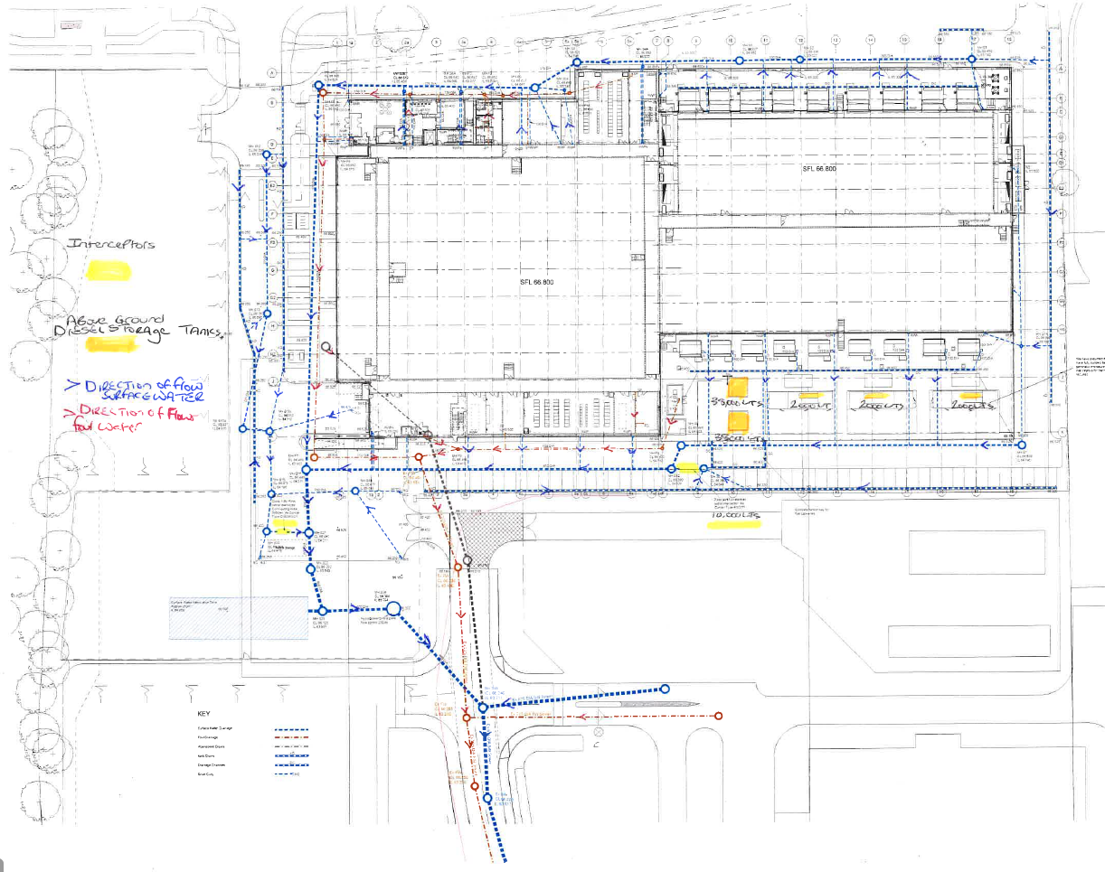

GROUND FLOOR INTERNAL DRAINAGE

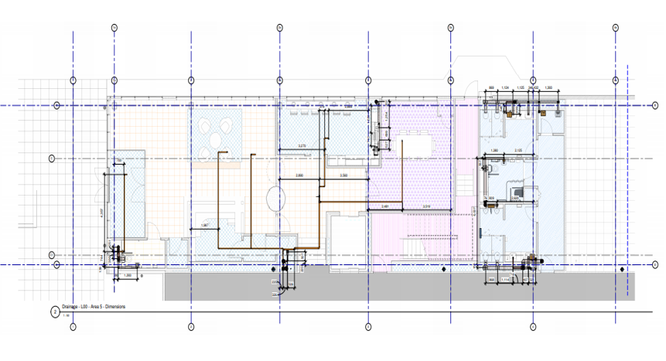

* Diesel oil fuel is stored in 2 above ground bulk storage tanks with capacity of 38,000 litres each in the south compound of the facility, and in 3 generator day tanks with capacity of 2,000 litres capacity each in the generator enclosures.
* There is Condor ANO/11 Fuel Forecourt interceptor (10,000 litres capacity) by fuel fill points in South Access road, Alarm box is in East Corridor by South Compound exit door
* There is a Condor CNB8s/21 By-pass separator for loading bay & Main entrance road/parking, Alarm box is in rear of loading bay
* There is a buried Surface Water Attenuation Tank in the South West corner of site with capacity of 64,000 litres
* Main water & fire water valves for site are located just inside the main gate to the right of reception
* The is a fire hydrant just outside main gate on the right hand corner of Connect Way & Manor Royal

# 4.0 Chemical, product and waste inventory

**COSHH Folder is in Tech OPS office & COSHH Cupboard in Workshop**

**5.0 Emergency Procedures**

## 

## 5.1 Chemical Spill

This is very unlikely to happen as only very small amount of chemicals on site in & are kept in COSHH cupboard, but in the event of a chemical spill the following procedures should be followed:

IMPORTANT INFORMATION

Toxic or corrosive vapors may be released in a fire situation or following the mixing of chemicals.

A chemical spill should only be dealt with by an appropriately trained member of staff.

**PPE** isavailable in **each spill kit** and has been issued to all engineers**.**

**Equipment –** Spill kits located at various points around site.

**Drainage –** The types of drains are a mixture of surface water and foul drainage.

**Drainage plans** are held **in heath and safety folder, section 7.**

**Training –** regular refresher training is provided in spill response.

EMERGENCY ACTION

1. ASSESS THE SITUATION

Ensure that no person in the vicinity is at risk. Evacuate the immediate area if significant risk is present and consider evacuation of adjacent areas.

Ensure that Hazardous Substance Assessments are available for reference prior to contact with spill. Observe the recommendations, in particular for PPE.

Assess how big the spill is and providing it does not present a risk to health, take action to summon help and then contain the spillage if trained in the correct procedure which includes use of spillage kits, hazards and risks and use of required PPE. If not, barrier off the area and await assistance.

2. RAISE THE ALARM

Inform Security on **014835 45550**. In the event of a fire, contact the Fire and Rescue Services. If chemicals have entered the drain instruct security to follow their own protocol and contact the relevant authorities as required.

3. PROTECT YOURSELF

Avoid direct contact with skin, eyes and clothing. If contact is made with skin, wash with copious amounts of water and seek medical attention.

Wear appropriate Personal Protective Equipment, in accordance with the Material Safety Data sheet and Hazardous Substance Assessments. **PPE** isavailable in **each spill kit** and has been issued to all engineers

4. CONTAIN THE SPILL

Contain the spillage/leak as far as is safely possible using the spill kit. Spill kits are located at various locations around the site.

Ventilate the area to dispel possible toxic fumes is safe to do so. For any area where there a potential release of toxic chemical vapor due to accidental mixing or fire, evacuate the immediate area and consider evacuation of adjacent building areas.

Cooperate, coordinate and support the Fire and Rescue Services operations.

Bag and dispose of the spill kit for recovery and disposal.

Formally record and report the incident to the client and internally to the QHSE Manager or specialist.

Complete the QHSE Accident/Incident Report.

Review this plan and document your changes.

## 

## 5.2 Fuel / Oil Spill

In the event of a spillage or leakage of oil the following procedures must be followed:

*IMPORTANT INFORMATION*

A fuel/oil spill should only be dealt with by an appropriately trained member of staff.

**PPE** has been issued to all engineers and is available in each spill kit**.**

**Equipment –** Spill kits are located at various locations around the site

**Drainage –** The types of drains are a mixture of surface water and foul drainage.

**Training –** regular refresher training is to be undertaken periodically.

*EMERGENCY ACTION*

1. ASSESS THE SITUATION

Ensure that no person in the vicinity is at risk. Evacuate the immediate area if significant risk is present and consider evacuation of adjacent areas.

Ensure that Hazardous Substance Assessments are available for reference prior to contact with spill. Observe the recommendations, in particular for PPE. Do you understand what the spill material is, what are the risks and necessary controls?

Assess how big the spill is, can it reach drains and water courses? Do you need assistance or the emergency Services?

Providing it does not present a risk to health, take action to summon help and then contain the spillage if trained in the correct procedure which includes use of spillage kits, hazards and risks, use of required PPE.

2. CONTROL ACCESS

Limit access to the area.

Where possible isolate the area of the spillage with tape or warning signs to prevent staff and members of the public accessing the area.

3. PROTECT YOURSELF

If you think it’s safe to stop the spill, put on the protective clothing located in the spill kit. Be aware of increased slipping hazards.

In an enclosed space, there may be a small ignition risk – stop any hot works, extinguish any naked flames e.g. smoking material and don’t access the area.

DO NOT access a confined space without following correct procedures and having formed an escape plan in case overcome by fumes. If in doubt – stay out!

If appropriate request clean-up assistance using the radio (in accordance with your procedure).

4. CONTAIN THE SPILL

If it is safe, you are trained and wearing PPE, stop the source – do you need to turn off valves, taps or patch holes?

Always cover the drains first to protect the environment.

Contain the spill using the equipment provided e.g. absorbent socks and pillows within the spill kit.

5. RAISE THE ALARM

Raise the alarm if you feel it’s necessary. Follow your escalation sequence for office hours and out of office hours.

Where the spill is substantial advice accordingly and request a clean-up crew.

This may include emergency services, alerting local businesses, or calling the National Environment Agency.

6. ABSORB THE SPILT OIL/FUEL

Once you have the incident contained you can use the equipment in the spill kit to absorb the spilt material e.g. with absorbent pads.

Where the spill is substantial ensure that the area is cordoned off and the spill contained and await assistance. Refer to section 2: Emergency Contact Details.

7. DISPOSE OF POLLUTANTS

Do not throw used spill materials in the general waste bin. Arrange for appropriate disposal in accordance with local requirements.

8. REFILL SPILL KIT

After the incident order new materials to refill your spill kit.

9. RECORD THE INCIDENT

It is essential that information relating to an incident is recorded with the Company Central Reporting Point. Complete and return the incident reporting forms in accordance with the ‘Incident Reporting’ procedure and undertake any actions to ensure such incidents do not re-occur.

10. REVIEW YOUR PLAN

Review your pollution prevention response plan, document your changes and feedback where necessary to the QHSE Team.

# 6.0 General Information

*Potential Environmental Impact*

Chemicals, fuel and oil can cause harm to human life. If they enter drains this may cause water pollution and result in harm to aquatic life. Even non-hazardous organic substances and liquids used as a fire fighting medium must be contained where possible.

*Training*

Appropriate training will be provided to relevant employees on the following procedures during mobilization of contracts and annually thereafter.

*Health Checks*

Any person who has been exposed to a hazardous substance should report the occurrence to their Manager/Supervisor. Any person showing symptoms following exposure should seek medical attention.

*Disposal of Hazardous Waste*

Following the containment of spilled/leaked material, we must, in conjunction with the client’s procedure, arrange for a controlled clean up and disposal; including any remaining substances, its packaging and any absorbent medium used in the containment and clean-up process.

It is essential that the hazardous substances/materials are disposed of by licensed waste contractors who have the necessary licenses [Please refer to waste management rule].

# 7.0 Distribution and Revision

A copy of this plan will be stored in an easily accessible location, Spill Folder in the Tech Ops office.

In order for the plan to remain effective, it is important that it is tested regularly and reviewed. Any significant changes to the premises, people or procedure must be reflected in a revised plan. Revised copies MUST be sent to all plan holders and old versions MUST be destroyed.

|  |  |  |
| --- | --- | --- |
| Revision Number | Issue date | Changes |
| Rev A | 07/02/2019 | Creation date |
| REV B | 13/09/2019 | Update |
|  |  |  |
|  |  |  |

This plan (and any updates) are to be distributed to the following personnel.

|  |  |  |
| --- | --- | --- |
| Name | Revision | Date issued |
| Entire team briefed on content  Master copy held in folder tech ops Office | Rev A |  |
|  |  |  |
|  |  |  |
|  |  |  |

# 8.0 Attachments

8.1 Crawley Campus Spill trained personnel

|  |  |  |
| --- | --- | --- |
| Name & Position | Date Attended | Renewal Due |
| Peter Hutchinson – Data Centre Campus Manager | 14.02.19 | 14.02.21 |
| Michael Brydon – Technical Operations Manager LGW15 | 14.02.19 | 14.02.21 |
| Ashley Church – Shift Technician LGW15 | 14.02.19 | 14.02.21 |
| Luke Gray – Technical operations Manager LGW16 | 14.02.19 | 14.02.21 |
| Warren Downer – Shift Technician LGW16 | 14.02.19 | 14.02.21 |
|  |  |  |
| Taz Taskin – Crawley Campus Security Supervisor | 14.02.19 | 14.02.21 |
| Laura Kemp – Crawley Campus Security officer | 14.02.19 | 14.02.21 |
|  |  |  |
|  |  |  |
|  |  |  |
|  |  |  |
|  |  |  |
|  |  |  |
|  |  |  |
|  |  |  |
|  |  |  |
|  |  |  |
|  |  |  |
|  |  |  |
|  |  |  |
|  |  |  |

8.2 Aid & Spill Kit location

|  |  |  |  |  |  |  |
| --- | --- | --- | --- | --- | --- | --- |
| |  | | --- | | cid:image007.jpg@01D1EC20.75F19410 | | **LGW16 1st Aid Kits Locations** | | | | |
| **Site Ref** | **TYPE** | **Ground Floor Location** |  |  |  |
|
| A1 | Aid | Security |  |  |  |
| E1 | Eye | Security |  |  |  |
| E2 | Eye | UPS A |  |  |  |
| A2 | Aid | UPS B |  |  |  |
| E3 | Eye | UPS B |  |  |  |
| E4 | Eye | UPS C |  |  |  |
| A3 | Aid | UPS C |  |  |  |
| E5 | Eye | UPS D |  |  |  |
| E6 | Eye | Generator 1 |  |  |  |
| E7 | Eye | Generator 3 |  |  |  |
| E8 | Eye | Generator 5 |  |  |  |
| A4 | Aid | Facilities Workshop |  |  |  |
| E9 | Eye | Facilities Workshop |  |  |  |
| B1 | Burn | Facilities Workshop |  |  |  |
| B2 | Bio | Facilities Workshop |  |  |  |
| E10 | Eye | Loading Bay |  |  |  |
| A5 | Aid | Loading Bay |  |  |  |
|  |  |  |  |  |  |
| **LGW16 Spill Kits Locations** | | | | | |
| **Site Ref** | **TYPE** | **Ground Floor Location** |  |  |  |
|
| SK1 | Oil | External Plant North |  |  |  |
| SK2 | Oil | External Plant South |  |  |  |
| SK3 | Oil | External Plant South |  |  |  |
| SK4 | Oil | Loading Bay |  |  |  |
| **LGW16 Fire Grab Bag Location** | | | | | |
| **Site Ref** | **TYPE** | **Ground Floor Location** |  |  |  |
|
| FG1 | Various | Security - confirm all contents are present |  |  |  |

8.3 COSHH

