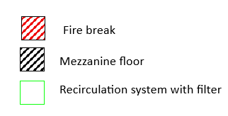
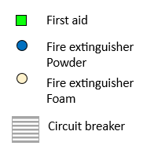
Surface water drain
Fire Exit
Ø300
10°
4000
6742
2000
500
2500
，

Muster pont

Foul sewer drain

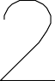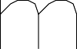

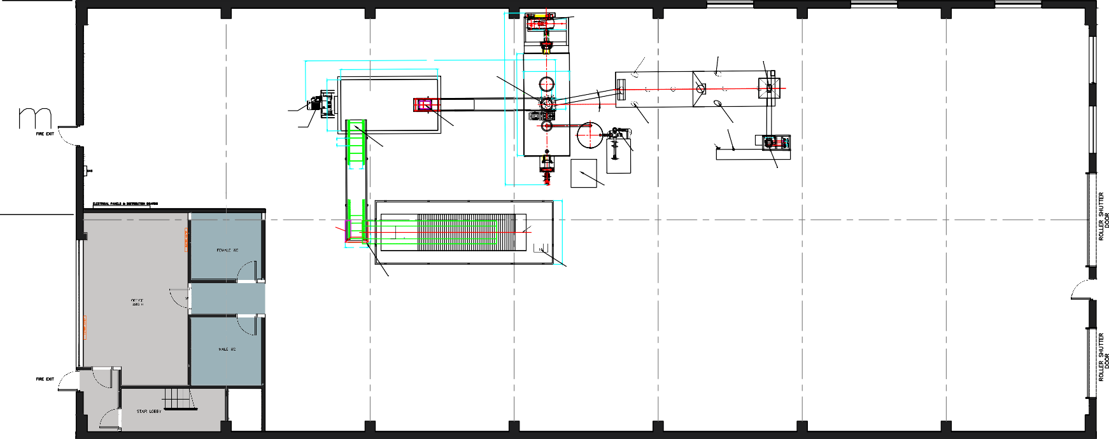
Driving motor: 45Kw
Vibration Motor: 0.75Kw
Vibration Motor: 0.75Kw
9817
3800
φ1800
Screw feeding conveyor motor: 1.2Kw
（Estimated power）
Screw feeding conveyor motor: 4Kw
400
400
Silo push motor: 11Kw
Silo stirring motor: 22Kw
Scrape type lifting machine motor: 5.5Kw
Vibration Motor: 0.75Kw
Vibration Motor: 0.75Kw
Bag sewing machine motor: 200W
300
Belt feeding
conveyor motor: 5.5Kw
Vacuum pump motor: 15Kw
Conveyor motor: 0.37Kw
500
Buyer prepares
Packaging machine motor: 2Kw（Estimated power）
Mold Tem. Controller Heaing power: 160Kw
3-sided guard plate
imported This side is raised to 1.3m above the ground，Used to prevent products from falling out.
Pull plate motor: 0.75Kw
850
900
High pressure filter press machine motor: 3Kw
Belt conveyor motor: 1.5Kw
4KW
3KW
224KW
44KW
5.5KW


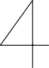
Output storage

Loading/Unloading

Female WC

Cutting station

Office
Input storage

Male WC
Ultra High Pressure Water jetter

3 x 32kw commando sockets
28KW
250KW

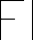
➡️ Nearest Fire Hydrant – approx. 147 m south-west (off-site on public mains, start of Sherrington Way)

