Fire Prevention Plan – Re-Tyre
Version 2.0 | October 2025
Prepared for: Re-Tyre, Unit 5 Sherrington Way, Lister Road Industrial Estate, Basingstoke, RG22 4DQ
Prepared by: Charlotte Wingrove – Director of Environmental Affairs

1 Introduction
This Fire Prevention Plan (FPP) explains how Re-Tyre prevents, detects, controls, and responds to fires at its waste-recycling facility. It has been prepared in full alignment with the Environment Agency (EA) guidance document “Fire Prevention Plans: Environmental Permits” (Version 5, March 2023). The plan describes every activity carried out on-site, the materials present, and the physical measures in place to achieve the three EA fire-prevention objectives:
- Minimise the likelihood of a fire occurring;
- Prevent fires spreading within the site or beyond; and
- Contain any fire water and prevent pollution of the environment.
All processing and storage occur within the main building at Unit 5 Sherrington Way. Operations are fully enclosed, small-scale, and use ultra-high-pressure water-jetting (UHPW) equipment to cut and recycle waste tyres into reusable rubber materials. This plan forms part of the company’s Environmental Management System and will be reviewed annually or following any fire, near-miss, or significant operational change.

2 Types of Combustible Materials
The facility handles only non-hazardous rubber and associated components. Combustible materials consist of whole tyres, tyre pieces, and rubber crumb produced through the UHPW process. No persistent organic pollutants (POPs) or liquids containing flammable solvents are accepted. Small quantities of non-waste combustible items (such as pallet wood or packaging) may be present but are stored separately from the tyre stock. All combustible materials remain inside the building at all times.

3 Waste Processing Activities
Waste tyres are unloaded within the reception area and transferred directly to the processing line. Operations include mechanical cutting, UHPW cutting, filtration through a filter-press system, drying via an oil-fired dryer, vibration through a shaker table, and final bagging of the crumb. Each stage occurs under supervision of trained staff. No open burning, shredding outdoors, or uncontrolled heat sources are present. Finished crumb and processed rubber are stored in sealed bags or containers awaiting dispatch.

4 Site Layout Plan
The layout plan (Annex 1) identifies the waste reception and storage areas, processing line, oil-fired dryer, fire-extinguisher points, fire exits, staff welfare area, office, and the designated roadside muster point. The plan also shows access routes for fire appliances and the direction of the nearest public hydrant.
Note: The Site Layout Plan is indicative and not drawn to scale. All distances, pile sizes, fire breaks, and access measurements are as detailed within this Fire Prevention Plan. The plan accurately represents spatial relationships between key features for operational and fire-prevention purposes.

5 Managing Common Causes of Fire
Potential ignition sources include electrical faults, overheating of mechanical equipment, hot work, and human error. Electrical systems are installed and maintained by competent electricians and inspected annually. All portable appliances are PAT-tested. Motors used in the UHPW system, filter-press, and dryer are fitted with overload protection. Hot-work permits are required for any welding or cutting and are issued only after the area has been cleared of combustible material. The oil-fired dryer is subject to manufacturer maintenance schedules, with daily visual checks for leaks and carbon build-up. Staff are trained to recognise overheating and unusual odours and to isolate power immediately if required. Smoking is prohibited anywhere within the building or yard, and “No Smoking” signage is displayed at all entrances. The building is locked when unoccupied to prevent unauthorised access or arson.

6 Preventing Self-Combustion
Tyres and rubber crumb are inherently stable when stored indoors and away from direct heat or sunlight. No biological or chemical reactions capable of generating self-heating occur under site conditions. All stock is rotated on a first-in-first-out basis to avoid long-term accumulation. Ambient temperatures are monitored by staff, and any unusual warmth within storage areas triggers investigation and removal of affected material for cooling or processing.

7 Managing Waste Piles and Separation Distances
Only limited volumes of material are stored at any time. Whole tyres are kept in a single contained bay, never exceeding the pile height or footprint specified in this plan (normally less than 10 m³). Processed rubber crumb is stored in sealed bags on pallets, separated from the tyre storage area by clear gangways at least 6 metres wide. Aisles are kept free of obstruction to allow personnel and firefighting access. No storage occurs outside the building, so exposure to wind and rain is eliminated.

8 Preventing Fire Spread
Internal separation is maintained through physical spacing and the non-combustible nature of walls and floors. All workstations and waste areas are arranged to prevent fire propagation between equipment. The building’s roller-shutter entrance provides full-width emergency access for firefighting, and clear zones are maintained around electrical panels and the oil-fired dryer. In the event of fire, staff will isolate power and close doors to limit oxygen ingress.

9 Quarantine Area
A dedicated external quarantine bay is not required because all waste types can be processed within 24 hours, and no incompatible or reactive materials are accepted. In the unlikely event that material must be isolated following a fire, it will be placed in sealed containers and transferred off-site to a suitably permitted facility for investigation or disposal.

10 Fire Detection and Alarm Systems
The building is fitted with optical smoke detectors linked to audible alarms covering all operational zones. Detectors are tested monthly using manufacturer-approved test equipment, and a full inspection and calibration are carried out annually by a qualified contractor. Manual call points are positioned near exits to allow staff to raise the alarm immediately. Alarm activation triggers an evacuation of all personnel to the designated muster point.

11 Fire Suppression and Extinguishing Equipment
Portable extinguishers are positioned at strategic points throughout the facility, including near the cutting stations, the dryer, and the storage areas. Extinguishers include CO₂, dry-powder, and foam types appropriate to electrical and rubber fires. Each unit is serviced annually by a certified engineer and visually checked weekly. No automatic sprinkler system is installed, as the scale of operation and full indoor enclosure make portable equipment proportionate. Water for firefighting will be supplied from the public mains hydrant located off-site.

12 Firefighting Techniques and Evacuation Procedures
In the event of a fire, trained staff will immediately raise the alarm, call 999, and attempt first-aid firefighting only if it is safe to do so. Electrical power and oil supplies to the dryer will be isolated at the main shut-off points. All personnel will evacuate through the nearest exit and proceed to the designated muster point at the front of the property by the roadside. The Site Supervisor will take the attendance register and account for all personnel. No one may re-enter the building until authorised by the Hampshire & Isle of Wight Fire and Rescue Service. The Fire and Rescue Service will be provided with a copy of this plan upon request to aid familiarisation.

13 Water Supplies
A public mains fire hydrant is located at the start of Sherrington Way, approximately 482 feet (147 metres) south-west of the rear of the site. It provides an indicative flow rate of 1 500 to 2 000 litres per minute and is readily accessible to fire appliances via the estate road. Its position is off-site but clearly marked on the Site Layout Plan (Annex 1) with an arrow showing its south-west direction. There are no obstructions or parking restrictions that would prevent hose-laying from this hydrant to the site entrance. This supply provides adequate firefighting water for the building’s size and activity level.

14 Managing Fire Water and Pollution Control
The operational floor is constructed of reinforced concrete and is impermeable. There are no drainage channels, gullies, or interceptors within the building. In the event of a firefighting operation, water used for suppression will be contained entirely within the building using doorway bund boards and temporary barrier dams installed across the roller-shutter and pedestrian exits. This ensures fire water and debris cannot escape to external areas or surface drains. Once cooled, the retained fire-water mixture will be pumped out by a licensed waste contractor using vacuum tankers and taken to an authorised waste-treatment facility for safe disposal. All actions will be recorded within the site’s incident log, and any contaminated materials will be removed promptly to restore normal operations.

15 During and After an Incident
Immediately upon discovery of fire, the alarm will be raised, and the emergency services called. The Site Supervisor or most senior person on-site will assume control until the Fire and Rescue Service arrives. All power and oil systems will be isolated. After the fire is extinguished and the Fire and Rescue Service declares the site safe, the Supervisor will conduct an inspection to identify damaged areas and any potential secondary risks. An environmental assessment will determine whether any contaminated material requires removal. The cause of the fire will be investigated, corrective actions identified, and the FPP reviewed and updated accordingly. A written incident report will be submitted to the EA within 24 hours of the event.

16 Training and Testing
All employees receive induction training covering fire prevention, alarm activation, extinguisher use, and evacuation routes. Refresher training is provided annually. Fire drills are conducted twice per year and recorded in the site’s Health and Safety Log. Weekly housekeeping inspections check for accumulation of combustible material, and monthly fire-equipment inspections verify that extinguishers and detectors are serviceable. Records of all training and inspections are kept for EA review.

17 Keeping the Plan Under Review
This FPP will be reviewed every 12 months or sooner if there is any change to site layout, process, or waste type. It will also be reviewed after any fire, near-miss, or EA instruction. Updated versions will be circulated to all employees, and obsolete copies removed from use. The revision status and date are shown on the document header.

18 Conclusion
This Fire Prevention Plan demonstrates that the Re-Tyre facility operates with comprehensive controls to minimise fire risk, prevent spread, and contain any fire water. All operations take place indoors within a secure, impermeable building. Proportionate measures—smoke detection, extinguishers, bund barriers, and trained staff—ensure that the site fully meets the three objectives of the EA’s fire-prevention guidance.

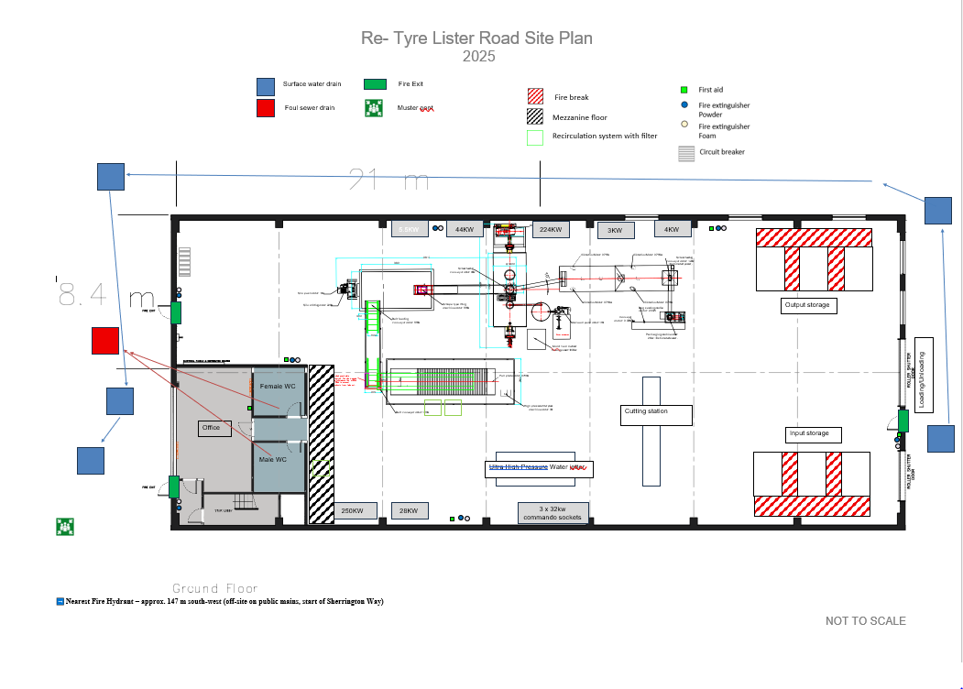
Annex 1 – Site Layout Plan
Annex 2 – Sensitive Receptors Plan
This section identifies and assesses the nearest sensitive human and environmental receptors surrounding the Re-Tyre facility at Unit 5 Sherrington Way, Lister Road Industrial Estate, Basingstoke, RG22 4DQ. The purpose is to demonstrate that the site is suitably located and that potential fire-related impacts—smoke, odour, noise, heat, and contaminated runoff—can be effectively mitigated and will not pose an unacceptable risk to people or the environment.
The reference point for all distances is the approximate centroid of the site at coordinates 51.251212, -1.104207. The site is situated on an established industrial estate with neighbouring units of similar commercial and light industrial use. All waste and processing operations are fully enclosed within the building, which substantially reduces the potential for emissions or smoke to travel off-site during any incident.
Nearest Residential Receptors
The nearest established residential area is located to the east along Wella Road (RG22 4AE), approximately 0.19 kilometres (193 metres) from the site boundary. The residential dwellings are separated from the site by intervening industrial units, internal access roads, and landscaping, providing a substantial physical buffer.
Educational Receptors
The nearest school is Chalk Ridge Primary School (RG22 4ER), located approximately 0.52 kilometres south of the site. Cranbourne Secondary School (RG21 3NP) lies approximately 0.72 kilometres north-east, and Brighton Hill Community School (RG22 4HS) is approximately 0.84 kilometres to the west. The separation distance and enclosed operation mean there is minimal likelihood of smoke or particulate impacts on these receptors.
Healthcare Receptors
The nearest medical and care facilities are located over 900 metres from the site. These include Camrose, Gillies & Hackwood GP Surgery (RG22 4EH) at approximately 0.97 kilometres, Pemberley House Care Home (RG21 3HL) at 1.18 kilometres, and Basingstoke & North Hampshire Hospital (RG24 9NA) approximately 3.29 kilometres away. Dashwood Manor Care Home (RG23 7GF) and Beggarwood Surgery (RG22 4AQ) are both beyond 3.4 kilometres. The risk of smoke, heat, or pollution impacts to these receptors is negligible given the distance, prevailing wind direction, and indoor-only operations.
Open Spaces and Watercourses
The nearest designated open space is Down Grange Meadow Local Nature Reserve, approximately 2.07 kilometres west-southwest of the site. The nearest main watercourse is the River Loddon, with the closest reach located approximately 2.58 kilometres north-east at Eastrop Park. There are no surface-water features or drains connected to the Re-Tyre facility, and the building’s floor is impermeable. In the event of a fire, all fire water will be contained within the building using temporary doorway bunds and subsequently removed by tanker to a licensed facility. This ensures that no contaminated water could reach any external receptor or watercourse.
Summary of Sensitive Receptor Risk
Given the small scale of operations, fully enclosed processing environment, impermeable flooring, and significant separation distances to the nearest sensitive receptors, the risk of adverse environmental impact from a fire at the Re-Tyre site is extremely low. The combination of fire-prevention measures, containment of fire water, and distance to receptors ensures compliance with the EA’s objectives for preventing harm to human health and the environment.
