Re-Tyre Drainage Plan
Permit Reference: EPR/MP3129LS/A001
Prepared by: Charlotte Wingrove
Version: 1.0 – October 2025

Document Control
Item | Detail
Site name and address | Re-Tyre, Unit 5 Sherrington Way, Lister Road Industrial Estate, Basingstoke RG22 4DQ
Permit reference | EPR/MP3129LS/A001
Prepared by | Charlotte Wingrove
Version | 1.0
Date | October 2025
Next review due | October 2026 or after any drainage alteration / incident

Contents
- Introduction
- Site Overview
- Internal Drainage
- External Drainage Infrastructure
- Foul Drainage
- Drainage Types and Flow Direction
- Surfacing and Drainage Catchments
- Pollution-Prevention Measures
- Discharge Points
- Inspection, Maintenance and Review
- Conclusion
- Annex A – Site Drainage Plan (Drawing)

1 Introduction
This Drainage Plan forms part of Re-Tyre’s environmental-management system for its tyre-recycling facility at Unit 5 Sherrington Way, Basingstoke.
It describes the site’s drainage layout, surfacing, and pollution-control arrangements in line with the Environment Agency’s Guidance.
The aim is to ensure that drainage features are clearly identified and that all staff can easily locate, understand, and manage them in both normal and emergency conditions.

2 Site Overview
Re-Tyre occupies a single industrial building within the Lister Road Industrial Estate. All waste activities—unloading, UHPW cutting, filter-press operation, drying, shaker-table separation, and bagging—take place entirely indoors on an impermeable concrete floor.
External areas comprise a concrete hardstanding yard for loading/unloading, a marked car park, and narrow margins of unmade ground. No external waste storage or processing occurs. The site lies on gently graded land draining toward Sherrington Way, which contains the public surface-water and foul sewers.

3 Internal Drainage
There are no internal drainage channels or gullies within the operational floor area. The reinforced-concrete slab is fully impermeable and slopes slightly toward the main roller-shutter door to aid cleaning.
Process areas have no connection to either the surface-water or foul-sewer systems. Any wash-water from equipment maintenance is collected manually using wet vacuums and disposed of off-site via a licensed waste contractor.
During any spill or firefighting incident, doorway bund boards and temporary barrier dams are deployed across all exits to contain liquids inside the building. Retained fire water or contaminated liquid is then removed by vacuum tanker and sent to a permitted waste-treatment facility. This ensures there is no pathway for pollutants to leave the building.

4 External Drainage Infrastructure
The front yard consists of sound concrete hardstanding that falls gently eastwards toward Sherrington Way.
Two grated gullies collect clean rainfall runoff; these connect to a surface-water drain (Ø300 mm) that exits the site and joins the public surface-water sewer beneath Sherrington Way.
These gullies are inspected monthly for silt or damage. Because no waste, oil, or chemicals are handled outside, the only potential contaminants are from minor vehicle drips, which are controlled by regular sweeping and prompt clean-up using absorbent granules and spill kits stored beside the loading bay.
There are no interceptors or separators. The external system conveys only uncontaminated rainwater from hardstanding and roof areas.

5 Foul Drainage
A separate foul-sewer connection serves the office and welfare block. This line carries only domestic wastewater (toilets, washbasins, and kitchen sink) and connects to the public foul sewer on Sherrington Way.
No trade effluent or process water enters this system. Consequently, no trade-effluent consent is required from the sewerage undertaker.

6 Drainage Types and Flow Direction
The drainage network comprises two distinct and fully separated systems:
- Surface-water system: two external gullies draining by gravity eastwards to the public surface-water sewer on Sherrington Way.
- Foul-water system: internal domestic waste pipework from welfare facilities, flowing to the public foul sewer in the same roadway.
Flow direction arrows and manhole locations are shown on the Site Layout Plan (Final). There are no combined drains and no cross-connections between the systems.

7 Surfacing and Drainage Catchments
Area | Surface type | Drainage destination | Notes
Internal operational floor | Reinforced concrete, impermeable | None (self-contained) | No gullies or outlets
Loading/unloading yard | Concrete hardstanding | Surface-water gullies → public surface-water sewer | Falls toward Sherrington Way
Car park | Hardstanding | Same gullies as yard | Clean rainwater only
Perimeter strips | Unmade / gravel | Infiltration to ground | Outside activity zones
Total drained hardstanding: ~200 m² (yard + car park).

8 Pollution-Prevention Measures
Pollution-control measures include:
- All waste storage and treatment indoors on impermeable flooring.
- No external storage of oils or liquids.
- Spill kits, absorbent pads, and drain-covers positioned near loading area.
- Staff trained to deploy covers immediately if a spill occurs.
- Routine cleaning to remove debris from hardstanding.
- Doorway bund boards for fire-water containment.
- Removal of retained liquids by licensed tanker.
These measures ensure the drainage system conveys only clean water and cannot act as a pollution pathway.

9 Discharge Points
The site has only two authorised discharge points:
- Foul sewer – domestic wastewater from office/welfare facilities.
- Surface-water sewer – clean rainwater from external hardstanding.
There are no discharges to soakaway, combined drains, or watercourses.

10 Inspection, Maintenance and Review
All gullies, manholes, and visible drain runs are inspected monthly. Checks confirm gratings are intact, outlets clear, and no evidence of staining or silt build-up.
Any defects are repaired promptly, and findings are logged in the site’s Environmental Management System.
If resurfacing or drainage alteration occurs, this plan and the Site Layout Plan will be reviewed and re-issued. Updated versions will be provided to the Environment Agency if any change affects pollution-control performance.

11 Conclusion
The Re-Tyre site benefits from a simple, well-defined drainage arrangement that separates clean rainwater from foul sewage and completely isolates process areas.
All operations take place indoors on impermeable flooring with bund containment, eliminating the risk of process liquids entering drains.
Surface water from external hardstanding is clean, passes through two gullies, and joins the public surface-water sewer on Sherrington Way.
Together with staff training, inspection, and spill-response procedures, this system ensures that drainage infrastructure presents no risk of pollution.

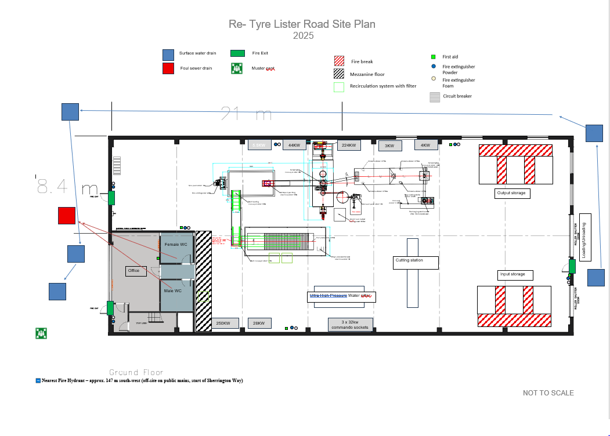
Annex A – Site Drainage Plan (Drawing)

