Centrica Business Solutions UK Ltd

Application for an Environmental Permit at a Multi-Operator Installation

Appendix 4

Site Condition Report

1.0 SITE DETAILS

Name of the applicant | Centrica Business Solutions Ltd
Activity address | c/o Pincroft Dyeing and Printing Co Ltd  Market Street  Adlington  Chorley
National grid reference | SD 6032812690

Document reference and dates for Site Condition Report at permit application and surrender | Environmental Permit Application Site Report – Centrica Business Solutions Ltd – Pincroft CHP

Document references for site plans (including location and boundaries) | The site location boundaries are shown in Figures 1 & 2 of the permit application

Note:
In Part A of the application form you must give us details of the site’s location and provide us with a site plan. We need a detailed site plan (or plans) showing:

- Site location, the area covered by the site condition report, and the location and nature of the activities and/or waste facilities on the site.
- Locations of receptors, sources of emissions/releases, and monitoring points.
- Site drainage.
- Site surfacing.

If this information is not shown on the site plan required by Part A of the application form, then you should submit the additional plan or plans with this site condition report.

2.0 Condition of the land at permit issue

Environmental setting including:  - geology  - hydrogeology  - surface waters |  | Superficial Geology  The British Geological Survey (BGS) 1:50,000 Drift Edition, Wigan, Sheet 84, indicates that the Site is likely to be underlain by cohesive and granular alluvium extending to depths up to 40 metres below ground  level (mbgl).  Bedrock Geology  The British Geological Survey (BGS) 1:50,000 Solid Edition, Wigan, Sheet 84, indicates that the solid geology comprises mudstones, siltstones, sandstones and coals belonging to the Pennine Lower Coal  Measures.  Hydrogeology  The superficial deposits and the solid geology are indicated to contain Secondary A aquifers comprising permeable layers capable of supporting water supplies at a local scale, and in some cases forming an  important source of base flow to rivers.  No direct information is available on the direction of groundwater flow at the Site, but it is considered that this will generally be in a south-westerly direction.  Hydrology  The River Douglas flows along the southern  boundary of the main Pincroft Dyeing and Printing Co. site.
Pollution history including:  - pollution incidents that may have affected land  - historical land-uses and associated contaminants  - any visual/olfactory evidence of existing contamination  - evidence of damage to pollution prevention measures |  | The approximate 234 m² area of land leased to Centrica Business Solutions UK Ltd (CBS) forms part of the Pincroft Dyeing and Printing Co. Ltd site and is within the existing permitted installation site boundary belonging to Pincroft Dyeing and Printing Co. Ltd, as shown in Figures 1 & 2 of the permit application.  A summary of information on site usage taken from historical maps is shown below.  Prior to commencement of the CHP development, the area of land leased to CBS was part of an approximately 2m deep man made reservoir supplied by water from the River Douglas through a network of man made channels and used for process use at the main Pincroft site. The reservoir is a brick and clay-lined structure. Sheet piling installed in accordance with BS 8004:1986 or BS EN 1997-1:2004 and the ICE. Specification for Piling and Embedded Retaining Walls was used to separate a small part of the reservoir and this area was then de-watered. Following completion of the dewatering, all soft material was removed from the base of the area and the clay lining layer exposed. Following proof rolling, the area was filled with type 6F2 stone, with a final 150 mm layer of Type 1 stone beneath the 200 mm mesh reinforced concrete floor slab.  The concrete floor slab includes a 200mm wide x 150mm high reinforced concrete upstand to the platform perimeter to prevent any run off from the area to the adjacent reservoir.
Evidence of historic contamination, for example, historical site investigation, assessment, remediation and verification reports (where available) |  | There are no known pollution incidents associated with this part of the main Pincroft site.  Historical above ground storage tanks were recorded approximately 10 m to the east of the Site between the 1950s and 1990s. It is understood that these tanks contained diesel fuel used in Pincroft’s facility processes.  There are no recorded Contaminated Land Register Entries and Notices within 1 km of the CBS Site.  There are no recorded landfill sites within 250m of the CBS site  There are forty-seven (47) Potentially Infilled Land records within 1 km of the Site. The table below provides additional details for potentially infilled land located within 250 m of the Site:
Baseline soil and groundwater reference data |  | Not required
Supporting information | - Source information identifying environmental setting and pollution incidents  - Historical Ordnance Survey plans  - Site reconnaissance  - Historical investigation / assessment / remediation / verification reports  - Baseline soil and groundwater reference data

Potentially infilled land within 250m of the CBS site
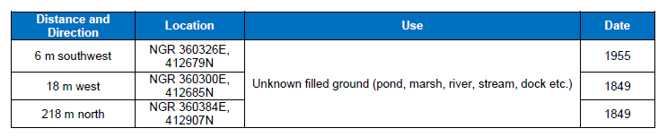

Site history based on historical maps
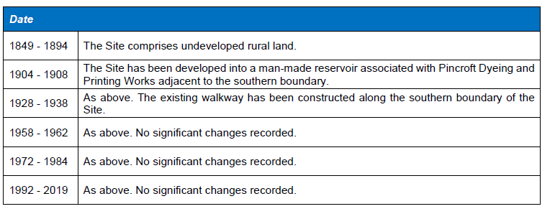

3.0 Permitted activities

Permitted activities | The CHP plant is being permitted as a Directly Associated Activity (DAA) to the main Pincroft site permit
Non-permitted activities undertaken

Document references for:  - plan showing activity layout; and  - environmental risk assessment. | - Figures 1 & 2  - Appendix 1 Environmental Risk Assessment  - H1 tool output

Note:

In Part B of the application form you must tell us about the activities that you will undertake at the site. You must also give us an environmental risk assessment. This risk assessment must be based on our guidance (Environmental Risk Assessment - EPR H1) or use an equivalent approach.

It is essential that you identify in your environmental risk assessment all the substances used and produced that could pollute the soil or groundwater if there were an accident, or if measures to protect land fail.

These include substances that would be classified as ‘dangerous’ under the Control of Major Accident Hazards (COMAH) regulations and also raw materials, fuels, intermediates, products, wastes and effluents.

If your submitted environmental risk assessment does not adequately address the risks to soil and groundwater we may need to request further information from you or even refuse your permit application.

4.0 Changes to the activity

Have there been any changes to the activity boundary? |  | Not applicable at time of permit application
Have there been any changes to the permitted activities? |  | Not applicable at time of permit application
Have any ‘dangerous substances’ not identified in the Application Site Condition Report been used or produced as a result of the permitted activities? |  | Not applicable at time of permit application
Checklist of supporting information | - Plan showing any changes to the boundary (where relevant)  - Description of the changes to the permitted activities (where relevant)  - List of ‘dangerous substances’ used/produced by the permitted activities that were not identified in the Application Site Condition Report (where relevant)

5.0 Measures taken to protect land

Not applicable at time of permit application
Checklist of supporting information | - Inspection records and summary of findings of inspections for all pollution prevention measures  - Records of maintenance, repair and replacement of pollution prevention measures

6.0 Pollution incidents that may have had an impact on land, and their remediation

Not applicable at time of permit application
Checklist of supporting information | - Records of pollution incidents that may have impacted on land  - Records of their investigation and remediation

7.0 Soil gas and water quality monitoring (where undertaken)

Not applicable at time of permit application
Checklist of supporting information | - Description of soil gas and/or water monitoring undertaken  - Monitoring results (including graphs)

8.0 Decommissioning and removal of pollution risk

Not applicable

Checklist of supporting information | - Site closure plan  - List of potential sources of pollution risk  - Investigation and remediation reports (where relevant)

9.0 Reference data and remediation (where relevant)

Not applicable
Checklist of supporting information | - Land and/or groundwater data collected at application (if collected)  - Land and/or groundwater data collected at surrender (where needed)  - Assessment of satisfactory state  - Remediation and verification reports (where undertaken)

10.0 Statement of site condition

Not applicable

