CATS AND DUST LIMITED
UNIT 12 TWIN LAKES INDUSTRIAL ESTATE BRETHERTON ROAD, LEYLAND, PR26 9RF

DUST & PARTICULATE EMISSION MANAGEMENT PLAN

VERSION NUMBER 1.1 DATE 25/11/2022

Revision History
Revision Date | Description | Sections Affected | Revised By | Approved By
25/11/2022 | Update |  | D Alcock | S Bryce

Contents
1 Introduction 3
2. Sensitive Receptors 3
Image 1.1 Cats and Dust site. 4
Image 1.2 Opposite Site 4
Figure 1.1 Closest Sensitive Properties 5
Table 1.1 Distances to Selected, Representative Sensitive Locations 5
3 Operations at UNIT 12, TWIN LAKES IND EST 6
3.1 Waste Deliveries to RF Recycling 6
3.2 Overview of Waste Processing and Dust Controls 6
Table 2.1 Typical waste types brought to 12 TWIN LAKES IND EST 6
Figure 2.2 Site Layout Plan 7
Table 2.2 Typical Destination for Recovered Materials and Residual Wastes 8
4 Dust and Particulate (PM10) Management 8
4.1 Responsibility for Implementation of the DMP 8
4.2 Sources and Control of Fugitive Dust/Particulate Emissions 9
4.3 Visual Dust Monitoring 9
5. PM10 Monitoring 9
6. Reporting and Complaints Response 10
6.1 Reporting of Complaints 10
7. Summary and management responsibilities 10

Introduction
This document is in response to a request under Cats and Dust Limited’s permit application. The purpose of the following is to explain that dust isn’t considered a waste, nuisance or by-product of our business but the fact that any dust generated in our process has a potential monetary value as it will contain small amounts of precious metals oxides. It is therefore not just a precaution but a necessity to the business to ensure we have no dust residues anywhere within the site.

Twin Lakes Industrial Estate is located on a modern Industrial Estate in Leyland, Lancashire, surrounded immediately by other businesses. The site has a single secure point of access that determines a “no through-traffic” situation and such does not attract a high number of vehicles or pedestrians.

The site’s operations (including loading and unloading of all materials) is contained within a closed environment. The structure of which is steel frame, part block walls with the rest clad in metal.

The main process which happens within the premises is the de-canning of waste automotive catalysts. This is a simple process that uses a set of shears to cut in half the metal can containing the catalyst and then allowing the catalyst material to fall from the can in a broken state, thus separating the inner component from the outer casing.

We have very strict dust control policies (dust capture and value recovery) that all or Cats and Dust’s staff are made aware of and are reminded of on a regular basis. As there are no recognised standards in our industry, we have employed best practices learned through our years of expertise, knowledge and by consulting with dust extraction experts.

Central to Cats and Dust’s business is the recovery of precious metals contained within the core of waste catalysts. Therefore our entire operation is focused on maximising the collection of all materials containing value. This isn’t an awareness of dust management and prevention; this is our primary business and a requirement for our success. Our management system and risk control procedures demonstrate that we are well equipped to prevent environmental or health and safety dangers. This is not because of precautionary measures, but because a key component in the day- to-day operation of the business is that no dust, if present, has the ability to leave our site (due to an enclosed operation with internal abatement only).

2. Sensitive Receptors

Whilst taking into consideration proposed potential sensitive receptors and the guidance provided we have listed what we consider these to be in Table 1.1 below.

There are other potential receptors within the local business community. However, these potential receptors are not at a higher risk of susceptibility to any adverse effects (due to age, health condition, or the possibility of prolonged direct exposure) as would be small children or the elderly. We have therefore provided imagery of the immediate local community. These images illustrate that during normal operating hours none of the immediate receptors have any external operations or operate in an open environment, thus reducing the potential of both short-term and long-term exposure to any particulate matter.

Image 1.1 Cats and Dust site.
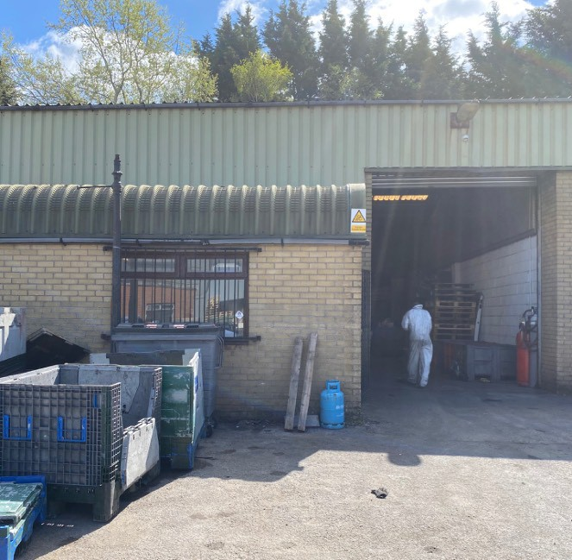

Image 1.2 Opposite Site

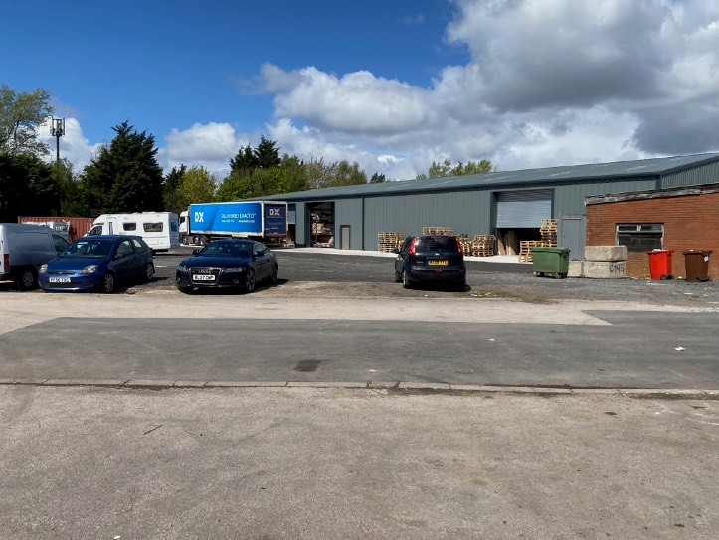

Figure 1.1 Closest Sensitive Properties
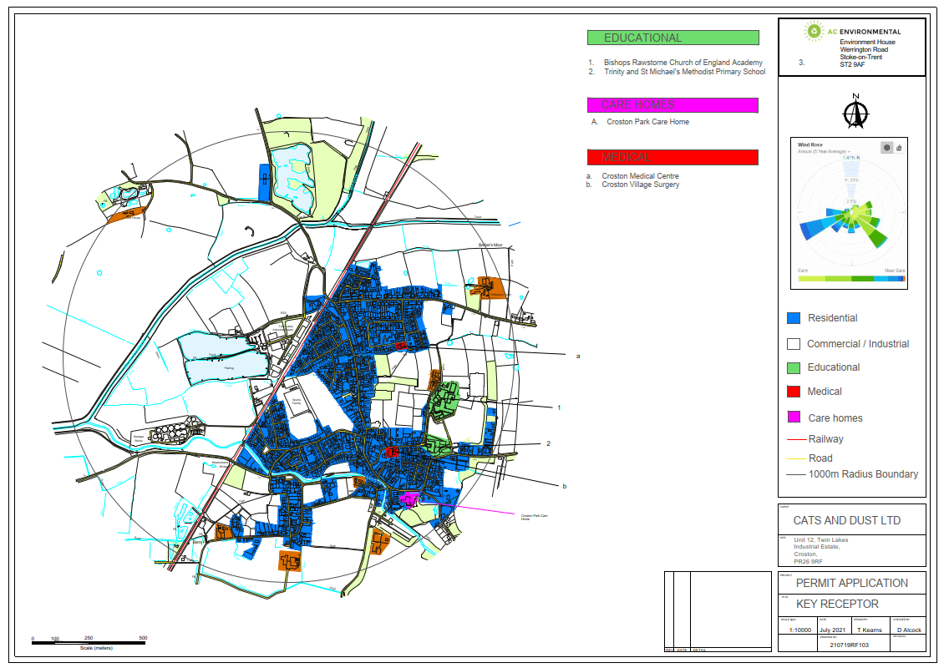

Table 1.1 Distances to Selected, Representative Sensitive Locations

Boundary | Closest Property | Approximate Distance  to Cats and Dust Boundary (m)
East | Residential Properties | 50
North/West | Other industrial operations | 0-180
East | Rainbow Day Nursery | 280
North | Little Acorns Nursery | 240
East | Bishops Rawstorne Church of England Academy | 700
East | Trinity and St Michael's Methodist Primary School | 750
East | Croston Park Care Home | 813
East | Croston Medical Centre | 500
East | Croston Village Surgery | 617

Operations at UNIT 12, TWIN LAKES IND EST

Waste Deliveries to RF Recycling

All waste is delivered to site in containers, using either 7.5 ton curtain side vehicles or 3.5 ton light commercial vans. No waste is openly transported. Containers are steel cage or solid surface type.

Waste automotive catalysts are delivered to site, still within the exhaust system and not open to agitation or any form of activity which could cause deconstruction of the units. If broken units are to be transported these are in sealed solid containers to prevent loss of value through material escaping, which includes fine particulate matter.
All waste delivered is accompanied by a waste transfer note, which is then recorded and the delivery matched to details before acceptance.

Customers do not require any information regarding dust as no waste materials are permitted to be shipped unless fully sealed.

Overview of Waste Processing and Dust Controls

Table 2.1 Typical waste types brought to 12 TWIN LAKES IND EST

EWC Code | Product Description | Tonnes per week | Destination within facility (see figure 2.2)
 |  |  | Storage | Processing | Sorting | Goods In/ Out
16.01.21* | Waste automotive catalysts containing rcf | 5 | Yes (green zone) | Yes (orange zone) | Yes (yellow zone) | Yes (red zone)
16.01.22 | Waste automotive catalysts | 5 | Yes (green zone) | Yes (orange zone) | Yes (yellow zone) | Yes (red zone)
16.08.01 | Spent Catalysts containing Gold, Silver, Rhenium, Rhodium, Palladium, Iridium or PlaAnum | 1 | Yes(green zone) |  | Yes(yellow zone) | Yes (red zone)
Total |  | 11

Figure 2.2 Site Layout Plan
Storage
Processing
Office Space
Decanning Area

Milling and Sampling

Goods In/ Out

Sorting
Toilet

The site is focused on both dust prevention and dust capture. As stated in the introduction, every gram of dust has a value. Therefore, the infrastructure that we employ involves ensuring all areas of processing are contained in a shielded environment and have dust control by LEV with HEPA filters. This is known as the decanning area.

A decanning station (shown in Figure 2.2) is a single enclosed alligator shear with access to the front for the input of waste catalysts. LEV points are set specifically within each enclosure at a level designed to maximise dust capture.

The milling and sampling area (shown in Figure 2.2) is a sealed and self-contained environment within the processing area. Material entering this area is deposited via an open hopper. At this entry point there are extraction points which remove any dust into a secure container to ensure 100% capture of valuable materials.

All equipment is visually checked daily for signs of seal breaches which may cause loss of particulate material which would also lead to a direct financial loss.

During processing we have a closed-site policy. No visitors are allowed during processing. All workers wear disposable clothing which is removed within the site confines and the entire facility is vacuumed at the end of each working day. This includes all floor and working surfaces, including storage and equipment.

Table 2.2 Typical Destination for Recovered Materials and Residual Wastes

Destination for Recovered and Residual Materials: Export from Unit 12, Twin
Lakes Ind Est
EWC | Product Description | Average Weekly  Tonnage | Material End Use
 |  |  | Smelting for reuse of
16.08.01 | spent catalysts containing gold, silver, rhenium,  rhodium, palladium, iridium or platinum | 1 | metals in various  products including
 |  |  | new catalysts
 |  |  | Smelting for
16.01.17 | Ferrous metals e.g. cleaned CAT shells and exhaust stubs removed from CATs | 10 | reproduction of steel
 |  |  | or iron
Total |  | 11

Dust and Particulate (PM10) Management

Responsibility for Implementation of the DMP

Ultimate responsibility resides with the managing director, with the operations supervisor ensuring its daily compliance and the operational staff tasked with making sure they follow procedures correctly.

Both our Dust and Particulate Policy and this Dust Management Plan will be reviewed on an annual basis or in the event of continued failing.

All staff are all given specific training in their roles, which for the operational staff includes the necessity for dust and particulate collection and sign to say they are competent and understand the instructions. The site is inspected at the end of each day by management.

Although repeating information found previously in this document, it is essential to the success of Cats and Dust’s business that all dust is captured. Unlike other organisations it is not just a nuisance or hazard, but capture of dust is key to the financial success of the company, therefore every staff member may be disciplined for situations where they have put the company at risk of financial loss through non-compliance with procedures regarding dust capture.

Sources and Control of Fugitive Dust/Particulate Emissions

Site operations include handling, storage and treatment by cutting of Catalytic Converters. Whilst in theory these operations could give rise to dusts, in practice the measures in place to capture dust for it’s financial value, ensure that no dust escapes and therefore there are no operations at the site that could give rise to the production of airborne dust and particulates. Only a failure of equipment or an incident could cause the potential release of dust/particulate matter.

In the event of such an incident, local receptors are immediately protected as all operations are within a closed building and situated away from any doorway.

Visual Dust Monitoring

The operational supervisor is the initial point of first dust capture (control and monitoring). This activity is on three levels:

    - Routine maintenance and inspection of equipment that is designed to contain and collect dust at the point where it may be created. This includes LEV ducting, shielding and sheeting.
    - Site walk round as part of site health and safety activities. Looking for hazards caused by misplaced items (trip hazards etc) during these daily routines. The site is also inspected for dust residue.
    - Operational activity monitoring by staff. This is where it is the actual worker who participates in an activity where dust capture is necessary. It is part of their duty to ensure he or she is aware of the environment around them and the effectiveness of all dust capture equipment they are using.

Following these inspections action can be taken e.g. cleaning of surfaces with damp rags, vacuuming using an industrial vacuum with HEPA filter, to collect any dust residue that may have occurred.

As the sites operational activities and storage are all contained within a secure and sealed building there is no need for site dust monitoring out of hours.

We do not record air quality in our dust monitoring. This is not considered necessary due to the extremely low volume of dust that we may create. However, LEV testing will be undertaken to coincide with our maintenance check.

In the unlikely event that, dust deposits are detected the area will be immediately vacuumed to remove any dust particles found.

In the event of a complete failure of dust collection, whereby visible accumulations of dust are produced, then all activities will cease and the building shall remain closed until the source has been located and corrected and an entire clean up (vacuum and capture) has been completed.

PM10 Monitoring
The site does not use technology to monitor its site for dust and particulate matter. Our site policies, procedures and practices are considered sufficient to adequately control dust and to make fixed permanent monitoring for dust unnecessary, based on our long-standing expertise of the industry.

Reporting and Complaints Response

6.1 Reporting of Complaints
Complaints are unlikely given the procedures outlined above, but should complaints be received these are firstly recorded and reported to site management. Site management would then undertake a complaint investigation to ascertain the vera city of the complaint and suitable action would be taken in response to the complaint. These actions may include rectification or repair works, review of procedures or re-training of staff. Any complaints will be fully investigated, and a response provided to the complainant within 48 hours.

7. Summary and management responsibilities
It is the company’s aim to ensure every gram of dust is captured and contained within our site. This plan is key in making staff understand the value of the dust we might create and how important it is to the company that airborne/free dust is not created but that all dust is captured and contained.
This management plan ensures that dust shall not be created which can escape site processes. Its prime aim is to ensure collection of dust as any dust contains highly valuable precious metal particles and is the sole source of revenue for the company.
Escape of dust is simply not acceptable.

Senior management are involved in regular daily visual inspections and conversations regarding the effectiveness of equipment and procedures that capture dust we might create in our processes.

“Dust is not to be tolerated at any level within our business”

Cavin Mears
Managing Director
Cats and Dust Limited

