G E Heard & Sons LTD

Marshlands Road, Farlington, Portsmouth, Hampshire, PO6 1SS

DUST & EMISSION MANAGEMENT PLAN
(DEMP)
VERSION NUMBER: 1
DATE: 10 02 2025

Table of Revisions:
Date | Comments
10/02/2025 | Initial Draft

Contents Page
1. Introduction
1.1 Sensitive Receptors
2. Operations at G E Heard & Sons Ltd
2.1 Waste Deliveries to G E Heard & Sons Ltd
2.2 Overview of Waste Processing, Dust, and Other Emission Controls
2.3 Mobile Plant and Equipment
3. Dust and Particulate (PM10) Management

3.1 Responsibility for Implementation of the DEMP
3.2 Sources and Control of Fugitive Dust and Emissions
3.3 Enclosure of Waste Processing & Storage Areas
3.4 Visual Dust Monitoring

4. Particulate Matter (PM10) Monitoring
5. Actions When Alarm is Triggered
6. Reporting and Complaints Response
6.1 Engagement with the Community
6.2 Reporting of Complaints
6.3 Management Responsibilities
6.4 Summary

1. Introduction
G E Heard & Sons Limited, located at Marshlands Road, Farlington, Portsmouth, Hampshire, PO6 1SS, operates within the jurisdiction of Portsmouth City Council. Our facility specializes in the reconditioning of steel and plastic drums and Intermediate Bulk Containers (IBCs). The reconditioning process involves several key steps:
- Storage: Drums are categorized and stored based on their type.
- Washing: Each drum undergoes thorough washing to remove internal residues.
- Inspection and Drying: Post-washing, drums are inspected for integrity and then dried.
- External Residue Removal: Any external residues are meticulously cleaned.
- Shot Blasting: Drums are shot blasted to remove rust and old paint, preparing them for reuse.
- Leak Testing: Each drum is tested to ensure there are no leaks.
- Painting: Finally, drums are repainted.
Our facility is surrounded by other industrial units, which provides a natural buffer to neighbouring areas. The site features a high fireproof concrete boundary wall between our yard and the neighbouring property, which aids in minimizing emissions. Additionally, we have upgraded our drum washing machine exhaust to a turbo exhaust system to further control emissions.
According to Portsmouth City Council, there are currently five Air Quality Management Areas (AQMAs) in the city, designated due to predicted exceedances of the annual nitrogen dioxide National Air Quality Objective (NAQO).
portsmouth.gov.uk
However, our specific location in Farlington is not within any of these designated AQMAs.
Without the implementation of abatement controls, certain processes at our facility, such as shot blasting, have the potential to generate dust emissions. However, our site infrastructure and operational procedures have been developed over time to effectively minimize these emissions. The high boundary wall and upgraded exhaust systems are examples of our commitment to reducing environmental impact.
This Dust and Emissions Management Plan (DEMP) has been developed as part of our license application and serves as a proactive measure to monitor and manage dust emissions during our operations. The purpose of this document is to outline the strategies and controls we have in place to prevent and mitigate dust and other emissions, ensuring compliance with environmental regulations and demonstrating our commitment to environmental stewardship.
This DEMP is an integral component of our broader environmental management system and is intended for use by operational staff, management, and external auditors. It will be accessible on our shared drive and in printed form on-site to ensure all relevant personnel can refer to it as needed.
1.1 Sensitive Receptors
G E Heard & Sons Limited is located within an industrial area; however, there are several sensitive receptors within a 1,000-meter radius that must be considered when assessing the potential impact of dust and emissions. These receptors include residential areas, educational institutions, healthcare facilities, recreational spaces, and ecologically sensitive sites. Additionally, the presence of industrial and commercial activities such as paint shops, offices, diesel generators, busy roads, and food manufacturing facilities within the vicinity must also be considered for potential cross-impact of emissions.
Key sensitive receptors within 1,000 meters of the site include:
- Residential Areas:
  - Housing in Farlington and Drayton to the north and west of the site.
- Educational Institutions:
  - Solent Junior School (~900m northwest)
  - Springfield School (~1,000m west)
- Healthcare Facilities:
  - Farlington Dental Practice (~800m northwest)
- Recreational Areas:
  - Drayton Park (~950m west)
  - Portsmouth Golf Course (~1,000m northeast)
- Ecologically Sensitive Sites:
  - Langstone Harbour SSSI (~500m southeast)
- Industrial and Commercial Activities:
  - Surrounding industrial units that may also generate emissions.
  - Busy roads, including the nearby A27, which contributes to background air pollution.
  - Potential paint shops, diesel generators, and air conditioning systems within the industrial estate that may be affected by or contribute to airborne particulates.
Given the proximity of these receptors, it is important to ensure that dust and emissions from the site are minimised to prevent any adverse effects on air quality, environmental integrity, and public health. Mitigation measures, such as maintaining clean operational areas, regular monitoring, and controlling emissions at the source, are essential to comply with regulatory requirements and protect the surrounding community.


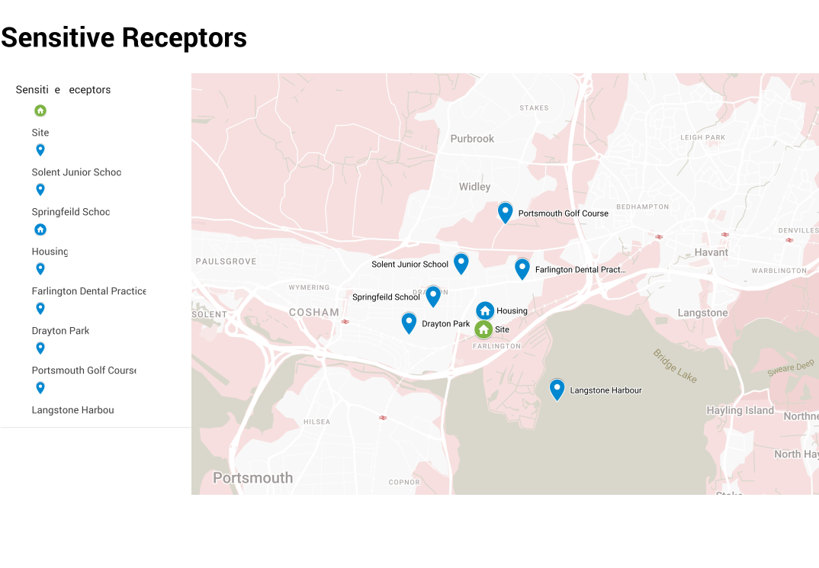 Figure 1.1: Nearby Sensitive Receptors
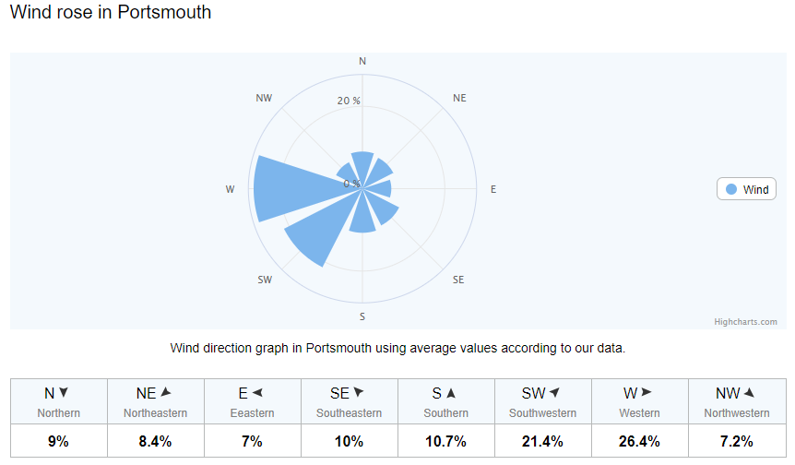

Figure 1.2 : Average wind direction at G E Heard & Sons LTD

Table 1.1 Distances to Selected, Representative Sensitive Locations
Boundary | Closest Property | Approximate distance to G E Heard & Sons Ltd site boundary (m)
North | Farlington Housing | 380
Southeast | Langstone Harbor SSSI | 500
northwest | Farlington Dental Practice | 800
Northwest | Solent Junior School | 900
west | Drayton Park | 950
Northeast | Portsmouth Golf Course | 990
west | Springfield School | 1000

Table 1.2 Sources of Dust and/or other Emissions
Company | Address | Type of Business | Distance from G E Heard & Sons Ltd site boundary (m)
Network rail | Marshlands Road | Busy Railway Line | 0
Tilbury Metals | Old Reservoir Road | Metal Recycling | 0
A & B Motors Ltd | Marshlands Road | Vehicle Body Shop | 10
Part worn tyres 4 U | Marshlands Road | Tyre garage | 23
Motormex | Marshlands Road | Vehicle repair | 40
Production & Development Services | Marshlands Road | Metal works | 40
1st Castle Motorcycle Training | Farlington Playing Field | Motorcycle Training | 68
KKM | Old Reservoir Road | Haulage | 74
Portsmouth Fiberglass | Marshlands Spur | Fiberglass | 86
A & B Motors Ltd | Old Reservoir Road | Vehicle Body Shop | 102
Steer | Fitzherbert Road | Vehicle Body Shop | 166
Sainburys | Fitzherbert Road | Supermarket | 185
Richmond | Fitzherbert Road | Large Car sales | 188
Strukta | Fitzherbert Road | Builders Merchants | 230
 | A27 | Busy Dual Carriageway | 506
Cmex | Walton Road | Concrete Plant | 1000
2. Operations at G E Heard & Sons Ltd
2.1 Waste Deliveries to G E Heard & Sons Ltd
All waste deliveries to G E Heard & Sons Limited are transported by road using articulated lorries. The lorries are Euro 5 / Euro 6.
The waste primarily consists of empty drums and IBCs, which are classified as waste upon arrival at the site.
Each load is accompanied by a consignment note, ensuring full traceability and compliance with waste management regulations. These records document key details such as the type and quantity of waste, the origin of the load, and the responsible carrier.
While the delivered drums are empty, they are still considered waste and must be handled in accordance with environmental and safety regulations. No special instructions regarding dusty loads are currently required, as the waste does not generate significant airborne dust.

.

Table 2.1 Typical waste types brought to G. E. Heard & Sons Ltd
European Waste Code (EWC) | Product Description | Tons/week | Destination within facility
15 01 10 | Packaging containing residues of or contaminated by hazardous substances (Drums) | 30 | Barrel Stock Storage
15 01 02 | Empty packaging contaminated with residues of non-hazardous substances (Drums) | 20 | Barrel Stock Storage
15 01 10 | Packaging containing residues of or contaminated by hazardous substances (IBCs) | 6 | IBC Storage Area

2.2 Overview of Waste Processing, Dust, and Other Emission Controls
The site layout is optimised to ensure efficient handling and minimal double handling of waste materials. The processing of drums and IBCs is carried out in clearly defined areas within the concrete yard, including designated areas for washing, inspection, shot blasting, painting, and storage.
Shot blasting takes place within an enclosed blasting cabinet inside the main building. Dust from this process is extracted via ducting into an external dust collection silo. The silo captures particulate matter, and the collected dust is periodically transferred into sealed drums and removed by a licensed waste contractor.
The concrete yard reduces dust generation from vehicle and foot traffic.
2.3 The following mobile plant and equipment is used on site:
The following mobile plant and equipment is used on site:
Description | Make | Model | Emission Rating
Forklift Truck | Hyster | H2.5FT | Stage V (Euro V equivalent)
Jet Washer | Kärcher | Diesel Model | N/A (used for washing, not mobile site plant)

The forklift is owned by the company and is maintained according to the manufacturer’s recommended service schedule. Regular inspections are carried out, and any necessary repairs or replacements are performed promptly to ensure safe and low-emission operation.

The site uses ultra-low sulphur diesel (ULSD) and encourages anti-idling practices to reduce unnecessary emissions. The use of mobile plant is limited to essential operational activities, thereby minimising fuel consumption and emissions

3. Dust and Particulate (PM10) Management
3.1 Responsibility for Implementation of the DEMP
The Site Manager is responsible for implementing and maintaining the Dust and Emissions Management Plan. In their absence, the Operations Supervisor will act as deputy.
Staff are trained in dust awareness, housekeeping protocols, and environmental monitoring as part of their induction and receive refresher training annually. Records of all training are maintained on-site.
The DEMP will be reviewed annually or following any significant change to site operations or after any complaint related to dust or emissions
3.2 Sources and Control of Fugitive Dust and Emissions
While dust is minimal at this site, the following potential sources have been identified:
Source | Pathway | Receptor | Control Measure
Vehicle movement on concrete | Airborne Suspension | Nearby Receptors | Site Speed limit (5mph) regular sweeping and washing
Shot blast inside building | Ventilation system | Dust collection silo | Enclosed process with ducted extraction
Forklift engine emissions | Atmospheric dispersion | Surrounding area | Well-maintained Euro V Engine anti-idling policy
Manual cleaning and painting | Air (minor) | Minimal Offsite risk | Carried out inside or enclosed areas

Preventative controls include:
- Fully enclosed shot blasting process
- Outdoor silo for dust capture
- Weekly visual inspections
- Minimal open-air waste handling
- Clean concrete yard maintained by jet washing
Should any control fail, or dust emissions be observed offsite, the responsible person will investigate immediately, cease relevant operations, and implement corrective action.
3.3 Enclosure of Waste Processing & Storage Areas
All shot blasting and painting operations are fully enclosed within the site building. Other activities such as washing and storage take place in open yard areas, which are bounded by concrete walls to disrupt wind flow and reduce the likelihood of wind-blown dust.
Due to the low-dust nature of the operation and full containment of the dust-producing activity, further enclosure is not considered necessary currently.
3.4 Visual Dust Monitoring
Visual dust monitoring is carried out weekly as part of routine site inspections. These inspections are recorded, and any observations of visible dust are noted and acted upon.
If visible dust is detected:
- The activity will be paused
- The source will be identified
- Dust suppression (e.g. dampening with jet washers) will be applied if needed
- The event will be logged in the site diary
In the event of persistent issues or complaints, further investigation or enhanced monitoring may be undertaken.

4. Particulate Matter (PM10) Monitoring
Note: PM10 refers to airborne particulate matter that is less than 10 microns in diameter — small enough to enter the lungs and cause health concerns.
Due to the low-dust operations and full enclosure of the dust-producing process (shot blasting), continuous PM10 monitoring is not currently installed.
Should operations change significantly, or if required by the Environment Agency, G E Heard & Sons Ltd is prepared to install indicative PM10 monitoring equipment to monitor particulate levels and help identify potential sources.
5. Actions When Alarm is Triggered
Not applicable currently, as no PM10 monitoring system with alarms is in place.
If installed in the future, an appropriate action level (e.g. 75 µg/m³ over 5 minutes) will be set. The Site Manager or Supervisor will be alerted by email or SMS and will:
- Investigate the source of dust
- Cease dust-generating operations
- Apply corrective measures (e.g. cleaning, isolation of source)
- Resume operations only once PM10 levels fall below the trigger threshold
All findings will be logged and the DEMP updated if required.

6. Reporting and Complaints Response
6.1 Engagement with the Community

The site maintains open communication with neighbouring businesses. Although there is minimal risk of dust emissions impacting the wider community, contact details are displayed at the site entrance, and local businesses can raise concerns directly with the Site Manager.
6.2 Reporting of Complaints
Any complaints relating to dust or emissions are recorded in the site complaints log. The complaint is investigated within 2 working days, and findings are shared with the complainant where possible.
Each record includes:
- Date/time of complaint
- Nature of concern
- Operational status of site
- Investigation outcome
- Actions taken

6.3 Management Responsibilities
The Site Manager is responsible for handling complaints. All complaints are reviewed at management meetings, and if recurring themes are identified, they will trigger a formal review of the DEMP.
6.4 Summary
This Dust and Emission Management Plan outlines the steps taken by G E Heard & Sons Ltd to minimise environmental impact from site operations. Through proactive design, enclosed dust-producing activities, and regular inspections, the business aims to remain compliant and protect local air quality.
The DEMP will be reviewed annually or following any significant operational change, dust complaint, or at the request of the Environment Agency.

