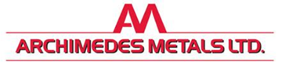

**Non-technical Summary.**

1. **Introductory Note**

This non-technical summary accompanies the permit application for a bespoke permit for Archimedes Metals Ltd, a metals recycling site based at 9-10 Ackworth Road, Hilsea, Portsmouth PO3 5NS.

The company have been operating under a T9 exemption but due to changes with the environmental permitting regime they are now required to obtain an environmental permit.

Due to their proximity (approximately 900m) to Chichester and Langstone Harbour SSSI, SPA and RAMSAR sites the company are required to apply for a bespoke permit.

1. **Site activities**

The site intends to continue to operate as they have under the T9 exemption treating the same wastes in the same way. This includes a range of non-ferrous and ferrous metals, cable, batteries, catalytic converters and general wastes including non-hazardous white goods such as washing machines. For processing the wastes on site within the processing shed there are 2 x static pedal operated shears, 1 x baler and 2 x cable strippers.

1. **EWC codes**

The EWC codes will follow those in the equivalent standard rules permit with the addition of:

**For light white goods such as washing machines:**

**20 01 36** Discarded electrical and electronic equipment other than those mentioned in

20 01 21, 20 01 23 and 20 01 35

**For cable which the site is unable to prove as non-hazardous:**

Cable from construction and demolition work 17 04 10* and 17 04 11

Cable from vehicles 16 01 21* and 16 01 22

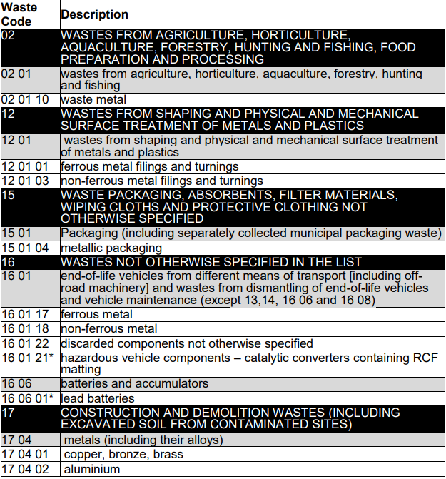

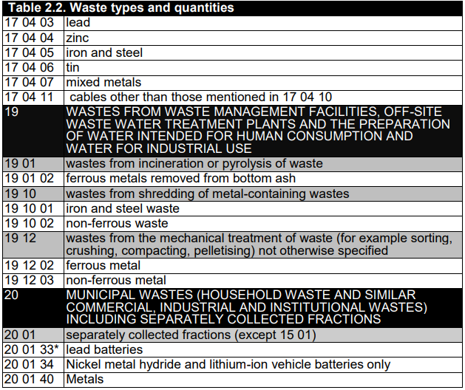

1. **Technical guidance**

Waste acceptance procedures are detailed in the site’s Environmental Management System. All waste is categorised using the Environment Agency’s WM3 waste classification guidance version 1.2 GB (Oct 2021).

For the acceptance and processing of cable the site has followed the guidance in RPS276.

Appropriate measures followed and written into the management system are:

Non-hazardous and inert waste: appropriate measures for permitted facilities.

Waste Electrical and Electronic Equipment (WEEE) to cover the cable accepted and

End of Life Vehicles (ELV) to cover the catalytic converters and cable.

1. **Conclusion**

There are no new risks associated with this metal recycling site as it will continue to operate as per the T9 exemption, this includes waste acceptance, waste processes and waste throughput (which is limited by the operational area of the site).