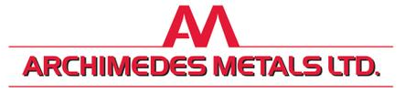

Fire Prevention Plan

Archimedes Metals Ltd

9-10 Ackworth Road

Hilsea

Portsmouth

PO3 5NS

V1.0 December 2023

**Contents**

1. Introduction

Figure 1 Aerial view of Archimedes Metals Ltd.

Figure 2 aerial view of the industrial estate

1. Site Information

Figure 3 A 1km plan of the surrounding area

Figure 4 windrose showing the prevailing wind

1. Site History
2. Waste Acceptance and Controls
3. Waste storage and volumes

Table 1.0 waste types and volumes

1. Security
2. Managing Common Causes of Fire
3. Fire Detection
4. Fire Impact Reduction Measures
5. Quarantine Area
6. Suppression and Fire Fighting Techniques
7. Water Supply
8. Water Containment
9. Contingencies

Appendix I – Site plan

Appendix II - Drainage plan and suppression points

|  |  |
| --- | --- |
| Site Address | 9-10 Ackworth Road, Hilsea, Portsmouth PO3 5NS |
| Site Operator | Archimedes Metals Ltd |
| NGR | SU 66441 04182 |

|  |  |  |  |
| --- | --- | --- | --- |
| **Contact** | **Position** | **Office hours contact** | **Emergency contact** |
| Jason Bulloch | Director/Technically Competent Manager | 07886936544 | 07886936544 |
| Queen Alexandra Hospital | Cosham, Portsmouth PO6 3LY | 0239228600 | 999 |
| Copnor Road Surgery (closest to site) | 358 Copnor Road, Portsmouth PO3 5EL | 023 9200 9265 | 999 |
| Eastern Hampshire Police Station | Airport Service Road  Portsmouth PO3 5GE |  | 999 |
| Cosham Fire Station | Wayte Street, Cosham, Portsmouth PO6 3BS | 023 8064 4000 | 999 |
| Environment Agency | Station Road, Romsey SO51 7LP | 03708 506 506 | 0800 80 70 60 |
| Portsmouth City Council | Civic Office, Guildhall Walk, Portsmouth  PO1 2AL | 023 9282 2251 | 023 9282 2251 |
| Southern Water | Southern House, Yeoman Road, Worthing, West Sussex BN13 3NX |  | 0330 303 0368 |

**Version Control.**

|  |  |  |  |
| --- | --- | --- | --- |
| **FPP prepared by:** | **Position** | **Date** |  |
| Claire Cowdrey BSc(Hons) MCIWM | Environmental Consultant | December 2023 | Original for permit application. |
| **Updated:** |  |  | **Next Review Date** |
|  |  |  |  |
|  |  |  |  |
|  |  |  |  |
|  |  |  |  |
|  |  |  |  |
|  |  |  |  |
|  |  |  |  |
|  |  |  |  |
|  |  |  |  |
|  |  |  |  |
|  |  |  |  |
|  |  |  |  |
|  |  |  |  |
|  |  |  |  |
|  |  |  |  |
|  |  |  |  |

This document must be reviewed annually or sooner from the date of approval or should there be changes made to the site or incidents which may impact on the Fire Prevention Plan.

|  |
| --- |
| **1.0 Introduction.** |
| Archimedes Metals Ltd is a family run business which has been operating from the site in Hilsea, Portsmouth since 1987. The current owner/operator has had control over the operations since 1992.  The site is located within a busy industrial estate located to the north of Portsmouth with good links to the M27, A27 and the M275.    There are 8 full time employees at the site and 1 part time employee.  The site’s opening times are:  7:30am – 4:45pm Monday – Friday  7:30am – 11:45am on Saturdays.  This plan has been prepared as part of a permit application as it is the intention of the site to continue to sort and store combustible waste as part of the waste treatment and transfer operation at an Environment Agency Permitted site. It forms part of the Management System for the site but is a standalone document. As well as being kept digitally a hard copy will be kept in the main office on site, next to the entrance and all staff and contractors are made aware of its contents on induction. The plan is tested and reviewed annually or sooner if required.  This plan sets out how the site will comply with the guidance set by the Environment Agency and how it will:   1. Minimise the likelihood of a fire happening 2. Aim for the fire to be extinguished within 4 hours 3. Minimise the spread of the fire within the site and to neighbouring sites.   In accordance with Archimedes Metals Ltd’s permit no more than 75,000 tonnes of waste will be accepted at the site in any 1 year.  Fire Prevention Plan Testing.  The plan is tested annually. Staff on site are asked numerous questions from the Fire Prevention Plan to test  their understanding of it and ensure they are aware of what to do in the event of a fire. This is recorded in the  site diary. This also tests the Fire Prevention Plan’s relevance and should any updates or modifications to the  site or the plan be required these will be carried out immediately. The Environment Agency will be sent an  updated copy for approval.    Annually, a practical exercise to test the FPP takes place and is recorded in the site diary. Like a spill drill this  includes, using the pollution control equipment, plant and machinery and fire control equipment  on site to ensure all staff know what to do safely in the event of a fire. A different scenario is scripted by the site  management each year to ensure over time different causes and effects are considered. This is all preceded with  the strict instruction that in the event of a real fire on site these procedures will only be carried out if safe to do  so and protection of human life is paramount. These practical exercises are reviewed, and feedback given to  staff on their performance.    The site office is within the perimeter of the operational site, to the right of the entrance, and away from  significant processing and storage areas. A hard copy of the Fire Prevention Plan, site drainage plan  and waste storage plan are kept in the office to assist the Fire and Rescue Service if needed. |
|  |

**Figure 1 Aerial view of Archimedes Metals Limited (source: googlemaps.com)**

Archimedes Metals Ltd

SU66441 04182

**Figure 2 Aerial View of the wider industrial estate (source: googlemaps.com)**

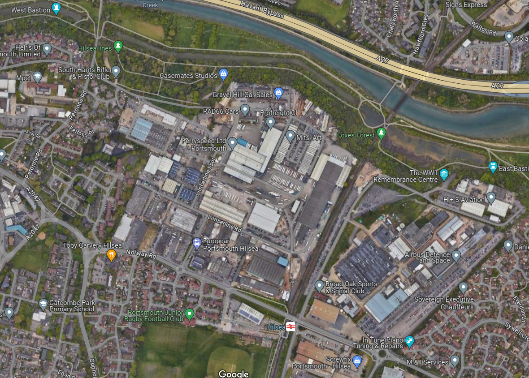

Archimedes Metals Ltd

|  |  |
| --- | --- |
| **2.0 – Site Information** | |
| Site activities | The permitted activities undertaken at the site relate to the storage, processing, handling and  transfer of waste metals including:   * Storage * Sorting * Separation * Grading * Shearing * Baling * Compacting * Cutting using handheld equipment |
| Site Plan | * Area plan – see Figure 1 * FPP Site plan – see Appendix I |
| Site Plan 1km radius | Figure 3 is an aerial plan of Archimedes Metals Ltd denoting a 1km radius. Sensitive receptions within the 1km boundary are listed below.  The site is situated within a busy industrial estate.  North   |  |  | | --- | --- | | 100m | Portsbridge Creek – Tidal waterway | | 200m | A27 main trunk road | | 208m + | Residential dwellings | | 274m | Redwood Park School | | 447m NW | Highbury College | | 515m NW | Highbury Primary and Nursery School |   West   |  |  | | --- | --- | | 710m | MPTC – military college | | 500m + | Residential dwellings |   South   |  |  | | --- | --- | | 553m | Residential dwellings |   East   |  |  | | --- | --- | | 509m | Chichester and Langstone Harbour RAMSAR site, Special Protected Area & Langstone Harbour SSSI | | 509m | Solent Maritime Special Area of Conservation | | 600m | Residential dwellings |  * There are no groundwater, boreholes, springs or wells used for human consumption within 1km * There are no nursing homes, hospitals or care homes within 1km of the site. |

Figure 3. A 1km plan of the site (source: Defra magicmaps.gov.uk)



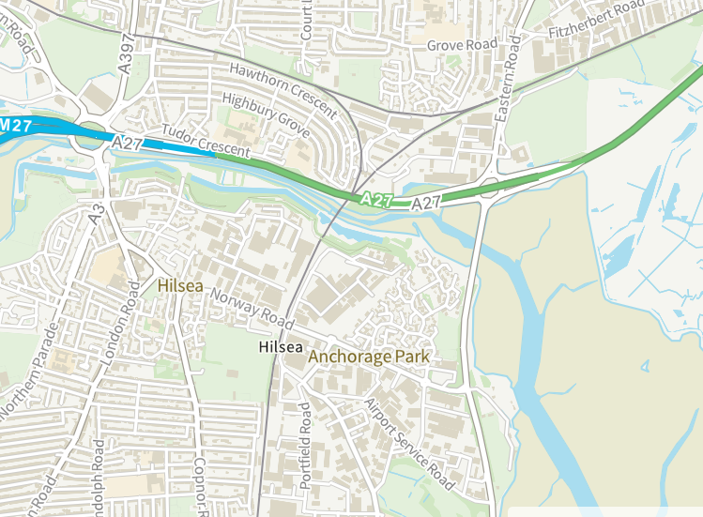

The site

|  |
| --- |
| The windrose taken from [www.world-weather.info](http://www.world-weather.info) (Portsmouth) (figure 4) shows the prevailing wind direction is mainly from the south to west quadrant. In the unlikely event of a fire this would mean that there is a bigger possibility that any smoke generated would be directed away from the main industrial estate and would be carried off over the adjacent lakes and estuaries. |

Figure 4. Windrose (source: world-weather.info)

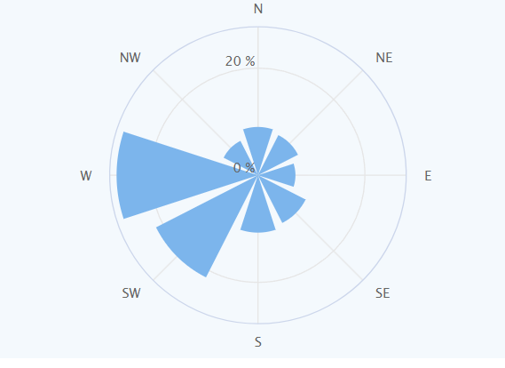

|  |  |
| --- | --- |
| 3.0 Site History | |
|  | The current site has been used for scrap metal processing operations since 1987 and the current owner/operator took over the running of the site from his father in 1992. Over that time major improvements have been made to both the infrastructure and the processes on site. The site is completely paved with an impermeable surface which leads via a class 1 full retention interceptor to the main foul sewer (see appendix II site drainage plan). The site is surrounded by solid metal fencing or brick-built walls. There is extensive CCTV and antitheft devices on site and the main gate is securely locked out of hours. There is processing shed on site where smaller metal waste is sorted into component parts as best as is practically possible.  The site infrastructure comprises of a large, fixed processing building measuring 23m x 15m and is completely enclosed. The transfer shed is used for the manual sorting of metals, shearing, baling and stripping of cables. |

|  |  |
| --- | --- |
| 4.0 Waste Acceptance and Controls | |
| Waste acceptance  Rejected loads  Hot loads | Archimedes Metals Ltd operate 2 X skip lorries for their larger skip collections from clients. Members of the public are also permitted to deposit scrap metal on site. All members of the public who enter the site with wastes are asked to produce evidence that they are registered with the Environment Agency to carry waste. Wastes brought in by householders from their homes are exempt from registering. Archimedes Metals have a register of regular clients and are able to confirm waste carrier’s registration.  The waste types currently accepted on site are ferrous and non-ferrous scrap metal, mixed metals batteries, cable and catalytic converters.  Waste metals are collected from household, commercial or industrial premises where a declaration is signed by way of receipt and a waste transfer note is completed to ensure that only permitted wastes are collected.  Skip lorry operatives will visually inspect the skips in situ and refuse to remove any loads which do not comply with the permit conditions. On arrival at the site the lorries commence on to the weighbridge and into the main site. Once the skip arrives on site the general content of the skip is checked again by site staff and the driver to ensure consistency with the description on the waste transfer note.  All tipping of waste is monitored by yard operatives as a matter of Health and Safety as well as permit compliance. The load will continue to be sorted and placed in to separate bays or containers for storage and onward recovery. Each skip is unloaded individually and machine sorted before the next skip is unloaded.  Rejected Loads.  Should a driver discover a skip which contains wastes which are not permitted at Archimedes Metals Ltd the skip will not be removed from site until the customer has removed the non-permitted wastes.  If a load reaches the site and is rejected before tipping the load will be returned to the customer. The customer will be informed and a note of the customer shall be made against their ticket. It will also be recorded in the site diary. Should the load be tipped and a small amount of non-conforming waste is discovered this waste is removed to the non-permitted wastes quarantine area within the yard. This is then investigated with the customer. The non-permitted wastes are disposed of as soon as is reasonably practical. Should a large amount of non-conforming wastes be discovered the entire skip will be reloaded and returned to the customer.  Should a hot load be contained within the skip waste, or an entire skip load is seen to be smouldering on inspection, the whole skip will be immediately removed to the FPP quarantine area (see appendix I). It will be dealt with appropriately by either dosing with water or by using the fire hydrants on site. Water supplies are covered separately within this document. If necessary, the Fire and Rescue Service will be called. |

|  |  |
| --- | --- |
| 1. Waste Storage and Volumes | |
|  | The site receives and processes scrap metal waste mainly within the processing building. The processing building is approximately 23m wide along the front elevation with a depth of 15m to the rear of the site meeting the permit boundary. It is in parts a 2-storey building with part of the upper floor accommodating the staff room and a mezzanine for the storage of parts for the machines. The site processes all incoming waste as soon as is practically possible prior to exporting it off site. The processing building floor is swept regularly to prevent vermin, build up of dust and fluff and to ensure good housekeeping and a safe working environment.  The incoming waste is tipped and sorted immediately. Not only does this allow the site to run efficiently it also allows for the skip lorry to get back on the road to continue the collections. Once sorted all wastes are placed in either RORO skips, smaller 6 yard skips, containers such as battery boxes or the purpose built concrete bay. Once sorted into skips this waste is stored outside and removed off site within a maximum of a 30 day period or sooner depending on contracts. See Appendix I the site plan showing the skip storage areas.  It is very rare that wastes are stored for more than 30 days due to the efficient operation of the site. The operators receive, sort, treat and transfer waste as quickly as possible to maximise the potential income from the site and to reduce the fire risk of combustible material.  All incoming and outgoing stock is passed across the site weighbridge and all details of this are held electronically to maintain accurate records of stock movements. Waste transfer notes are held on site for 2 years.  Stock levels are constantly monitored to ensure that the volume of waste held does not extend beyond the designated storage areas as specified. This ensures compliance with the permit.  By the end of each working day Archimedes Metals Ltd store the combustible waste in the bay or containers/skips. This allows for smaller volumes of waste and adds small fire breaks between each container/skip. |

Table 1.0 Waste types and volumes

|  |  |  |  |  |  |  |  |
| --- | --- | --- | --- | --- | --- | --- | --- |
| **Waste type** | **Number on site plan** | **Container type** | **length** | **width** | **Height** | **Max tonnage** | **Max storage time** |
| Household cable | 1 | RORO | 5400mm | 2360mm | 2750mm | 15t | 4 weeks |
| Ali Swarf | 2 | RORO | “ | “ | “ | 12t | 4 weeks |
| Ali | 3 | RORO | “ | “ | ‘’ | 5t | 4 weeks |
| Ali re-fines | 4 | 20 yard skip | 5400mm | 1700mm | 1250mm | 4.5t | 3 weeks |
| Stainless steel | 5 | 20 yard skip | “ | “ | “ | 2t | 3 weeks |
| Lead | 6 | 20 yard skip | “ | “ | “ | 15t | 4 weeks |
| Single cable | 7 | 12 yard skip | 3700mm | 1800mm | 1700mm | 3.5t | 4 weeks |
| SWA Cable | 8 | 20 yard skip | 5400mm | 1700mm | 1250mm |  |  |
| Batteries | 10 | Battery boxes | 1m | 1m | 1m | 1t x 25 boxes | 4 weeks |
| Copper | 11 | Hippo bags | 1 | 1 | 1 | 25 bags = 15t | 4 weeks |
| Brass | 12 | Metal ‘bins’ | 500mm | 500mm | 1000mm | 15t | 4 weeks |
| Catalytic converters | 13 | Battery box | 1 | 1 | 1 | 10 catalytic converters | 4 weeks |
| Mixed steel | 14 | Bay | 5m | 5m | 2.5m | 150t | Daily |
| General waste | 9 | 12 yard skip | 3700mm | 1800mm | 1250mm | 1t | 2 weeks |

|  |  |
| --- | --- |
| 6.0 Security Controls | |
| Site Boundary  CCTV  Visual checks | The site is surrounded by a mix of metal fencing with anti-intruder barbed wire along the top, brick walls and 4m high metal walls and buildings. The main entrance gates are locked out of hours which provides security to the site. The site boundary is checked at the beginning and end of each working day to ensure the perimeter is secure. Any faults or issues will be noted in the site diary and repaired immediately, where possible, and within 48 hours if external contractors are required.  The site has 360° CCTV with motion detection. The cameras are positioned so that they cover the whole of the site, this includes the weighbridge office and the processing building as well as the site boundary. This provides CCTV cover for all permitted activities. Out of hours this can be viewed by any device linked to the camera network. It is also monitored by CIA security company and can be linked to the police. Inside the processing building are several sensors along the sheet metal rear boundary walls. All the above were installed by a fully qualified and certified electrician. The industrial site is also covered by a 24-hour security patrol which includes physical inspections of the estate at periodic intervals throughout the night.    There is fire detection in both the main weighbridge office and the processing shed which was installed by a fully qualified and certified electrician. The fire detection is UKAS accredited and undergoes monthly tests.  There are usually at least 8 people within the yard. This includes the TCM who also controls the weighbridge and incoming wastes. This ensures there is a constant presence within the site to keep a visual awareness of any potential fire hazards present. At no time will the site be unmanned for longer than 1 day a week or 2 during bank holidays. The TCM lives within a 5 minute drive of the site.  The permitted area is approximately 1300m² and therefore all the storage areas are clearly visible from the centre of the site. Most of the sorting and processing of smaller wastes takes place in the building. Larger loads are sorted and stored in skips or bays in the outside yard.  Visual fire checks take place throughout the day by all members of staff on site. Due to the size of the site and the small number of staff employed, staff training on fire detection and what to do on discovering a fire is easier to roll out through toolbox talks and in staff meetings.    Should a waste pile or container appear to be smouldering:  - Site staff will notify the TCM or senior member of staff on site either in person on by radio.  - A further visual check will be made.  - If it is a skip or container, it will be isolated from surrounding wastes at as great a distance as possible. If it is safe to do so the container will be moved to the quarantine area.  - If it is a pile of waste, it will be doused with water from the outside hose and/or the fire extinguishers will be used.  - Should the site bring the smouldering waste under control, visual checks will continue every half an hour for a further 3 hours.  - Should the waste pile be found to continue to smoulder after being doused with water/extinguishers it will be spread out if possible, using the machinery on site, doused with more water and allowed to cool.  - If none of the actions above reduce the risk of a fire taking hold the Fire and Rescue Service will be called.  - Archimedes Metals will not put their staff at risk and at no point will staff be asked to fight a fire that is unsafe to do so. They will remove themselves to the safety of the muster point off site.  Staff are asked to be vigilant and visually check the waste throughout the working day. Staff always check the wastes on their arrival at site as this forms part of the waste acceptance checks. Staff are all aware of the Fire Prevention Plan from their site induction and annual testing making them familiar with the contents and procedures contained within it.  All staff carry radios at all times. This is for health and safety purposes and also for communication in emergencies such as a fire. |
|  |  |

|  |  |
| --- | --- |
| 7.0 Managing Common Causes of Fire | |
| Plant and Equipment  Electrical safety  Fuel  Gas canisters  Hot works  Industrial heaters  Smoking | There is a mix of static and mobile equipment at Archimedes Metals Ltd and the specific details of these are:   * 2 X fork lift trucks * 1 x grab * 3 x shears (in the building) * 1 x baler (in the building) * 2 x cable strippers (in the building) * 2 skip lorries * All plant and equipment are subject to a daily visual inspection as part of the fire check and any defects are recorded in the site diary and actioned immediately. The plant and machinery is checked for build-up of dust or loose fibres, leaks or spills of fuels or oil. The last daily check takes place half an hour after the machinery including the shears, baler and cable strippers have ceased being used for the day to allow any hot exhausts or parts to cool. * All plant and machinery is maintained by a qualified mechanic and undergoes all required servicing and checks as per the manufacturers recommendations. The company store the details of the worked hours of the machines as records to feed into servicing schedules. * Details of the servicing and maintenance can be found in the associated file for each piece of machinery and equipment along with the PUWER and LOLER requirements. These files are kept in the main office and available to be viewed when required. * Should any plant or equipment be seen to be leaking any form of liquid it will be stationed away from the waste and within the quarantine area. The spill kit will be used to prevent any leaks from migrating away from the machinery. The leak will be contained using a drip tray or container and a fully qualified mechanic will be called out to the site. * All plant, machinery and vehicles operated by Archimedes Metals are fitted with cab sized fire extinguishers. These extinguishers are Kitemarked (BS EN 3:1996) and CE marked. * All plant and equipment is stationed in the quarantine area overnight and when not in use, except for the fork lift truck which is kept in the building. All keys are removed from vehicles and locked in a safe. Two members of staff have access to the keys out of hours.   The electrical supply for the office area is provided by mains electricity which supplies a purpose built office space and small kitchenette.  The processing building also runs off mains electric which powers the static plant and lighting.  All electrical equipment within the office is subject to a regular visual inspection for damage and replaced as required. All the required electrical equipment is PA tested annually by a qualified electrician.  All electrics on the site were originally installed by a qualified electrician and undergo checks every 5 years by M. Winslade Electrics. Checks are scheduled within the site’s online calendar system and the site’s electrical contractor is scheduled in line with this to carry out the inspections. A record of the electrical checks is kept in the site maintenance folder. The folder is kept in the main office and is available for viewing. All faults or advisory recommendations are acted upon immediately.  Within the processing building the mains electricity is locked off out of hours. There are emergency shut off points located on or near the static plant in case of a health and safety incident, a fire or any other emergency. All staff working within the processing building are given a full induction before using any of the equipment on site. The shear, baler and cable strippers are used only when required and are switched off when not in use.  There is lighting around the processing building and the outside yard area to allow staff to be able to process waste for longer during winter months. The lights are operated manually from within the office. When any repairs are made to the processing building roof the integrity of the lights and wiring is visually inspected by a fully qualified and certified electrician. Concurrently any dust which has accumulated on the electrics and lighting is cleared. Should any lighting repairs be needed the site’s fully qualified and certified electrician is employed to do so and all paperwork and receipts pertaining to this are kept on site.  Fuel in the form of diesel used for the machinery is stored within a bunded tank with a shut off valve which is located in the northern part of the site. This is kept locked and access restricted to Archimedes Metals Ltd employees only.  This includes:  A 2500ltr bunded tank. The site make a business decision to only fill the tank to 1000ltrs maximum.  There is a fully enclosed and locked cage which is used to store gas cannisters and aerosol waste which has arrived on site as incidental waste. Incidental gas cannisters and aerosols which are brought on to site. The cage is kept in a shaded part of the site to keep the cannisters cooler during hot weather. Acetylene is not used on site. This forms a very small amount of incidental waste on site.  Should a piece of equipment require welding, cold welding (or contact welding) will be used. A disc cutter is sometimes used by the site to reduce metal down to a more practical size for onward transportation. This is a two person job: One person doing the disc cutting and a second watching where the sparks land. Portable fire extinguishers are always positioned next to the disc cutting area. Disc cutting always takes place in the centre of the yard which is also the quarantine area away from waste processing and storage areas. All the relevant risk assessments and training is in place before any staff undertake this activity.  There are no industrial heaters on site.  Smoking is not permitted on site. |

|  |  |
| --- | --- |
| 8.0 Fire Detection | |
|  | The site relies on visual inspections and the vigilance of staff throughout the day and this is regularly discussed during staff meetings. The two formal inspections carried out by the TCM are recorded on the daily check sheet and are carried out at the beginning and end of each day. In addition to this the CCTV is constantly monitored from the main office to back up constant visual inspections. CCTV is monitored out of hours to enhance security and fire detection. All wastes are stored in bays or containers which will limit the spread of a fire and reduce the volume of waste which can self-combust.  The second and final fire watch of the day will be the last job once all other activities have ceased. There will be no operation of machinery for at least 30 minutes before all staff leave the site. This will be sufficient time for any plant or machinery to cool including the static plant within the building. The fire watch and end of day procedure will ensure the site is left clean and tidy to reduce the build-up of dust and particulates which could self-ignite if they came in to contact with a hot exhaust.  The fire checks include:   * Checking plant and machinery to ensure it is as clear of waste as practical * Making sure all areas around skips and containers have been swept and are clear of waste. * Shut-off and lock-off all electrical power to plant and other equipment * Clearance of wastes which have accumulated under and around equipment * Ensuring that any flammable materials such as fuels have been secured * Check that mobile plant has been moved to the out of hours area * Check that the CCTV is working and the boundary is secure |

|  |  |
| --- | --- |
| 9.0 Fire Impact Reduction Measures | |
| Waste acceptance  Waste Storage | To ensure that only permitted waste is handled at the site a documented specification has been prepared to outline the types of materials that can be processed. This is part of the pre-acceptance procedures and is provided to all customers prior to any delivery being arranged.  A visual inspection of the material is carried out on arrival at the site to ensure that it is in accordance with the permit. All waste enters the site with a completed waste transfer note. This insures there is maximum control over specification, quantity and tonnages.  All waste that arrives on site is sorted either manually or by machine and then stored in designated bays or within containers. Any wastes stored near to the boundary of the site are stored within thick concrete bays constructed from panels which are fire resistant for up to 4 hours or within skips.  Wastes are always stored in their largest (unprocessed) form for as long as possible on site. Processing will only commence once there is a large enough volume to warrant it prior to removing the load off site, although the largest pile of waste is the mixed steel and this is processed and moved daily, therefore reducing any incidence of self-combustion. Sorting of individual loads of waste, storing it in small volumes and having a high turnover of wastes significantly reduces the risk of a fire occurring at this waste site. |

|  |  |
| --- | --- |
| 10.0 Quarantine Area | |
| Quarantine area | The quarantine area must hold at least 50% of the largest pile of waste. For Archimedes Metals Ltd this is 50% of 5m x 2.6m x 3m = 39m³. This means a quarantine area of 19.5m³ is required. The dimensions of the quarantine area are 5m X 5m allowing a height of 1.5m giving enough space for 37.5m³ of waste storage. See appendix I Site Plan. This also allows for a 10m distance from any waste processing or storage areas which is important due to the size of the site.  The quarantine area is the turning area for lorries arriving and leaving site and therefore is always kept clear of waste and plant or machinery during the working day and free to be used in the event of a fire or for any isolation of smouldering wastes. Out of hours the quarantine area is used to store the skip lorries, plant and machinery. In an out of hours emergency the directors have access to the office and keys to the vehicles which could then be moved on the adjacent road where they could be safely parked without blocking access to the site.  If small amounts of waste were seen to be smouldering in an incoming load for example this would be driven straight to the quarantine area and doused with water allowed to cool.  The quarantine area is on impermeable pavement which drains to the full retention class 1 interceptor and foul sewer. The entire site is curbed to prevent run-off See section 13.0 Containment. |

|  |  |
| --- | --- |
| 11.0 Suppression and Fire Fighting techniques | |
|  | The office area is provided with portable fire extinguishers suitable to be used on any fire that may develop in the office area. The staff room, the processing building and the office are hard wired to a fire alarm.  In the event of a fire developing anywhere within the site the emergency services will be called immediately and employees of Archimedes Metals Ltd will monitor the situation until their arrival at the site.  If safe to do so staff will use plant and machinery to move either burning waste or the unburnt waste around it. The grab on site is able to pick up the front of any container to drag it to the quarantine area or to pull surrounding skips and containers away from burning waste. RORO skips have wheels situated at the rear of the container and can be moved easily without causing damage to the site infrastructure, skip or machinery. Once the Fire and Rescue Service are in attendance the site will be able to assist in any way instructed by the Chief Fire Officer in attendance using any plant and equipment they have.  There is one formal access point to the site which is the main entrance accessed by a main road through the industrial estate. The other 3 sides of the site are surrounded thick brick or metal walls.  Although the site does not have a formal suppression system the processing building is fitted with automatic bulb fire extinguishers as shown in appendix 1. They are strategically positioned over each piece of static equipment as this is where there is most risk of a fire. The automatic extinguishers will work on class A, B and C fires and electrical fires. They fully discharge at a temperature of 79°C covering 6m2. They are maintained every 5 years as per the manufacturer’s specification. |

|  |  |
| --- | --- |
| 12.0 Water Supply | |
|  | |  |  |  |  | | --- | --- | --- | --- | | Largest pile size | Water supply in litres per minute (pile vol x 6.67) | Water supply 3 hours required by EA (water supply per min x 180) | Total available water on site. | | 39m³ | 260 | 46,823 | 813,000 |   The site is serviced by mains water. There is an outside tap which is fed by a 2 inch main and always connected to a hose. This can be used for damping down any small fire which the Site Manager feels is safe to do so. The tap has a flow of 20 litres per minute and therefore over 3 hours would give 3600 litres of available water. Two meters to the left as you exit the main gate is a fire hydrant which serves the industrial estate. Hydrants placed specifically on trading estates have an average flow rate of 75l/s. This gives a further 810,000 litres of water available over a 3 hour period. In addition to the mains water supply in the yard there are fire extinguishers which have previously been mentioned in this document.  The total water available to the site is 813,600 litres of water for a 3 hour period which exceeds the 46,823litres required. Given the proximity of the fire hydrant Archimedes Metals Ltd feel that the availability of water is more than adequate. This is in addition to the added protection of immediately sorting all of the waste which arrives on site, the quick turnover and the small storage volumes. Cosham Fire Station which is nearest to the site is a 7 minute drive in normal traffic. |

|  |  |
| --- | --- |
| 13.0 Fire Water containment. | |
|  | The areas of the site where transfer, treatment and storage of waste takes place drains across an impermeable pavement via a 5000ltr class 1 full retention CE marked certified to EN858-1 interceptor to main foul sewer. See appendix II Site Drainage Plan. The entire site slopes towards the central area of the yard where the open drains are situated. Water cannot escape the site as there are either concrete walls and bays or metal sheeting covering the entire boundary of the site. Due to the gradient of the site any fire water will naturally drain into the centre of the yard. If required the drains can also be blocked using drain covers to prevent the escape of fire water into the interceptor until such time as expert advice is available from the EA, Southern Water and the Fire and Rescue Service.  **Processing building.**  Staff vigilance would alert the manager to any fire within the waste or equipment situated in the building. The building is also fitted with fire detectors which will operate to sound an alarm. There are no drains within the building and all water would be held within the boundary walls of the building and can be directed to the interceptor after such occurrence.  **Bays**  If a fire started within the bay or a pile of loose of waste awaiting sorting any firefighting run off would be directed, via the gradient of the paving, towards the centre of the site and through the interceptor.  **Quarantine Area**  Again, due to the gradients within the site any firefighting water used within the quarantine area would run away from the perimeter. The quarantine area is within the centre of the site.  The interceptor does not contain a shut off or automatic closure device but as mentioned above is class 1 full retention interceptor and will retain any fire water directed through it. The water will not by-pass the interceptor. |

|  |  |
| --- | --- |
| 14.0 Contingencies | |
|  | In the event of an emergency that significantly disrupts the business activities of Archimedes Metals Ltd the premises will be closed until such time as appropriate action can be taken to restore the premises to full operating capability. From their diary they will be able to contact customers to let them know that the skip collection will be delayed. In cases where this cannot happen Archimedes Metals Ltd have a number of contacts within the waste industry where skip lorries can be diverted. This includes other metal recycling sites across Hampshire where there is a reciprocal arrangement and communications on this have already been established. The number of skips to be diverted from Archimedes Metals would be very small as it would only be the skips in transit at the time the fire is discovered. All other skips that had not been collected would be left in situ until an alternative collection date could be arranged. Members of the public and small businesses using the site would be re-directed.  Any burnt material will be removed off site to landfill. Any plant or machinery that has been affected by any fire on site will be repaired or replaced. Any damage to the infrastructure including the impermeable pavement and drainage system will be fully repaired before the commencement of waste acceptance. In the unlikely event of a fire, site surface cleaning, drain clearance and residue removal will be undertaken and an authorised waste carrier will be employed to carry away any liquids to a treatment facility permitted to accept them. Any incident which occurs at the site will be fully investigated by senior members of staff and the correct authorities informed. The site’s risk assessment, management system and fire prevention plan will be updated accordingly and sent to the Environment Agency for review.  A copy of the fire prevention plan is held at the site and it is also held electronically and can be accessed by directors and the site’s environmental consultant externally. All employees of Archimedes Metals Ltd are made aware of the fire prevention plan to ensure that all elements of it can be effectively implemented.  The fire prevention plan will be reviewed annually and updated sooner if any changes to the site are made which would affect the Fire Prevention Plan. |

Appendix I Site Plan

Appendix II Drainage Plan

