


Hemerdon Mining Waste Facility

Environmental Permit Application
EPR/FB3639RK/A001
Ecological Mitigation & Enhancement Strategy Document Reference: Section 4E
May 2013

CONTENTS
1.0 INTRODUCTION 1
2.0 SCOPE OF THE STRATEGY 3
4.0 BIODIVERSITY RECEPTORS 6
5.0 SPECIES 6
6.0 HABITATS 15

APPENDICES
Appendix 4E-1 Portworthy Compensation Channel

SLR
T:\Projects\01939 - Wolf Minerals\00004 - Hemerdon Mine\Tech\WPL\Output\Ext\Final\Section 3 Waste Management Plan\Appendix 3H\Appendix 3H-

INTRODUCTION

Wolf Minerals (UK) Ltd (Wolf) has retained SLR Consulting Limited (SLR) to prepare a Waste Management Plan in support of an Environmental Permit (EP) application. The application is for a Mining Waste Facility (MWF) at the Hemerdon Mine, Devon. The mine is comprised of an open pit, processing facility, MWF and associated infrastructure; this application relates solely to the MWF.

The Hemerdon site is located within an area characterised by historic and current quarrying and mining operations. The city centre of Plymouth is located approximately 10km to the south west, with the suburban town of Plympton approximately 3km to the south west, as shown on Figure 1 below. There are a number of scattered farms and residential properties within 2km of the proposed site boundary in all directions, with the small villages of Yondertown, Sparkwell and Hemerdon to the southeast and south, respectively.

Figure 1-1 MWF and Site Location
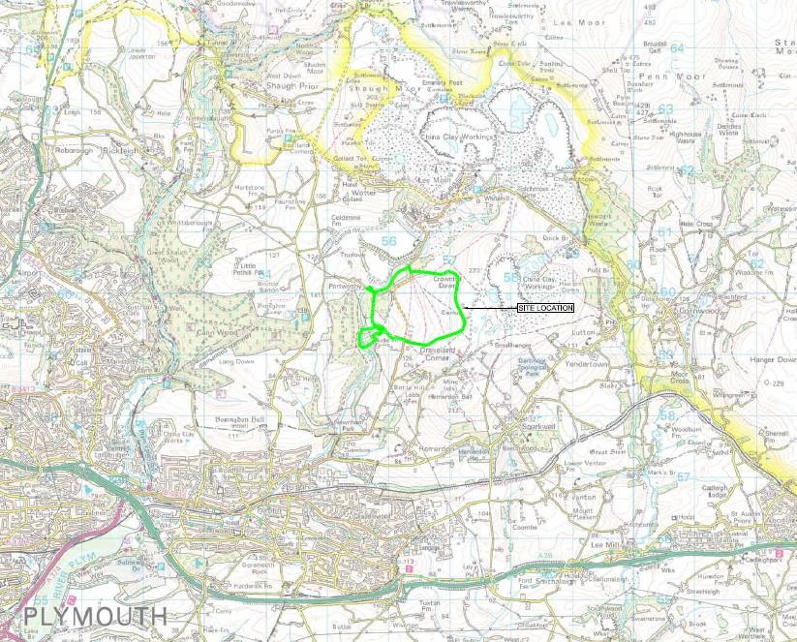

The MWF lies on Crownhill Down, covering an area of approximately 175 hectares extending to the lower slopes of the Tory Brook valley. Waste from the open pit will be used to progressively construct the MWF embankments with tailings (generated from the processing plant) continuously deposited and contained within the MWF. The final stage of the MWF’s development is show in Figure 1-2 below.

Figure 1-2 MWF Graphic
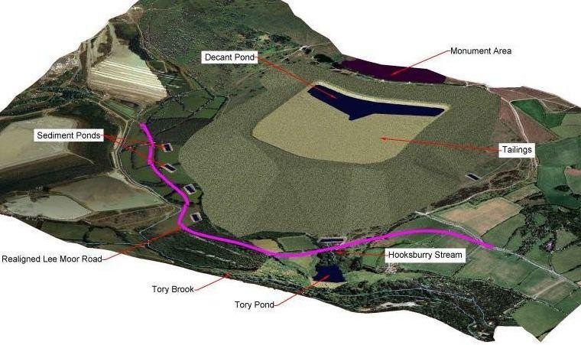

The site benefits from conditional Planning Permission, granted by Devon County Council (the Mineral Planning Authority) in 1986. A Modification Order was approved (January 2011) updating the planning conditions in line with legislative changes since 1986.

The wastes generated at the site are defined as extractive waste, which fall under the scope of the Mining Waste Directive (MWD), and an Environmental Permit (EP) is therefore required.

SLR Consulting Limited (SLR) was appointed by Wolf Minerals to produce an Ecological Mitigation & Enhancement Strategy (EMES). This strategy has been prepared alongside an Ecological Risk Assessment (ERA) which evaluates the ecological baseline, operating environment, restoration strategy, final landform and an assessment of the ecological risks associated with operating and the restoration of the MWF site.

The EMES presented in this document provides a descriptive overview of the environmental measures proposed, and where appropriate, specifies necessary enhancement, monitoring, management and/or mitigation actions required to avoid potentially adverse effects on ecological receptors and/or contravention of wildlife legislation.

The Strategy has been designed to address the implications of the currently proposed MWF development. The Strategy has been designed to complement the existing Restoration Concept and ERA and includes measures to address the impacts arising from the current proposal. The Strategy sits under the umbrella of the Modification Order and the Unilateral Undertaking (UU) which sits within that and are the precedent documents regarding habitat
restoration. In the event of any inconsistencies between this document and the UU, the details in the UU will take precedent.

The Strategy is restricted to the MWF only and does not take into account enhancement measures undertaken on adjoining land under Wolf Minerals control, e.g. the provision of tree planting outwith the west boundary.

This EMES has been prepared as part of the submission to the EA for an environmental permit for the proposed mining waste facility (MWF).

SLR’s team of Ecologists are members of the Chartered Institute of Ecology and Environmental Management (CIEEM). SLR has extensive experience in producing corporate biodiversity plans and ecological mitigation and management plans, particularly for the minerals and waste industry across England, Scotland and Wales.

  - Strategy Purpose

The purpose of this EMES is to provide a single point of reference for all ecological mitigation, compensation and enhancement measures proposed as part of the permitted MWF at Crownhill Down. These measures include:

    - legal requirements for mitigation and compensation with respect to legally protected species;
    - avoidance and mitigation measures implemented during the operational phases of development to minimise the adverse effects upon biodiversity resources;
    - compensation measures, including the creation of new habitats to replace those lost to development;
    - management prescriptions for those habitats retained or created through the development to ensure they maximise their biodiversity value; and
    - monitoring requirements, including those likely to be required under any wildlife development licences issued by Natural England.

This version of the EMES has been prepared to a level commensurate with the current stage of project development and implementation. It establishes the mitigation strategy, design and management principles necessary to ensure effective delivery of the ecological vision for the site.

The EMES is intended to be the vehicle for delivery of biodiversity planning obligations under current and future development plans at the site and to provide a reporting and review mechanism for biodiversity planning.

SCOPE OF THE STRATEGY

This Strategy provides detailed ecological mitigation and enhancement measures to be implemented before, alongside and upon completion of the Crownhill MWF proposal. The long-term commitment to the site is of nature conservation gain. Mitigation measures are provided for bat roosts, reptiles and badger and enhancement proposals for mire, watercourse, woodland and grass/ heath habitats.

It should be noted that the EMES presents likely methods by which mitigation and enhancement measures may be undertaken. The Strategy is not a definitive document and should not be read as such. It is expected that some modification to the Strategy will occur throughout the operational period of the MWF; this will be guided through a monitoring programme as identified in the Restoration Concept.

The Strategy will reviewed annually in consultation with Devon County Council (DCC) and other relevant statutory agencies as stated in 3.3 of the UU.

The EMES provides:
    - an ecological vision for the future of the site;
    - a strategy for ecological management of the site;
    - mitigation implementation plans for valued ecological receptors;
    - preliminary designs for habitat creation and enhancement measures; and
    - a programme for monitoring and review.

These measures are required to ensure the effective delivery of the ecological measures outlined in the ERA and Restoration Concept which accompanies the submission to the EA for an environmental permit for the proposed facility.

  - EMES Review Process

The aim of the EMES is to provide nature conservation gain in the long term. Management tasks will be reviewed annually in consultation with DCC and other relevant statutory agencies each year throughout the operational life of the MWF.

At the end of each year the success of the mitigation/management strategy for each species group or habitat will be assessed to confirm that there have been no unforeseen residual negative impacts arising from the MWF. Should it be found that residual negative impacts are present the mitigation/management strategy for that species group or habitat will be revised for the next year. The results of the revised strategy will be reviewed at the end of the next year period, with revisions to the mitigation/management strategy designed and implemented if necessary to ensure that the aims of the EMES are met.

This is a working baseline document. Detailed habitat creation, design and management prescriptions will develop and evolve throughout the lifetime of the development. The monitoring and review programme will enable modifications to the EMES to be discussed, evaluated and incorporated into updated versions of the EMES. It is proposed that the review of the EMES will involve a management group of the relevant stakeholders and consultees, with a function to pass on pertinent information to a wider audience.

The EMES addresses all aspects of the proposed and permitted development at the Crownhill MWF, and will ensure that ecological issues are a priority throughout the construction, operational and restoration phases of the development.

  - Existing Plans and Documents

The EMES draws upon a wide range of existing information. A number of existing site- specific plans and documents have been used to prepare this report including:

Devon County Council, Modification Order relating to Hemerdon Mine, Plympton, Plymouth, Devon, 29th November 2010.

Stephens Scown Solicitors. (2010). Unilateral Undertaking. Hemerdon Mine and Crownhill Down. Plympton, Near Plymouth, Devon.

Gillingham, J. (2012). Crownhill Down, Pasture and Hemerdon Mine Reptile Survey 2011.
Gillingham, J. (2013). Tree Visual Inspection and Bat Emergence Survey. Hooksburry Wood, Crownhill Down, Hemerdon.

Hughes, M.R. (2009). Hemerdon Mine - Ecological Site Investigations. Michel Hughes Associates. This documents includes details concerning the methods and results pertaining to: Habitats and Ecological Features Survey; Hedgerow Survey; Flora Survey; Bat Survey; Dormouse Survey; Badger Survey; Breeding Bird Survey; Aquatic Macro-invertebrate Surveys; Reptile Survey; Butterfly Survey; and Dragonfly and Damselfly Survey.

Hughes, M.R. (2009) Restoration Concept. Hemerdon Mine. Michel Hughes Associates.

Hughes, M.R. (2013) Ecological Risk Assessment. Hemerdon Mining Waste Facility. Michel Hughes Associates.

  - MANAGEMENT VISION, OBJECTIVES AND DELIVERY

  - Introduction

The MWF lies on Crownhill Down, covering an area of approximately 175 ha extending to the lower slopes of the Tory Brook valley with a midpoint located at NGR SX568595. Waste from the open pit will be used to progressively construct the MWF embankments with tailings (generated from the processing plant) continuously deposited and contained within the MWF. A description of the consented phased development is found within Section 4 of the Restoration Concept.

The Restoration Concept acknowledges that the consented Hemerdon Mine proposals will significantly modify the local landscape and have an impact on the biodiversity of the site variously in the short and medium term. It is also considered necessary to appraise what would be now acceptable or desirable and, importantly, what may be realistically achievable within the framework of the extant consent and which would not frustrate the development objectives. To that end the Restoration Concept defines principles adopted to guide the working and restoration strategy of the Hemerdon Mine site, namely Retention and Incorporation, Avoidance, Enhancement, Restoration, Compensation, Management and Monitoring.

It is intended through the EMES that the Crownhill Down MWF site will undergo a staged process of habitat retention, removal, restoration, creation, management and monitoring in compliance with the principles identified in the Restoration Concept. Although the final target habitats and species are to be defined, due to the spatial and temporal scale of the MWF, it is intended that phased ecological input will ensure that the site, once operations have ceased, will support a diverse assemblage of species in a wide range of habitat types which in turn will compliment those habitats found within the wider Devon landscape.

Experience from the ecological mitigation and restoration of the Crownhill MWF will be shared with the wider scientific and ecological management community and will be seen as a best practice example of ecologically-led restoration.

  - Statement of Management Aims

The EMES aims to increase the overall nature conservation value of the MWF site through:

- the maintenance of existing habitats of ecological value;
- the enhancement of the biodiversity value of retained areas; and
- the restoration of operational areas to habitats of biodiversity value.

The implementation of the EMES will increase the diversity and quality of habitats within the Crownhill site and ultimately the variety of fauna that can be supported.

The principle aims of the EMES are to:
- maintain and enhance the overall biodiversity value of the site where it is feasible to do so;
- take opportunities to create habitats of ecological importance;
- maintain, and where possible enhance, the ecological value of retained habitats;
- maintain the viability of species and their habitats;
- monitor and report the success of the plan using measurable targets;
- regularly review the plan to ensure it is appropriately targeted.

Management objectives have been set for each ecological feature, i.e. species or habitat area, within the site. Management objectives will be SMART – Specific, Measurable, Achievable, Relevant and Time-specific.

  - Management Principles – Operational Area

The main objectives within operational areas will be to deliver on the core business objectives of the commercial operations, working in accordance with the planning regulation and environmental permitting regime agreed. Biodiversity objectives will be incorporated from the wider EMES, wherever possible. Requirements relating to legally protected species will be incorporated into the phased development and restoration of the MWF operations.

4.0 BIODIVERSITY RECEPTORS

Section 2.3 of the ERA provides a summary of the baseline conditions and biodiversity receptors within the MWF boundary. Full descriptions of all habitats and habitat features on Crownhill Down are given in Appendices 1 and 2 of the Ecological Site Investigation (ESI). Indicative habitat losses and gains are presented within the ERA (Table 7).

Receptors identified within this strategy are as follows: Habitats: broadleaf woodland; mire; and grassland/ heath. Species: bats; badger; birds; and reptiles; and epiphytic lichens.

Detailed mitigation and enhancement measures for these receptors are presented within this Strategy. More general ecological measures and good working practices are also provided. Although specific mitigation measures are included for certain species, primarily due to their legal status, it is expected that the enhancement measures associated with habitat creation and restoration will benefit biodiversity per se including invertebrates and flora.

SPECIES

  - Bats

This section of the EMES provides details of the bat mitigation strategy for the MWF. The measures proposed here will seek to maintain and enhance the Favourable Conservation Status (FCS) of local populations of the bat species present.

In summary, bat surveys identified an assemblage of bat species utilising the MWF permit boundary for roosting, foraging and commuting. The following bat species are known to use the site:

    - common pipistrelle Pipistrellus pipistrellus – low levels of activity, primarily individual bats;
    - soprano pipistrelle Pipistrellus pygmaeus – low levels of activity, up to three bats recorded roosting in tree within Hooksburry Wood;
    - Myotis spp. - low levels of activity;
    - greater horseshoe bat Rhinolophus ferrumequinum – low levels of activity;
    - noctule Nyctalus noctula – very low levels of activity;
    - natterer’s Myotis nattereri – very low levels of activity; and
    - whiskered/Brandt’s Myotis mystacinus/brandtii – very low levels of activity.

The only potential for roosting bats was recorded within the Hooksburry Woodland, part of which will be lost through the creation of the Tory Pond. The central areas of Crownhill Down were only occasionally used by bats which is likely to be reflective of its open nature and relatively poor foraging value.

The tree surveys undertaken in 2012 identified intermittent roosting use of two trees within Hooksburry Wood. The numbers of bats observed using the roost sites and the timing of use indicated that they were non-breeding summer and transitional roost sites for soprano pipistrelles. The roosts were assessed to be of lower conservation significance when measured against the criteria given in the Bat Mitigation Guidelines as they contained low numbers of common species and were not breeding sites.

    - Mitigation and Enhancement Strategy

Mitigation of the impacts of the MWF development on the bat assemblage associated with the site will follow the following strategy:

Where it is not possible to avoid a negative impact or reduction in the current habitat resource, mitigation will be implemented. All mitigation involving the disturbance of, or interference with, a bat roost will be conducted under the appropriate development licence from Natural England.

Any residual impacts will be compensated through the creation of new areas of bat foraging and commuting habitat, e.g. woodland ride creation and/ or enhancement of existing habitats and flight corridors. In addition to mitigation and compensation, there will also be significant habitat enhancement projects during the progressive restoration of the MWF site. Such measures will benefit the local bat assemblage, creating a net gain for local bat species. For example, substantial new areas of wetland, broadleaf woodland and semi-natural grass/ heath, all of which represent bat foraging habitat, will be created.

    - Detailed Bat Mitigation Measures

The proposed bat mitigation strategy has, at its core, two key elements:

- Mitigation for impacts to the existing bat roosting resource i.e. trees; and
- Mitigation for impacts to bat foraging habitat.

The following section considers these and sets out how they will be delivered to ensure the FCS of the bat assemblage is maintained.

    - Mitigation for Existing Roosts

All bat species are classified as European Protected Species (EPS) and as such the animals during all their life stages as well as the places they occupy for resting and breeding are afforded full protection through inclusion on Annex IIa and Annex IVa of the European Habitats and Species Directive (92/43/EEC), transposed into national law through the
provisions of The Conservation of Habitats and Species Regulations. The species are additionally afforded full protection through inclusion on Schedule 5 and the provisions of Section 9 of Part 1 of the Wildlife and Countryside Act 1981, as amended by Schedule 12 of the Countryside and Rights of Way Act 2000.

The construction of the Tory Pond will require the removal of a number of trees within Hooksburry Wood including the two trees identified as intermittent roosts (JG Ecological Surveys, 2013). Works that would result in “damage or destruction of a breeding site or resting place” will need to be carried out under a European Protected Species Licence (EPSL) issued under Regulation 53 by the Wildlife Licensing Unit of Natural England (NE).

Prior to works all trees within Hooksburry Wood which will be affected by the construction of the Tory Pond will be re-surveyed using ground-based methods and classified in accordance with the Bat Conservation Trust 2012 methodology.

Category 2 trees, including those trees containing features determined by the licensed bat worker as either unsuitable for roosting bats, or not containing roosting bats, or signs of bats will be felled within one week of inspection under the supervision of a suitably trained ecologist and/or licensed bat worker. As a precautionary approach, trees with features suitable for roosting bats, but believed not to contain roosting bats, will be section felled by a tree climber, lowering parts of the tree containing potential roost structures to the ground gently and orientating any holes upwards to allow any concealed bats to escape overnight.

All Category 1 and 1* trees (trees with bat roosts or the potential to support bat roosts) will be climbed and inspected or have emergence/ re-entry surveys carried out immediately prior to felling. If bats are not present then the trees will be felled. If bats are found to be present soft felling under licence will be adopted.

As such where bat roosts are found an EPSL will be applied for, and obtained, prior to commencement of the Tory Pond works. The EPSL will have regard to the timing of tree felling, to minimise the risk of injury to bats, and compensation will provide for replacement roosts prior to felling. The Method Statement accompanying the EPSL application will provide detail regarding the location of the roosts, species and proposed mitigation and compensation measures.

Any subsequent felling works will be timed from mid- to late September through to the end of October, or alternatively from the beginning of March to the middle of March of any given year. These timing constraints will avoid any disruption to summer roosting bats and minimise the risk of disturbance to torpid bats during the colder winter months.

    - Enhancement for Bats

Retained habitat areas will be enhanced for roosting bats. New roost provision will be tailored to the species identified present on site. Some 50 Schwegler woodcrete bat boxes (a combination of types 1FD and 2F) will be positioned on retained mature trees (three to a tree) along the retained woodland edge areas of both Hooksbury and Lower Hooksbury Wood. These boundaries offer local foraging opportunities both along the pasture/woodland edge and along the Tory Brook corridor. Existing tree and shrub cover will provide sheltered commuting routes to the new roost sites.

Plate 1. The Schwegler 2F and 1FD woodcrete boxes. Source: BCT.

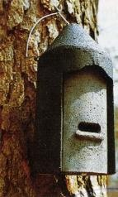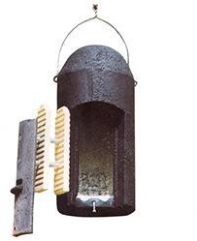

In addition four Schwegler 1FW Hibernation boxes will be installed on retained mature trees. These will provide opportunities for hibernation in winter and encourage large colonies in summer. All boxes will be monitored on an annual basis by licenced bat workers. Where boxes have been damaged or are missing these will be replaced.

Plate 2. The Schwegler 1FW woodcrete box. Source: NHBS.
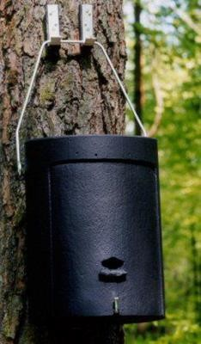
The location of the MWF is primarily within an area of exposed species-poor grassland, improved grassland and plantation woodland of low value to foraging and commuting bats. Hooksburry woodland and the Hooksburry Stream are considered to be of greatest value to foraging and commuting bat species and it has been recognised that these, for the most part, will be lost.

In accordance with the Restoration Concept substantial areas of the MWF will be enhanced through the phased establishment of significant areas of broadleaved woodland, wetland and a new compensation channel adjacent to Portworthy Lane. This will provide a higher value foraging resource for a range of bat species than is currently provided by the habitats currently present.

As part of the wider ‘landscape-based’ approach to enhancement potential bat commuting routes will also be enhanced through the creation of a significant belt of woodland along the west boundary of the site, linking up woodland and hedgerow habitats to the north and south and thus facilitating the movement of bats.

  - BADGER
Surveys to investigate for the presence of badgers Meles meles were conducted in 2008. Evidence for this species was not found within the MWF site during the 2008 survey and no incidental sightings were recorded since.

Through the provisions of the Protection of Badgers Act 1992 (as amended) it is an offence to wilfully take, injure or kill a badger [Section 1(1)] or to damage, destroy or obstruct a sett [Sections 3(a), 3(b), 3(c)] or disturb a badger when it is occupying a sett [Section 3(e)]. Although not specifically recorded within the MWF area the species was identified within the wider Hemerdon Mine complex. Therefore, as a precautionary measure, mitigation is included to ensure that no contravention of the above Act occurs.

    - Mitigation Strategy

Prior to the start of site preparation and excavation it is proposed to re-survey the entire MWF area, as a precautionary measure, to determine current usage by badgers. This will serve to inform the required process for the management of the species and the necessary licencing process, as appropriate. Survey methodology will consist of standard search for field signs including setts.

Where badger setts are found within the MWF site an appropriate mitigation strategy will be implemented. All mitigation involving the disturbance of, or interference with, a badger sett will be in accordance with NE’s Standing Advice and, where necessary, be conducted under the appropriate licence from Natural England.

    - Enhancement for Badgers

Badgers have not been found within the MWF site and thus enhancement for this species has not been specifically targeted. Nevertheless the Restoration Concept includes phased habitat restoration which includes habitats which will be of benefit to badger including extensive deciduous woodland planting thus providing greater diversity of foraging territory and resources; and improved habitat connectivity.

Woodland planting proposed through the site incorporates fruit trees, including elder, damson and crab apple, amongst the other proposed species. These will provide an additional food resource for the badgers that will be present in the autumn, a particularly important time when badgers are gaining weight for the forthcoming winter.
  - Birds

A total of 24 species of birds were identified nesting within or holding a breeding territory over at least part of the MWF area in 2008^{Error!} ^{Bookmark} ^{not} ^{defined.}. Most species were associated with the peripheral habitats of the site.

Of particular significance was the presence of Dartford warbler Sylvia undata which is afforded specific protection at a European level through being listed on Annex 1 of the EU Birds Directive. Overall, the breeding bird assemblage was considered to be characteristic of the habitats present, their extent and management condition, within their geographical range. Subsequent to the 2008 survey the majority of gorse scrub within the MWF site has been cut down and burned, most likely through ongoing land management practices. Due to the lack of scrub the MWF is currently deemed unsuitable for this species.

    - Mitigation and Enhancement Strategy

The principal objectives for mitigation and enhancements for bird receptor species are:

    - avoidance of damage or disturbance to bird nests as required by law; and
    - restoration of habitat suitable for Dartford warbler.

The details of the mitigation and enhancement strategy are:

- Avoid destruction, damage or disturbance to nesting birds;
- Creation of new habitat to replace habitats being lost; and
- Biodiversity gain through site wide mitigation, enhancements and longer term management.

    - Detailed Bird Mitigation Measures

Details of the proposed mitigation and enhancement measures are provided below:

Avoidance of damage or disturbance to bird nests as required by the Wildlife & Countryside Act 1981. Habitats would be removed outside of the breeding bird season (1st March – 31st July). If suitable habitat has to be removed during this period then habitat would be checked for breeding bird nests, if any are found and identified as being in use then this area of habitat would not be cleared until the bird has completed or abandoned its nesting attempt.

Regular monitoring of nests, if found to be being used by a Schedule 1 bird species to ensure that they are not disturbed whilst nesting.

    - Enhancement for Birds

Provide net biodiversity gain for birds for the development phases in combination with a long-term management strategy through the following:

- retained and created grassland/ heath sward will offer opportunities for ground nesting bird species, such as skylark.
- grassland and deciduous woodland, in addition to the Portworthy Compensation Channel, will offer foraging opportunities for a range of bird species. Woodland planting will include peripheral fruiting shrubs as a food source.
- additional planting and encouragement of scrub, and in particular western gorse Ulex gallii, within restored areas. This will offer increased opportunities for nesting (including encouragement of Dartford warbler back to the site) and also provide enhanced foraging through the planting of fruit producing species.
- erection of fifty nest boxes on retained trees. A combination of box types will be installed to encourage a range of different species e.g. woodpeckers, owls and small passerines.

  - REPTILES

Surveys of reptiles were conducted at numerous locations across the MWF area between 2010 and 2011. Slow-worm Anguis fragilis and common lizard Zootaca vivipara were identified in low numbers at just a few localities (with a single grass snake Natrix natrix, identified from a peripheral location (JG Ecological Surveys 2010, 2011)). All three species are common and widespread in Devon.

Higher numbers of reptiles were recorded within the tin streaming area adjacent the B3417 (an area of previous gorse, now removed) which had an average of one common lizard and
  - slow-worms per survey visit, and the road bank and ditch near Firtree Cross (a bracken and gorse filled shallow ditch and roadside bank) which had an average of 2.6 slow-worms and 1.9 common lizards per survey visit. Figure 9 within the 2011 reptile survey report illustrates the location of reptiles within the Crownhill site.
The MWF would not cause harm or disruption to a significant population of reptiles. Nonetheless, common lizards and slow worms are listed on Schedule 5 of the Wildlife and Countryside Act 1981 (as amended) such that it is an offence to intentionally kill or injure these species. In this regard therefore environmental measures are required to remove protected animals from development areas prior to the commencement of the MWF works.

    - Mitigation and Enhancement Strategy

The potential impacts of the development are:

    - risk of direct killing or injury of individual animals during site operations;
    - loss of medium to low quality terrestrial habitat, including foraging habitat and potential hibernation sites;
    - fragmentation of habitats caused by the loss of terrestrial habitat; and
    - the restoration and creation of new habitat suitable for reptiles.

Mitigation of the impacts of the MWF development on the identified reptile populations will follow the following strategy:

    - avoidance of killing or injury through use of a displacement and, where necessary capture and translocation strategy, from areas of the site likely to contain reptiles prior to areas being released for construction, to safe areas; and
    - no net loss of populations within the site in the medium and long-term by ensuring no net loss of potential habitats and enhancement of phased habitats for reptiles (i.e., providing artificial refuges and hibernacula).

    - Detailed Reptile Mitigation Measures

The details of the mitigation and enhancement strategy are given below, but broadly fall into three categories:

    - reptile mitigation via a displacement scheme;
    - creation of new habitat as compensation for lost habitats;
    - biodiversity gain through site wide mitigation, enhancements and longer term management.

    - Mitigation Proposals for Reptiles

Due to site specific conditions a variation on the standard reptile mitigation practice will be adopted to reflect:

    - the low populations of reptiles recorded;
    - the size of the site;
    - the Restoration Strategy for the site which provides for the phased restoration to grass/ heath and wetland of a large part the area, habitats which would be suitable for reptiles; and
    - the opportunity to enhance retained habitats on Crownhill Down for reptiles.

The majority of the site consists of short grazed turf unsuitable for reptiles with localised patches of suitable habitat as shown in Figure 9 of the 2011 reptile report. Reptiles will be removed from the footprint of the MWF through the adoption of a vegetation management / removal by hand approach. This would manage reptiles into areas of retained vegetation
located to the north, east and south. The method of approach will be detailed within a method statement.

The receptor habitats will be enhanced through the provision of six reptile hibernacula using the design specified in Figure 1. Four hibernacula will be placed in a sunny, well-drained position orientated so that one of the long banks faces south; these will be targeted for slow worm and common lizard. They will be located in patches of habitat suitable for dispersal
e.g. tussocky grassland and in areas of minimal public disturbance. Each will be at least 4 m long, by 2 m wide by 1 m high. An additional two hibernacula will be placed near to the Portworthy Compensation Channel. This will provide refuge for the aforementioned species and grass snake. Where practical stone walls will also be established to provide additional habitat for reptiles, and in particular common lizard.

In addition the method statement will include site-specific management which will take place to displace reptiles from suitable habitat e.g. areas of more rank, tussocky grassland and scrub. The method for undertaking this management is as follows:

  - vegetation to be cut with hand operated cutters between May and mid-September only when ambient temp > 15ºC, sunny with no rain, usually between 10.00 hrs and
16.00 hrs;

  - direction of cut to be from centre of works area outwards;

  - the vegetation will be removed over a number of days to enable the gradual migration of reptiles from the site as the habitat is degraded;

  - the vegetation will be cut down to not less than 15 cm, arisings raked off and removed from works area;

  - the area will be left for 48 hrs before a second cut down to ground level and the removal of arisings (in suitable weather conditions as above);

  - further cutting/ chemical control will be undertaken to maintain bare ground as above;

  - the works will be carried out under an Ecological Clerk of Works (ECoW) to oversee the operation and to hand trap and remove any reptiles that become isolated and/or become at risk of injury due to the clearance works;

  - where areas cannot be completely cleared of vegetation due to roots, stumps or boulders then they will be isolated by vegetation removal and then refuges laid around within the area so that any remnant reptiles can be trapped and moved; and

  - once all vegetation has been removed and an appropriate period of warm weather has passed the top soil and stumps/ boulders will be removed under an ECoW;

    - Enhancement for Reptiles

The projected Restoration Concept provides a phased programme of habitat creation that includes habitats that will be of value to reptile species; these include extensive areas of grassland/ heath and wetlands including a compensatory channel. Managed appropriately these habitats will enhance the MWF site for reptile species beyond that of its current value. Further details regards these habitats, and their management, are provided in Section 6 of this EMES.

Figure 1. Hibernacula design. English Nature 2001.
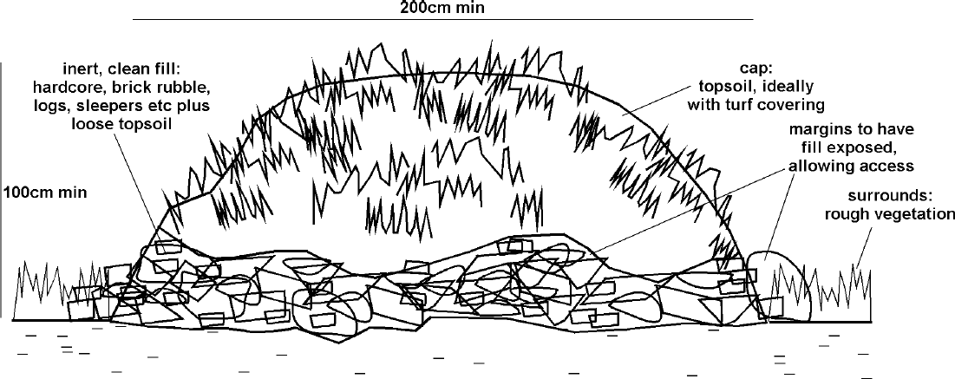

  - LICHENS

A vegetation survey and landscape assessment of Crownhill Down and Smallhanger Waste recorded three red data book species of lichen growing on trees within Hooksburry Wood (Sanderson and Cross, 2004).

The construction of the Tory Pond would necessitate the removal of a number of mature oak trees some of which may host a number of epiphytic lichens including those recorded as red data book species (Church, Coppins & Gilbery, 1996).

    - Mitigation and Enhancement Strategy

The potential impacts of the development are:

- loss of habitat (mature oak trees);
- loss of epiphytic lichens; and
- the retention and creation of habitat suitable for epiphytic lichens.

    - Mitigation Proposals for Lichens

A number of mature oak trees will be retained to the boundary of the Tory Pond. These, coupled with similar trees within the wider landscape, will act as reservoirs of epiphytic lichens. Whilst translocation of rare lichens has been considered in compiling this Strategy it is deemed inappropriate in this instance due to the availability of retained, host trees, the long-term habitat creation and management programme, and the questionable success rates of such methods.

    - Enhancement for Lichens

Cryptogams are characteristic of temporally dynamic habitats suggesting a high dispersal capacity. To maintain sustainable populations epiphytic lichens have to respond to a dynamic landscape in which suitable trees appear, grow and fall. There is little evidence of isolation by distance and therefore the retained trees and those in the surrounding landscape will provide sources of colonisation of future trees within the created woodlands on the MWF.
The planting of the broadleaf woodlands within the MWF will include a high proportion of local, native oak trees. These will act, once mature, as suitable hosts for a range of epiphytic species including lichens that will colonise through natural dispersal from retained trees.

HABITATS

Introduction

This section summarises the proposed habitat enhancement and management strategy for the MWF. It is not a function of the EMES to provide details regarding total areas of habitat retention, creation and enhancement rather it provides an overview of intended methods and outcomes to achieve an overarching and long-term objective: to enhance and maintain the biodiversity of the site.

The progressive creation and enhancement of habitats within the MWF has been spatially and temporally visualised within the Restoration Concept through provision of drawings illustrating habitat type and extent after 1, 5, 10, 15 years from commencement of operations. The final habitat objective at the end of operations is illustrated in Drawing 16349-6. It must be emphasised that this is conceptual as the final habitat mosaic will be determined by underlying abiotic factors such as drainage and growth medium, and biotic factors such as land management. As such the phased restoration of the MWF will be informed through an annual monitoring programme to ensure that appropriate habitat creation, enhancement and management is encouraged.

At present it is intended that the MWF, once operations have ceased, will primarily consist of an expanse of acid grassland bounded to the north, south and west by broadleaf woodland. Habitat diversity will be enhanced through the retainment, protection and creation of new mire, the creation of a new watercourse with pool and pond features (the Portworthy Compensation Channel) and development of scrub habitat.

  - Mire

Descriptions of the mire habitat can be found within Section 2 of the ESI, Section 2 of the ERA and within the Hooksburry Mire report (SLR, 2013).

An intact mire system, hereafter known as the Hooksburry Mire, was recorded in 2008 below Bude Farm which supported a diverse flora with affinity to the M25a Purple Moor-grass- Tormentil mire; Cross-leaved Heath sub-community and small quantities of the M21a Bog Asphodel-Sphagnum papillosum valley mire; White Beak-sedge-Sphagnum denticulatum sub-community. Wet scrub woodland had developed on the slope below the mire demonstrated successional development of the mire to its woodland counterpart the W4b Downy Birch-Purple Moor-grass woodland; Soft-rush sub-community.

Other mire habitat was recorded within an area of historic tin stream-working comprising a network of seepage zones, runnels and small pools between linear rubble ridges and mounds.

Subsequent to the 2008 report the former tin stream-working habitats have undergone significant human-related damage with respect to the mire-associated vegetation communities. All areas of mire within this complex were found reduced to ‘mud-wallows’ by March 2009 and have since undergone further degradation due to archaeological excavations. However, the Hooksburry Mire below Bude Farm remains intact and it is this mire which is discussed further within the EMES.
    - Mitigation for Hooksburry Mire

The potential impacts of the MWF, and in particular the development of the Tory Pond are:

- direct loss of habitat deemed to be of European importance; and
- indirect loss through alteration of local hydrology affecting input, through-flow and seepage from the mire.

Mitigation of the impacts of the MWF development on the Hooksburry Mire have been achieved through the iterative design process which has sought to avoid direct interference of the mire through appropriate positioning of the pond with a top water level to 68.5m AOD. At 68.5 AOD the Tory Pond would only directly affect a negligible proportion of the mire. This part of the mire, located towards the toe of the system to the western edge is deemed transitional where it merges with raised banks supporting tree dominated habitat. As such it would not be expected to significantly affect the retention and seepage of water out of the mire and the integrity of the habitat would be maintained. In addition the Tory Pond is likely to affect groundwater levels to the extent that opportunities may exist for the Hooksburry Mire to expand, over time, to the south-west and north.

Two main spring lines were identified which feed the mire, a spring line running from the east boundary and seeping west and north and a second spring originating from a pasture field to the south and entering the mire beneath a hedge-bank. These spring lines will not be directly affected by the MWF or Tory Pond thus continued input of water into the mire system will be maintained.

    - Mire Enhancement

The Hooksburry Mire is a relatively self-contained habitat which is primarily reliant on maintenance of local hydrology rather than management. Constant moisture due to a surplus of water is a central feature of mires. When the source of water reduces in volume they dry out, their mineralization rate rises and, as a result, so does their nutrient content. This has a detrimental affect on the species associated with the mire system e.g. Sphagnum spp. and grasses such as Molinia caerulea. In addition, the probability of scrub encroachment increases. The mitigation discussed in the previous section will ensure maintenance of the hydrological regime of the mire and as such enhancement of this habitat is not required. It is likely that the proximity of the Tory Pond will also reduce issues associated with scrub encroachment along the west and north boundary of the mire as conditions would become more waterlogged.

Opportunities for mire development will be sought with respect to the potential wetland habitat creation in the vicinity of the former tailings lagoon however this will depend on the underlying growth medium and the local hydrology of the area.

The loss of the mosaic of mire associated communities recorded within the area of historic tin stream-working will, in part, be compensated for by the creation of suitable features along the course of the Portworthy Compensation Channel (see Section 6.3).

    - On-going Management and Monitoring

The Hooksburry Mire may require periodic or low-level ongoing management with respect to scrub and bracken encroachment, particularly along the slightly drier north-east boundary. Nevertheless the current level of scrub, principally gorse and willow, is not considered onerous and will be left in situ to add diversity.

Grazing and burning of the mire will be avoided.

A monitoring programme will be instigated to inform on the condition of the vegetation communities and to identify any adverse changes which may require management intervention. Monitoring will consist of Phase II National Vegetation Survey across the entire mire system with additional Phase III belt transect survey undertaken from the mire to the Tory Pond.

  - Wetlands

An un-named stream (here referred to as the ‘Hooksburry Stream’) rises from numerous springs and seepage zones on Crownhill Down to the west of the B3417, becoming a single watercourse within Lower Hooksburry Wood before merging with the Tory Brook within Newnham Park. This watercourse running within an area of historic tin stream-working comprises a network of seepage zones and runnels between linear rubble ridges and mounds. A total of nine very small peaty pools were located, primarily within the more elevated area of historic tin workings, which are widely used as ‘watering holes’ by livestock. At several their margins were found to be heavily poached and the pools reduced to ‘mud- wallows’ with generally little or no aquatic vegetation.

    - Mitigation for Hooksburry Stream

The Hooksburry Stream, along with its associated wetland habitats will be lost due to the MWF and construction of the Tory Pond. No specific mitigation is proposed for the loss of this habitat feature.

    - Portworthy Compensation Channel

In order to compensate for the loss of the Hooksburry Stream a new compensation channel will be created to the south of the new Portworthy Road. The watercourse has been designed so that the ecological value of the channel will be enhanced through inclusion of features such as pools, channels of varying depth and width, a pond and stretches of various flow rates. As such the design process has sought to mimic, where possible, may of the physical features associated with the Hooksbury Stream. It is not however the intention to replicate the stream but rather to provide a linear wetland feature which provides opportunities for a diversity of riparian and aquatic flora and fauna to flourish, many of which are likely to occur within the Hooksburry Stream system. The compensation channel will be fed via a sediment pond to the east which in turn will be rainwater fed.

The design allows for stretches of narrow channel along steeper gradients where water flow will be elevated, a series of flow velocity control structures consisting of stone gabions, widened channel sections cutting across zones of low gradient and a large pond. The pond, and two of the channel pool areas, will be excavated to a greater depth to allow retention of water during dry spells.

The stone gabions will consist of variable sized local stone set across the channel. This will create conditions of varied flow rate, duplicating conditions found within naturally eroding upland stream systems. A series of four gabions will be included within the upper reaches of the channel each incorporating widened sections of channel to create deeper pool areas behind the gabions (Figure 2). The pools will not be the same size or depth. Below the tier of gabions the channel course will meander northwest towards a large pond after which the channel flows down, and into, Tory Brook.

Figure 2. Long section showing proposed gabion flow velocity control structure with pool.



Plate 3 is included to illustrate the typical structure of a newly created compensatory channel (with stone gabion to the foreground). Shallow meandering banks and point bars will encourage wider transitional zones of riparian vegetation to establish between the water channel and terrestrial habitats. A variety of boulders and medium-sized stones, along with riffles within the channel will provide opportunities for a wider range of invertebrates and lower plants. The average water depth of the channel will be c.10 cm. The depth of the channel will however be increased, and the width decreased, where faster flow is to be encouraged.

Plate 3. Example of a compensatory channel that has just been completed.
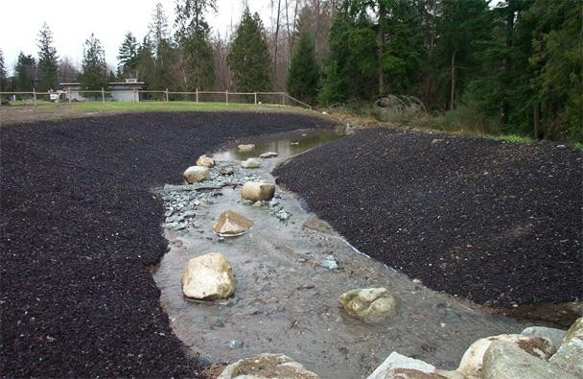

The colonisation of the channel, pools and pond will be primarily through natural colonisation. No vegetative material is to be introduced to the system from outwith the Crownhill site to reduce the potential for exotic species entering the channel.

The potential for translocating stone, sediments and vegetation from the Hooksburry Stream will be investigated. Where it is deemed appropriate, and/or feasible, translocation of material will be undertaken to ‘kick-start’ some of the pool and pond habitats along the Portworthy compensatory channel.

The Portworthy Compensation Channel and pond will be protected using stock-proof fencing to avoid poaching of the bank sides. The fencing will incorporate the channel, pond and a buffer zone of at least 10 m width.

In addition to the channel new wetland habitat opportunities will be provided within the former tailings lagoon and within, and along the margins of, the Tory Pond.

Full details on the Portworthy Compensation Channel are provided in Appendix 4E-1
    - On-going Management and Monitoring

The colonisation of the channel and pond will be monitored to identify and record colonisation by flora, invertebrates and fish. In addition seasonal water flow, pool and pond water retention and sediment deposition loads will be carefully monitored to ensure that the channel is functioning appropriately.

Where it is deemed necessary remedial vegetation management (either through planting and/or cutting) and engineering works to the channel will be undertaken.

  - Woodland and Scrub

Wood pasture was identified from the unenclosed part of Lower Hooksburry Wood, at the south-western extent of Crownhill Down. The woodland canopy is dominated by mature oak with little shrub or ground flora evident. The vegetation of this woodland was found to comprise the W11a Sessile Oak-Downy Birch-Wood-sorrel woodland; Broad Buckler-fern sub-community and the W17c Sessile Oak-Downy Birch-Dicranum majus woodland; Sweet Vernal-grass-Common Bent sub-community.

Lower Hooksburry Wood is not evaluated to be of specific European or UK significance, nor identified as Ancient Woodland and has not been afforded statutory protection. Nevertheless, the woodland is identified to be of local nature conservation significance. During 2009/2010 Lower Hooksburry Wood was included in the Newnham Estate’s 4x4 off- road and mountain bike course, resulting in parts of the woodland and the Hooksburry stream which extends through it being affected by these activities. An extensive programme of archaeological investigation has been carried out within the Environmental Permit boundary and this ongoing work has further degraded habitats associated with Lower Hooksburry Wood.

Gorse and bracken scrub was identified occurring in large blocks over considerable parts of Crownhill Down, comprising variously the U20a Bracken-Heath Bedstraw community; Sweet Vernal-grass sub-community and the W23a Gorse-Bramble scrub; Sweet Vernal-grass sub- community, mainly as mixed community stands in a wider mosaic with close-grazed U4a Sheep’s-fescue-Common Bent-Heath Bedstraw grassland; Typical sub-community.

Breeding Dartford warbler, stonechat and yellowhammer territories were identified associated with some larger blocks of gorse scrub at the time of the 2008 survey. Between 2009 and 2011 the gorse scrub was cleared from Crownhill Down reducing the potential for scrub-associated fauna to occur e.g. Dartford warbler and reptiles.

    - Mitigation and Enhancement Strategy

The Restoration Concept details the phased planting of broadleaf woodland over the lifetime of the operational phase of the MWF. Subsequent to the end of operations it is intended that an extensive block of native broadleaf woodland will be established on the MWF to the west, north and east linking up retained woodland blocks. This is in addition to the planting of trees within the residual field areas in Smallhanger Valley and Hooksburry Valley, on the edge of Crownhill Down but outwith the MWF.

The species to be planted, and mode of planting and subsequent management, will be agreed with DCC. It is likely that the woodland will be planted with bare-rooted transplants (1
+ 1: grown from seed, transplanted after one year, lifted one year later). The species selected will be native and the composition will reflect those woodlands, such as Hooksburry Wood, already established within the MWF and surrounding landscape. Typical species will include sessile oak, birch, hazel, and beech.

The final choice of species will be dictated by the underlying growth medium and drainage. The Forestry Commissions Ecological Site Classification Decision Support System (ESC- DSS) will be used to assist species selection. ESC-DSS is designed to match key site factors with the ecological requirements of different tree species and woodland communities, as defined in the NVC.

Trees and shrubs will be planted during the winter period using notch-planting technique or, where the landscape permits, machine-planting may be a preferred option. Canopy trees will potentially be planted in groups to reduce competition e.g. blocks of c. 36 trees planted 2 m apart; under-storey trees and shrubs will be planted in smaller groups.

The woodland design will potentially incorporate scalloped rides in order to enhance overall biodiversity value for species of flora and fauna and to facilitate future management of the woodland.

It is intended that the woodland edge will be transitional rather than abrupt. Planting will used to create a graded profile utilising shrubs such as hazel and gorse, and small trees such as crab apple. This will extend outwards, across an ecotone boundary, into the proposed grassland habitat (Figure 3). Additional pockets of scrub will be planted within the wider grassland landscape with a minimum of ten 20 m x 20 m blocks of gorse dominated habitat to encourage Dartford warbler back onto the MWF site.

Figure 3. Example of woodland edge habitat. FC, 2005.
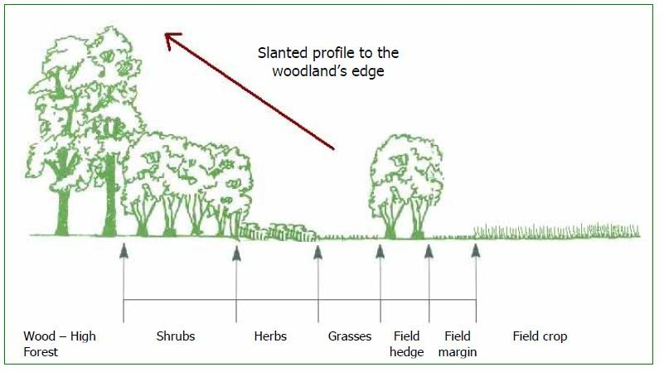

All newly planted trees and shrubs will be protected either through individual spiral guards or stock-proof fencing.

    - On-going Management

After planting, maintenance will be required for beating up so that the planting density is maintained. This will occur for the first five years after planting, after which failures are deemed unlikely.

  - Grassland and Heath

Acid grassland was identified as the most extensive habitat type extending over most of the Environmental Permit area of Crownhill Down. Over the majority of the higher ground to the east of the B3417 it comprised an overwhelmingly grass-dominated, species-poor sward providing close affinity to the U3 Bristle Bent grassland community. To the west of the B3417
acid grassland was found primarily on ground located to the higher peripheries of the historic tin streamworking zone.

The U3 community is recognised to be treatment-derived. Effectively, the community is here derived from former H4 heathland community, having become seriously degraded over time consequent to over-frequent burning and excessive grazing. The specific habitat area is not evaluated to be of European or UK significance, has not been afforded statutory protection and is not considered to be of specific local nature conservation significance.

An extensive programme of archaeological investigations has been carried out within the Environmental Permit boundary. In effect a considerable area of Crownhill Down has been both turned-over and significantly disturbed by way of complying with the DCC archaeological investigation requirements. Continued investigations comprising a further 90 trenches are programmed for 2013.

Relict heathland vegetation was identified restricted to reasonably defined areas on Crownhill Down. The tin streaming ridges within the area of historic workings were found to support patchily distributed, close-grazed heathland with affinity to the H4a Western Gorse- Bristle Bent heath; Bristle Bent-Bell Heather sub-community, although bracken and gorse were abundant associates over the whole area. Close-grazed heathland, where more elevated soil-moisture conditions prevail, was located to the northern margin of the main tin streaming zone (east of Wheal Florence), there providing a transition to the H4c Western Gorse-Bristle Bent heath; Cross-leaved Heath sub-community. Heathland was identified from the highest ground on Crownhill Down, where the prevalence of deer-grass marked the transition from lowland heath H4c sub-community to more upland-type heath H4d Western Gorse-Bristle Bent heath; Deer-grass sub-community.

The management régime has, over a long period of time, resulted in the near total suppression of heathland vegetation, the site evidently too intensively grazed and too frequently swaled. Thus, grass species have become a dominant component and ericoid species have significantly diminished, the conversion from H4 heathland to U3 grassland proceeding rapidly, as has already occurred over the majority of Crownhill Down to the east of the B3417. This has resulted in the progressive and continuing decline in the overall nature conservation value of the site.

The importance of H4 heathland communities is recognised through their inclusion in the habitat category ‘European dry heaths’ listed on Annex 1 of the Habitats Directive^{Error!} ^{Bookmark} ^{not} ^{defined.}. However, the relict heathland on Crownhill Down is not evaluated to be of specific European or UK significance and has not been afforded statutory protection. The archaeological investigations have extended across the areas of relict heathland, with the resulting impacts identified.

    - Mitigation and Enhancement Strategy

The majority of acid grassland and degraded heath habitat will be lost to the MWF. However some retainment will occur to the east boundary as shown in the Restoration Concept.

The final objective is to create a broad mosaic of heath and acid grassland habitat, in accordance with Schedule 3 of the Restoration Concept i.e. establishment and development of ‘moorland/rough grass’. While the underlying growth medium means it may, in theory, be possible to re-create acid grassland and heath habitats within the MWF site, the gross changes in soil profiles and chemistry means that in practice re-establishment of true heath may not be possible. The overall aim, therefore, is to create extensively managed "natural" grasslands with no predetermined view as to the composition of the vegetation communities which develop. These new, potentially heath-type, habitats will form valuable habitat types in
their own right, particularly if managed to create a varied habitat structure. Nevertheless, where possible, encouragement of heath-dominated habitat will take place.

    - Grassland Creation

The grassland will be created in phases and linked to the retained grass/ heath habitat. To accelerate the natural succession process and to inaugurate restoration a native grass sward mix will be sown into the growth medium. The type of seed mix will be determined once the physical and chemical characteristics of the growth medium are known.

Where the establishment of U4 (Festuca ovina-Agrostis capillaris-Galium saxatile) grassland, which is the typical grazed vegetation of moderately or well-drained base-poor mineral soils, is feasible, the sowing mix may include grasses such as common bent Agrostis capillaris, sweet vernal grass Anthoxanthum odoratum, sheep’s fescue Festuca ovina and red fescue Festuca rubra. Typical forbs may include yarrow Achillea millefolium, heather Calluna vulgaris, heath bedstraw Galium saxatile, harebell Campanula rotundifolia, devil’s-bit scabious Succisa pratensis and common bird’s-foot trefoil Lotus corniculatus.

To encourage establishment of heath-associated shrubs the above seed mix will be combined with seed from heather Calluna vulgaris, bell heather Erica cinerea and western gorse Ulex gallii.

Regardless of the seed mix used successful establishment will rely on good seed-bed preparation, control of undesirable species and careful management, especially in the first year.

Sowing will preferentially occur in the autumn. A fine seed-bed will be prepared through repeated harrowing and rolling of the growth medium (a fine seed-bed with a good tilth is required because the seeds of many wildflower and grass species are small).

The seed will be sown with an inert substance, e.g. barley meal, by tractor-mounted seed or fertiliser broadcasters. Once sowing has taken place the site will rolled to ensure good contact between the seed and soil to encourage rapid germination and establishment.

    - On-going Management and Monitoring

Careful management will be required during the first growing season of each sown phase to control competition from undesirable species and to encourage tillering and vigorous establishment of the sown sward. Undesirable ‘weed’ species may require treatment via cutting or spot herbicide treatment.

Once established, the sward will be cut and/or grazed to encourage tillering. The first cut or opening up of the sward to grazing should be at least eight weeks after sowing. Further cuts may be necessary, depending on soil fertility and growing conditions.

In the longer term, low intensity grazing management will be re-introduced, in order to enhance and thereafter maintain the open areas and prevent undesirable scrub encroachment. In the short-term however cutting may need to be employed to prevent scrub encroachment and domination by more competitive species.

Heath and acid grassland is a complex habitat with a mixture of vegetation communities often found in an intimate patchwork. Such a habitat cannot be artificially created. Ongoing management will therefore be aimed at promoting natural colonisation processes in part through the aforementioned extensive grazing management. Management will not be aimed at establishing pre-determined vegetation communities such as heather stands, since in
time, the heath and grassland habitats which develop more naturally will be of greater value to wildlife. The new ‘heath-type’ habitats may appear as grasslands rather than true heath communities dominated by dwarf shrubs such as heather and gorse.
A monitoring programme will be established for each phase of grass/ heath creation. Phase II NVC and Phase III quadrat survey will be conducted in years 1, 3, 5 and at 5 year intervals thereafter to monitor the establishment of the sward and the effect of instigated management.

  - CLOSURE

This EMES has been prepared by SLR Consulting Limited with all reasonable skill, care and diligence, and taking account of the manpower and resources devoted to it by agreement with the client. Information reported herein is based on the interpretation of data collected and has been accepted in good faith as being accurate and valid.

This report is for the exclusive use of Wolf Minerals; no warranties or guarantees are expressed or should be inferred by any third parties. This report may not be relied upon by other parties without written consent from SLR.

SLR disclaims any responsibility to the client and others in respect of any matters outside the agreed scope of the work.

