Noise Management Plan (NMP)
Contents:
1.0 Who is this plan for? 2
1.1 Version control 2
2.0 Introduction 3
2.1 Site description 3
2.2 Maintenance and review of NMP 3
2.3 Relevant sector guidance on which the NMP is based 3
3.0 Receptors 4
3.1 List of receptors and map 4
4.0 Source of noise and site processes 7
4.1 Noise at the WPF 7
4.2 Noise Impact Assessment (NIA) conclusions 8
4.3 Noise sources 9
5.0 Best Available Technique (BAT) and Process monitoring 12
5.1 Onsite monitoring procedures & improvements 12
5.2 Monitoring off site sound levels 15
6.0 Noise reporting 16
6.1 Complaints reporting 16
6.2 Community engagement 16
6.3 Pro-active noise monitoring 17
6.4 Reactive noise monitoring 17
7.0 Appendices 18
Appendix A 18
Appendix B 19
Appendix C 22

Davidstow Creamery, Camelford, Cornwall, PL32 9XW
Environmental Permit Number; BN6137IK
DC-EMS-DAV-38 Noise Management Plan - Revision 1

Who is this plan for?
This Noise Management Plan (NMP) is designed to support the teams at Davidstow Creamery and Water Processing Facility (WPF) by providing a structured approach to managing noise emissions. It is intended for:
- Operational staff (WPF & Creamery)
- Environmental and compliance teams
- Surveyors and technical personnel
- Contractors
This plan will be communicated directly to all relevant personnel involved in noise management activities.
The NMP outlines procedures for:
- Monitoring and implementing contingencies to minimise noise pollution during normal and abnormal operating conditions.
- Preventing unacceptable off-site noise impacts, as defined by the Environmental Permit.
- Conducting noise assessments and responding effectively to external complaints.

1.1 Version control
Revision Number | Purpose for Revision | Authorised by | Date submitted to Environment Agency | Revision Owner
1 | First issue | R Barnett | 24/12/2025 | E Gregory

2.0 Introduction

2.1 Site description
In summary, SDUK’s Davidstow facility comprises of:
- A Creamery receiving milk which is pasteurised and processed into cheese. Whey from the cheese making process is used to manufacture whey cream, sweet whey powder and whey protein concentrate.
- A Water Processing Facility (WPF) which receives process wastewater from the Creamery and employs physico-chemical, biological and membrane processes to treat water for subsequent discharge to the River Inny or reuse within the Creamery.
The Creamery operates for approximately 358 days per year, 24 hours per day (other than an annual maintenance shut down around October/ November). The Water Processing Facility is manned 365 days per year, 24 hours a day with the majority of operational activity completed during daylight hours (07:00-19:00).
Davidstow Creamery is located in a predominantly rural location; the nearest villages to the site are Trewassa, Davidstow and Tremail with other smaller residential areas such as Treworra. The land use surrounding the Creamery and WPF is predominantly rural and agricultural, with a low population density. There is potential for seasonal and/or intermittent noise emissions from local farming activities, a fallen stock facility, a local substation as well as traffic from the A395 and the A39.

2.2 Maintenance and review of NMP
The Davidstow Health, Safety and Environment Manager is responsible for developing and maintaining this document. Reviews of the NMP are typically undertaken on an annual basis or following significant change on site that has potential to affect noise emissions sources and/or control of emissions.
The NMP forms part of Davidstow’s Environmental Management System (EMS) and is filed under EMS/ Sites/ Davidstow/ 8.1 Operational Control.
The Creamery and Water Processing Facility (WPF) Operations Managers (supported by the HS&E Manager) are responsible for training relevant people in their teams. Training will be reviewed and updated as/when significant change occurs.
All personnel undertaking off-site noise surveys will be trained in completion of the odour and noise community survey reporting form shown in Appendix B. The Environmental department is then responsible for; collating records of noise related complaints, conducting associated investigations and implementing actions based on monitoring outcomes.

2.3 Relevant sector guidance on which the NMP is based
- Noise and Vibration Management: Environmental Permits
- Control and Monitor Emissions for Your Environmental Permit
- Environmental Noise (England) Regulations 2006
- BAT Reference Document for the Food, Drink and Milk Industries (FDM BREF)
- BS 4142:2014+A1:2019

3.0 Receptors

3.1 List of receptors and map
As described in Section 4, the principal sources of noise are found within the WPF hence location of receptor is described relative to the WPF.
Receptor locations are shown in the map below.
Ref. | Receptor Type | Direction from WPF | Approx Distance to Site Boundary (m) | Sensitivity to Noise  - Low (e.g. footpath/road)  - Medium (e.g. industrial/workplace)  - High (e.g. housing/pub/hotel)
1 | Blacka Lane local to Creamery (north) - residential properties | W | 1,000 | High
2 | Trewassa –residential properties & maintenance workshop | NW | 300 | High
3 | Treworra – residential properties | E | 500 | High
4 | Tremail - residential properties | E | 2,000 | High
5 | Airfield | S | 1,500 | Low
6 | Inny Vale – residential properties | ENE | 1,500 | High
7 | Air Museum | W | 1,500 | Medium
8 | St Kitts Farm – residential properties and commercial | W | 2,000 | High
9 | Fallen Stock Yard – commercial | ESE | 1,500 | Low
10 | Davidstow Church & The Pines (residential) | N | 1,000 | High
11 | Pendragon House, Trehane House and Bungalow - residential properties | NW | 2,000 | High
12 | Barnpark Farm | WSW | 500 | Medium
13 | Blacka Lane local to Creamery (south) - residential properties | WSW | 1,500 | High

The prevailing winds within the region are from the west-southwest, west, and northwest, with a secondary component from the southeast and relatively minor frequency of winds from the south and southwest. It is also important to note that high wind speeds can influence the perception of noise. Strong winds can elevate background noise levels due to rustling vegetation, the sound of wind itself, and other ambient sources, which may either mask operational noise or conversely, draw more attention to it depending on the conditions and listener sensitivity.
The majority of any prior noise complaints relating to SDUK’s operations have originated from Treworra to the east-northeast, with few sporadic complaints from Trewassa to the northwest of the WPF. Hence, wind frequencies from the west-southwest and southeast are typically responsible for increased noise propagation in the area.
A proprietary weather station – which includes wind speed and direction – is installed at the WPF. The weather station provides real time data as well as the functionality to review historic data which is used to support investigation of any noise complaints.

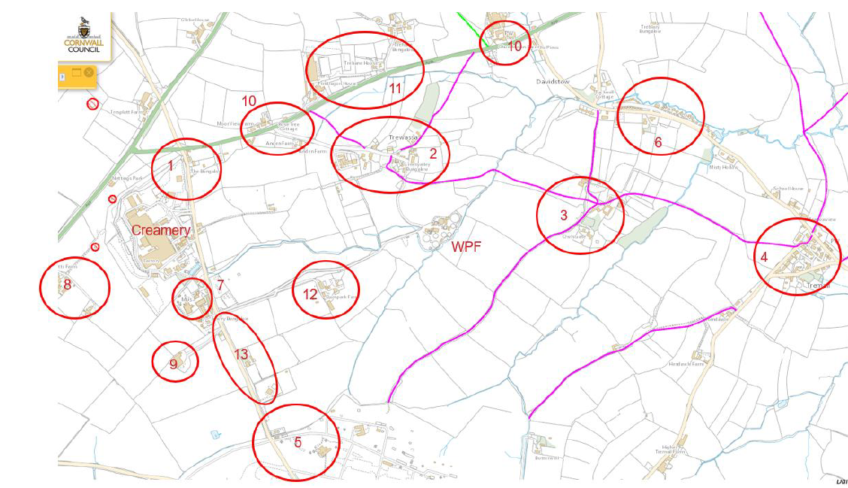
Location of Receptors

4.0 Source of noise and site processes

4.1 Noise at the WPF
The WPF contains a wide range of mechanical and process equipment, each contributing to the site's overall acoustic profile. While many operations are associated with low to moderate noise levels, certain activities and equipment have the potential to generate elevated sound pressure levels depending on operational conditions. The site’s acoustic profile remains relatively stable due to the continuous nature of operations; however, the combined effect of multiple noise sources can increase the potential for offsite disturbance if not effectively managed.
Qualitative assessments conducted by Hepworth Acoustics Ltd, supported by offsite surveys and historical complaint analysis, have helped to identify the main contributors to site noise.
This has provided the guidance needed for the classification of noise sources into low, medium, or high-risk categories, guiding the prioritisation of mitigation measures. In line with BS 4142:2014+A1:2019, which provides a framework for assessing the impact of industrial and commercial sound, acoustic zones can be classified based on their potential to cause environmental disturbance as follows:
- ‘High Risk’ areas exhibit elevated noise levels (typically ≥80 dB), indicating a strong potential for environmental impact. These sources are likely to contribute to offsite noise emissions, particularly during sensitive times of day and specific wind vectors to noise-sensitive receptors. These areas should be prioritised for mitigation through acoustic containment, operational scheduling, and regular review to minimise nuisance.
- ‘Medium Risk’ locations (typically 70–79 dB) present a moderate potential for environmental disturbance. While not immediately likely to cause offsite impacts, they may contribute to cumulative noise levels or become problematic under certain conditions such as wind direction or low background noise.
- ‘Low Risk’ areas (typically <70 dB) are unlikely to contribute significantly to environmental noise emissions. These zones are typically located at site boundaries or near passive infrastructure and serve as useful reference points for acceptable acoustic performance. Maintaining these quieter zones contributes to overall site acoustic balance and offers a useful reference point for ongoing environmental monitoring and planning.
These risk categories - as well as operational experience and anecdotal feedback provided by any prior complaints and observations from site visitors including representatives of the Environment Agency – have been used to assign risk categories to noise sources. Please refer to Section 4.3 below.
In addition to the higher risk areas shown in the table above, several medium-risk components—including both ground level and gantry pumps and aerators, have been identified as contributing to elevated noise levels. These sources will be reviewed as part of a broader noise reduction strategy to support overall site acoustic performance and reduce the potential for future impact.
It is important to note that high level equipment does have the ability to propagate noise and therefore in the context of this noise management plan there is a need to include this in determining future areas of improvement.

4.2 Noise Impact Assessment (NIA) conclusions
A number of assessments have been undertaken to assess the impact of noise emissions on nearby sensitive receptors.
These assessments - which have been conducted in accordance with relevant standards (typically comprising 7-day continuous monitoring using calibrated equipment with consideration of weather data) and undertaken by acoustic experts - have included:
- Assessment of noise sources at the WPF and receptors with a focus on residential premises in Trewassa (closest to the WPF) and Owls Gate, Treworra (in the prevailing wind direction from of the WPF) – Hepworth including 2018, 2019, 2020, 2021, 2022 and 2025.
- Assessment of ambient noise levels at locations remote from both the Creamery and WPF intended to assess ‘background conditions’ – WSP 2023.
Acoustic consultant’s assessment have been based on measured sound levels and taken account of context including the long-standing presence of the WPF, habituation of receptors, and masking by ambient sounds.
Based on acoustic monitoring data, the overall conclusion of the noise impact assessments undertaken by acoustic specialists appointed by SDUK has been that the site presents a low impact in most areas when context is considered as standard BS4142 makes provision for.
The Environment Agency’s Acoustics & Air Quality Modelling & Assessment Unit (AQMAU) interpretation of acoustic consultants’ conclusions takes a different approach to consideration of context in light of the assessment of ‘background conditions’ undertaken in 2023 which is referred to above. Primarily in that context cannot reduce a significant adverse impact to low without mitigation. Furthermore, that existing operations do not form part of the background sound climate for assessment purposes. AQMAU considered that additional noise control measures were required to achieve compliance with EA standards.
AQMAU’s interpretation of the impact of noise emissions from the WPF has been taken in to account in development of this, and future iterations of, the NMP.

4.3 Noise sources
The WPF has been reviewed, and areas broadly assigned a risk category based on the LA_eq & LA_90 dB as assessed by Hepworth Acoustic Ltd in February 2025 as well as operational experience and anecdotal feedback provided by any prior complaints are observations from site visitors including representatives of the Environment Agency.

Equipment | Risk (Contribution to overall impact) | LA_eq | LA_90 | Operational Conditions | Comments
Centrifuge | High | 86 | 86 | The centrifuge is set within an enclosed building and is in continuous operation with roller shutter door. This door is opened approximately three times a day for a maximum duration of ten minutes to allow for sludge trailer removal. | This equipment is set within an enclosed building 5m to the front of the Centrifuge with doors shut is 65dB LAeq.
Aerzen blowers | High | 87 | 88 | Two Aerzen blowers are required for AT3, the blower setpoint is variable based on oxygen requirement of tank.  One Aerzen blower is required for BT2, the blower setpoint is variable based on oxygen requirement of tank. | This equipment is set within an enclosed building 5m to the front of the Aerzen building with doors shut is 66 dB LAeq.
AT1a & AT1b | Medium | 77 | 77 | There are four triton mixers and four blowers in AT1a & AT1b, the number running will depend on oxygen requirement for the tank. Typically, all four will be running at the same time to mitigate sludge dead spots in the tank. | As of November 2025, AT1 a is not currently operational.
Kirton Plant | Low | 61 | 60 | The Kirton plant (recovered water plant) is responsible for recycling treated effluent back to the main site for reuse in the factory. Before Project IRIS, this plant would run 2 ultrafiltration modules and 2 reverse osmosis units 24/7. | As of October 2025, this plant is functioning as a standby plant and is not routinely operational daily.
AT3 Jet mix | Medium | 70 | 67 | Provides mixing of the tank and functions as part of the aeration equipment (air and effluent are mixed and injected via Korting aeration nozzles). This equipment runs continuously alongside the Aerzen blowers.

Equipment | Risk (Contribution to overall impact) | LA_eq | LA_90 | Operational Conditions | Comments
MBRs and DAF1 | High | 80 | 80 | There are four ultrafiltration membranes as part of the membrane bio reactor (MBR). Typically, three of these will be running continuously.  DAF1 is situated in the MBR building, in general, it will run continuously but will have periods of downtime due to effluent demand. | This equipment is set within an enclosed building 5m to the front of the MBR, DAF with doors shut is 65dB LA_eq.
BT2 Jet mix | High | 83 | 84 | Provides mixing of the tank and functions as part of the aeration equipment (air and effluent are mixed and injected via Korting aeration nozzles). This equipment runs continuously alongside the Aerzen blowers. | This equipment is set within an enclosed building 5m to the front of the BT2 Jet Mix with doors shut is 64dB LAeq.
DAF 2 | Low | 69 | 68 | DAF2 is situated in its own building, in general, it will run continuously but will have periods of downtime due to effluent demand.
BT1, Divert & OCU | High | 81 | 81 | Balance Tank 1 has four Landia mixing aeration units situated on the outside of the tanks, with air inlets at height (approx. 1 ft above tank level).  Divert tank has one Landia mixing aeration unit with air intake at height of tank (similar to BT1).  There are a range of pumps associated with Divert and BT1 linked to effluent transfer and the DAFs that all operate 24/7 under normal circumstances.  The odour control unit for BT1/Divert is a joint system and has 3 parts to it, a wet phase where water and diox are circulated around via a small pump and 2 dry media phases. The air is pulled through the system via a fan and motor at the end of the scrubber. The scrubber is operated 24/7. | Equipment is installed at ground level within and close to the 5m acoustic barrier to the north boundary of the WPF which reduces the potential for noise propogation.
AT2 | Medium | 68 | 67 | There are four triton mixers and four blowers in AT2, the number running will depend on oxygen requirement for the tank, typically all four will be running to mitigate sludge dead spots in the tank. | This is a gantry level reading and therefore has the potential to propagate noise further. BS 4142:2014+A1:2019 and therefore this has upped the classification of the area as a medium risk zone.
DAF 3 | Medium | 73 | 72 | DAF3 is situated outside next to BT1, in general, it will run continuously but will have periods of downtime due to effluent demand.

This assessment highlights the importance of prioritising noise mitigation efforts in the above high risk operational zones defined in line with BS 4142:2014+A1:2019. In this instance high risk operational zones include Centrifuge building, Aerzen building, DAF1/MBR House and BT1/Divert/ OCU area.
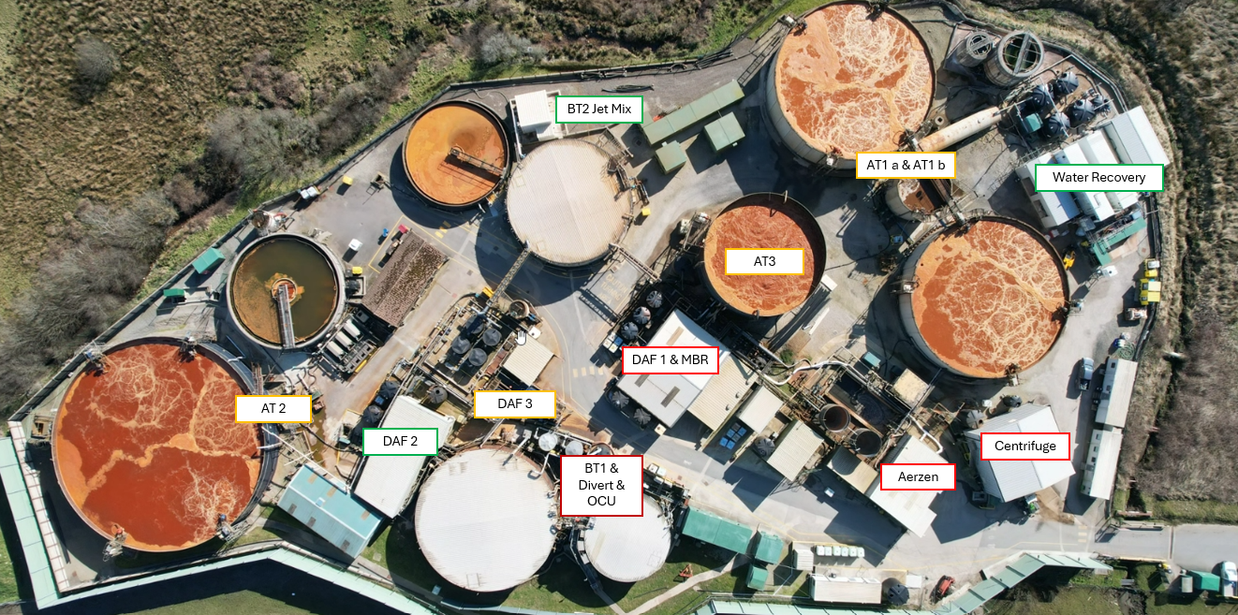
The below image demonstrates the unmitigated risk ratings of WPF equipment.

5.0 Best Available Technique (BAT) and Process monitoring
This section of the NMP considers how noise emissions from the principal sources identified in the table above are prevented or minimised through the consideration of relevant BAT.
Appropriate Measures / Best Available Techniques (BAT)
This noise management plan has considered BAT for noise control as specified in the Food Drink and Milk Best Available Techniques Reference document (FDM BRef) as shown below:
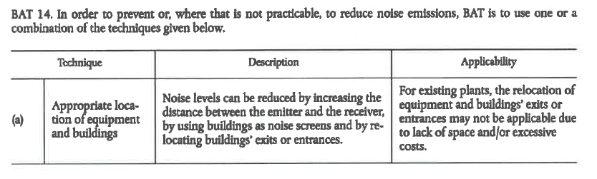
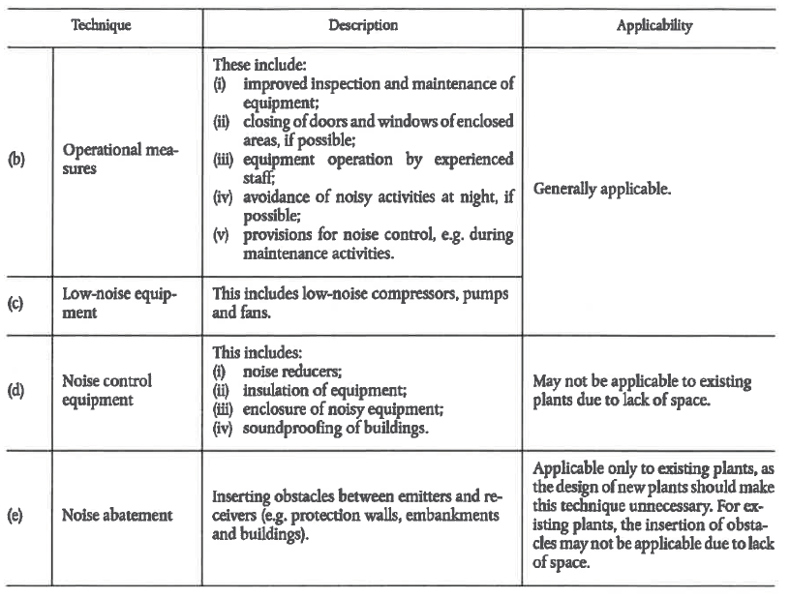
The adoption of BAT for principal noise sources is summarised in Table 5.1 below.

5.1 Onsite monitoring procedures & improvements
Monitoring will focus on key operational zones to verify control measures and support internal compliance. Results will guide targeted mitigation and identify equipment that may have degraded or worsened creating greater noise nuisance.
Description of procedure/ control | Further information | Status
Aerzen Blowers - BT2 and AT3 | Permanent solution for Aerzens implemented following;  - their replacement with smaller, inherenty quieter units  - relocating the blowers to witin a building at the WPF  - installing acoustic mitigation features to building ventilation louvres and air pipework | Complete September 2025
BT2 Jetmix Pump Housing | Contained in purpose built building and installed with accoustic ventillation. | Complete January 2024
Centrifuge Housing | Noise abatement through enclosure within purpose built building. | Complete
MBR Building Housing | Noise abatement through enclosure within purpose built building. | Complete
DAF 2 Housing | Noise abatement through enclosure within purpose built building. | Complete
Triton Blower Accoustic Covers  (AT1a,AT2 & AT3) | Accoustic covers implemented due to the gantry positioning of the blowers providing a higher risk of noise propogation. | Complete January 2024
5m Acoustic Wall – (North side of WPF ) | Designed by Sound Barrier Solutions and installed by Wakefield Solutions. | Complete March 2024
Post Project IRIS – Aeration Tank Removal | AT1a tank has been taken out of service, reducing high level aeration mixing on one tank. | Complete November 2025
New Roller Shutter Doors for High Risk Buildings | Noise-reducing roller shutters for Centrifuge, DAF 2, and Aerzen buildings (See appendix A for location of new roller shutter doors) | Planned February 2026
DAF 3 | Replacement of DAF 3 including upgrade of the feed and outlet pumps. | Planned April 2026
BT1 and Divert Landia/Pumps | Equipment is installed at ground level within and close to the 5m acoustic barrier to the north boundary of the WPF which reduces the potential for noise propogation. | Ongoing
Low-Noise Pumps and Motors Procurement Procedure | Introduced to ensure all replacement pumps/blowers are selected based on the lowest practicable noise output (See Appendix C) | Planned January 2026
International Efficiency (IE) rating of pumps and motors | Review of all pumps and motors at the WPF to efficiency and identify areas for improvement. | Planned March 2026
Continuous dB Monitoring (Envirosuite) | Weekly review of continuous noise data with automated alerts to relevant stakeholders | Ongoing
Maintenance of Existing Noise Barriers | Quarterly visual inspections | Ongoing
Tankering Activities | Planned within operational hours 07:00–19:00 where possible.  Proactive communications issued to community liaison group for weekend work or unavoidable out‑of‑hours activities. | Ongoing
Maintenance Activities (Including Annual Shutdown) | Site inductions emphasise noise control requirements.  Contractors must prepare RAMS addressing noise emissions for relevant tasks.  All contractor work is controlled under Permit to Work processes that include noise considerations.  Time phasing to avoid night‑time work.  Proactive community communication before major works, supported through routine liaison meetings. | Ongoing
Asset Care and Preventative Maintenance Programme | Introduction of asset care on WPF equipment.  Lubrication routes to ensure bearings are lubricated at appropriate frequencies, currently every three months.  Vibration analysis is currently completed on a monthly basis, with scope to adjust the frequency if required.  - Early identification of worn bearings, structural issues, and other vibration‑related defects.  - Provides visual inspection opportunities for early defect detection.  - Identifies optimisation opportunities, including switching off equipment that is unnecessarily running.  Air leak management - Routine inspections to identify and repair air leaks across the WPF. | Ongoing
Centrifuge Doors | Building doors remain closed other than for trailer exchange. | Ongoing

In addition to the adoption for key noise sources, several other BAT features are relevant to the design and operation of the WPF as a whole:
- Personnel operating the WPF day to day are well aware of the need for operation of the WPF in accordance with defined noise controls e.g. keeping building doors closed.
- Noise management forms part of maintenance contractors working at the facility via induction, risk assessment and permits to work.
- Retained contract personnel (e.g. sludge skip drivers) are routinely briefed on the need to observe noise controls.
- Vehicle movements and deliveries are scheduled for daytime operational hours and weekends avoided under normal circumstances.
- Wherever possible, scheduling of maintenance activities during daytime hours with any out of hours working (such as the typically annual maintenance period) being proactively communication to nearby receptors.
- Noise abatement of the WPF facility. The acoustic 5m high barrier to the north boundary of the WPF is designed (by specialist Sound Barrier Solutions, SBS) and installed (Wakefield Acoustics) to reduce the potential for noise emissions to affect nearest residential receptors of Trewassa.
This section details the current and planned control measures in place to prevent or minimise noise emissions, particularly from high and medium risk sources. These measures are informed by sector-relevant, up-to-date guidance and BAT, as referenced in Section 2.3, and include both containment and abatement strategies where applicable (see Table in section 5.0).
Following the adoption of BAT and process monitoring procedures mentioned above the mitigated rating of the Water Processing Facility can be seen below.
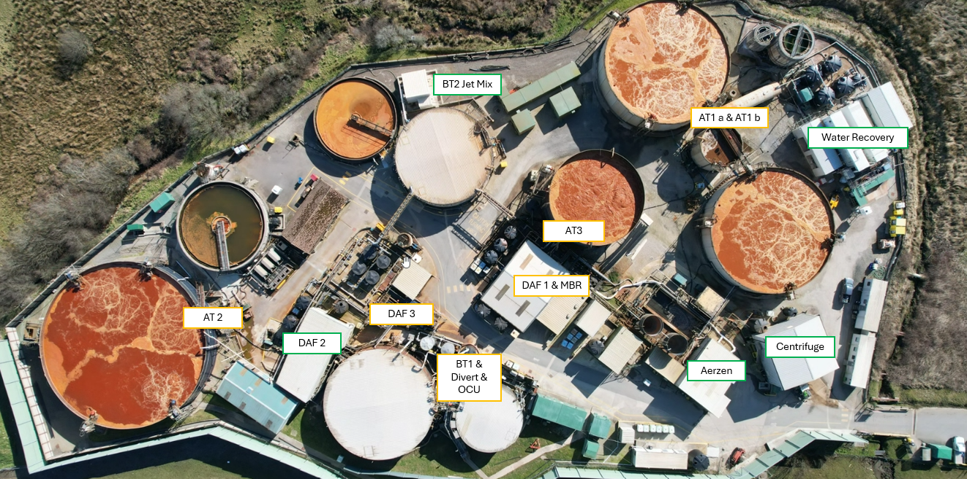

5.2 Monitoring off site sound levels
Off-site sound levels will be monitored (typically annually) at Treworra and Trewassa by a qualified specialist following appropriate standards and using appropriate equipment during representative operational periods.
Monitoring will provide quantifiable evidence of mitigation effectiveness and support compliance with relevant noise thresholds. Results will inform where noise control efforts are most effective and where further action may be required.
The WPF benefits from a proprietary continuous noise monitoring system called ‘Envirosuite’. The Envirosuite system entails continuous real time measurement of sound levels using a fixed monitor location on the boundary of the WPF in line with the prevailing wind direction. As well as real time data, the Envirosuite system allows historic information to be assessed which (in combination with recorded wind speed/ direction) informs investigation of any noise complaints.
Weekly monitoring is also carried out in our plant health forum where ‘Envirosuite’ noise monitoring decibels for the week are reviewed by the Site director, engineering manager, water processing facility specialist and the environmental team.
Measured noise levels are recorded at higher than normal levels (taking account of wind speed/ direction) prompts further on/ off site investigation.

6.0 Noise reporting

6.1 Complaints reporting
Noise complaints may be received through two primary channels:
- Via email or telephone from the Environment Agency’s National Incident Recording System (NIRS) team, where the complaint has been raised directly with the EA.
- Via phone call or email to Davidstow Site Security, Creamery, or WPF Operations Managers.
All complaints are logged by the Environmental Advisor in the Complaint Log, which forms part of Davidstow’s Environmental Management System (EMS) and is retained under: EMS / Sites / Davidstow / 9.1 Performance Evaluation / 8. Complaint Log.
Each entry in the Complaint Log includes the nature of the complaint, date and time, location, and any details provided by the complainant regarding noise level and character. This ensures accurate tracking and facilitates effective investigation.
Upon receipt of a noise complaint, a noise survey is initiated using the standard form provided in Appendix B. If the survey identifies operational issues or non-compliance, the Engineering Manager and WPF Process Specialist are notified immediately to implement corrective actions. This process ensures timely resolution and continuous improvement in noise management performance.
Once the survey is completed and submitted to the Environmental Team, an investigation is carried out using survey findings and data from the online Envirosuite monitoring system. Following the investigation feedback is provided to the Environment Agency.

6.2 Community engagement
Community Liaison meetings are held with representatives of the local community (members of Davidstow Parish Council) and the Environment Agency on a bi-monthly basis or as agreed with the local community. Meetings are documented and shared with participants and posted on SDUK’s website.
SDUK attendees typically comprise the Site Director, WPF Operations Manager and Environmental Management.
Community representatives (and other members of the community) are invited to provide feedback on noise emissions directly to SDUK between meetings in any addition to any reports sent to the EA.

6.3 Pro-active noise monitoring
Davidstow undertakes the following periodic pro-active monitoring of odour emissions:
- Periodic noise assessments of emissions from principal sources at the WPF as well as nearby receptor locations. Monitoring is undertaken by a specialist noise consultancy e.g. Hepworth Acoustics.
- Periodic internal qualitative and quantitative noise assessments both on site and at different receptor locations.
- Community surveys are completed by WPF personnel (typically managers or their deputies and members of the environment team). Results of off-site monitoring are recorded using form F.EV.05 shown in Appendix B. Surveyors can make use of portable equipment to measure dB at different locations.
- Online noise monitoring telemetry is provided at the WPF comprising a fixed noise monitor located on the site boundary local to BT2 referred to as the Envirosuite System. This allows noise data to be routinely reviewed as part of operational Tier meetings.

6.4 Reactive noise monitoring
Reactive noise monitoring essentially follows the same process as described for pro-active monitoring above.
When complaints are received from the NIRS team in a timely fashion and/ or directly from the local community which enable a meaningful investigation, a community survey is undertaken and recorded using form F.EV.05 shown in Appendix B.
These surveys are then recorded here EMS/Sites/Davidstow/9.1.1Performance Evaluation/8.Complaint Log.
Noise complaint investigation are informed by data from the fixed noise measurement device (Envirosuite system) described above in combination with wind speed/ direction data from the on-site weather station.

7.0 Appendices

Appendix A
Illustration showing location of planned roller shutter door improvements.
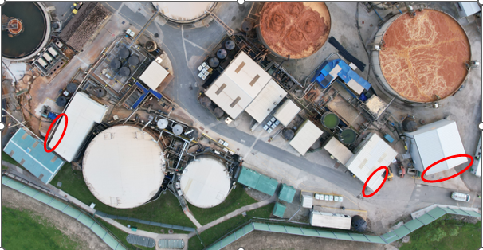

Appendix B
Off-site odur and noise monitoring survey template.
Completed By
Date: - | Time
Wind direction |  | Weather/Other
Location | Odour  (any H₂S?) | Character/description of odour & noise | Intensity level | Noise (dB)
1 Site
2 Trewassa
3 Treworra
4 Tremail
5 Airfield
Other notes, people met, comments
Observations at other locations on drive
Location map is at the end of the document.
1 Site | Any main site observations
2 Trewassa | At field gate beside workshop
3 Treworra | You can go up the lane saying “Treworra Barton/Belle tents”.  Can park in the turning spot beside farm gate/Belle tents.  Can also walk along the lane to next farm gate, closer to plant.
4 Tremail | Field gate – higher part of hamlet
5 Airfield | Any observations as the route is taken

INTENSITY – for good or bad odours
 | What is that like?
0 No odour | Clear fresh air or rain/wind
1 Very faint odour | Smell something taking deep breath or not constant  (even cut grass or faint sewage types)
2 Faint odour | Imagine bbq smoke 2 or 3 gardens away, you’re aware but it’s not bothering you.
3 Detect odour | Arrive and notice it when you get out of the car, and it is constant.
4 Strong odour | It is an obvious smell, persistant – like fresh paint in a closed up house.
5 Intense odour | You’ll notice it in the car and constant, perhaps quite unpleasant as you stand at the location. Doesn’t lessen while there.
6 Extremely strong odour | Strong enough it may make you wretch, cover your mouth and probably move away quickly
CHARACTERISTICS – description examples
Character of Odour | What is that like?
Healthy sewage treatment plant | Like fresh garden compost, a bit earthy, soil after rain
Unpleasant | Should be evident – anything you wouldn’t want to be around yourself.  Sat having a cuppa – would you want to keep smelling it?
Sulphur like/eggy | Indicates high hydrogen sulphide almost certainly form our plant.  IMPORTANT – please report that back to the WWTP team.
Sewage | Blocked drains, septic tank
Anoxic | Bottom of a pond black sticky anoxic sludge, smells unpleasant but not like eggy smell
Fishy | Rotting fish, blood fish & bone manure
Gone off milk/cheesy | Should make sense
Sweet | Calcium phosphate sometimes is like this
Acrid | Acidic, drain unblocker
Smokey | Woodsmoke, bbq, field burn off
Metallic | Burnt brake pads, angle grinding
Silage | Sweet, grass smell
Manure, agricultural | Stronger muck smell either from animal yard or spreading  (not expecting you to say which unless you see the operation)
Others | Anything else you smell good or bad:  Paint, vomit, blossom, wild garlic, garbage (bottom of a dirty wheelie bin)

INTENSITY – for loud and quiet noise
 | dB | What is that like?
0 Barely Audible | 0-20 | Includes the threshold of human hearing (0 dB), normal breathing (10 dB), and rustling leaves or a ticking watch (20 dB)
1 Quiet/Calm | 30-40 | Characterised as "pleasant" or "peaceful". Examples include a soft whisper, a quiet library, or a bedroom at night
2 Moderate/Normal | 50-60 | Typical for everyday environments like a quiet office, moderate rainfall (50 dB), or a normal conversation (60 dB)
3 Noisy/Loud | 70-80 | Levels that begin to interfere with communication. Examples include vacuum cleaners, heavy traffic (70 dB), and noisy restaurants (80 dB)
4 Very Loud/Dangerous | 90-110 | Sounds that can cause hearing damage over time, such as lawnmowers (90 dB), motorcycles (100 dB), and shouting directly into the ear or rock concerts (110 dB)
5 Painful/Threshold of Pain | 120-140 | Immediate physical discomfort or pain occurs at these levels, which include sirens, jet planes taking off (120 dB), and fireworks or gunshots (140 dB).

Questions and Answers
Tremail
Odour intensity (1-6):
H₂S Levels:
Character of odour:
Noise:
Comments:
Q – Why do we need to do this?
A – To better understand day to day what odours/noise our operations are making. Partly so we can pick up things to improve/fix and also to experience what our neighbours do.
Q – Am I looking for just “bad” odours and loud noises from just us or anywhere?
A – Any odours good or bad in these locations will help us build a picture of impacts and see if they are related to wind directions and operations.
Q – Should I speak with our neighbours?
A – It would of course be courteous to introduce yourself or say hello if they are there during these trips. Any feedback is helpful. It may not always seem like it but often impacted neighbours near any industrial operations often wish to be heard – just listened to. It’s all helpful.
Q – Should I explain the WPF operations to them?
A – No you don’t but please say you will pass the information on to the plant.
If it is strong from the WPF sewage, acidic, eggy – please report that back to the WPF team

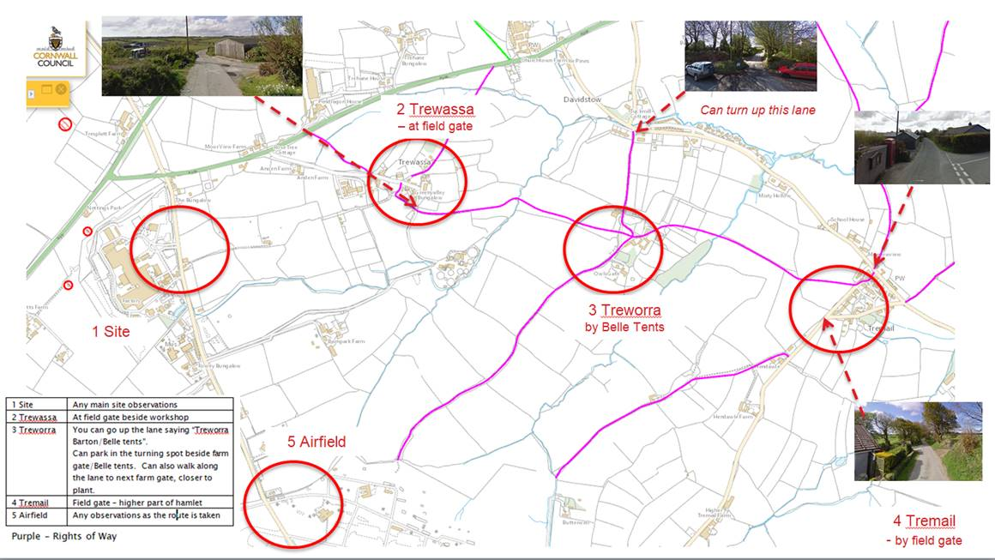

Appendix C
Standard operating procedure (SOP) for procurement of low-noise pumps and motors.
- Introduction

This procedure outlines how Saputo Dairy UK ensures all replacement pumps and motors purchased for the Water Processing Facility (WPF) consider the lowest commercially achievable noise specification as a key purchasing criteria. The process supports the Noise Management Plan and Environment Agency permit requirements by reducing noise impact on sensitive receptors, including site boundaries and nearby residential areas.

- Purpose and Scope

The purpose of this SOP is to guide Saputo Dairy UK personnel involved in engineering, procurement, and project planning on how to specify, evaluate, purchase, install, and verify pumps and motors with the lowest practicable noise emissions.
It applies to:
- All new installations
- Replacements of existing pumps or motors
- Temporary or hire equipment where noise output is relevant
- Any project where the chosen equipment may influence the site’s noise profile or compliance margin
- Responsibilities

The Engineering Manager is responsible for the implementation of this procedure and the training of all operators. The Health Safety and Environment Manager is responsible for the review of this procedure. This SOP should be reviewed every year unless a modification or change is made to the procedure before then.

- Standard Operating Procedure

4.1 Initial assessment. | The initial assessment should confirm the pump or motor’s location in relation to any nearby noise-sensitive receptors to understand potential impacts. At this stage, the applicable internal noise criteria and any relevant expectations set by the Environment Agency must be identified. Based on these factors, consideration should be given to whether additional controls such as acoustic enclosures, noise screens, or damping materials may be required to achieve acceptable noise levels.
4.2 Specification requirements | Procurement specifications must include either the equipment’s declared sound power level (LwA) or sound pressure level (LpA) measured at 1 m. All supplied data should demonstrate testing in accordance with ISO 3744 or ISO 3746. Suppliers must be instructed that the lowest reasonably practicable noise level is mandatory, with preference given to equipment designed with variable-speed drives, low-cavitation pump geometry, and high-efficiency IE3 or IE4 motors. Evidence of tested noise performance must be provided with the quotation.
4.3 Supplier evaluation | At least two comparable quotations should be obtained, each providing the required noise data. Suppliers must be evaluated and ranked based on acoustic performance, technical suitability, efficiency, and cost. The quietest technically and commercially feasible option should be selected. Where a noisier item is chosen for operational or technical reasons, the rationale must be clearly documented.
4.4 Pre-Installation controls | Before installation, appropriate controls such as vibration isolation pads, flexible couplings, or acoustic lagging should be incorporated into the design. The installation layout must also be reviewed to ensure it minimises rigid pathways that could transmit noise into structures or adjacent areas.
4.5 Installation | During installation, all equipment must be fitted strictly in accordance with manufacturer instructions. Guards, covers, and any acoustic enclosures must be correctly installed to ensure their noise-reducing benefits are fully realised.
4.6 Commissioning | At commissioning, all relevant details including model numbers, serial numbers, and declared noise levels must be recorded. The Environmental Advisor must be notified so they can verify the equipment configuration and noise information.
4.7 Post-Installation Noise Verification | A spot noise measurement must be carried out within seven days of installation. This reading should be compared with the manufacturer’s declared data and any criteria specified in the site’s Noise Management Plan. If elevated noise is detected, the cause must be investigated and corrected, considering factors such as pump alignment, cavitation, faulty mounting, or other mechanical issues.

