ODOUR MANAGEMENT PLAN (OMP)

1. INTRODUCTION 2
1.1 Site Description 2
1.2 Maintenance and review of the OMP 2
1.3 Relevant sector guidance on which this OMP is based 3
1.4 Version Control 3
2. RECEPTORS 4
2.1 Receptor List and Map 4
2.2 Wind Rose and Source of Weather Data 5
3. SOURCES OF ODOUR AND SITE PROCESSES 7
3.1 Odorous Materials Entering and Leaving Site 7
3.2 Odorous Materials 8
3.3 Overview of odorous processes and emissions 9
4. CONTROL MEASURES AND PROCESS MONITORING 12
4.1 APPROPRIATE MEASURES AND BEST AVAILABLE TECHNIQUES (BAT) 12
5. ODOUR REPORTING 15
5.1 COMPLAINTS REPORTING 15
5.2 COMMUNITY ENGAGEMENT 15
5.3 PRO-ACTIVE ODOUR MONITORING 15
5.4 REACTIVE ODOUR MONITORING 15
6. ABNORMAL EVENTS 16

APPENDIX 1 OFF SITE ODOUR MONITORING RECORD 17

Davidstow Creamery, Camelford Cornwall, PL32 9XW
Environmental Permit number: BN6137IK

Who this Plan is for
This Odour Management Plan (OMP) has been prepared by Dairy Crest Limited (trading as Saputo Dairy UK) (hereafter referred to as “SDUK”) to support the Davidstow Creamery and Water Processing Facility (“WPF”) teams in:
- monitoring and contingencies to control and minimise odour pollution during normal and abnormal operation,
- preventing unacceptable off-site odour pollution as described by the Environmental Permit BN6137IK, and
- undertaking odour surveys and responding to external complaints.
This OMP will be communicated directly to those SDUK employees involved in managing odour emissions, undertaking off-site odour surveys and responding to complaints.

1. Introduction

1.1 Site Description
In summary, SDUK’s Davidstow facility comprises:
- a Creamery receiving milk, on a daily basis, which it pasteurises and processes into cheese. Whey from the cheese making process is used to manufacture whey cream, demineralised whey powder and whey protein concentrate. Lactose powder is processed to produce galacto-oligosaccharide (GOS), a prebiotic syrup, and
- A Water Processing Facility (WPF) which receives process waste water from the Creamery and employs physico-chemical, biological and membrane processes to treat water for subsequent discharge to the River Inny (in accordance with the Permit conditions) or reuse within the Creamery.
The Creamery and WPF operate for approximately 358 days per year, 24 hours per day (other than an annual maintenance shut down around October/ November). Operation is relatively consistent during the year with some variation in site throughput associated with peak milk volume receipts referred to as the ‘spring flush’.
Davidstow Creamery is located in a predominantly rural location; the nearest villages to the site are Trewassa, Davidstow and Tremail with other smaller residential areas such as Treworra nearby. The land use surrounding the Creamery and WPF is predominantly rural and agricultural, with a low population density. There is potential for seasonal and/or intermittent odour releases from local farming practices and a fallen stock facility located to the south of the Creamery.

1.2 Maintenance and Review of the OMP
The Davidstow Environment and Sustainability Manager is responsible for developing, maintaining and updating the OMP. Reviews of the OMP are typically undertaken on an annual basis or following significant change on site that has the potential to affect odour emissions sources and/or control of emissions.
The OMP forms part of Davidstow’s Environmental Management System (EMS) and is filed under EMS/ Davidstow/ 8.1 Operational Control.
The Creamery and Water Processing Facility (WPF) Operations Managers (supported by the Environment and Sustainability Manager) are responsible for training relevant people in their teams.
All personnel undertaking off-site odour surveys will be trained in completion of the odour survey reporting form shown in Appendix 1.

1.3 Relevant Sector Guidance on which this OMP is based
- Environment Agency’s Technical Guidance Note H4 ‘Odour Management’
- EA’s Environment Agency Odour Management Plan Template Final V2 05/05/21

1.4 Version Control
Rev | Purpose for Revision | Authorised By | Submitted to EA | Owner
4 | Routine update and adoption of EA template for OMPs | C Appleton | 2023 | G Jones
3 | Routine update | S Cook | 2021 | S Magor
2 | New format with olfactometry results | M Youds | 2018 | M Bardell
1 | First issue | M Bardell | 2016 | AMP

2. Receptors

2.1 Receptor List and Map
As described in Section 3, the principal sources of odour are within the WPF. The location of each receptor is described relative to the WPF.
Ref. | Receptor Type | Direction from WPF | Approx Distance to Site Boundary (m) | Sensitivity to odour  - Low (e.g. footpath/road)  - Medium (e.g. industrial/ workplace)  - High (e.g. housing / pub / hotel etc.)
1 | Residential properties on Blacka Lane local to Creamery (north) | W | 1,000 | High
2 | Trewassa –residential properties & maintenance workshop | NW | 300 | High
3 | Treworra – residential properties | E | 500 | High
4 | Tremail - residential properties | E | 2,000 | High
5 | Airfield | S | 1,500 | High
6 | Inny Vale – residential & holiday properties | ENE | 1,500 | High
7 | Air Museum | W | 1,500 | Medium
8 | St Kitts Farm – residential and commercial | W | 2,000 | High
9 | Fallen Stock Yard – commercial | ESE | 1,500 | Low
10 | Davidstow Church & The Pines (residential) | N | 1,000 | High
11 | Residential properties – Pendragon House, Trehane House and Bungalow | NW | 2,000 | High
12 | Barnpark Farm | WSW | 500 | Medium
13 | Residential properties on Blacka Lane local to Creamery (south) | WSW | 1,500 | High

2.2 Wind Rose and Source of Weather Data
Meteorological data has been obtained from Cardinham weather station near Bodmin to the south of Davidstow and the receptors identified in section 2. A wind rose is shown below which is representative of all years of data assessed.

A meteorological station recording wind speed and direction as part of the Envirosuite monitoring system is located at the WPF and is used to assess off site impacts and during complaint investigation.

The prevailing winds within the region are from the west-southwest, west and northwest, with a secondary component from the southeast and relatively minor frequency of winds from the south and southwest.
The majority of odour complaints relating to SDUK’s operations have been received from residents in Trewassa to the northwest of the WPF and Treworra to the east-northeast, hence the wind frequencies from the southeast and west-southwest are typically responsible for transporting any odours from the WPF to the sensitive properties.

Location of Receptors shown in the table above

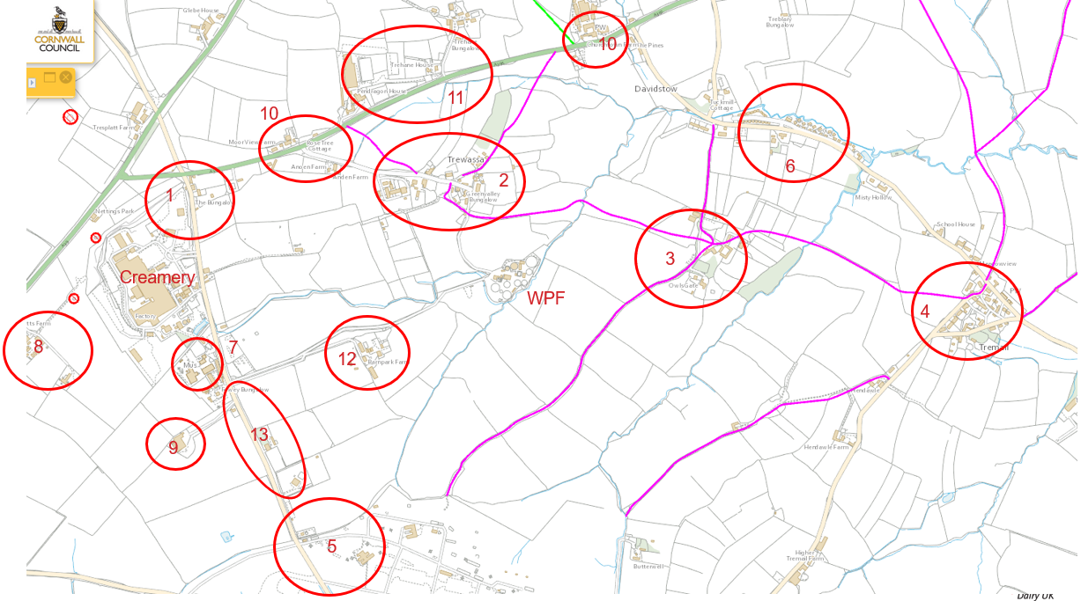

3. Sources of Odour and Site Processes

3.1 Odorous Materials Entering and Leaving Site
The raw materials delivered to and received at the Creamery and WPF are of inherently low odour potential.
Sources of odour arise when ingredients, by-products, process waste water or waste generated during the operation of the Creamery or WPF degrade. Degradation typically results from (i) storage and handling of materials under oxygen deficient conditions (ii) when materials are allowed to acidify which increases the potential for formation of hydrogen sulphide (H₂S) and/ or (iii) excessive retention time of such materials in tanks.
Although of low odour, some inputs to waste water processing can exacerbate the potential for odour formation e.g. the use of sulphuric acid which increases the sulphur content of process waste water.
Section 3.2 identifies the different types of potentially odourous materials on site.
Extensive olfactomeric assessments of odour emissions at the WPF were conducted in 2017 to define and quantify an inventory of the main sources of odour. This was further updated by assessments carried out in 2020, 2021, 2022 and 2023. The outcome of the olfactometry assessments have been used in assigning low, medium or high risk, as detailed below.
Section 3.3 identifies the processes associated with the use of potentially odourous materials, their locations and potential to contribute to offsite odour emissions.

3.2 Odorous Materials
Odorous and Potentially Odorous Material | Odour Potential  High / Medium / Low Risk | Maximum quantity on site at any given day | Maximum time held on site (hours or days) | Location of odorous materials on site | Additional Comments
Out of specification or surplus whey | Medium | 300 tonnes in lagoon | 7 days | Creamery | Rated medium risk if excessive residence time and hot weather
Untreated process waste water from Calcium Phosphate (CaP) plant | Low | 450 tonnes in CaP Balance Tank | 3 days | Creamery | Low as typical residence time is <1 day
CaP Cake | Low | 20 tonnes | Inventory of cake press/ belt and cake trailers awaiting export | Creamery | Low as trailers are routinely exchanged & accumulations routinely (daily) removed from belt press & conveyor
Untreated process waste water - Balance Tank 1 (BT1) & Divert Tank) | High | 2,500 tonnes | Typically 1-2 days (residence time in BT1 and Divert Tank) | WPF - BT1 and Divert Tank | Rated as high risk if stored under adverse conditions of high pH or low dissolved oxygen (DO)
Part treated process waste water – Balance Tank 2 (BT2), Anoxic Tank 2 (AN2) and Anoxic Tank 3 (AN3) | Medium | 3,000 tonnes | Typically 1-2 days (residence time in BT2, AN2 and AN3) | WPF – BT2 and AN2 and AN3 | Rated as high risk if stored under adverse conditions of high pH or low DO
Part treated process waste water Aeration Tank 3 (AT3) | Medium | 3,000 tonnes | Typically 1-2 days (residence time in AT3) | WPF –AT3 | Low under normal operating conditions.  High if contents stored under adverse conditions of low DO
WPF Sludge | High | Inventory of sludge pits and 2x 8 tonne sludge trailers | Sludge trailers removed daily | WPF | Sludge is inherently odourous
Waste cheese curds | Low | 1 tonne | 1-2 weeks between collections | WPF | Rated as low risk due to low inventory unless retained on site for excessive time during hot weather

3.3 Overview of Odorous Processes and Emissions
Ref | Building | Type of Process | Type of Emission Point | Odour Potential | Additional Comments
WPF | Inlet well | Untreated process waste water/ open well | Area | Low
WPF | DAF units 1-3 | Partially treated waste water/ open units within buildings (DAF1&2) and externally (DAF3) | Area | Medium
WPF | Balance Tank 2 | Partially treated waste water / open tank | Area | High
WPF | Anoxic Tanks 1-3 | Partially treated waste water / open tanks | Area | Medium
WPF | Aeration Tanks 1A, 1B, 2 & 3 | Aerated waste water / open tanks | Area | Low (AT1A,B and 2)  Medium (AT3)
WPF | RAS / WAS Chambers | Sludge / open wells | Area | Low
WPF | Bottom sludge pit | Sludge / open chamber | Area | Low
WPF | Top sludge pit | Sludge / open pit | Area | Low
WPF | Sludge conveyor | Dewatered sludge / agitation | Area | Medium
WPF | Sludge trailer | Dewatered sludge / open trailer | Area | Medium
WPF | Odour Control Unit | Treated emissions / vertical stack | Point | High | OCU serves BT1 and Divert Tank
WPF | Cheese curd waste bins | Waste storage | Point | Low
Creamery | Open top buffer tank | Partially treated waste water / open tanks | Area | Medium
Creamery | Flocculation tank | Partially treated waste water / open tanks | Area | Low
Creamery | Sludge conveyor | Dewatered sludge / agitation | Area | Low
Creamery | Sludge trailer | Dewatered sludge / open trailer | Area | Low
Creamery | Odour Control Unit | Treated emissions / vertical stack | Point | Low | OCU serves covered storage lagoon

Site Plan Showing Location of Odourous Process Locations – WPF

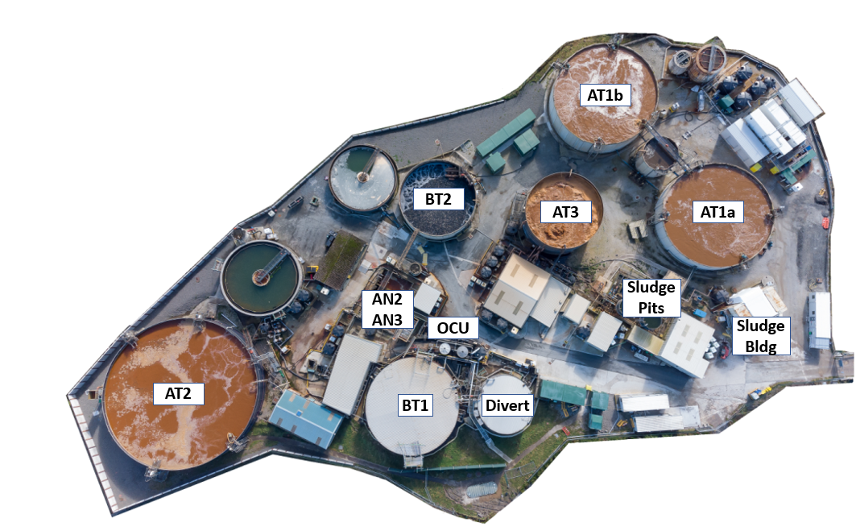

Site Plan Showing Location of Odourous Process Locations – Creamery
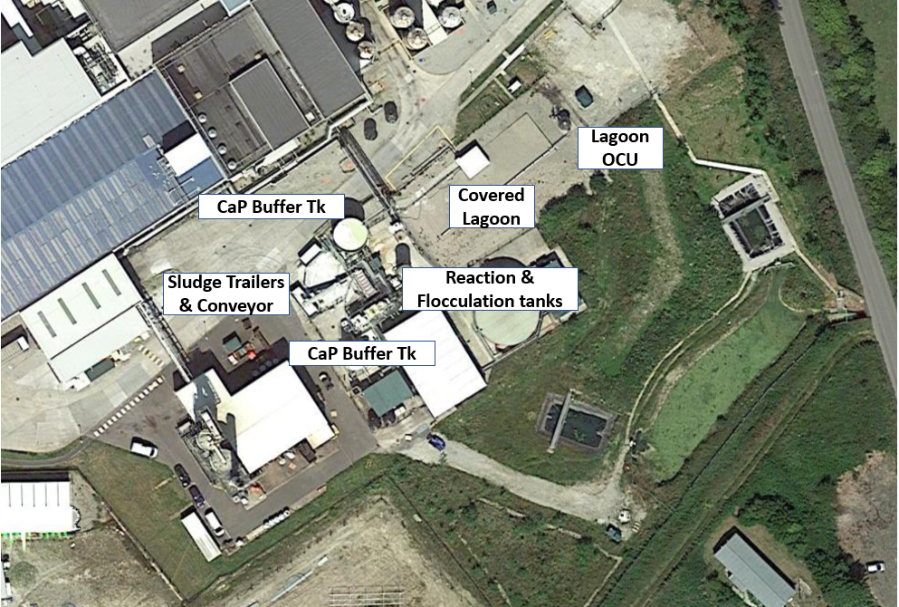

4. Control Measures and Process Monitoring

4.1 Appropriate Measures and Best Available Techniques (BAT)
Odorous and potentially odorous process/material | Control Measures (Appropriate Measure / BAT) | Monitoring frequency | Monitoring procedure and optimum process parameters | Trigger level | Action taken if outside optimum process parameters
Out of specification or surplus whey | - Use of covered contingency storage lagoon to hold high strength waste ingredients and by-products awaiting either subsequent processing at the WPF or export from site by road tanker  - Single stage OCU serving covered lagoon | Continuous  Annual | Manual inventory checks and retention time minimised  Annual ‘health check’ of condition of OCU serving the lagoon | 300 tonnes  Retention > 1week  >1 ppm H₂S | Export via road tanker  Replace OCU media if depleted with H₂S emissions > 1 mg/Nm³
Untreated process waste water – CaP Plant | - Residence time of Demin effluent in CaP Balance Tank minimised at <1 day during normal operation | Continuous | Monitoring of tank level and residence time | >3 days in summer | Export via road tanker
CaP Cake | - Maintaining process condition of CaP Plant for effective precipitation and flocculation  - Automated dosing of sulphuric acid to minimise residual sulphur level in waste water received by the WPF  - Housekeeping of CaP Plant to remove residual cake  - Routine exchange of cake trailer | Continuous  Continuous  Daily  Daily | pH dosing and polymer feed rate (visual check of floc)  pH of flocculation tank  Standard Operating Procedure  Trailer level automatically detected and auto trailer changeover | Poor floc  pH >4  Residual solids  Trailers full | Tankering  Tankering  Manual clean  Exchange trailer
Untreated process waste water - WPF | - Short interval control of Creamery operations  - Use of Unplanned Event Reporting (UER) form to manage and communicate unplanned discharges of ingredients, by-products and products to drain | Daily  Continuous | Unplanned losses to drain minimised or communicated to WPF using UER form | Unplanned Event | Higher strength effluent routed to lagoon, Divert Tank and/ or tankering
Untreated process waste water - WPF | - Continuous monitoring of Dissolved Oxygen (DO) Levels in reception tanks  - Desludging of BT1 and Divert tanks | Continuous  Annual | >1.0 mg/l DO  Sludge accumulation | <1.0 mg/l DO  Poor DO | Increase aeration rate  Remove sludge
 | - Automatic diversion of high strength effluent from BT1 to the Divert Tank using pH, COD and/or turbidity (being commissioned in summer 2023)  - Automated dosing of caustic to BT1 to maintain pH >8 (being commissioned in 2023) | Continuous  Continuous | Daily COD load <12 tonnes  Daily lab analysis of COD of influents  Visual checks of WPF inlet well  pH >8 | COD load >13 tonnes/ day  pH <8 | Higher strength effluent routed to Divert Tank and/ or tankering.  Manual diversion if automated system fails  Manual addition of caustic
 | - Covered and extracted WPF reception tanks BT1 and Divert Tank | Periodic integrity test e.g. smoke  Annual | Maintain slight negative pressure  Preventative maintenance of extraction fan | Visual detection of fugitive emission during testing | Remedial works to tank cover/ duct work to minimise fugitive emissions and maintain negative pressure in both tanks
 | - Monitoring of H₂S levels in BT1 and Divert tank headspace  - Multi-stage Odour Control Unit (OCU), extract fan and exhaust stack (wet/ dry (Diox) / dry (Triox)).  - Monitoring of H₂S levels in OCU exhaust | Continuous  Continuous  Continuous | <10 ppm H₂S verified via manual measurement  Annual ‘health check’ of condition of OCU serving BT1 and Divert  < 1 ppm H₂S verified via manual measurement | >10 ppm H₂S  >1 ppm H₂S in exhaust | Increase pH via manual additional of caustic.  Reduce COD load  Additional of Diox Max  Replace media from site or consignment stock  Increase Diox max dosing of wet stage of scrubber.
Part treated process waste water – BT2 and AN2,AN3 | - Short interval control of WPF operations  - Covered and extracted WPF buffer tank BT2 and AN2 and AN3 (due for completion in spring 2024)  - OCU serving BT2, AN2 and AN3 ((due for completion in spring 2024) | Daily  Continuous  Continuous | Daily review of key WPF metrics (process parameters and lab results)  Maintain slight negative pressure  < 1 ppm H₂S in exhaust | >1 ppm H₂S | Increase aeration  Replace media from site or consignment stock
Part treated process waste water – AT3 | - Maintain Mixed Liquor Suspended Solids (MLSS) through COD feed rate and sludge wasting  - Aeration of AT3 via jet mix system and DO  - Maintain low Ammoniacal Nitrogen (Amm-N) Levels  w | Daily  Continuous  Daily | Lab analysis of MLSS  >1.0 mg/l DO  <1.0 mg/l Amm-N | MLSS >15,000 mg/l  < 1.0 mg/l DO  >3 mg Amm-N | Reduce feed, increase sludge wasting  Increase aeration  Add nitrifying bacteria
WPF Sludge | - Sludge centrifuges located inside closed container  - Sludge conveyor and trailers located inside closed building with roller door only opened for exchange of trailer  - Frequent exchange of trailers  - Sludge building housekeeping to prevent sludge accumulation  - Sludge pit inventory minimised and periodically de-sludged to remove any stagnant material at the base of the tank | Continuous  Continuous  Daily  Daily  Annual | Doors closed except during trailer exchange  No overfilling of trailers  Minimise solids outside of trailers  Routine removal of any solids accumulation | Doors open | Close doors  Exchange trailer  Manual clean  Periodic de-sludging
Cheese Curd Waste | - Frequent emptying of covered bins | Scheduled collections | Visual checks on inventory of bins to prevent overfill | Bins full or scheduled collection time exceeded | Empty bins

5. Odour Reporting

5.1 Complaints Reporting
Complaint reports are received either:
- via email and/ or call from the Environment Agency’s National Incident Recording System (NIRS) team if the complaint has been raised with the EA, and/ or
- via phone call or email to Davidstow Site Security, Creamery or WPF Operations managers.
All complaints are recorded in a Complaint Log by the Environment and Sustainability Manager. Details of the nature of the external complaint are recorded as well as time/ date, location, level and description of the character reported by the complainant.
The Complaint Log forms part of Davidstow’s Environmental Management System (EMS) and is retained under EMS/ Sites/ Davidstow/ 9.1 Performance Evaluation/ 8. Complaint Log.

5.2 Community Engagement
Community Liaison meetings are held with representatives of the local community (members of Davidstow Parish Council) and the Environment Agency on a typically monthly basis or as agreed with the local community. Meetings are documented and actions/notes shared with participants.
SDUK attendees typically comprise the Davidstow Site Director, WPF Operations Manager, Environmental Management and Project Management.
Community representatives (and other members of the community) are invited to provide feedback on odour emissions directly to SDUK via email/security gate house between meetings in addition to any reports sent to the EA.
Where possible, SDUK will proactively advise Community representatives of abnormal operational conditions that have the potential to increase odour emissions so that they can advise the wider community.

5.3 Pro-active Odour Monitoring
SDUK undertakes the following periodic pro-active monitoring of odour emissions:
- On-site - Periodic (typically annual) olfactomeric assessment of emissions from principal sources at the WPF and Creamery. Olfactometric assessment is periodically supplemented with chemical speciation of principal sources. Monitoring is undertaken by a specialist odour consultancy e.g. Olfasense
- Off-site - Community surveys by Creamery personnel (typically operations managers or their deputies and members of the Davidstow environment team). Results of off-site monitoring are recorded using form F.EV.05 shown in Appendix 1. Surveys can include the use of portable equipment to measure H₂S concentrations at low levels (ppb). Survey results are recorded as part of the Complaint Log referred to in section 5.1 above.
- Use of remote, fixed monitoring equipment at locations previously known to be affected by periodic increases in odour emissions i.e. Trewassa and Treworra. Current or recent historic measured ground level concentrations of H₂S can be accessed remotely using a web-based system referred to as Envirosuite.

5.4 Reactive Odour Monitoring
Reactive odour monitoring follows the same process as described for pro-active monitoring above.
When complaints are received from the NIRS team in a timely fashion and/ or directly from the local community to enable a meaningful investigation, a community survey is undertaken and recorded using form F.EV.05 shown in Appendix 1.

6. Abnormal Events
Operating experience and risk assessments have shown the following abnormal events to have the potential to materially affect odour emissions from the WPF.
Abnormal Event | Recovery Steps
Unplanned discharge of ingredient, by-product or finished product to drain typically as a result of Creamery equipment breakdown or unplanned event | Material is routed either to the covered, extracted and abated contingency lagoon located at the Creamery or the Divert Tank at the WPF.  In addition, material can be exported directly from storage tanks at the Creamery e.g. storage tank T417
Increased waste water load at WPF | Export of surplus via road tanker  Increase pH in BT1 through manual addition of caustic to supplement caustic dosed via the automated pH control system (being commissioned in summer 2023)  Manual dosing of a proprietary odour suppressant (typically ‘Diox Max’ an aqueous solution of stabilised chlorine dioxide) added to BT1 in controlled doses of typically 1,000 litres over a 12 hour shift, depending on plant conditions
Failure of WPF aeration equipment | Replace with spares which are retained on site  Obtain rental blower(s) from retained contractor
Failure of WPF equipment e.g. DAFs reducing forward flow through WPF increasing inventory/ residence time in BT1 and Divert Tank | Amend production schedule of Creamery if possible to reduce waste water volume e.g. cleaning schedule  Export via road tanker
Increased ammonia in aeration circuits | Reduce feed, increase DO, add nitrifying bacteria, control Mixed Liquor Suspended Solids (MLSS) via sludge wasting rate
Power cut | Manual diversion to contingency storage lagoon at Creamery and/ or Divert Tank  Export via road tanker

Appendix 1 Off Site Odour Monitoring Record
Completed By
Date: | Time | 09:00 15:00 OTHER:
Wind direction |  | Weather/Other
Location | Odour  (any H₂S?) | Character of odour | Intensity level | Noise
1 Site
2 Trewassa
3 Treworra
4 Tremail
5 Airfield
Other notes, people met, comments
Observations at other locations on drive
Location map is at the end of the document.
1 Site | Any main site observations
2 Trewassa | At field gate beside workshop
3 Treworra | You can go up the lane saying “Treworra Barton/Belle tents”.  Can park in the turning spot beside farm gate/Belle tents.  Can also walk along the lane to next farm gate, closer to plant.
4 Tremail | Field gate – higher part of hamlet
5 Airfield | Any observations as the route is taken
INTENSITY – for good or bad odours
 | What is that like?
0 No odour | Clear fresh air or rain/wind
1 Very faint odour | Smell something taking deep breath or not constant  (even cut grass or faint sewage types)
2 Faint odour | Imagine bbq smoke 2 or 3 gardens away, you’re aware but it is not bothering you.
3 Detect odour | Arrive and notice it when you get out of the car, and it is constant.
4 Strong odour | It is an obvious smell, persistant – like fresh paint in a closed up house.
5 Intense odour | You’ll notice it in the car and constant, perhaps quite unpleasant as you stand at the location. Doesn’t lessen while there.
6 Extremely strong odour | Strong enough it may make you wretch, cover your mouth and probably move away quickly

CHARACTERISTICS – description examples
Character of Odour | What is that like?
Healthy sewage treatment plant | Like fresh garden compost, a bit earthy, soil after rain
Unpleasant | Should be evident – anything you wouldn’t want to be around yourself.  Sat having a cuppa – would you want to keep smelling it?
Sulphur like/eggy | Indicates high hydrogen sulphide almost certainly from our plant.  IMPORTANT – please report back to the WPF team.
Sewage | Blocked drains, septic tank
Anoxic | Bottom of a pond black sticky anoxic sludge, smells unpleasant but not like eggy smell
Fishy | Rotting fish, blood fish & bone manure
Gone off milk/cheesy | Should make sense
Sweet | Calcium phosphate is sometimes like this
Acrid | Acidic, drain unblocker
Smokey | Woodsmoke, bbq, field burn off
Metallic | Burnt brake pads, angle grinding
Silage | Sweet, grass smell
Manure, agricultural | Stronger muck smell either from animal yard or spreading  (not expecting you to say which unless you see the operation)
Others | Anything else you smell good or bad:  Paint, vomit, blossom, wild garlic, garbage (bottom of a dirty wheelie bin)

Questions and Answers
Tremail
Odour intensity (1-6):
H₂S Levels:
Character of odour:
Noise:
Comments:
Q – Why are we doing this?
A – To better understand day to day what odours our operations are making. To experience what our neighbours do. So we can pick up things swiftly to improve/fix.
Q – Am I looking for just “bad” odours from just us or anywhere?
A – Any odours good or bad in these locations will help us build a picture of impacts and see if they are related to wind directions and operations.
Q – Should I speak with the local community?
A – It would of course be courteous to introduce yourself or say hello if they are there during these trips. Any feedback is helpful. Often impacted neighbours near industrial operations wish to be heard. It’s all helpful.
Q – Do I have to explain the WPF operations, especially if it is smelly?
A – No you don’t. But if it is bad, please say you will pass the information on to the WPF Operations Manager for investigation.
If it is strong and from the WPF sewage, acidic, eggy – please report directly to the WPF team
