Summary of Environmental Management System

Tarmac Trading Limited (Tarmac) has in place an Environmental Management System (EMS) that is accredited to the international standard: ISO 14001. The site will be operated under the overarching Core EMS which covers Tarmac sites across the UK. The specific EMS procedures to support the operation of this type of regulated facility under an Environmental Permit in England have been developed with reference to relevant guidance produced by the Environment Agency (EA). The EMS follows the Plan Do Check Act (PDCA) cycle described in EA guidance as illustrated below:
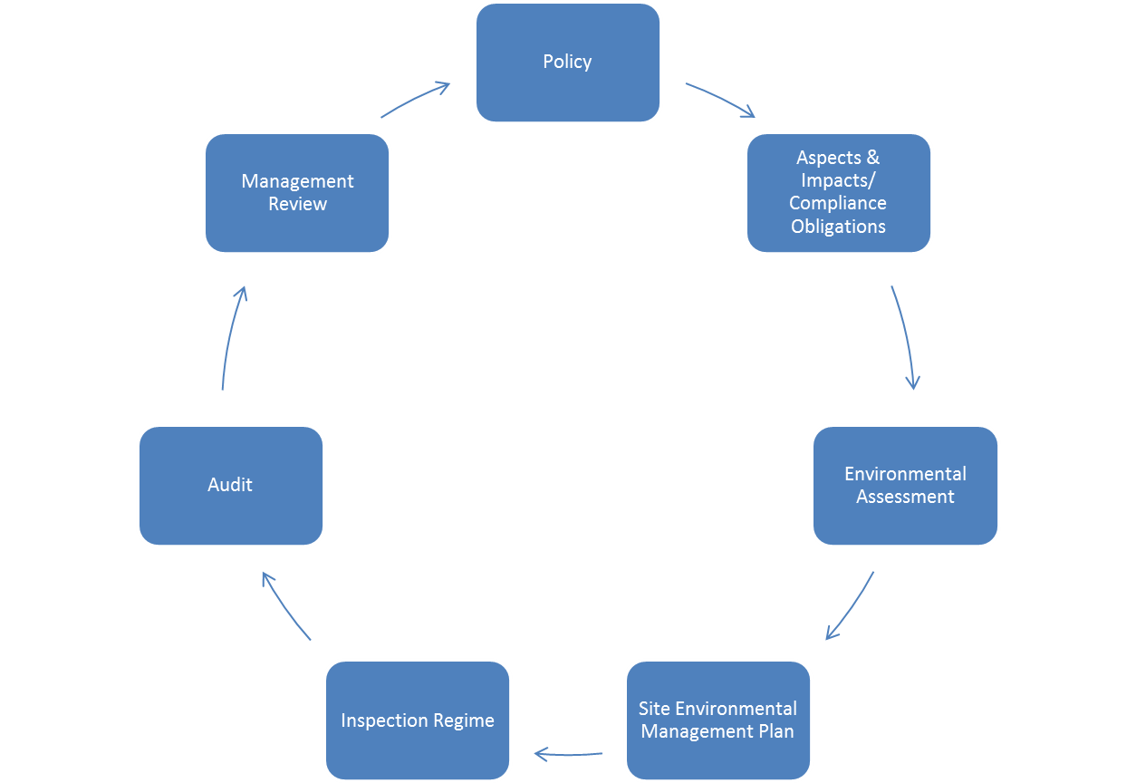

A copy of the EMS will be held at the site and will be available for inspection once the site is operational following the issue of the Environmental Permit for the site. A summary of the key elements of the EMS is provided below.

Company Environmental Policy

The EMS is underpinned by the company Environmental Policy which outlines its’ high level vision, how it expects operations to be managed and its environmental performance to be communicated to its stakeholders and to enable the effective deployment of the related principles across its operational sites.

Tarmac is committed to preventing its activities polluting the environment and the continual improvement of its environmental performance. Through a dedicated environmental and sustainability panel business objectives are developed. Environmental performance measures are also monitored by these forums and targets set to enable performance levels to be continuously improved.

Tarmac aims to minimise the environmental impact of its activities by:

- Regularly monitoring the effective deployment of the EMS through a series of graded audits
- Prior to undertaking work on behalf of Tarmac, all sub-contract personnel will be made aware of site-specific environmental concerns and vulnerabilities through the site induction process
- Reducing the amount of waste materials generated by their activities, attempting to recycling and reuse such materials wherever practical and where this is not achievable, disposing of such waste in a responsible manner
- Seeking to use raw materials in an efficient manner, replacing them with substitute recycled raw materials where practicable and safe to do so
- Promoting the efficient and reduced use of water, fuels, and energy, thereby reducing carbon emissions, and mitigating the potential for climate change
- Purchasing, utilising, and storing materials in a manner which poses minimal risk to both individuals and the environment, as far as is practical
- Monitoring of consented permits and licences

The EMS has been deployed effectively through the Company’s management organisation. Managers and employees are assigned environmental responsibilities and will be expected to play a full and active part in managing the environmental aspects of the activities for which they have responsibility. Operational management will be supported by a team of competent advisors and performance will be monitored by environmental auditors.

Company Environmental Standards

A core suite of aspects applied to activities controlled by Tarmac is audited to monitor compliance to the relevant environmental standards. All operational sites are the subject of an Environmental Assessment and maintain an up-to-date Site Environmental Management Plan (SEMP).

Waste operation specific aspects

The following aspects have been identified having regard to the protection of the environment, compliance with any environmental permits and the highest standards of operation. These are in addition to the core company aspects described above.

The following aspects relevant to waste operations will be managed in accordance with any relevant company policies and procedures, site authorisations and statutory obligations.

- Dust and particulate matter;
- Mud, litter and other debris;
- Noise;
- Security;
- Waste acceptance and rejection;
- Water management;
- Working face operations.

Environmental Assessment

The site manager shall be responsible for the Environmental Impact Review of the operations, in normal and abnormal conditions, to identify the key environmental aspects of its activities. Through this process the aspects of the operations, that may have a significant impact on the environment, can be identified, prioritised for corrective action and improvement together with an evaluation of legal compliance at the site. The site manager/supervisor, together with representatives from the site/area and the compliance and environmental permitting personnel shall identify and prioritise the potential significant environmental impacts of the operations. The potential impacts most relevant to waste operations have been identified to be:

- Bio-diversity and Ecological Management Visual Impact;
- Dust;
- Fuel & Chemical Storage;
- Gaseous emissions monitoring (inert landfill only);
- Groundwater monitoring Management (inert landfill only);
- Legislation and Documentation;
- Noise;
- Solid Waste Management;
- Vegetation Management;
- Vibration;
- Traffic.

Site Environmental Management Plan

The Environmental Impact Review provides the prioritised potential significant environmental impacts for inclusion in the SEMP. The plan shall identify objective(s) and target(s) for each significant impact and ensure that they are relevant to achieving the overall objectives of the Business Unit. The objective (the improvement action) shall be specific to the corrective/preventative action. The target for the improvement shall have a date for completion, the person responsible for the action and verification of the completion by the authorising person. The SEMP shall be reviewed regularly and shall be consistent with legislation, environmental procedures and the Tarmac environmental policy. The SEMP may be updated at anytime in order to implement changes/corrective actions identified by any management mechanism.

Each site shall undertake all necessary monitoring and measuring of operational activities, as required by legislation, such as environmental permits and planning consents. All such monitoring and measuring information shall be documented and recorded on a monitoring schedule.

Environmental Occurrence/Non-Conformance Reporting System

The environmental occurrence/non-conformance reporting system has been developed in order to document, investigate and mitigate significant impacts on the environment and for initiating and implementing corrective and preventative action. All incidents shall be reported, whether or not an external person/agency is involved. Any system non-conformances are also to be documented for corrective and preventative action.

Inspection Regime and Audit

The Environment Manager shall establish and monitor an annual inspection programme ensuring that all sites are audited by an ‘independent’ manager who has no responsibility for the site. The auditor shall complete an associated audit summary sheet, agreeing and summarising as necessary a list of recommended actions in consultation with the site manager. The audit summary sheet shall then be included in the SEMP and priorities and timescales assigned. A date for a follow-up visit to ensure close out of any actions has been completed will be set up by the visiting auditor and the manager/supervisor. The follow up visit must also be used to ensure previous actions implemented are continuing to work and are effective.

In addition, the Company’s own internal monitoring compliance team will carry out monthly monitoring across a range of determinants relevant to the abstraction and watercourse to ensure that the compliance levels and consent are being complied with.

Management Review

There will be a tiered review of the EMS at top management level, local area level and at site management level including the procedures, environmental policy and the objectives and targets for the company in order to support its ongoing effectiveness, suitability, adequacy and stability.

Site and Equipment Maintenance Plan

Plant and machinery are subject to maintenance schedules in line with manufacturer recommendations and requirements. Site staff report problems with equipment and this is then assessed and actioned as necessary and as soon as possible.

It is in the company’s interests to ensure all plant is operation and maintained which ensures both continuity of business and greater environmental protection.

Contingency Plans

In accordance with Company MS-EP-CORE-16 the Site Environmental Management Plan will include site specific contingency plans.

Accident Prevention and Management Plans

Pollution Prevention procedures for the site are outlined in MS-EP-CORE-09 Pollution Prevention. The procedures cover pollution prevention measures for dust, odour, noise and spills and inspection of equipment and emergency response. In accordance with Company MS-EP-CORE-16 the Site Environmental Management Plan will include site specific emergency response procedures.

Managing Staff Competence and Training Records

Employees will be suitably experienced and trained through various mechanisms to ensure they are competent to carry out their duties in line with company procedures and training schedules. Particular attention will be given to the familiarisation of the staff with the Environmental Permit and other compliance requirements and potential emissions and prevention of accidental emissions. Training will be recorded in accordance with the Company procedures. Contractors employed at the site will undergo a site induction and competency will be checked. Internal audits and inspection by the compliance team and internal auditors will ensure that training has been completed and actions are in line with this by employees and contractors.

Record Keeping
Records will be kept in accordance with the requirement of the Environmental Permit,

How to comply with your environmental permit.

