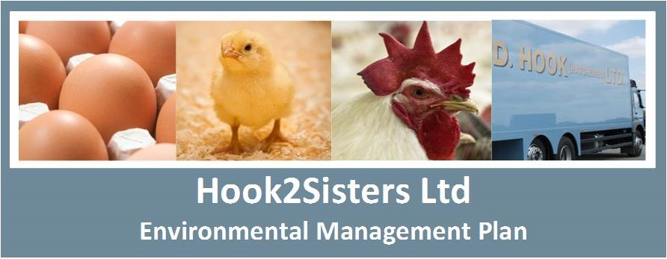
ODOUR MANAGEMENT PLAN – OVERCOTE, SP3930UV
Introduction

This Odour Management Plan (OMP) has been prepared to support the overall Environmental Management System in place at Overcote Poultry Unit. The overriding principle of this OMP is to ensure the day-to-day activities are carried out in accordance with this document to help minimise the overall environmental impact. This OMP has been prepared as Best Practice.
The purpose of this OMP is to…
- Establish the likely source of odours arising from the farm.
- Set out procedures at the farm in order to mitigate or minimise the risk of odour.
- Formalise an effective method of dealing with any odour complaints quickly and efficiently.

Installation Background

The site is currently used for rearing broilers in 12 purpose built poultry houses to approximately 6 – 8 weeks of age.

An application has been submitted to vary the permit to reflect the proposed changes in infrastructure and increase in broiler numbers. The 12 sheds are to be demolished and replaced with 6 sheds to modern standards with high velocity ridge extraction. Gable end fans will be installed on all the houses which will be operational during increased temperatures. Daily adjustments will be made to the temperature and ventilation programme to ensure optimum conditions for the poultry. The existing permit boundary for the installation will remain the same.

The application is also to increase broiler number placement from 133,000 to 336,000.
Broilers will be placed at a day old and reared to approximately 6 – 8 weeks of age. Feed will be supplied to the birds via sealed auger systems and water via suspended nipple cup systems.

At the end of the growing cycle all birds will be removed from site with the buildings being dry cleaned by means of compressed air to remove dust build up from the building internals and equipment before litter is removed and the sheds washed. All spent litter is removed from site as it is cleared from the sheds.
Each shed will have a sump of approximately 1m³ situated at the lowest point to collect and contain wash water which is then piped into above ground holding tanks. Surface water run-off from roofs and concrete hardstanding is directed to soakaways

Carcasses will be stored on-site in metal containers ready for collection as required and are disposed of in accordance with the current Animal By Products Regulation.

Sensitive Receptors within 400m of Overcote farm permit boundary are:

- Commercial, 11m, N (TL 34893 71916)
- Commercial, 66m, E (TL 35142 71801)
- Commercial, 133m, WbS (TL 34715 71722)
- Residential, 223m, WSW (TL 34639 71669)
- Residential Estate, Ashton Close, 230 W (TL 34619 71757)
- Residential Estate, Overcote Lane, 142m, WNW (TL 34734 71917)
- Residential Estate, The Furlongs, 263m, WNW (TL 34611 71948)
- Residential Estate, St John’s Close, 208m, NW (TL 34693 71994)
- Residential Estate, Chapel Close, 306m, WNW (TL 34609 72057)
- Residential Estate, Silver Lane, 360m, WNW (TL 34583 72117)
- Residential Estate, Bedlams, 290m, NWN (TL 34751 72147)

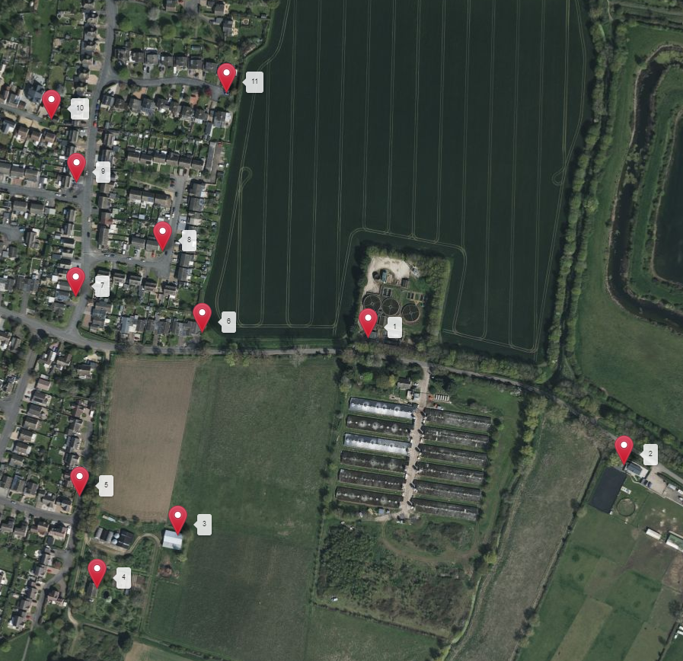
Potential Odour Sources
The following sources have been identified as contributing to a potential medium - high risk odour source.

- Odour emissions from compound feed selection
- Odour emissions from feed delivery and storage
- Odour emissions from ventilation techniques
- Odour emissions from litter conditions and management
- Odour emissions from carcass storage and disposal
- Odour emissions from drinking water systems
- Odour emissions from de-stocking
- Odour emissions from dirty water management

Pathways and Receptors

The pathway for all the above sources is via the atmosphere, with the most sensitive receptors being inhabitants of nearby residential dwellings. The wind direction will significantly influence how receptors are affected.

Odour Management and Control Measures
Odour Related Issue | Potential Risk and Problems |  | Actions taken to prevent and minimise risk
Manufacture and selection of compound foods | Milling and mixing of compound feeds  Poor quality and odorous ingredients  Feeds which are “unbalanced” in nutrients, leading to increased excretion, litter moisture and higher emissions of ammonia and other odorous compounds |  | No on-site milling or mixing.  Feed specifications are prepared by the feed compounder’s nutrition specialist.  The nutritionist ensures that protein and phosphorous content is reduced as the rations change throughout the flock cycle.  Feed is only supplied by a UKASTA accredited feed mill, so that only approved raw materials are utilised in production.  A feed sample for every load of feed delivered to the site is left and documented for both quality assessment and traceability. Samples are kept on site for a minimum of three months.
Feed Delivery and storage | Creation of dust during delivery |  | Feed delivery systems are sealed to minimise atmospheric dust.  Dust catchment systems will be in place on all silos.  Annual condition checks are carried out and documented.
Ventilation Techniques | Inadequate air movements within the buildings can lead to high humidity and subsequently high moisture levels within the litter.  Inadequate control of inlet and fan controls leads to poor dispersal of potential odours. |  | The ventilation system is regularly adjusted either automatically or manually to aid optimum internal environmental conditions.  The ventilation system is designed to efficiently control and, when required, remove humidity from within the buildings.  Maintenance schedules are in place and are carried out in line with manufacture’s recommendation and guidance. This is to minimise the risk of any breakdowns during the flock cycle.  In the event of a breakdown, an electrician is on call 24hrs a day.
Litter Conditions and Management | Building design and quality |  | All walls and ceiling voids have been insulated to prevent condensation and cold bridging.  Should any aspect of the building structure fail, a full investigation will be carried to source and rectify any issues as they arise.
Carcass disposal | Inadequate storage of carcasses on site  Carcasses stored on site for prolonged period of time. |  | Carcasses are stored in lockable, sealed containers. Carcasses are removed at least weekly or at a higher frequency if required.
Destocking of livestock | Higher levels of odour release through increased ventilation  Turning over of any damp litter during machine access and in house movements |  | Ventilation controls to be used to control the release of odours while still maintaining optimum temperature control throughout the depletion process.  Machinery movements to be kept to a minimum to help avoid the churning up of litter.
Clean out.  (Litter removal,  wash down and disinfection) | Creation of dust during clean down  Heaping up and removal of large quantities of potentially high levels of odorous material  Loading of lorries / trailers.  Use of odorous products to disinfect buildings following wash down. |  | All internal areas are blown down using high pressure air lances to remove areas of trapped dust which in turns help reduce the amount of dirty water.  Litter is to be removed as soon as reasonably practical following bird removal.  Only DEFRA approved disinfectant and detergents are used on site and are applied by trained personnel.
Dirty Water management | Standing or open stored dirty water during the production cycle or clean-out  Removal of dirty water form stores |  | Areas around the houses are to be kept clean throughout the flock cycle.  Dirty water is removed from site using vacuum tankers with all removals being documented through transfer note. Routinely the storage tanks are checked before and after wash down.

Abnormal Conditions and Control Measures
Odour Related Issue | Potential Risk and Problems |  | Actions taken to prevent and minimise risk
Feed Delivery and storage | Spillages of feed during delivery and storage |  | Any spillages are cleaned up immediately.
Litter Conditions and Management | Odours arising from wet litter and poor management.  Disease / virus outbreaks leading to poorly conditioned birds – excessive excretion leading to higher moisture content within the litter. |  | Controls on feed and ventilation help maintain litter quality additional controls include.  Use of a veterinary health plan, with specialist veterinary input as necessary.
Management of drinking water systems | Spillages of surplus water from drinker systems |  | Use of nipple drinkers and drip trays to minimise the risk of spillages and water wastage.  Systems to be checked daily by farm personnel and any abnormalities to be documented and rectified as required
Power outage | Loss of electrical supply to the site resulting in failure of ventilation system |  | The site is equipped with an emergency generator that can be used in the event of a power outage. The generator is tested weekly to ensure functionality in the event of an emergency.

On Farm Monitoring and Continual Improvement
- Internal relevant humidity, temperature and littler quality is to be monitored by farm personnel and recorded on each house card daily.
- Complaints and subsequent actions are to be logged on site.
- Staff are to receive training regarding Environmental Permitting Regulations – which will include odour management and any new company procedures.
- Staff perform daily checks for odour levels around the boundary, regular checks will also be carried out by the Area Manager.

Odour Complaints Procedures
Any odour complaints received in direct relation to the installation shall be recorded. Odour complaints shall be fully investigated and records available at future inspections. Complaints received directly from the public will be notified to the Environment Agency (EA).

Investigations shall consider…
- The activities taking place at the time of the complaint.
- The timing of the complaint.
- The weather conditions at the time of the complaint.
- Any non-routine operations on site.
- Any changes that may have been made to Standard Operating Procedures.
- The receptor and the impact that may have been caused.

Following all investigations into complaints, if the issue is caused by an operation at the site, a discussion will be had with the EA and any agreed mitigation measures will be implemented to help minimise the impact.

Review
This OMP will be subject to review following any EA substantiated complaint or every four years, whichever is sooner.

