Non-Technical Summary

(NTS)

Recycle for Future Ltd

183 Fengate,
Peterborough,

PE1 5PE

Email: info@recycleforfuture.com

Telephone: 01733 358807

 | Prepared By: | Approved By:
Name: | Martin Harper  (HS / HR / TCM) | Awais Butt  (Managing Director)
Signature: | 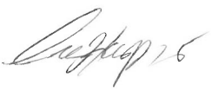 | 
Date:
This document is the property of Recycle for Future Ltd and shall not be copied in part or in full without the written permission of the Managing Director.

Document Revision Record

This schedule will be updated, when necessary, by the issue of amended pages.

REVISION | DATE | REVISION DETAILS | PREPARED | APPROVED
01 | 13/11/2023 | Version 1 | B Rimmer | A Butt
02 | 08/08/2024 | Review following EA feedback. | B Rimmer | A Butt

Contents: |  | Page:
1.0 | Introduction…………………………………………………………………………………. | 3
2.0 | Waste Stream Acceptance……………………………………………………………….. | 4
3.0 | Industries Serviced………………………………………….…………………………….. | 5
4.0 | Hazardous Waste………………………………..………………………………………… | 5
5.0 | Location…………………………………………………………………………………….. | 5
6.0 | Recycling Process…………………………………………………………………………. | 6
7.0 | Wastes Received and Stored……………………………………………………………. | 7
8.0 | Drainage…………………………………………………………………………………… | 7
9.0 | Emissions………………………………………………………………………………….. | 7
10.0 | Fire………………………………………..…………………………………………………. | 7

1.0 Introduction:
Recycle for Future Ltd is a UK-based company that supplies scrap and regrind. They have 20 years in-house experience in the recycling industry.
Our core business is focussed on sourcing plastic scraps, however, there is ongoing requirements for paper also. Some of the plastic scraps and regrinds that the company purchase are supplied to their partner facility where they are pelletised. These high-quality pellets to manufacturers across Asia and Europe.
The company operates from their facility in Fengate, Peterborough – PE1 5PE.
The site currently operates under:
A T4 exemption (WEX284475): Preparatory treatments (baling, sorting, shredding, etc).
These are operated under in tandem with regulatory position statement for small scale heat treatment of waste plastics for reuse: RPS 112.
The company aims to treat up to 52,00 tonnes of plastic wastes per annum.
Under the bespoke permit, this would instead be 52,000 tonnes per annum.

2.0 Waste stream acceptance:
The proposed waste streams accepted at the site will be limited to those listed in the table below -
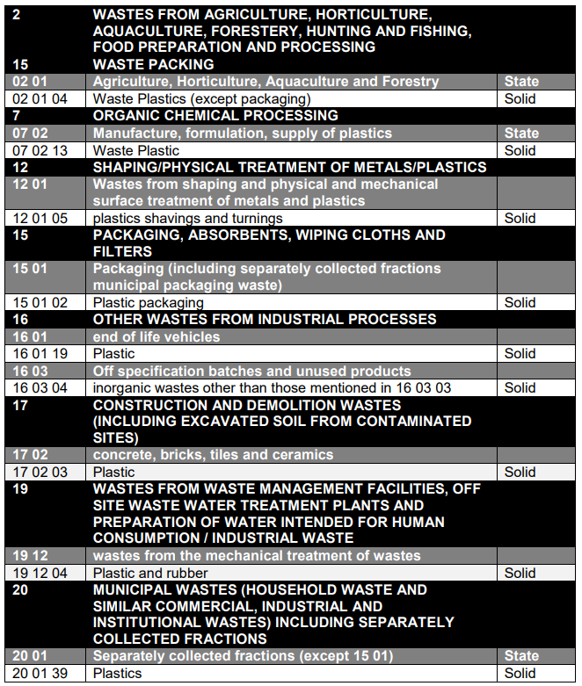

3.0 Industries Serviced:
Recycle for Future Ltd accepts waste from the waste sector, but also off-specification material from the manufacturing industry and then provides recycled plastic pellets to manufacturing sectors.

4.0 Hazardous waste:
Recycle for Future Ltd will not accept any hazardous waste at the facility a strict waste acceptance process will be in place and adhered to.

5.0 Location:
The company’s site at is located on a mixed-use industrial estate – Fengate, Peterborough. The site comprises of an outside storage area and a building for waste treatment and product storage.

6.0 Recycling Process
The recycling process is simple as the site only accepts plastics wastes that have been purchased for processing or to be resold.

The in-house procedure from start to finish is as follows:
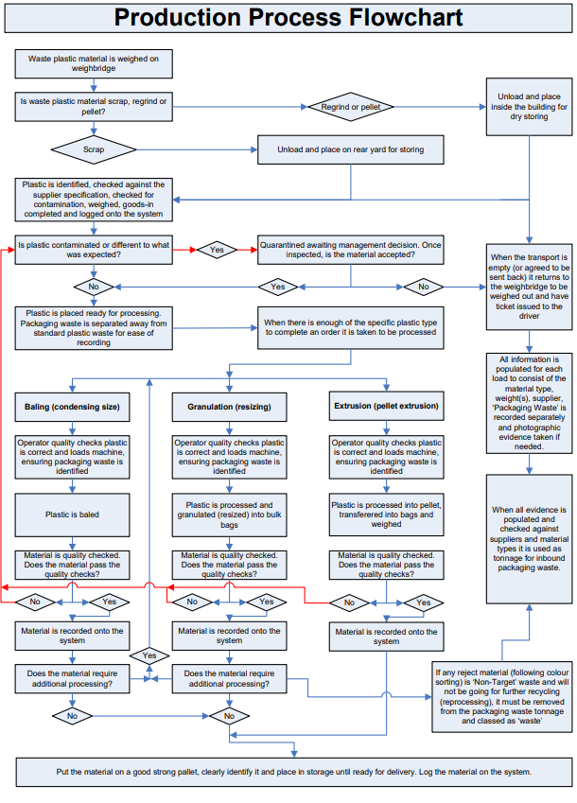

7.0 Wastes received and stored:
Feedstock Acquisition: Plastic waste is sourced from diverse streams, including:
Post-consumer waste: Collected from kerbside recycling programs, drop-off centres, and material recovery facilities (MRFs).
Post-industrial waste: Generated from manufacturing processes, often consisting of clean, homogeneous plastic scrap.
Sorting and Pre-processing:
Manual & Automated Sorting: Incoming plastic waste is segregated based on resin type (PET, HDPE, PVC, etc.), color, and form factor. Advanced technologies like near-infrared (NIR)
Size Reduction: Large plastic items are shredded or granulated into smaller, uniform pieces for easier handling and processing.
Reprocessing:
Extrusion and Compounding: Clean plastic flakes or granules are melted and extruded through a die to form strands, which are then cooled and pelletized. Compounding may be used to introduce additives that enhance the properties of the recycled plastic.
Baling and Packaging: Sorted plastic waste is often compressed into bales or packaged in containers to facilitate transportation.
Shipping and Transportation: The packaged plastic waste is shipped via cargo vessels or other modes of transport to the destination country.
Output and Applications:
Recycled Plastic Pellets: A versatile feedstock for various manufacturing processes, enabling the creation of new plastic products.
The only waste to be received under the permit will be plastics. The volume of waste to be received are -
As previously approved, the waste throughput for the permitted waste plastic stream shall not exceed the limits as follows:
5,200 tonnes per calendar year (or 100 tonnes per week) for heat treatment of relevant plastic wastes.
15,600 tonnes per calendar year (or 300 tonnes over any 7 days) for cleaning, washing, spraying, or coating treatment of relevant plastic wastes;
3,000 tonnes indoors over any 7 days for baling, sorting, or shredding of relevant plastic wastes.

The waste storage limit for the Fengate Site shall not exceed 500 tonnes over 12 months. Records showing waste plastic throughput and storage limits for any specified period shall be kept on-site and provided to the Waste Planning Authority within 10 days of a written request.

Under the new Bespoke Permit, the company will aim for:

The maximum quantity of waste to be received within 1 week is 1,000 tonnes.
The maximum quantity of waste to be received within 1 year is 52,000 tonnes.
The maximum quantity of waste to be stored on the site at any time is 1,000 Tonnes

The waste storage limit for the Fengate Site shall not exceed 1000 tonnes over 12 months. Records showing waste plastic throughput and storage limits for any specified period shall be kept on-site and provided to the Waste Planning Authority within 10 days of a written request.

8.0 Drainage:
The outside storage area is on an impermeable concrete surface. Surface water from the outdoor storage area discharges to a separator chamber before being discharged into the adjoining riparian drain.

9.0 Emissions:
There will be an emission point for steam only Via extraction above machines when in process

10.0 Fire:
The site will operate to a Fire Prevention Plan. This can be found in the supplied documentation.
There are trained Fire Wardens on site, and annually inspected fire extinguishers.
Fire alarms are also tested weekly at 10 am every Monday.

