Site Condition Report

(SCR)

Recycle for Future Ltd

183 Fengate,
Peterborough,

PE1 5PE

Email: info@recycleforfuture.com

Telephone: 01733 358807

 | Prepared By: | Approved By:
Name: | Brandon Rimmer  (HS Advisor) | Awais Butt  (Managing Director)
Signature: | B. Rimmer
Date:
This document is the property of Recycle for Future Ltd and shall not be copied in part or in full without the written permission of the Managing Director.

Document Revision Record

This schedule will be updated, when necessary, by the issue of amended pages.

VERSION | DATE | REVISION DETAILS | PREPARED | APPROVED
01 |  | Version 1 | B Rimmer | A Butt

1.0 SITE DETAILS
Name of the applicant | Recycle for Future Limited
Activity address | 183 Fengate, Peterborough, PE1 5PE
National grid reference | TL 20746 98558

Document references for site plans (including location and boundaries) | Folder: Building Plans  Folder: Maps

Note:
In Part A of the application form you must give us details of the site’s location and provide us with a site plan. We need a detailed site plan (or plans) showing:

- Site location, the area covered by the site condition report, and the location and nature of the activities and/or waste facilities on the site.
- Locations of receptors, sources of emissions/releases, and monitoring points.
- Site drainage.
- Site surfacing.

If this information is not shown on the site plan required by Part A of the application form, then you should submit the additional plan or plans with this site condition report.

2.0 Condition of the land at permit issue

Environmental setting including:  - geology  - hydrogeology  - surface waters | Location:  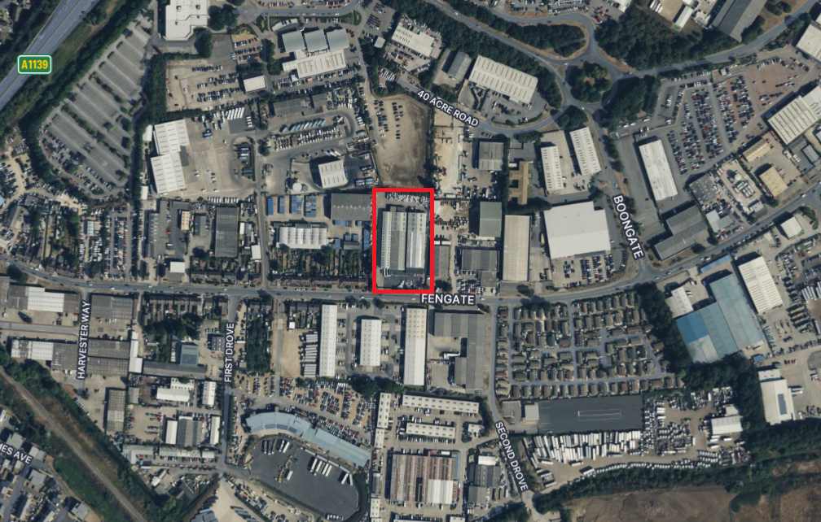  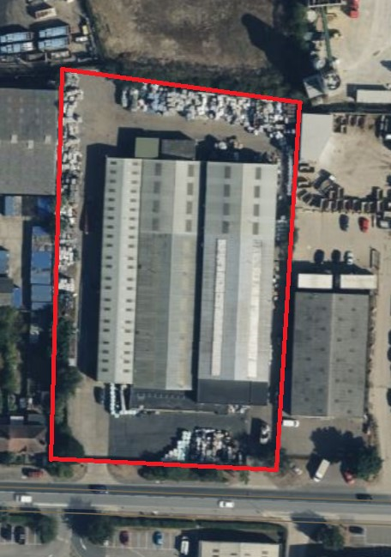  The site is located in Fengate, which is a predominantly industrial area of the city of Peterborough, in the Peterborough district, in the ceremonial county of Cambridgeshire, England. The industrial estate is known as Eastern Industry.  Facing the site, all the left, right, and rear of the site neighbour other businesses. The front of the site is direct access to the Fengate road.  All operational areas of the site are either: -  - Concrete or tarmacked roadway and yard,  - Within buildings with concrete floors.  The Fengate area is sparsely populated.  Geology:  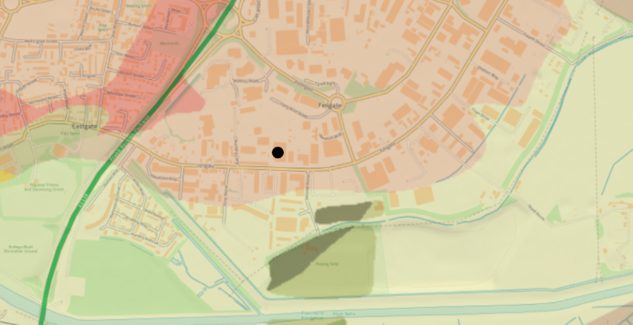  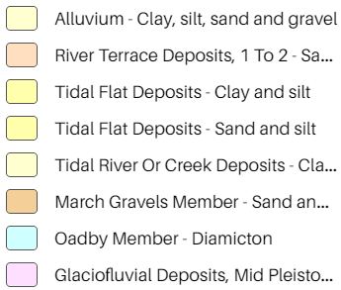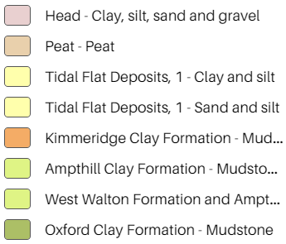  Bedrock geology  - Cornbrash Formation - Limestone. Sedimentary bedrock formed between 168.3 and 163.5 million years ago during the Jurassic period.  Superficial deposits:  - River Terrace Deposits, 1 - Sand and gravel. Sedimentary superficial deposit formed between 2.588 million years ago and the present during the Quaternary period.  There is no evidence for presence of the following: -  - Faults in the bedrock;  - Mining activity;  - Artificial (made) ground;  - Landslip issues;  - Radon issues.)  Local borehole records can be found in the supporting documentation.  Hydrology:  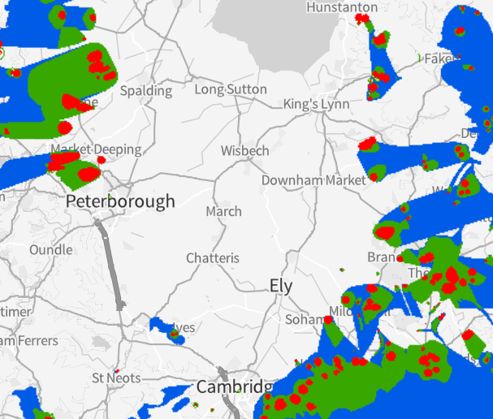  The site is not within, or close to a source protection zone.  Flood Risk:  Surface Waters:  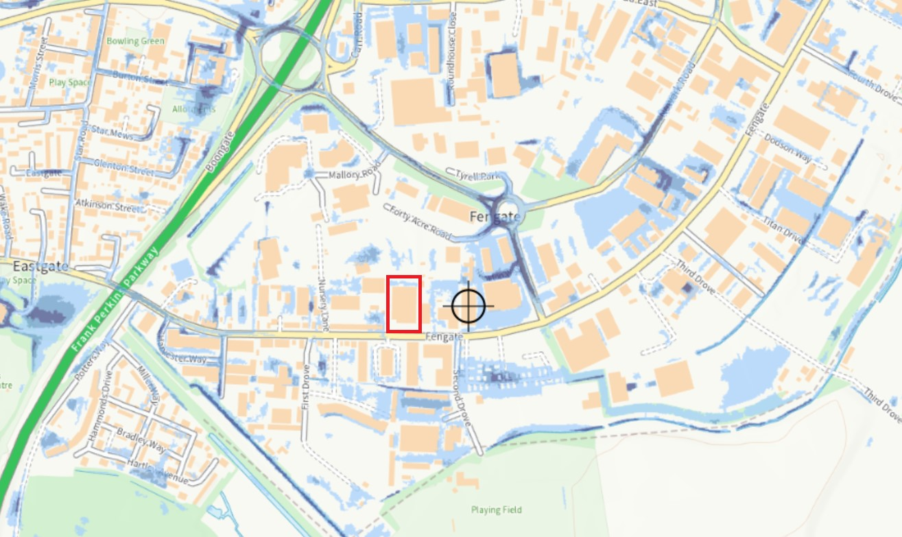  The risk the site has of flooding from nearby surface water is low. Low risk means that this area has a chance of flooding of between 0.1% and 1% each year. Flooding from surface water is difficult to predict as rainfall location and volume are difficult to forecast.  Rivers and Sea:  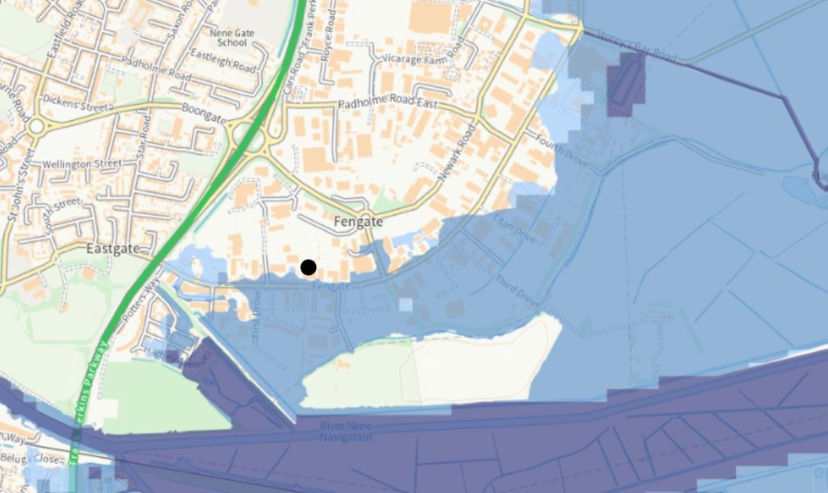  The risk the site has of flooding from nearby rivers is medium. Medium risk means that this area has a chance of flooding of between 1% and 3.3% each year. This considers the effect of any flood defences in the area. These defences reduce but do not completely stop the chance of flooding as they can be overtopped or fail.  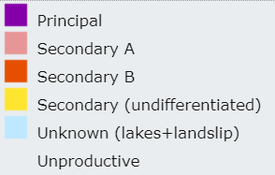  Principal Aquifer Maps:  Bedrock:  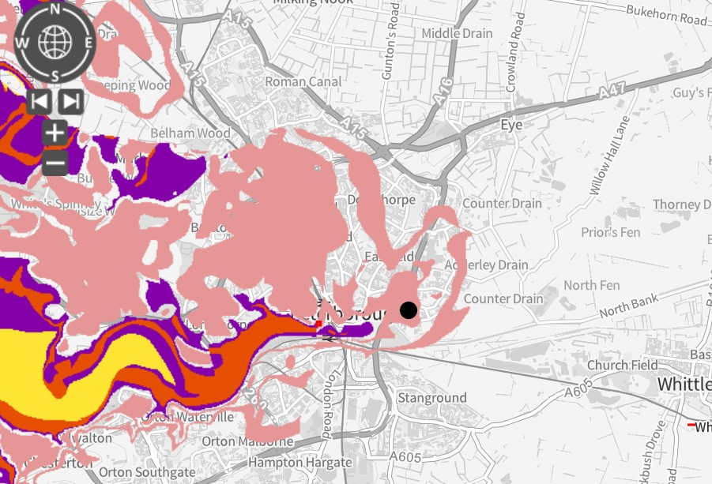  Superficial Drift:  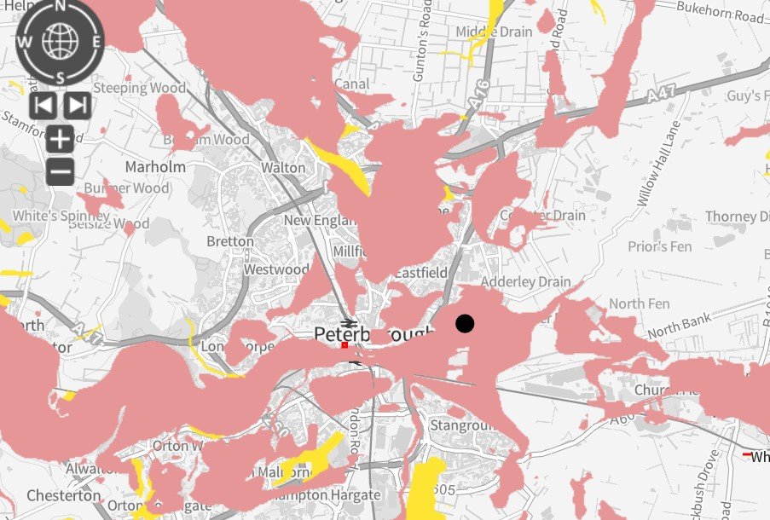  Topography Map:  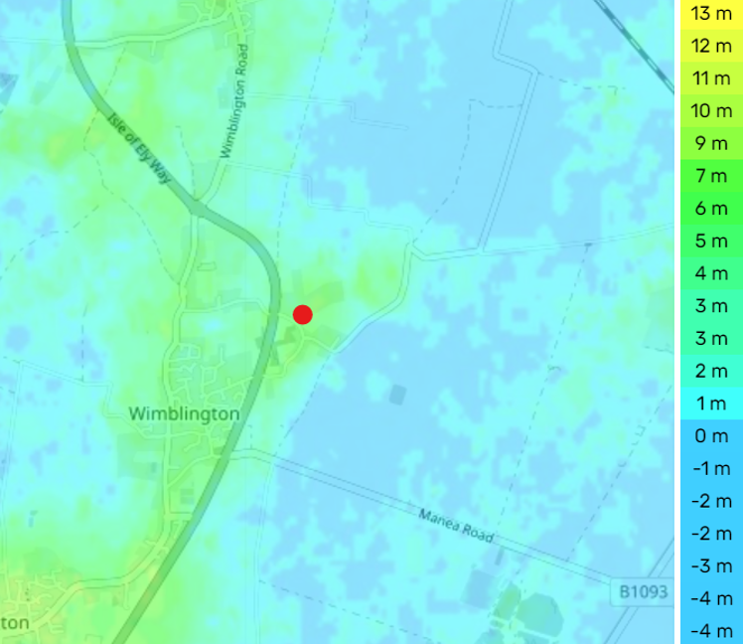  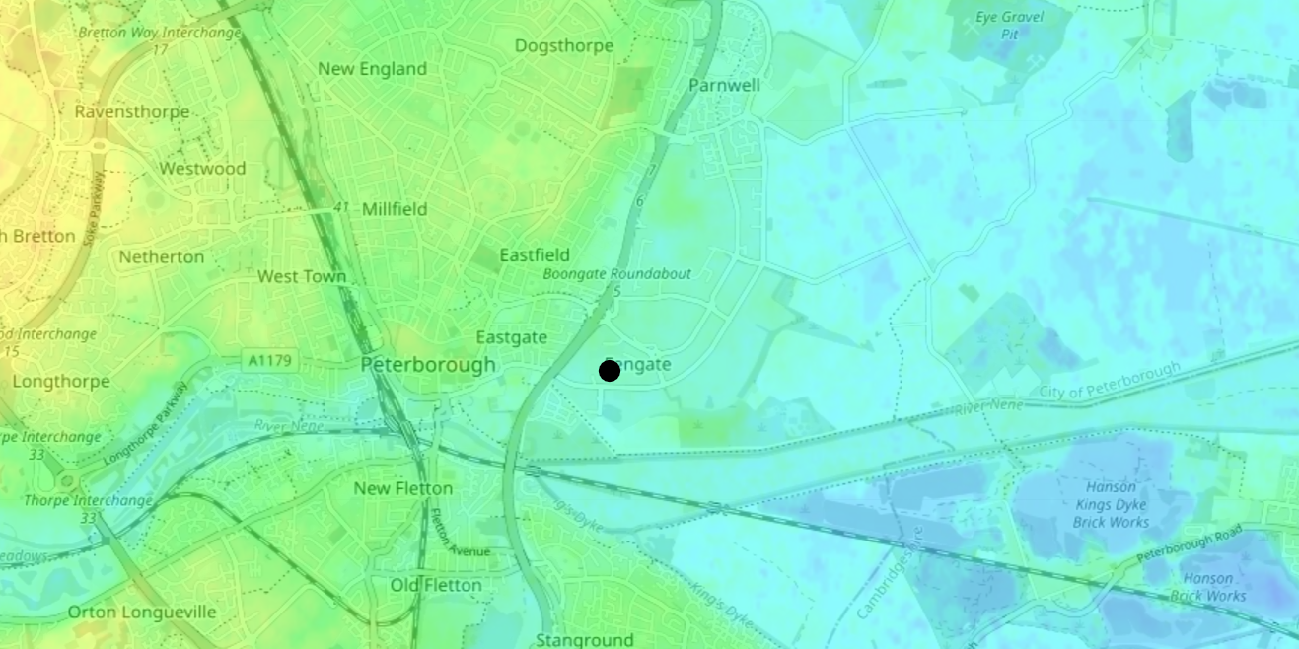

Pollution history including:  - pollution incidents that may have affected land  - historical land-uses and associated contaminants  - any visual/olfactory evidence of existing contamination  - evidence of damage to pollution prevention measures |  | Pollution Incidents:  The desktop search did not reveal any record of historical pollution incidents. The historical land use (agricultural/horticultural) means that the likelihood of any significant pollution incident is low.  There has been a fire incident since Recycle for Future started operations on the site. This was at a neighbouring business and there is no evidence of resulting contamination. This occurred in March 2021.  Historical Land Use:  Historical maps dating back to 1886 have been reviewed to assess previous land-uses. Prior to the 1979 Ordnance Survey (1:2,500) map these show no specific use for the site (or its immediate surrounding area).  Recycle for Future acquired the site in 2015 and proceeded to:  - Note changes to site.  Evidence of existing contamination:  There is no evidence of existing contamination. It was noted that all processing activities are undertaken within the buildings or on a concreted yard.  Pollution Prevention Measures:  The processes taking place on the site involve processing plastics in a solid state.  The operational areas of the yard and roadways are all concrete or tarmac and this is mostly in good condition.  The perimeter fence is also covered in netting to prevent loose materials escaping.  Diesel for the FLT’s is stored in a propriety plastic self-bunded tank on the concrete surface.  In the event of a significant spillage in these areas, liquid will drain via the yard drainage where any contaminants are met by an interceptor. This is cleaned regularly.  Oil for gearboxes etc. is stored in a locked steel shipping container with individual containers stored above drip trays or other secondary containment.  All pollution prevention measures appear to be in a good state of repair and suitable recorded inspections are undertaken.  Recycle for Future Ltd does not have a consent to discharge permit currently. However, water runoff from the chiller is evaporated from hard standing concrete, and any runoff into drains is met by an interceptor to ensure no contaminants leave site.
Evidence of historic contamination, for example, historical site investigation, assessment, remediation and verification reports (where available) |  | There is no evidence of historical contamination and no such information is available.  There have been no fires recorded since Recycle For Future started operations in 2015.
Baseline soil and groundwater reference data |  | The history (agricultural/horticultural use only) of the site and the nature of the activities now undertaken on the site mean that no baseline data has been collected.
Supporting information | Historical Maps

3.0 Permitted activities

Permitted activities | Recycling of plastics waste to produce a recycled plastic pellet and related storage.
Non-permitted activities undertaken | Related activities to serve the waste management activity including:  - Maintenance of plant and equipment  - Office tasks.  There is a portacabin on site serving as a production office.
Document references for:  - plan showing activity layout; and  - environmental risk assessment. | Supporting Documents/Site Plans;  - ERA_ Environmental Risk Assessment v1  - Site Plan

Note:
In Part B of the application form you must tell us about the activities that you will undertake at the site. You must also give us an environmental risk assessment. This risk assessment must be based on our guidance (Environmental Risk Assessment - EPR H1) or use an equivalent approach.
It is essential that you identify in your environmental risk assessment all the substances used and produced that could pollute the soil or groundwater if there were an accident, or if measures to protect land fail.
These include substances that would be classified as ‘dangerous’ under the Control of Major Accident Hazards (COMAH) regulations and also raw materials, fuels, intermediates, products, wastes and effluents.
4.0 Changes to the activity

Have there been any changes to the activity boundary? |  | No.
Have there been any changes to the permitted activities? |  | No.
Have any ‘dangerous substances’ not identified in the Application Site Condition Report been used or produced as a result of the permitted activities? |  | No dangerous substances are handled on site.
Checklist of supporting information
5.0 Measures taken to protect land

Use records that you collected during the life of the permit to summarise whether pollution prevention measures worked. If you can’t, you need to collect land and/or groundwater data to assess whether the land has deteriorated.

Checklist of supporting information | - Inspection records and summary of findings of inspections for all pollution prevention measures  - Records of maintenance, repair and replacement of pollution prevention measures, i.e., inspection chamber.
If your submitted environmental risk assessment does not adequately address the risks to soil and groundwater we may need to request further information from you or even refuse your permit application.

Mention perimeter fence netting

