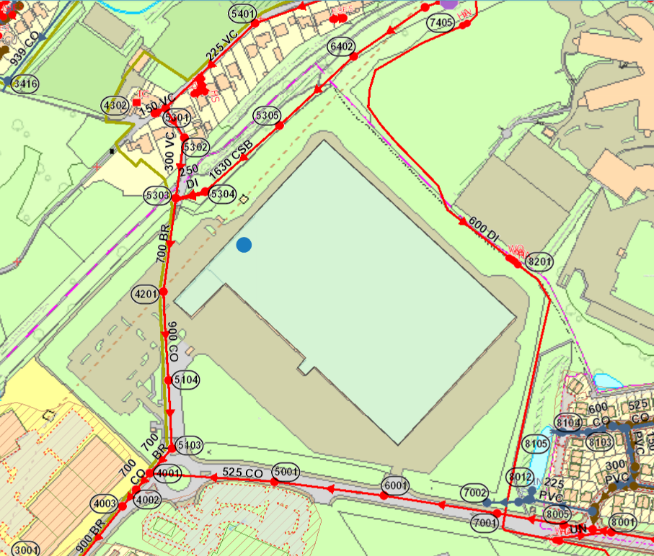

Foul & Effluent Joint Chamber Connects to United Utilities Sewerage Network
Foul Drain connects to the Foul & Effluent Joint Chamber
IGC Connection to UU Sewerage Network
UU Sample Point and MCERTS Effluent Meter connects to the Foul & Effluent Joint Chamber
3 stage Settling tanks with grease and fat trap.

