NOISE MANAGEMENT PLAN

WESTON POULTRY UNIT

The Old Airfield
Weston Green Road
Weston Longville
Norwich
Norfolk
NR9 5LB
Grid reference TG104151
Permit Number EPR/HP3931YF

Introduction
This Noise Management Plan (NMP) has been prepared to support the overall Environmental Management System in place at Weston Poultry Farm. The overriding principle of this NMP is to ensure the day to day activities are carried in accordance with this document to help minimise the overall environmental impact. Weston farm stands in a largely rural area but does have residential dwellings bordering the permit boundary.

The SSSI, Hockering wood is 2.5K from the site in a Westerly direction and the River Wensum which is both a SSSI and a Special Area of Conservation is 3.0 K from the site in a North Easterly direction. This NMP has been prepared as Best Practice.

The purpose of this Noise Management Plan is to:

- Establish the likely source of noise arising from the farm.
- Set out procedures at the farm to mitigate or minimise the risk of noise.
- Formalise an effect method of dealing with any noise complaints quickly and efficiently.

Potential Noise Sources
Undertaking a risk assessment for noise, the following sources have been identified as contributing to a potential medium - high risk noise source.

• Noise arising from vehicle movements into and around the site.
• Noise arising from ventilation systems and operations.
• Noise arising from de-populating (thinning and final depletion).
• Noise arising from cleanout (machines and loading of trailers).
• Noise arising from standby generators and other mobile plant

Sensitive Receptor Location Plan
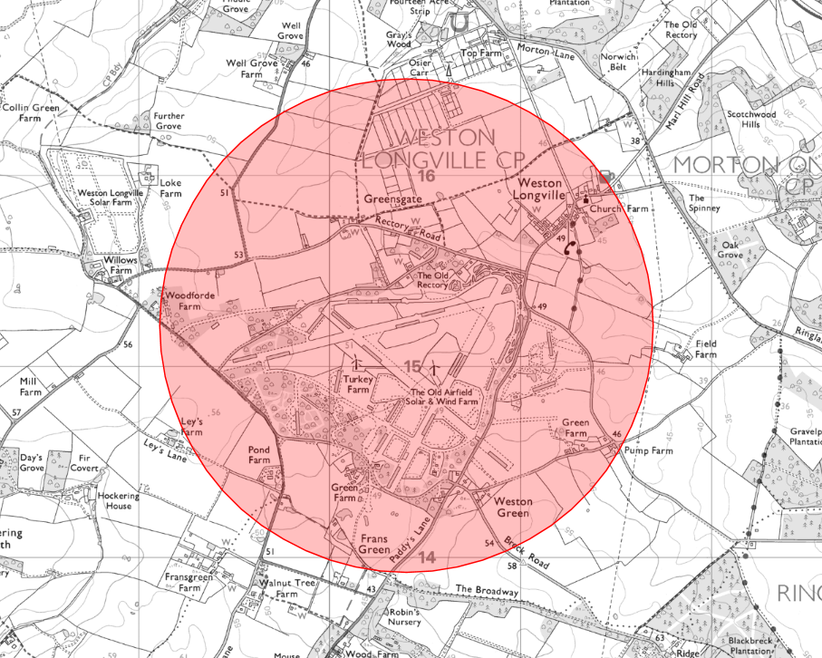
Pathways and receptors
The pathway for all the above sources would be via the atmosphere, with the most sensitive receptors being inhabitants of nearby residential dwellings the wind direction will significantly influence how receptors are affected.

Noise Management and Control Issues
Odour Related Issue | Potential Risk and Problem | Actions taken to prevent or minimise risk
Noise from vehicle accessing and manoeuvring Specifically HGV’s | Vehicles arriving at the site.  Revving of engines.  Reversing sirens.  Rattling of empty trailers loading  with catching modules  (Depopulation specific).  Rattling of empty bulker trailers.  Release of air brakes. | - 30mph speed restriction in place for any HGV’s coming to or leaving the site,  - 10mph restriction once on site.  - Reversing sirens to be replaced with low noise warming systems if complaints arise.  - Revving of engines to be always kept to a minimum.  - Speed restrictions to be always observed.  - Installation roads are maintained in good condition.  - All vehicles are maintained to minimise engine noise and are driven slowly to and from the site.
Noise from machinery working on site Catching forklifts (depopulation specific) | Loading and unloading of live bird modules on/off intake trailers and movement around site.  Cleaning out machines scraping internal floors to remove litter. | - Machine operators are to work inside buildings.  - All vehicles are maintained to minimise engine noise and driven slowly.
Skid steer, long reach loaders and compressors (muck out specific) | High pressure compressed air used for blowing down / cleaning building internals.  Long reach loaders used for loading bulker trailers (externally). | - High pressure air compressors or generators are to be positioned between buildings away from the direction of the sensitive receptors.  - High volume long reach loaders are to be kept well maintained.
Ventilation systems and operational techniques | Noise created from worn fan motors and bearing.  Noise created from large belt driven motors. | - All fans are inspected and maintained at the end of each cycle to maintain operational efficiencies.
Noise from feed deliveries (Delivery of feed into feed silos) | Engine noise from both vehicles and blowing motors.  Delivery of feed through pipework into silos.  Location of feed silos in relation to sensitive receptors.  Times of deliveries | - Request the use of modern well silenced vehicles.  - Delivery drivers will be requested to deliver feed under minimum pressure.  - No deliveries are requested for Sundays.
Noises from washing / disinfection operations | Prolonged engine noise from wash pumps running.  Location of washing trailers in relation to sensitive receptors.  Times of washing operation | - All wash pumps will be located with the service area (concrete apron)  - The washing operation is restricted to the 8am – 6pm curfew Monday to Saturday. With no washing being carried out on Sunday’s.
Waste removal / recovery Litter removal Wastewater removal General waste | Vehicle movements.  Access times. | - All vehicle movements are restricted to the 8am – 6pm curfew Monday to Saturday.  - No deliveries are requested for Sundays.
Excessive noise created by bird depletion | Bird excitement / stress.  Loading of modules onto trailers. | - Only approved contractor trained in the catching of poultry are to be instructed to load drawers in modules.  - Schedule loading so that birds are quickly loaded onto trailers and removed from site once complete.
Noise from standby emergency generator.  Alarm system. | Location of generator.  Building construction.  Routine testing of generator and alarm system. | - The standby generators are located next to buildings as far away as practical possible from any sensitive receptor.  - The building is which the generator is housed is an insulated timber or metal constructed building with an internal acoustic lining to help minimise any excessive noise.  - As it is a requirement to ensure the generator is always in working condition the power unit must be run and documented for two hours every week. This will be done by two single one hour tests.  Following any failure in power supply to the site the generator will automatically take over the supply to the site and will therefore run for as long as required without any restriction.  Daily system test (required by law) is carried out each morning. This is routed to mobile phones and no audible alarms used.  All electrical equipment is routinely maintained and therefore, the backup system is rarely required.
Repairs | Noise from construction equipment | - If repairs to the site are required, this is usually conducted during the daytime.  - In the event of major repair work likely to cause significant noise and disruption, neighbouring residents will be notified in advance.

Farm Monitoring and Continual Improvement
- Complaints and subsequent actions will be logged on site using form ESP08a.
- New Equipment will always be looked at regarding noise emissions.
- Staff will receive annual training regarding Environmental Permitting Regulations – which will include noise management and any new company procedures.
- Daily stockman checks are made to detect abnormally high noises.
- Checks of the surrounding areas and perimeters are made by staff who do not work regularly on the farm (typically the area/business manager). These checks are made at least monthly.

In accordance with BAT Conclusions BAT 9, in cases where noise nuisance at sensitive receptors is expected and/or has been substantiated, then additional noise monitoring will be introduced.
- Specific noise monitoring at the site boundary or other relevant locations in response to the potential nuisance using standard methods BS 7445-1 or equivalent.

- The use of a mobile monitoring station to include weather conditions and other environmental parameters would be introduced should any continual problems or complaints arise to provide detailed local climactic information.

- Monitoring would normally involve the commissioning of an independent specialist to undertake any such work. In the first instance noise monitoring at boundaries may be implemented using company staff other than those regularly employed at the farm. A protocol will be developed as required.

- Specialist noise monitoring can be carried out during the flock cycle if it is deemed necessary to help gauge and further understand noise levels beyond the farm perimeter.

Noise Complaints Procedure
Any noise complaints received in direct relation to the installation shall be dealt with according to the EMS documentation and recorded on a complaint’s investigation form ESP08a. Noise complaints shall be fully investigated and available at future inspections.
Investigations shall consider,

- The activities taking place at the time of the compliant
- The timing of the compliant
- The weather conditions at the time of the compliant
- Any abnormal operations either on site of nearby
- Any changes that may have been made to a standard operational procedure.
- The receptor and the impact that may have been caused.

Following all investigations into complaints if the issue is caused by an operation at the site a discussion will be had with senior management. Any practical proactive measures which can be agreed will be implemented to help minimise the impact.

The complainant will also be contacted following the investigation into the complaint and kept up to date with progress and any remedial action being taken.

Noise Contingency Plan
Various contingency measures have been drawn up to address possible situations where noise emissions cannot necessarily be controlled by normal operations.

Possible source specific actions are set out in the following table (Part 1- Source Specific Actions).

If there have been repeated and substantiated complaints relating to noise several possible site-specific actions are also set out (Part 2 – Site Specific Actions).

Where any remedial actions have been taken to address identified noise problems then appropriate checks will be carried out to ensure that these have been completed successfully. Checks will be in the form of visual inspection and testing of equipment and/or noise perimeter site tours as is relevant to the action point. Independent testing or monitoring may also be instructed if deemed necessary. The details of all checks on the efficacy of actions will be recorded.

Part 1 – Possible Source Specific Causes & Actions
Source | Potential Cause | Mitigation
Noise from vehicle accessing and manoeuvring Specifically HGV’s | Speeding drivers  Noise from horns | - Speeding / noisy drivers will be reported to senior management or commercial drivers company headquarters.  - Re-training of staff must follow asap.
Noise from vehicle accessing and manoeuvring Specifically HGV’s | Reversing sirens  Rattling trailers / equipment | - Reversing sirens will be replaced with low noise alternatives.  - Any equipment that is deemed to be a nuisance will be taken out of service and immediately serviced to rectify the problems.
Ventilation systems and operational techniques | Excessive noise from motors or belts | - Contact engineer asap to rectify problem.  - Erect sound barriers around the effected equipment using straw bales or concrete blocks if available
Noises from washing / disinfection operations | Excessive noise from machinery | - Erect sound barriers around the equipment using straw bales or concrete blocks if available.  - Replace machinery with quieter alternatives if practicable to do so.
Excessive noise created by bird depletion | Catching methods leading to bird over excitement | - Re-training of staff must follow asap.
Noise from standby emergency generator. | Engine malfunction leading to excessive noise. | - Hire or replace generator asap.  - Erect sound barriers around the generator using straw bales or concrete blocks if available.
Repairs | Noise from construction activities | - Erect sound barriers around the construction activities using straw bales or concrete blocks if available.

PART 2 – Possible Site-Specific Actions
In the event of repeat and substantiated complaints from any source then an independent noise assessment shall be carried out in conjunction with the Environment Agency and an appropriate third-party monitoring company. Monitoring will be undertaken in line with current guidance to identify the root cause of the noise and whether noise from the site correlate with specific times within the flock cycle. If normal operations are deemed to be the root cause, then any of the following site-specific actions relating to stocking densities, machinery may be put in place to help reduce the levels of noise to an acceptable level which is assessed by the EA as being below that deemed to cause pollution outside the permitted boundary. Operations will then be maintained at that level until such time as furthers measures can be put in place to reduce noise levels to an acceptable level and to allow normal operations to resume. Other options may be identified in addition to those included in the list below.

Site specific “low tech” options
- Construction of sound barriers using straw bales
- Construction of sound barriers using concrete blocks
- Construction of sound barriers using acoustic fencing
- Reconfiguring farm machinery
- Reconfiguring housing equipment
- Planting of barriers / hedgerows
- Construction of earthen banks.

Addition higher tech options will be considered where lower tech solutions are not sufficient to control noise, specific aspects of the normal operation are identified as the cause and financially viable techniques (BAT) are available and/or as the means to bring stocking densities and site output back to the original full capacity. Potential options, including those listed below, will be investigated with appropriate specialist suppliers, company technical experts and farm veterinarians. Other options may be identified in addition to those included in the list below.

- Replacement of farm machinery with low noise models of electric.
- Retrofitting noise-reducing mufflers on engines
- Design and building acoustic enclosures

Community Engagement
Contact will be made with the Parish Council to open lines of communication with the Parish Council and the operator. Updates regarding the site will be provided to the Parish Council as and when required.

Review
This Noise management plan will be subject to review after any substantial complaint or every 4 years.
Key responsibilities
Task | Staff Position Responsible | Notes
Noise checks/monitoring | - Farm Manager  - Area Manager | - Ongoing daily monitoring.  - Monthly, bi-monthly checks at perimeters.
Overseeing/monitoring feed deliveries, feed storage, spillages | - Farm Manager
Ventilation and heating system | - Site Stockmen  - Commercial Manager | - Responsible for day-to-day adjustment and monitoring.  - Responsible for design, selection and upgrade of system as required.
Stock inspections  Machinery systems | - Site Stockmen  - Commercial Manager | - Inspection at least 3 times per day. All inspections are recorded. Drinking water system  - Responsible for day-to-day adjustment and monitoring  - Responsible for design, selection and upgrade of system as required.
House clean out/washing operations | - Farm Manager | - Oversees the task.
Deliveries collections | - Farm Manager | - Farm Manager is responsible for planning and overseeing collections, deliveries, and on-site storage arrangements.
Documenting/reviewing abnormal events | - Area Manager
Reviewing annual plans | - Commercial Manager
Complaint’s log | - Farm Manager

