Noise Management Plan

CONTENTS
1. INTRODUCTION 1
Roles and Responsibilities 1
Site Description 1
Site Plan 2
2. SOURCES, PATHWAYS, RECEPTORS 2
Source Materials - Inventory 2
Pathways 3
Receptors and Wind Direction 3

3. PRIMARY NOISE CONTROL MEASURES 4
Noise Releases 4
Impacts 4
Management of Releases 5
4. Monitoring & Trigger Levels 6
Introduction 6
Communication 7
Complaints procedure 7
5. Incidents and Emergencies 8
Appendix A Site Plan – draft 9

Appendix B Noise Survey Form 10
Appendix C Noise Complaint Form 12

- INTRODUCTION
This document provides the Noise Management Plan prepared in accordance with
Environment Agency Guidance in support of a bespoke environmental permit
application at East Coast Waste Limited, Harfreys Road, Great Yarmouth, NR31
0LS. The application is for a new site adjoining the existing already permitted waste
Operation. The new application if for the crushing and grading of C&D waste and the
shredding of waste wood.

C&D aggregates are treated by crushing and grading. Waste wood is shredded.

  - It relates to the waste site operated by East Coast Waste Limited, Harfreys Road, Great Yarmouth, NR31 OLS.
The operation will include the grading/sorting of inert C&D waste & the shredding of waste wood only.

The overall responsibility for this procedure is the Environmental Manager. The Environmental Manager will be responsible for ensuring that all staff are trained in this procedure.

  - The Site Manager is responsible for ensuring that the day-to-day operations are carried out in accordance with this procedure.
  - All staff are responsible for implementing this procedure and have a duty to carry out their roles to prevent noise emissions.

Site Description
  - The site is located at NR31 0LS in Great Yarmouth. It is a industrial yard surrounded by farmland and agriculture with few immediate residential neighbours. The nearest is approx. 140m east across the A47. The station itself it sited in a large bowl like depression in the ground with high earth bunds which provides for sound attenuation.

  - A basic site layout is provided in Appendix A.
  - The company Environmental Management System (EMS) will be updated and revised accordingly as a living document as environmental and noise management develops
- SOURCES, RELEASES, IMPACTS
  - This section sets out the protection sources of noise, potential release points and receptors.

Source Materials - Inventory
  - Given the operations, it is considered that the activities which are most likely to give rise to noise are those in Table 1.

Activity | Description | Comments
Waste Delivery into fire bays | Delivery of waste into the the site | Managed and timed
Crusher | Crushing and grading of C&D waste | Managed and timed
Shredder | Shredding of wood waste | Managed and timed
Vehicle movements | Movements of material onto and off of site | Managed and timed
Table 1 Source Activities
  - It is anticipated that the likelihood of noise being emitted from these activities is medium/low on delivery or movement.

Pathways
  - The pathways by which the noises from the sources identified above may impact upon a receptor are primarily:
1. Air Movement of noise through air, particularly relevant on a site which will load/unload outside.
2. Direct exposure. Particularly for staff, they will be exposed immediately to any noises from the product handling on site.

Receptors and Wind Direction
  - The site is on a rural yard which means key receptors sensitive
to noise are staff and remote residential properties nearby.
  - The nearest residential properties are some 140m East across the A47 On Common Lane.
  - The key receptors are shown in Figure 1 below.
The prevailing wind direction in the area, where the site is located, is South-Westerly.
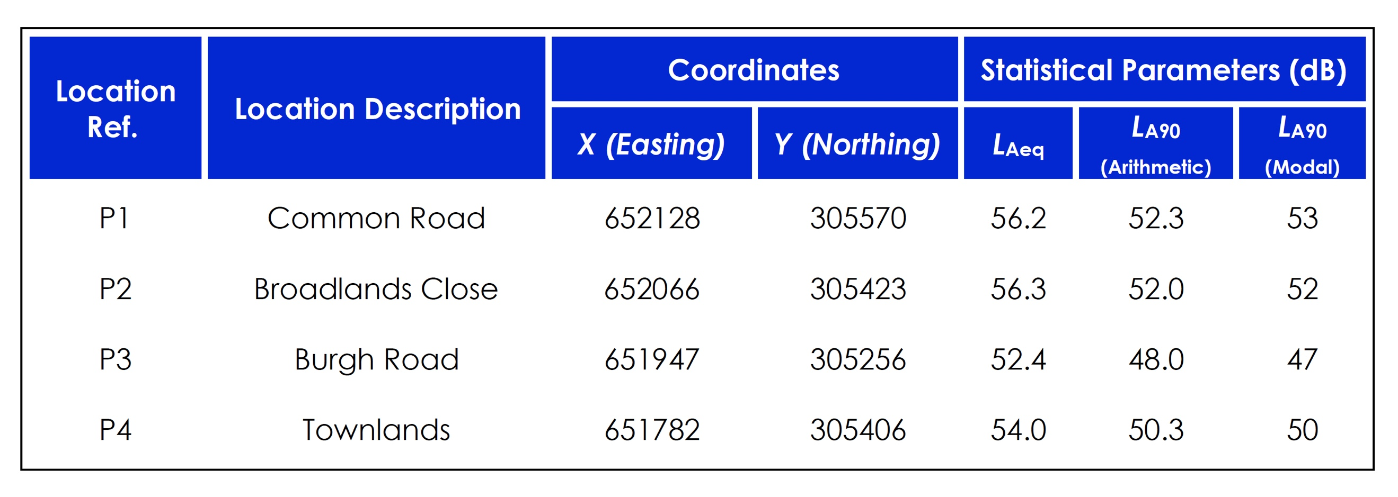

Key Receptors
The receptors shown below are within 1km of the site (black circle below). Sensitive human receptors include areas containing residential properties & light industry all round the site are also shown above.
The site is in on a small industrial estate which is bordered to the N&W by industry. There are no SSSI’s within 1Km but there is priority habitat (woodland) 500m SW. Key infrastructure includes the A47 to the east.
Wind Direction
According to the UK Met Office, the prevailing wind direction in the area is South-Westerly. This means the prevailing winds blow over the site to the north east, which is away from the bulk of the residential areas.

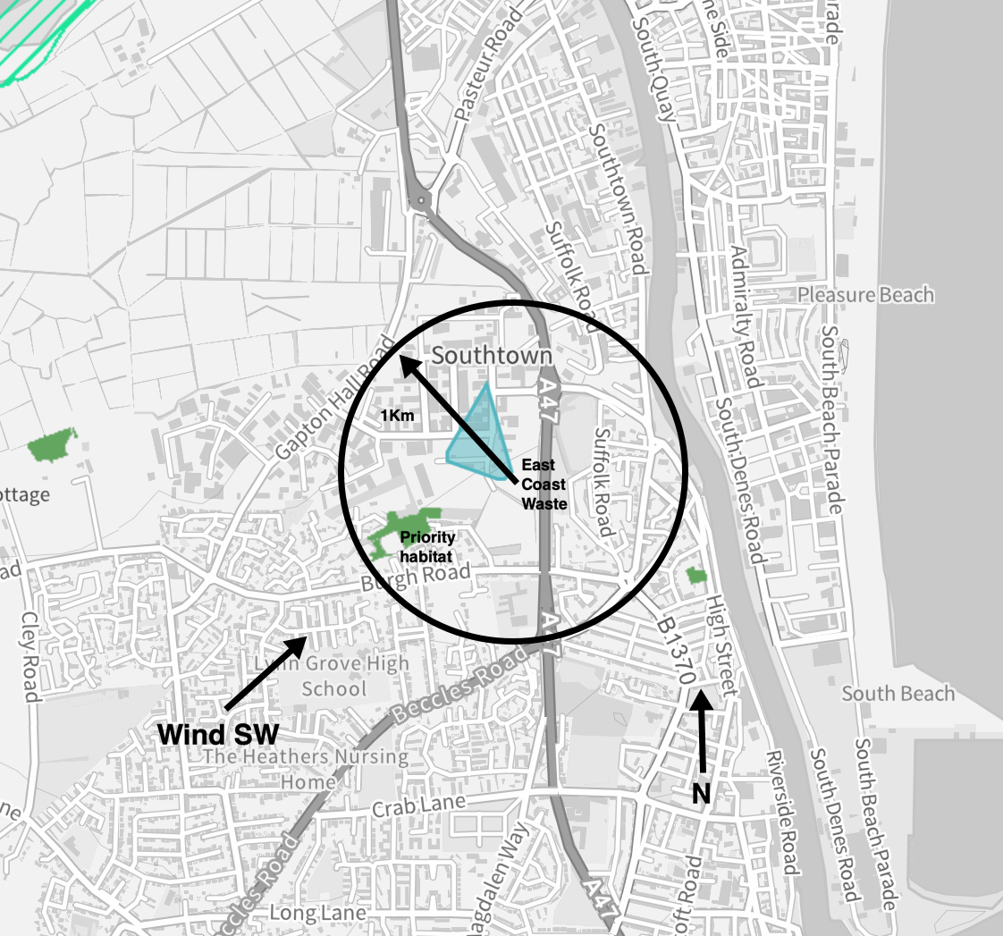

Figure 1: Site and Key Receptors

- PRIMARY NOISE CONTROL MEASURES
  - The control measures set out in this NMP are commensurate with the low noise potential for the operations, in accordance with the statement to this effect in H3 Guidance
  - Noise can only cause an impact when it is perceived at a receptor site. This NMP has identified that the key opportunities for release of noises are anticipated to be:

1. When waste is delivered to site and removed.
2. When waste is loaded and unloaded.
3. When the crusher/trommel/shredder process occurs.

Impacts
  - The impacts of any noises released as a result of East Coast Waste Limited’s activities will be linked to the receptors identified in Section 1.
  - The receptors are more likely to be impacted upon by noise in the following conditions:
- Prevailing wind direction is towards receptors; and
- Local weather conditions. Warm still weather will contribute to the perceived noise at receptors including staff on the industrial estate, school children and residents.
- Cumulative impacts. It is anticipated that cumulative impacts will be minimal. The site is not in an area dominated by facilities which may cause additional noise.

  - The impacts of noise from the site are anticipated to be minimal, given the nature of the operation and the location within a rural setting. However, this will be confirmed regularly with monitoring and communication with neighbours.

Management of Noise
  - If noise monitoring or complaints indicate a problem, East Coast Waste Limited Limited will respond appropriately. Management measures to control releases will include:
- Reducing the loading/unloading time on site. As part of the site’s Management System, information on the loading/unloading on site will be recorded via operations, including arrival time on site. Minimal handling will ensure that noise is not exacerbated.

If the Site Manager deems that noise is causing a disturbance, the Site Manager will log this as an incident, using the appropriate forms from the Management System and will take corrective action

The site management will liaise with the contractors/hauliers and transport contractors, with a view to minimising the storage and transport periods for vehicle movements;

- Unanticipated noises. Any unexpected noise shall be recorded as to composition, date and time received and cause of noise

- Timing of loading/unloading. Site Manager observes that the prevailing wind direction is will not create noises towards the direction of sensitive receptors or when winds are light and noise will be reduced.

- Containment and abatement. Given the nature of the operations on site, it is not considered necessary to implement containment and abatement techniques, other than those mentioned in the noise impact report. However, this is a ‘live’ document and as such will adapt if noise issues arise which are not managed by the actions in this NMP.

Noise Mitigation Strategy

In order to meet best practice without placing unreasonable burden on the site
operator, a detailed Noise Mitigation Strategy has been considered with East CoastWaste Limited and appointed consultants. The strategy will include the following:

▪ Restriction of use of the Crusher, Screen and Wood Shredder to 07:00-18:00 hours,
Monday to Friday;
▪ Formation of 3m high perimeter bund along site boundary;
▪ Minimise drop heights of materials; and
▪ All mobile plant with be fitted with broadband type reverse alarms to minimise
any tonal noise characteristics (e.g. Brigade bbs-tek white noise reversing alarm).

In terms of perimeter bunds, it must be ensured that they are formed to the

Therequired height, with no gaps (other than those shown on the site layout
drawing) or inconsistencies.

Further mitigation measures to reduce the noise impact of the proposed recycling
site
have been outlined below and would be adopted by East Coast Waste Limited as a
further demonstration of best practice.

The site operator will select the use of inherently quiet plant where appropriate. Such machines may be fitted with properly lined and sealed acoustic covers which would be kept closed whenever the machines are in use. The site operator will continue toimplement their policy of replacing older machinery with new, quieter machinery as it becomes available and as the business development allows.

Plant generating noise emissions which are known to be particularly directional
should, wherever practicable, be orientated so that the noise is directed away from
residential areas located to the east and south of the proposed development site.
All plant will be subject to regular maintenance checks. All plant and machinery
would be fitted with effective exhaust silencers and would be regularly inspected in order to ensure they are meeting the manufacturers’ noise rating levels. Any silencers which become defective would be replaced immediately.

All plant will be operated in a proper manner with respect to minimising noise
emissions, for example, no unnecessary revving of engines, switching off plant not in use, etc.

Wherever practically possible, plant fitted with reversing alarms will reverse in a
direction away from the nearest noise sensitive properties. In addition, plant would wherever possible manoeuvre in a circular manner to avoid the use of reversing alarms.

Good site management is also an effective method of reducing the potential impact of the waste recycling operations. East Coast Waste Limited management will aim to be proactive, to anticipate when potential noise problems may occur and to take the necessary preventative action. Site noise mitigation measures would be regularly reviewed and where appropriate, new equipment and/or practices implemented.

All equipment will be routinely monitored to ensure that it does not become louder with age. All equipment will be serviced and maintained as per manufacturers specification to ensure it is operating efficiently. Any defective equipment will be fixed immediately and noise levels from all plant will be checked on a quarterly basis with hand held equipment. Noise readings will be taken both inside and outside the earth bund to ensure it’s integrity and that it is still functioning as a noise screen.

- Monitoring & Trigger Levels

Introduction
  - To ensure that the noise control measures set out in Section 3 are being effective, East Coast Waste Limited will ensure noise monitoring is in place and communication with potential receptors is maintained.
  - The following monitoring activities are regularly undertaken to ensure continuous improvement:
- Site inspections by the site manager (as outlined below)
- Site audits conducted by the company’s management;
- Site audits and inspections by the Environment Agency.

  - All site personnel will be responsible for reporting any noise problems immediately to the site manager (or deputy).

Noise monitoring
  - The Site Manager will ensure that regular inspections are made of the site and its perimeter in order to identify any sources of noise and to establish whether any noise is discernible at the perimeter and thus likely to impact upon receptors.
  - In the event that noise is detected at the site boundary, additional monitoring will be undertaken at the sensitive receptors in accordance with Appendix B.
  - An auditory test will also take place in response to complaints. The surveyor will undertake the survey at the location of the complaint and at potentially sensitive receptor locations in the vicinity downwind from the site. At each location observations are made concerning the intensity of the noise, its persistence and character (these details will be logged in the pro forma, see Appendix C).
  - The surveyor may be the site manager or alternatively a staff member from the office or external person who is not used to the noises on the site.
  - Trigger Levels. If noise is detected at the assessment location and is judged to be a moderate or unacceptable noise, as defined in reference Table A - Appendix B, then the Site Manager and Management Team will be informed immediately and corrective actions will be determined and implemented.
  - Monitoring Frequency will be in accordance with Table 2

Technique | Frequency
Noise Monitoring / Auditory Testing | Weekly at site perimeter.  Noise detection will lead to receptor monitoring.  Increase frequency in response to complaints
Complaints system | Continuous (24 hours) via telephone reporting system to Environment Agency  Direct complaints to site in operational hours
Table 2 Monitoring Frequency

Communication
  - Liaison with neighbours. If noise is anticipated on site or weather conditions predicted indicate noises will increase, the Site Manager will liaise with neighbours and ensure they are aware of the situation, how long it is expected to last and how to make a complaint.
  - Signboard. The site will have a legible signboard giving contact details for the Environment Agency and the operator. These numbers can be used in order to make a complaint.

Complaints procedure
  - All complaints, whether direct from people in the neighbourhood, or via the Environment Agency will be treated seriously by East Coast Waste Limited and recorded in the Noise Complaints Form in Appendix C.
  - Trigger Levels. East Coast Waste Limited recognise that persistent noise can be a concern for neighbours and particularly for residential areas. Every complaint is a trigger for management to take action to investigate the cause of a complaint, as set out in the Noise Complaints form.

- Incidents and Emergencies
  - This section of the NMP relates to potential incidents or emergencies which may impact on the ability of East Coast Waste Limited to control noise from its site.
  - Potential incidents which may impact on noise are outlined as follows:
Potential Incident | Actions
Unexpected noise in loading or unloading | The Site Manager will:  - Communicate with local receptors on expected duration if excessive.  - Record start/stop timings  - Record the incident in the site diary and using the appropriate management system forms and records.
Low wind/still conditions | If noise monitoring detects a problem, the site manager will:  - Ensure handling is kept to a minimum  - Record the incident in the site diary and using the appropriate management system forms and records.
Unexpected noise during out of hours. Unlikely. | The site manager will  - Investigate the cause of the noise  - Identify if it can be rectified immediately  - Notify local receptors as soon as practical  - Records the incident in the site log

Appendix-A

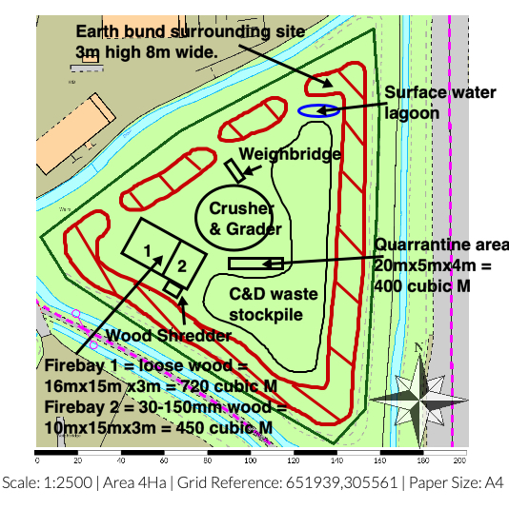

Appendix B Noise Survey Form

Noise Survey Recording Form |  | Reason for Noise Survey | Noise detected at boundary? Y/N  Complaint Y/N  Other
Name of Surveyor |  | Job Title
Date |  | Time of Survey Start/Finish
Air Temp. ºC |  | Wind Direction
Survey Results
Location | Noise Intensity  See Reference Table A | Noise Extent  See Reference Table B | Description of noise  e.g. intermittent, ongoing?

Reference Table A: Noise Intensity
Noise Intensity | Description
1 | No detectable noise
2 | Faint noise (barely detectable, need to stand still and look into wind)
3 | Moderate noise (noise easily detectable while walking, possibly offensive)
4 | Loud noise (bearable, but offensive noise)
5 | Very loud noise (this is when you really wish you were somewhere else)

Reference Table B: Noise Extent
Noise Extent | Description
1 | Local and not persistent (only detected during brief periods when wind drops or blows)
2 | Not persistent as above, but detected away from site boundary
3 | Persistent but fairly localised
4 | Persistent and pervasive up to 50m from site boundary
5 | Persistent and widespread (noise detected >50m from site boundary)

Appendix C Noise Complaint Form
Complainant Details
Time and Date of Complaint
Complainant Name & Address
Complainant Phone Number/ Email address
Noise Details
Date noise noticed
Time noise noticed
Location of noise (if not address above)
Wind Direction (e.g. From South West)
Complainants Description of Noise:
-What does it sound like
-Intensity (see reference Table A, Appendix B)
Duration – how long was it detected for
Constant/intermittent in this period
Complainant comments/observations
Additional Information
Are there other complaints from this area?
Is the site the likely source of noise?
What was happening on site when the noise occurred?
Corrective Actions
Actions Required
Deadline for Actions
Person Responsible for implementing actions
Form completed by
-Name and Role
Date
Signature

H3 Horizontal Guidance Noise Management (IPPC H3 part2)
http://www.metoffice.gov.uk/climate/uk/regional-climates/so
http://www.metoffice.gov.uk/climate/uk/regional-climates/

