East Coast Waste Limited
Fire Prevention Plan
June 2023
Version 1.0

East Coast Waste Limited,

Harfreys Yard,

Great Yarmouth NR31 0LS.

Document Control Sheet

Version Reference | Date | Reason for Change | Issued by
1.0 | 05/06/23 | Initial Draft | PD
Approved by |  | Paul Clements

CONTENTS
1 Introduction 4
1.1 Roles and Responsibilities 4
1.2 Purpose 4
1.3 Scope 4
1.4 Liaison with Fire Rescue Service (FRS) 4
1.5 General considerations 4
2 Causes of Fire 5
3 Fire Prevention Plan 6
3.1 Site Plan and Receptors 6
3.2 Material Receipt and Storage 6
3.3 Signage 8
3.4 Training, Awareness and Visitors 8
3.5 Security 8
3.6 Planned Preventative Maintenance 9
3.7 Self Combustion 9
3.8 Hot Works 10
3.9 Mechanical Treatment 10
3.10 Hot Exhausts 10
3.11 Additional Actions 10
4 Fire Detection and Management 12
4.1 Fire Detection 12
4.2 Fire Fighting Strategy 13
4.3 Managing Fire Water 14
4.4 Future Actions 16
5 Annex A: Site Layout 17
6 Annex B: Site Drainage 19
7 Annex C: Fire Fighting Access, Equipment & Water Supply Plan 20
8 Annex D: Key Receptors 21
9 Annex E: Waste Acceptance Procedures 22
10 Annex F: Fire Risk Checks Form for Fire Prevention 23
11 Annex G: Emergency Contacts 24
12 Annex H: EMS Documents 25

- Introduction
  - Roles and Responsibilities
The Site Director has responsibility for ensuring these procedures are adhered to. The Site Manager is specifically responsible for:
- Ensuring the adequate training of staff and contractors working on site regarding the content of these procedures;
- Ensuring the adequate provision of resources such as personal protective equipment (PPE);
- Ensuring the provision and maintenance of hand held fire extinguishers and other fire fighting equipment at the site is adequate.
  - Purpose
The primary purpose of this Fire Prevention Plan (FPP) is to guide staff and contractors in the prevention of fire for East Coast Waste Limited. This FPP also confirms the actions to be taken in the event of fire in order to minimise any impact on the environment and to control the fire where appropriate.
This FPP will be issued to the Fire Brigade in the event of a fire to aid with fire fighting.
  - Scope
This FPP has been prepared in accordance with Environment Agency guidance.
In addition, all fire prevention measures will meet the stringent insurance requirements for the business.
  - Liaison with Fire Rescue Service (FRS)
The FRS will be provided a copy of this FPP in advance of commencing operations.
  - General considerations
The East Coast Waste Limited site is located at Harfreys Yard, Great Yarmouth, NR31 0LS.
It is located to the west of the A47 in a light commercial/industrial area and is a long establisher operator in the area with an operation currently under two existing permits with the EA. The site is approximately 1.5 Hectares in size. At the time of writing this FPP, the site currently consists of concrete impermeable surface for wood storage and hardstanding for the processing of soil and stones. The site is bunded (soil bunds all round) and provides a good sealed drainage system. There is a drainage pond on site to collect surface water and has a sealed drainage system which is gulped out annually. There are no discharges to surface water. The site’s main activity is the storage and recycling of wood and construction & demolition wastes.
The surrounding land use is a mix of light industrial, residential & commercial business.
East Coast Waste Limited operate under an existing Environmental Management System [EMS] which identifies the potential sources of pollution from site activities and controls site operations to eradicate emissions or where that is not possible to minimise their effect on human and environmental health.
This Fire Prevention Plan [FPP] forms part of the EMS.
The individual fire emergency procedures for each part of the site form part of the FPP.
The site has sealed drainage there is no runoff to surface water from the process. See Annex B Site Drainage.

    - Causes of Fire
The following have been identified as potential causes of fire and their relevance to this site, when operational, is given in Table 1
Table 1 Causes of Fire and Applicability to the NR31 0LS Site
Cause of Fire | Applicability to the East Coast Waste Limited Site
- Arson or vandalism | Yes – see section 2.5 Security
- Self-combustion | No – see 2.7 Self Combustion
- Naked lights | No – none on site
- Plant or equipment failure | No – see 2.6 Planned Preventative Maintenance
- Electrical faults | No – none on site
- Discarded smoking materials | No – on site smoking is prohibited
- Hot works | No – see 2.8 Hot works
- Hot exhausts | No – see 2.10 Hot exhausts
- Industrial heater | No – none on site
- Open burning (adjacent to site) | No – no likely sources of burning adjacent to site
- Damaged or exposed electrical cables | No – no live cables on the site or to be introduced
- Reactions between incompatible materials | Not relevant given the waste types
- Neighbouring site activities | No - potential sources of risk from neighbouring land use
- Sparks from loading buckets | No – No loading buckets.
- Hot loads deposited at the site | No – not a risk given the types of materials and sources of materials.
Mitigation measures in relation to these activities, where under control of East Coast Waste Limited, are set out in this FPP.
- Fire Prevention Plan
East Coast Waste Limited recognises that the risk of fire cannot be eliminated. However, the site will be operated in accordance with a robust management system. Operational Procedures are listed in the site’s EMS Manual Section 1.6 ‘Operational Control’.
In addition to Operational Procedures, the following reasonable actions will be taken to minimise the risk of fire, in accordance with Environment Agency guidelines.
  - Site Plan and Receptors
A Site Plan is given in Annex A showing the key features of the site relevant to the Fire Prevention Plan including site access, security, vehicle parking, materials storage, drainage and buildings. Annex C is a Fire Fighting Equipment plan including the location of hose reels and hydrants.
A map showing key receptors within 1 km of the site is in Annex D.
  - Material Receipt and Storage
Waste will be collected using the company’s vehicles which will be removed from the customer’s site and returned to East Coast Waste Limited site. Raw material ( C&D waste and wood) are stored in the yard in concrete fire prevention bays prior to processing by shredding for the wood, and crushing and grading for the C&D waste. Waste acceptance procedures will be followed as set out in Annex E.
Only the waste types and EWC codes named on the environmental permit will be accepted at the site. Wastes entering the site will be inspected and registered at the site. Non-compliant waste materials not allowed on the permit will be turned away from the site or waste returned accompanied with a reject weigh bridge ticket.
    - Quarantine area
The site plan shows the Fire Quarantine Area. The Fire Quarantine Area will always be kept clear in case of emergency. The area has external fire extinguishers close by for quenching burning or smouldering material.
The Fire Quarantine Area is a dedicated emergency or quarantine area with a clear area of 6m around it. The rationale for this area is:
- The area is in the middle of the site, so is required to be kept clear, at all times, for access.
- Only small quantities of material would ever be put in this site i.e. those that can be dealt with safely by the staff on the site. Larger fire would be dealt with by the FRS.
- The quarantine area allows safe access around the edges in an emergency, it is 20mx5mx4m giving a volume of 400M3 and can accommodate at least 50% of the largest waste pile ( 720 CUMEC). See appendix A. a 6m clearance all round is observed.
- In the event of a fire or observed self-combustion, burning waste, if safe to do so, will be moved to the Fire Quarantine Area.
- The Fire Quarantine Area is signposted.
- Hot loads can be quarantined in this area until such times that they can be stored safely.
- The quarantine area, when made safe, will be emptied immediately. Should it be necessary to moves wastes to an alternative site then a local permitted site will be used.

    - Waste storage times
Wood will be stored on site for a maximum of 3 months. Consideration is given to the likely dry nature of the material and the implications this has for self-combustion. See 2.2.3 (stock rotation and management).
East Coast Waste Limited has key customers for each material. In addition, contingency customers are in place in case of a need to move material off site when the regular customer is not able to receive it. In this way, the stock will not build up to levels over the permitted limits.
    - Stock rotation and management
Given the limited storage time on site – max 3 months – stock rotation is deemed unnecessary, however;
The purpose of the stock check is:
- To turn wastes in order to ensure the waste is not at risk of self-combustion and any potential hotspots are dissipated;
- To ensure the waste volumes do not exceed those specified in the permit.
- To ensure waste is not kept on site for longer than allowed by the permit
Records will be maintained in the site office of the monthly stock checks.
The site manager in charge of stock checking will be vigilant for signs of combustion or hotspots. If any are found, these will immediately be quenched with water and reported to the management team. Stock rotation will be by mechanical means as necessary.
Waste will follow the first in/first out principle as detailed in Annex F points 10/11/12 and waste will be rotated in date order to ensure that waste is removed in date order.
    - Waste storage
Wood is concrete firebays as per Annex A and site plan on an impermeable surface. No other combustible waste will be stored on site overnight or inside a building.
Firebay 1 = loose wood = 16mx15mx3m = 720 cubic metres
Firebay 2 = wood (30-150mm) = 10mx15mx3m = 450 cubic metres.
C&D Waste is stored in the stockpile are inside the bunds. Inert non combustible C&D waste.

Firebays are constructed from legio blocks and have a sealed floor/wall interface.
A 1m freeboard will be observed for all waste in firebays.

  - Signage
Signage will be positioned throughout the facility showing Fire Exits and the position of extinguishers and other relevant fire fighting equipment.
All waste storage areas will be clearly marked to ensure waste throughput timescales are adhered to.
East Coast Waste Limited will reinforce fire prevention messages using signs with key messages for staff.

  - Training, Awareness and Visitors
All staff and contractors working on-site will be aware and understand the contents of this FPP and the site Fire Response Plan. Through site inductions and on-going staff awareness and training, East Coast Waste Limited will ensure that all relevant staff and contractors will:
- Understand what they must do during a fire.
- Know where the fire prevention plan is kept
- Participate in regular exercises to test how well this FPP plan works and to confirm staff understand what to do.
For visitors to the site:
- They will be escorted at all times and signed in.
- They will understand the No Smoking policy for the site.
- When signing in, information on the fire exits and muster point will be provided.
Training records are maintained as required by the site EMS.
Staff will be required to undergo regular fire training as part of the WAMITAB competency requirements. In addition, regular drills (annually) will be undertaken where desktop scenarios are played out and staff will be required to become familiar with this FPP as part of their ongoing competence. Site Manager will be responsible for implementing this plan and detailing annual tests and drills.

  - Security
The following security features will reduce fire risks from vandalism and deliberate arson through preventing access to the site by unauthorised people:
- Gates are closed and locked outside of office hours to block access further.
- Regular checks of the Perimeter and gates to the premises. The site is secured by bunds on all boundaries.
- Only one entrance/ exit point to the site to/ from the public highway is in place, which is secured by means of lockable gates to be locked shut at any time the site is left unattended.
CCTV/motion detectors which can be viewed remotely by the management team covering the whole of the permitted area and yard areas. This sends alerts out of hours
- Staff members can be on site within 30 minutes of an alert.

  - Planned Preventative Maintenance
The site has a Planned Preventative Maintenance Programme to ensure all machinery and components continue to remain effective. There is a 360 on site and a shovel loader.
There is a programme of routine planned maintenance is for each item of plant and machinery to manufacturers specifications, as well as the processing equipment in order to prevent breakdown and faults which may pose a fire risk.
Limited Electrical equipment including CCTV, lights will be used at the site.
A PAT certificate will be provided to demonstrate that this equipment has been checked by a qualified electrician. A PPM schedule and maintenance contract will be in place to ensure that electrical equipment & plant is fit for purpose and to minimise the risk of ignition sources.
All faults needing corrective action will be reported to the Maintenance Manager to be implemented.
For contingency, East Coast Waste Limited recognises that if needed to ensure a continued material throughput, machinery will be hired from specialists if a significant plant breakdown occurs. This is to ensure continued effective operations and prevent excessive storage of materials which are likely to give rise to the exceeding of permitted waste quantities.

  - Self Combustion
Given the stock rotation throughput times and material type, there is a limited potential for self-combustion. EA Guidance states that the risk increases when wastes are stored over 3 months and that combustible materials must not be stored for more than 6 months. Wastes on site are not likely to be stored for longer than 3 months.
Daily checks are made on the site as part of the Fire Risk Daily Checks Form (Annex F) and this includes checking for signs of self-combustion and housekeeping issues which may impact on fire risk.
The risk of combustion is low, as the wood materials which will be managed on site are stored in firebays, however they will be dry. As a result, a regime of turning the waste materials monthly during a stock take will be in place only if required. For details see 2.2.3 Stock Rotation and Management.
Heat will be released from waste before storing in piles.
The company has considered the risk of self-combustion and consider that given the storage times, management procedures in place and materials stored, the waste is unlikely to generate hot spots. However, during operation, if the site records show that hotspots do occur on site regularly, the Site Management will consider further measures such as thermal imaging.
In warmer weather waste piles will be sheeted or dampened as required to minimise the effects of external heating. Regular (daily) checks on waste piles will be made and the results recorded in the site diary.

  - Hot Works
Not undertaken on site.

  - Mechanical Treatment
Mechanical treatment means the use of mobile plant. The mobile plant used on site will be as follows:

- 1x360
- 1x shovel loader
- 1x wood shredder
- 1x crusher
- 1x trommell
- All equipment inspected & maintained under PUWER requirements
- Mobile plant parked remotely, secured and key out when site closed (See Fire Risk Daily Checks Form Annex F)
- Trained staff operate equipment
- Mobile plant is stored at least 6m away from combustible waste when not in use.
- Fire extinguishers fitted, equipment switched off when not in use, parked in remote area of site when not in use, keys safely stored

  - Hot Exhausts
During operations, site operatives will be vigilant for signs of ignition from operational hot exhausts.
At the end of the working day, vehicles will be parked away from combustible materials as indicated on the site plan. A Daily Site fire watch & Check at the end of the shift will be undertaken by the site manager or his nominee to check that there is no risk of ignition from exhausts. The fire watch will be conducted daily. See Fire Risk Daily Checks Form Annex F.

  - Additional Actions
Further actions to mitigate fire risk on site include:
- Overnight parking of vehicles away from processing and storage areas.
- The access route into the site is always kept clear and will therefore provide access for emergency vehicles.
- Site walkovers taken each day will identify any accumulations of combustible dust, litter or material which may pose a fire risk in the areas used by vehicles.
- Any Debris off site will be checked and removed at shift start and finish.
- Good housekeeping will be maintained at all times to ensure dust and wastes are prevented from accumulating on site.
- Operational vehicles will be fitted with fire extinguishers
- Any fuel/oil spills from plant or vehicles will be cleaned up immediately with absorbent material and disposed of correctly
Sources of ignition including non-energy efficient (heat emitting) light bulbs, lit cigarettes, naked flames and storage heaters will not be allowed on site.
- Cleaning – The site will be cleaned daily at the end of the operational shift in order to prevent build-up of dust, fluff and combustible waste. This will be focused on areas where dust may build up e.g. computer screens flat surfaces, mobile plant etc. Surfaces will be dusted, wiped and/or jet washed if appropriate.
- Regular inspections of vehicles and the main roads are made to ensure that no annoyance to other road users and neighbours is apparent.
- Activity location benefits from good sound attenuation provided by processing within bunded area industrial setting.
Ensure operations are only conducted within working hours and where practical noise is minimised by using the minimal movements of vehicles and materials onto and from site
- All other sources of ignition will be kept at least 6m from flammable & combustible waste

- Fire Detection and Management
  - Fire Detection & Suppression
East Coast Waste Limited will
- Provide portable extinguishers both CO2 and ABC types x 2 of each stored in the cabin on site. All staff will be trained in their use. The site manager will be responsible for directing their deployment.
- carry out regular inspections, including at the start and end of every working day
All staff are aware of this FPP and the risk of fire on site and are trained to remain vigilant.
Staff are trained in actions in case of fire detection.

East Coast Waste Limited do not deem it necessary to fit automatic fire suppression system as no waste is stored internally overnight.
Fire Suppression:
The Site Fire Fighting Equipment Plan (Annex C & J) shows the following items for fire suppression:
- 2 x Fire hydrants with at least 2000l/min flow in Harfreys Rd. Within the office, hand held fire extinguishers are also provided along with fire blankets for stores.
- No waste is stored under cover overnight and fire suppression is considered unnecessary.

    - Water Supplies
Table 2 shows the available water on site which can be delivered from hydrants. See Annex C for water supply site plan.

Table 2: Volume of Water Available
2xHydrant Delivery (l/min) | 4000
Number of Hydrants | 2
Total Hydrant Delivery (l/m) | 4000

Water supplies for fire fighting can come from the fire hydrants close to the site (Harfreys Rd), in addition to one or more FRS water supply trucks if the FRS deems it necessary.
The largest stockpile likely to require water for fire fighting is considered to be the loose wood bay, the largest pile - a maximum of 720m^{3.}

  - Fire Fighting Strategy
In the event of a fire being suspected or detected, the following steps will be taken:
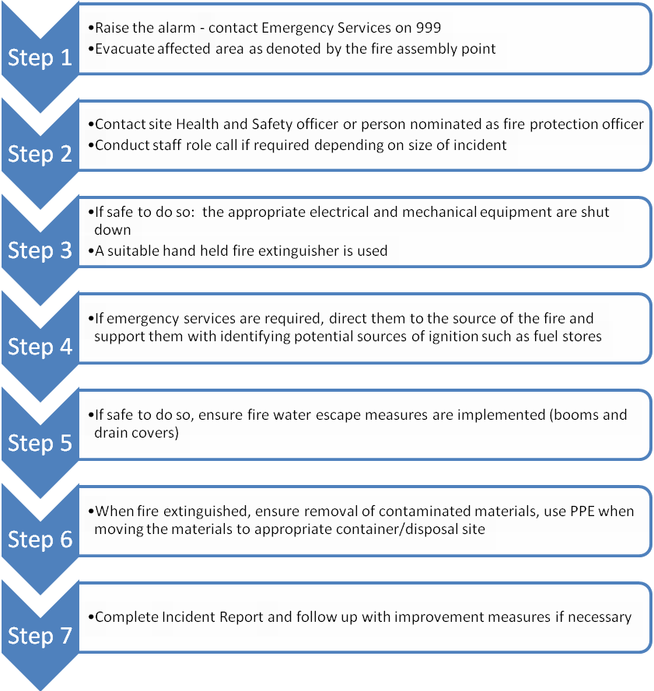
The Site Manager, will liaise with the Emergency Services on their arrival. The Site Manager will clearly identify him/herself to the Emergency Services on their arrival on site and update the FRS on the situation ensuring they are made aware of the location any compressed gases or flammable liquids on site.
Prior to arrival of the FRS on-site there are several measures that East Coast Waste Limited can take to help fight fire, assuming there is no risk to life.

- Hand held fire extinguishers & fire blankets can be deployed in order to contain fires where possible see 3.1
- Access to the hydrants located in the road may be used by East Coast Waste Limited staff if required – see annex C – Fire hydrants in Harfreys Rd <150m from the site.
- Fire blankets/sheets can be used to smother smaller isolated sources of fire. See 4.1
- The quarantine area is 400 cubic metres and can accommodate at least 50% of the largest waste pile (720 cubic metres in the yard). See appendix A.
- In the event of a fire or observed self-combustion, burning waste, if safe to do so, will be moved to the Fire Quarantine Area or alternative designated site.
- The Fire Quarantine Area is Demarked.
- The quarantine area, when made safe, will be emptied immediately. Should it be necessary to move or divert wastes to an alternative site then an alternative permitted location will be used. Vehicles will be directed to this site. (Note the only vehicles coming to site will be East Coast Waste Limited owned operated vehicles or suppliers and not the general public so all drivers will be notified to divert to this location).
- Neighbours and local businesses downwind will be notified of any potential fire incident by the site operator by telephone as soon as possible from the local contact list. This will be completed by telephone and will be completed as soon as it is safe to do so. Local receptors will be notified in order of proximity to the site and prevailing wind direction. Local receptors will be kept updated as to the progress of fire-fighting as new information comes to light and fully debriefed at the end of the event.
- Once the fire has been dealt with, post fire de-contamination arrangements will be agreed with the local EA officer
- The site is an impermeable surface and will be scraped clean
- The sump will be gulped out and cleaned by tankers with whom East Coast Waste Limited have a contract.
- Waste will be removed from site if necessary
- If necessary, soil and groundwater monitoring will be undertaken as agreed with the EA
- Once the local EA officer has agreed that the site is ready to become operational again then operations will recommence.

  - Managing Fire Water
Table 3 shows the potential volume of fire water which may need to be managed on site should the largest waste pile require quenching.

Table 3: Volume of Water Required – EA guidance 2000l/min for 3 hrs for 300cubic M
Water Required (L) for 1 cubic M/3hrs | 6.6
Total water required for 720cubicm/3hrs | 855,360L
*Based on EA guidance:

Table 4 shows the volume of fire water which can be contained within the site. The recycling operation benefits from being inside a bunded area and sealed drainage system around the perimeter which will contain firewater. There is one surface water lagoon on site in addition and this is emptied as required under a planned maintenance schedule by the operator. There is no discharge to surface water.

Table 4: Volume of Firewater Contained within Site
Average Site Length (m) | 150
Average Site Width (m) | 100
Water Depth (m)* | 0.1
Site Volume (m³) | 1500
Site Volume (l) | 1,500,000
*minimum height of curb or boom

These tables show that the site would be able to contain the volume of water needed in a worst-case scenario. Therefore, the key receptors in Annex D which could be affected by firewater will be protected. A pollution prevention boom inflatable will be deployed should firewater need to be contained during a fire. The site entrance will be protected by kerbing of 10cm to prevent egress of firewater out of the entrance. This is unlikely as the site slopes towards the lagoon to the NE.
The site is surrounded by large soil bunds on all sides to prevent the loss of firewater/surface water. The small entrances are ramped to provide water retention.

East Coast Waste Limited has a contact for emergency spillage response with a company which provides tankers to remove firewater. The company would come to site to remove water from the site contained by the walls. Surface Water from the yard is retained in an engineered sealed blind tank owned and operated by the operator. See Emergency Contacts, Annex G.

  - Future Actions
This plan is based on current planned operations. East Coast Waste Limited understand that it is important that this Fire Prevention Plan is maintained up to date and relevant to the business. Therefore, it will be updated accordingly, in collaboration with the Environment Agency as required, should business operations change in the future.

- Annex A: Site Layout

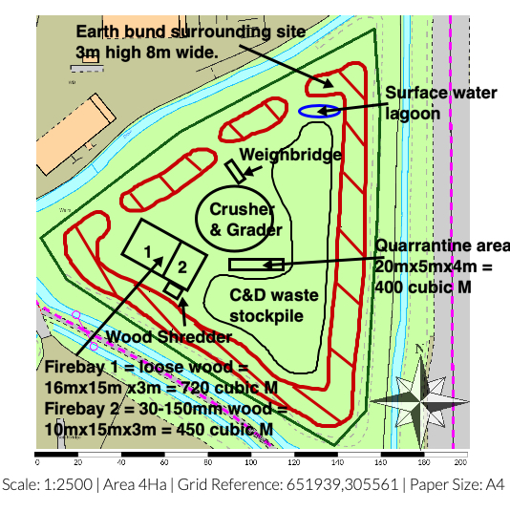

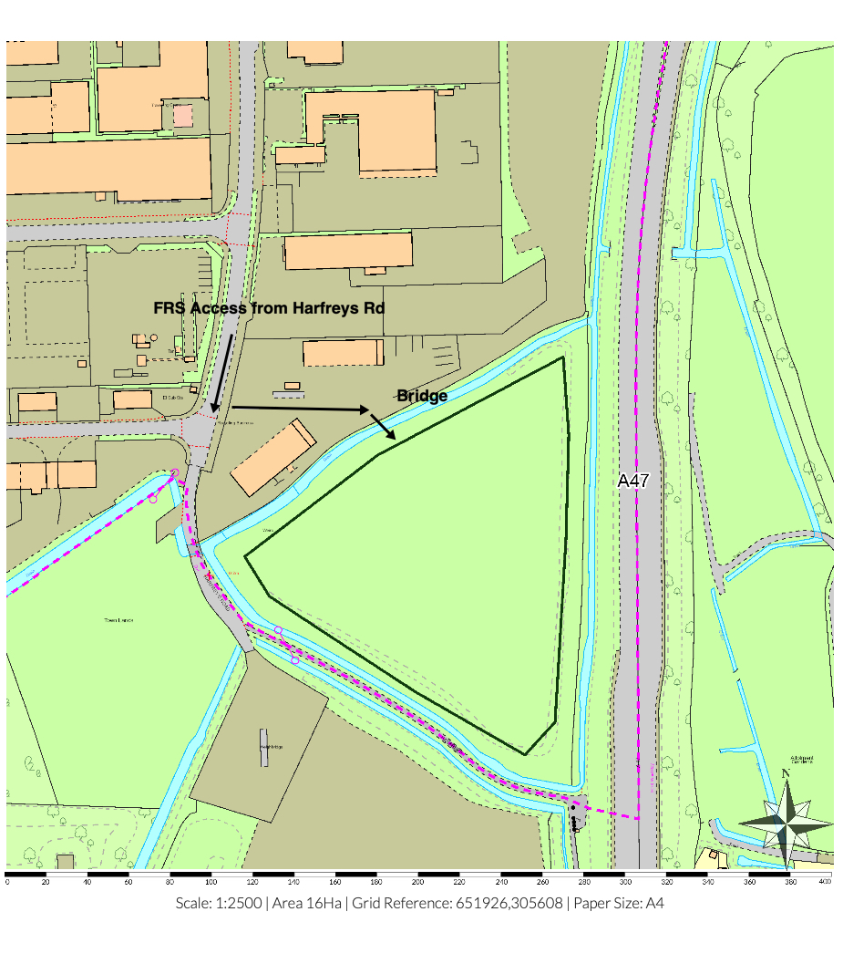A2- Site Access
- Annex B: Site Drainage

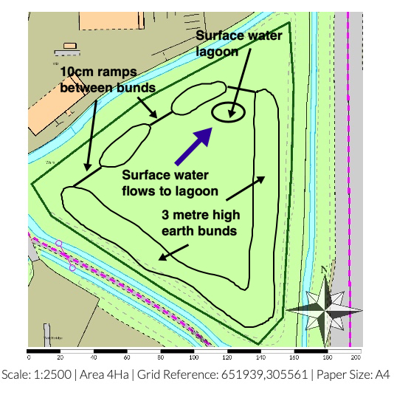
- Annex C1: Fire Fighting Access, Equipment & Water Supply Plan

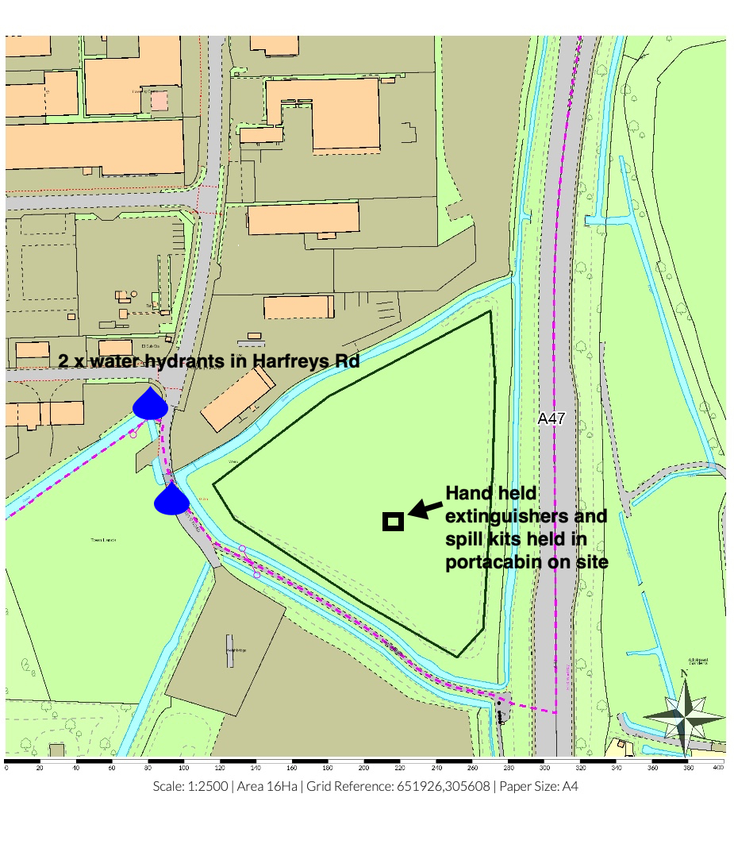
Car parking area

- Annex D: Key Receptors
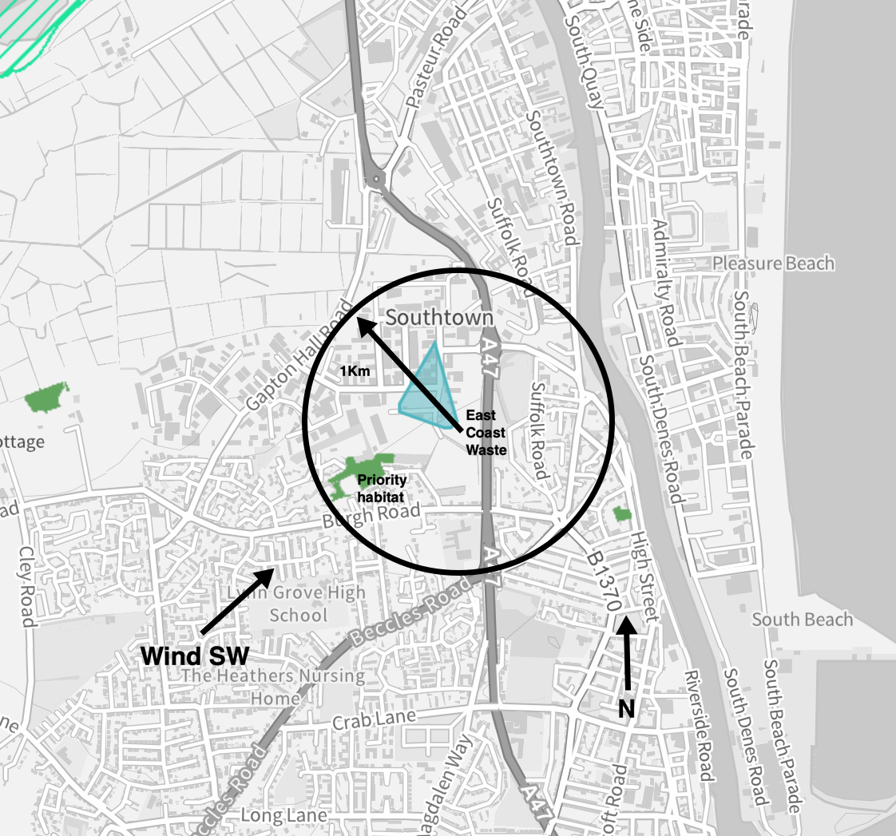 | Key Receptors  The receptors shown are within 1km of the site (black circle). Sensitive human receptors include areas containing residential properties & light industry all round the site.  The site is in on a small industrial estate which is bordered to the N&W by industry. There are no SSSI’s within 1Km but there is priority habitat (woodland) 500m SW.Key infrastructure includes the A47 to the east.  The nearest Fire Response Service is in Great Yarmouth NR30 2RP some 1Km NE.  Wind Direction  According to the UK Met Office, the prevailing wind direction in the area is South-Westerly. This means the prevailing winds blow over the site to the north east, which is away from the bulk of the residential areas.

- Annex E: Waste Acceptance Procedures
In order to identify non-compliant wastes including any hot loads, the following Waste Acceptance Procedure is implemented by East Coast Waste Limited.
Waste Acceptance
The procedure that shall be adopted at site is detailed below
1. Waste arrives on site.
2. Documentation is checked at the office at the entrance to the site. See annex A2.
3. All vehicles will have their contents examined during unloading and this shall be crosschecked with the documentation presented.
4. Staff will check that the type of waste is acceptable in terms of the waste permit.
5. If the waste is unacceptable the waste shall be isolated and arrangements put in place for the contractor to remove the waste from site or for the waste to be segregated in the quarantine area until such times that it can be removed.
6. If the person who is checking in the load is suspicious of, the load shall be sampled and inspected to ensure that it corresponds to the accompanying documentation. In any event compliance testing will be carried out at regular intervals.
7. Assuming the on-site verification is satisfactory, the load is checked in and directed to the yard as appropriate. the waste will be unloaded, and weigh bridge ticket issued.
N
- Annex F: Fire Risk Checks Form for Fire Prevention
The following regular check has been completed:

Checks to be made
- Signs of Self Combustion – no smoke visible /potential hot spots identified (daily)
- Storage areas – housekeeping is suitable (daily)
- Storage areas – pile sizes within permitted limits (daily)
- Exhausts – exhausts are cool and located away from combustible materials(daily)
- Fire fighting water – all hose reels and hydrants are accessible(daily)
- Fire extinguishers – all fire extinguishers are in the correct place and intact(daily)
- Fire Quarantine area – clear from waste and signage intact(daily)
- Mobile plant parked remotely, secured and key out when site closed(daily)
- Waste turned when? – recorded on waste inventory in site office(monthly)

Date | Morning check (initials) | Evening Check (Initials) | Issues to Report to Site Manager

- Annex G: Emergency Contacts

Name & Address |  | Telephone Number
Environment Agency | General Enquiries:  Incident Hotline Reporting: | 03708 506 506  0800 80 70 60
Electricity Supplier & mains switch location
Gas supplier & shut off valve location
Water supplier & shut off valve location
Local Authority Emergency Services
Insurance Company and policy number
Nearest Hospital
Emergency Spillage Response company

- Annex H: EMS Documents
Drainage & Bund Checks
- A current site drainage plan will be drawn up and displayed in the office areas for information. The standard colour coding of blue for surface water drainage that discharge to the environment and red for sealed or foul drainage systems will be employed.
- The integrity of sumps & storage areas will be visually inspected by the operator on a monthly basis. To achieve this, it will be necessary to sweep/ wash clean the impermeable surface that forms the licensed area and clear any debris that has collected in drain gulley’s to the front of the building. Where any defects are found, remedial steps will be taken promptly to maintain the integrity of the structure. If, however the integrity of the structure is breached a temporary repair will be made by the end of the working day and a full repair will be made by a competent team.

Area | When Checked | Date | Comments
firebays | weekly | 19/11/22 | Clean
Hardstanding | 6 monthly

Site Vehicle and Machinery Maintenance.

- All site vehicles and machinery will be fitted with working exhaust silencing equipment.
- Staff will not continue to operate any piece of machinery or equipment that appears to be visibly or audibly failing.
- All vehicles and machinery operated within the site will undergo regular planned preventive maintenance/ servicing and inspections, at the frequency deemed appropriate by manufacturer or required by legislation. As a minimum, this will be a statutory annual inspection of lifting (LOLER) and work (PUWER) equipment. Maintenance/ Servicing and inspection records will be kept on site for reference.
- Where the necessary maintenance and repair skill do not exist within the company, a contract for these services will be in place, so that the repair of site vehicles and machinery will be undertaken promptly.
- If mobile plant maintenance/ repair will involve the removal/ loss of potentially polluting fluids from the vehicle, if possible, the vehicle should be moved to impermeable concrete area and worked on there, where any spills will land on an impermeable surface. All fluid leaks or drained oils will be collected in a container and removed.
- Where mobile plant must be repaired in the location that it breaks down, if this is on hard standing, drip trays and absorbent mats will be put in place under the vehicle before work begins, to capture any spills of potentially polluting substances and prevent contamination to the earth below.
Plant and Vehicles will be inspected by driver and at service intervals.

Equipment | When checked | Date | Comments | signed
Delivery vehicles | weekly
FLT’s | Manufacturer’s Specification

Dealing with Spills

Scope: To detail how spills during normal and abnormal operations are dealt with to minimize impact on the environment
Responsibility: Site owner
Background: Spillage of oils and chemicals can have an impact on the soil and groundwater beneath the site.
The site carries quantities of absorbent granules and absorbent booms to mop up small quantities of hydrocarbon and other liquids if spilt. If used these are stored in a hazardous waste container until removed from the site by specialist contractor within a reasonable period of time.

- During normal operations, all staff have been made aware of the requirement to minimise fuel and liquid spills on site
- All staff have had appropriate training on how to deal with a fuel spill in the event of an incident occurring
- Absorbent is used to clean up the spill at source. If it is a larger spill and it is safe to do so then the source of the spill is curtailed if possible.
- The location of spill kits and absorbent material is identified on the site plan
- Where possible all spills are directed to the sealed drainage system for containment
- A store of general absorbent material will be kept on site in an easily accessible central location known to all site staff. The absorbent material will be hydrocarbon (fuel, oil etc.) absorbent, as this is the most likely material to be spilt on site.
- A boom will be kept on site. Management will know where the boom is stored on site and how it should be deployed so as to be effective. Booms length will be enough to cover the entrance to the site.

- Where leakage from any storage container on site is found, actions to remedy the leak will be taken. Any such leakage and remedial action will be recorded in the site diary.
In addition:
- The source of the leak or spill will be investigated, located and stopped.
- If any significant leaks or spills of substances occur, which have the potential to harm the environment or pose a risk to human health; the materials detailed under the section 'site provisions' will be utilized and disposed of appropriately.
- Any pooling leak or spill of a potentially polluting liquid will be soaked up with appropriate absorbent material, such as saw dust, sand or granules. The absorbent material will be cleared from the ground when it has soaked up all free polluting liquid.
- In the event of a significant and/ or on-going leak or spill of a potentially polluting liquid, clay damit mats or suction covers will be applied to drain grills to seal them to prevent (further) liquid from entering the drainage system.
- If any leaks or spills of substances occur, which have the potential to harm the environment or pose a risk to human health escape the site boundary, the management will inform the Environment Agency immediately. Any remedial action specified by the Environment Agency will be undertaken, a record of which will be made in the site diary.

Waste Acceptance, Storage and Inspection
To deal with the acceptance, storage & inspection of waste on-site.
Introduction
The company will introduce a system of storage on-site to minimise the potential for cross contamination and potential run off from wastes whilst stored on site.

Waste Types
Only the waste types and EWC codes named on the environmental permit will be accepted at the site. Wastes entering the site will be inspected and registered at the site. Non-compliant waste materials not allowed on the permit will be turned away from the site. A record will be made in the site diary.

Working Hours

Normal working hours will be 0800-0800 Monday - Monday

24 hours a day 7 days a week.

Responsibility

The Site Manager is responsible for identifying and highlighting non-conforming waste. The Environmental Manager is responsible for inspecting, documenting and safe removal of any non-conforming waste.

Waste Storage
Areas will be nominated on-site for storage. These will be labelled and identified on the site plan. The site plan will be updated on a regular basis provide a record of what type of waste and quantity is kept on computer system.

Waste Acceptance
The procedure that shall be adopted at site is detailed below
1. Waste arrives on site.
2. Documentation is checked at the office.
3. All vehicles will have their contents examined during unloading and this shall be crosschecked with the documentation presented.
4. Staff will check that the type of waste is acceptable in terms of the waste licence.
5. If the waste is unacceptable the waste shall be isolated and arrangements put in place for the contractor to remove the waste from site.
6. If the person who is checking in the load is suspicious of its contents, the load shall be sampled and inspected to ensure that it corresponds to the accompanying documentation. In any event compliance testing will be carried out at regular intervals if required
7. Assuming the on-site verification at the office is satisfactory, the load is checked in and directed to the yard as appropriate. Here, the waste will be checked again to verify that the description is correct.

Waste Area Inspection
As part of the EMS waste areas are inspected routinely, deviations from normal operation conditions, result are logged and acted upon in the site log.

Records
East Coast Waste Limited shall keep records of all waste loads rejected including;
- Date
- Name of Carrier
- Source of Waste
- Vehicle Registration
- Description of Waste
- EWC code
- Quantity of Waste
- Name of person carrying out inspection
- Destination of Load prior to rejection.

- Annex J: FIREBAY Specification

1. INTRODUCTION
A. Jansen Beton BV supplies concrete blocks referred to as ‘Legioblock’. The Legioblocks
are stacked to produce fire-resisting retaining walls when storing combustible materials such
as timber and tyres in the open air. Since legislation and regulations in the area of fire safety
must be met, an investigation was performed. This report provides details of said
investigation.
20110645.R01b
Retaining walls with Legioblock concrete blocks
Fire resistance investigation (situations without a roof construction)
Date: 16 February 2012
T H E E N V I R O N M E N T , N O I S E , B U I L D I N G C O N S U L T A N C Y S E R V I C E S , F I R E S A F E T Y , S P A T I A L P L A N N I N G ,
P O L I C Y C O N S U L T A N C Y S E R V I C E S
- 2 - 20110645.R01b
Bestandsnaam: 20110645.R01b Legioblock in de open lucht.docx
Dateiname: Speicherdatum: 22-2-2012 9:56:00
2. PRINCIPLES AND SCOPE
The investigation is based on the provided data and applicable standards, in particular:
· The standard: DIN EN 13501-1:2007 Klassifizierung von Bauprodukten und Bauarten zu
ihrem Brandverhalten - Teil 1: Klassifizierung mit den Ergebnissen aus den Prüfungen
zum Brandverhalten von Bauprodukten (Fire classification of construction products and
building elements - Part 1: Classification using data from reaction to fire tests; + Blatt A1
2009; Sheet A1 2009);
· The standard: DIN EN 13501-2:2008 Klassifizierung von Bauprodukten und Bauarten zu
ihrem Brandverhalten; Klassifizierung mit den Ergebnissen aus den Feuerwiderstandsprüfungen
(Fire classification of construction products and building elements - Part 2: Classification
using data from fire resistance tests, excluding ventilation services; + Blatt A1
Entwurf 2007; Sheet A1 Layout 2007);
· DIN EN 1363-1 Einheitstemperaturzeitkurve (Standard fire curve);
· Eurocode 2 Teil 1-2 (EN 1992-1-2) Bemessung und Konstruktion von Stahlbeton- und
Spannbetontragwerken – Teil 1-2 Allgemeine Regeln – Tragwerksbemessung für den
Brandfall (Design of concrete structures – Part 1-2: General rules – Structural fire design);
· Fire Recyclinghof Essen, 26 January 2011;
· Fire Kost Bochum, 16 July 2007.
The principles have been explained by the customer.
The most important objective with regard to the classification in storage sections separated
by concrete retaining walls is to prevent fire propagation. This mainly applies to fire propagation
towards the adjacent premises of third parties but also the adjacent storage sections and
buildings on the organisation's own business site. In addition, health and environmental risks
play a role as does the risk involved in fighting fire.
The concrete blocks are made of grade C25/30 concrete (no reinforcement) and their dimensions
(length x width x height) are 1.6 m x 0.8 m x 0.8 m or 1.6 m x 0.8 m x 0.4 m with the
related accessories. The concrete blocks are stacked on top of each other using studs and
holes that fit together. The blocks have chamfered edges that measure 10 mm. The thickness
of the retaining wall measures 0.8 m.
The concrete Legioblocks are incombustible and fall within the highest A1 class in accordance
with the DIN EN 13501-1 standard.
The present investigation is related to the following application area:
· Combustible materials such as timber, rubber and PVC. No combustible materials with a
specific energy higher than 35 MJ/kg. No liquid fuels or explosion hazardous materials.
· Retaining walls in the open air without a roof construction.
· Retaining walls up to a height of 6 metres.
· Retaining walls up to a height of 8.8 metres with combustible storage material up to 1.6
metres below the level of the retaining wall.
· Retaining walls higher than 6 metres where the vertical gap openings between the Legioblocks
(insofar as they are wider than 5 mm) are sealed to be fire-resistant.
· No covering of the storage materials (this may contribute towards fire movement through
the open seams of the retaining wall). No storage of large horizontal sheets (sheet width
>1 metres).
· Vertical retaining walls on one, two, three or all sides of the storage material.
- 3 - 20110645.R01b
Bestandsnaam: 20110645.R01b Legioblock in de open lucht.docx
Dateiname: Speicherdatum: 22-2-2012 9:56:00
· An appropriate structural stability of the retaining wall in accordance with the EN 1990 and
EN 1991-1 standards.
3. FIRE RESISTANCE ANALYSIS
A link with current standards such as the DIN EN 13501-2 standard has been sought as
much as possible when assessing the fire resistance of the Legioblock retaining walls. The
fire resistance is expressed in minutes where the criteria for Tragfähigkeid (R; Load-bearing
capacity), Raumabschluss (E; Integrity) and Wärmedämmung (I; Thermal insulation) have to
be met. The REI120 classification, for example, represents a structure that will meet these
three criteria for 120 minutes. The fire resistance of a retaining wall is determined by the following:
· The temperature behaviour and heat radiation on the cold side of the wall (§ 3.1).
· Spalling: decay of the concrete surface because of heat (§ 3.2).
· Fire-tightness.
· Open seams between the concrete blocks.
· Structural aspects: the wall may not collapse.
3.1. Temperature behaviour and heat radiation
Calculations have been made with regard to the temperature distribution in the concrete
based on the DIN EN 13501-2:2008 standard regarding the fire resistance of concrete. The
retaining wall has been represented schematically as a solid concrete wall with a temperature
of 1200 °C on the fire side. Temperature calcu lations have been made using the finite
element method. The following principles were used when making the calculations:
· Heat conductivity coefficient of the concrete: 2.0 W/mK
· Specific heat: 840 J/kgK
· Contact resistance on the fire side: 0 m2K/W
· Contact resistance on the protected side: 0.20 m2K/W.
The calculated temperature behaviour is shown in Figure 1. It shows that the calculated surface
temperature on the other side is less than 22 °C after 4 hours. The radiation heat is,
therefore, less than 1 kW/m2.
- 4 - 20110645.R01b
Bestandsnaam: 20110645.R01b Legioblock in de open lucht.docx
Dateiname: Speicherdatum: 22-2-2012 9:56:00
3.2. Concrete decay: 'spalling’
An internal pressure is created when concrete is heated quickly because the moisture present
is converted into steam in a short period of time of which the volume increases considerably
and quickly and the external layer can be compressed. This is referred to as 'spalling'.
Spalling has been taken into account when dimensioning concrete structures based on current
structural standards such as Eurocode 2. The spalling is factored into a reduced residual
cross section of the concrete wall. It must be concluded that the decay (‘spalling’) of the nonreinforced
concrete blocks is limited to the surface and does not have a considerable impact
on fire resistance based on Eurocode 2 regarding the fire resistance of concrete structures. It
has also been observed that the spalling was limited to the corners of the concrete blocks in
outdoor fires that have occurred during the last few years. This decay does not affect fireresisting
performance and the Legioblock retaining wall will remain erect during a fire for at
least 4 hours.
3.3. Seams/gaps
The blocks are stacked on top of each other using studs and holes that fit into each other.
Despite careful stacking, gap openings between the stacked blocks are unavoidable both
horizontally and vertically:
· The horizontal gaps between the blocks stacked on top of each other can be a few millimetres
wide. The gap widths specified here are related to the net (aerodynamic) passage
opening of the gap. It can be concluded that flashover does not occur based on the dimensions
(height and width) of the gaps.
· The dimensions of the vertical gaps between the blocks placed next to each other are
related to the flatness of the substrate and are often limited to a few millimetres. A single
exceptionally wide gap may be unavoidable locally up to a width of 30 mm. The probability
that there will be fire movement through a vertical gap up to 30 mm has been further considered
below. Heat radiation, air movements and air pressure differences as a result of
fire have been taken into account.
3.3.1. Heat radiation
The vertical gap can offer a 'view' of the seat of a fire from the compartment to be protected.
A 30 mm gap offers a view factor of at most 0.02. Based on a seat of a fire with a radiation
intensity of 100 kW/m2, the radiation intensity on the receiving side will be 0.02 x 100 = 2
kW/m2. This radiation intensity is so slight that flashover is excluded.
3.3.2. Air movements
The movements of air, hot flue gases and flames through an open gap are determined by the
air pressure difference between both sides of the gap. This pressure difference is determined
completely by the fire when there is no wind: air (oxygen) is suctioned through the gap in the
direction of the fire. Hot flue gases will not reach the other side of the retaining wall.
‘Cold’ smoke can already penetrate up to the other side of the retaining wall when the wind is
weak. There is no source of ignition here so that fire cannot occur.
The situation where fire and flames are immediately against the retaining wall with a gap
opening immediately above the seat of a fire when the wind is strong perpendicular to the
- 5 - 20110645.R01b
Bestandsnaam: 20110645.R01b Legioblock in de open lucht.docx
Dateiname: Speicherdatum: 22-2-2012 9:56:00
retaining wall has been further considered. The combustible flue gases can only penetrate to
the other side of the retaining wall when the wind pressure on the retaining wall is higher
than the thermal pressure. The thermal pressure will depend on the height of the seat of the
fire + flames (chimney effect). The surrounding buildings and the storage material reduce the
wind pressure on the retaining wall (when compared to the wind pressure in the open field
with a wind pressure coefficient of 0.8). On balance, hot smoke can only reach the other side
of the retaining wall under extreme theoretical conditions (a storm exactly perpendicular to
the retaining wall or a narrow stack of material immediately against the retaining wall).
Flames do not penetrate through the gap to the other side of the retaining wall.
3.3.3. Conclusion regarding seams/gaps
Flashover through the open gaps between the Legioblocks has been excluded sufficiently
based on the above when considering the favourable factors specified below.
3.4. Other fire resistance aspects
The fire resistance of building structures is generally determined based on fire tests, for example,
in accordance with the DIN EN 13501-2:2008 standard. The present storage situations
are essentially more favourable than the standard situation:
· The lapse of time of the local thermal load of the retaining wall is less favourable than the
‘standard’ fire curve from these standards.
· The room exposed to fire has an overpressure during the fire test while the room exposed
to fire has an underpressure in the open air as a result of thermally driven air movements.
· Cotton buds are used to assess the fire resistance (fire-tightness) during the fire test.
These cotton buds combust shortly after being exposed to heat. The present materials
combust less easily as a result of the higher heat capacity, specific mass and chemical
composition.
The relevant literature mentions the release of oil when rubber burns. Should this be the
case at all, it would involve a small quantity. Oil and fire-extinguishing water can seep
through to the other side of the retaining wall. The oil will be cooled down and there is no
source of ignition so that flashover cannot occur.
The structural stability of the retaining wall is important. The structure of the retaining walls is
generally dimensioned based on the worst case scenario where storage material is present
on one side with a large safety margin. The load combination during a fire (and possibly a
strong wind) does not form a factor of any significance. The retaining wall will, therefore, not
collapse should there be a fire.
The favourable behaviour during a fire has been confirmed based on fires that have occurred
during the past years.
- 6 - 20110645.R01b
Bestandsnaam: 20110645.R01b Legioblock in de open lucht.docx
Dateiname: Speicherdatum: 22-2-2012 9:56:00
4. CONLUSION REGARDING FIRE RESISTANCE
Insight has been obtained into the fire-resisting properties of Legioblock concrete retaining
walls as partitions for the storage of combustible materials in the open air based on the
investigation. It can be concluded based on the investigation that the retaining walls have
fire-resisting properties at the level of the REI 120 classification. This applies under the
application conditions described in Section 2.
Schoonderbeek en Partners Advies BV
Ing. C.A.E. Rijk.

EA Guidance For Fire Prevention Plans, Version 3 January 2021
Provision and Use of Work Equipment Regulations 1998 (PUWER)
http://www.metoffice.gov.uk/climate/uk/regional-climates/

