East Coast Waste Limited
Dust & Emissions Management Plan
CONTENTS
1. INTRODUCTION 1
Roles and Responsibilities 1
Site Description 1
Site Plan 2
2. SOURCES, PATHWAYS, RECEPTORS 2
Source Materials - Inventory 2
Pathways 3
Receptors and Wind Direction 3

3. PRIMARY Emission CONTROL MEASURES 4
Releases 4
Impacts 4
Management of Releases 5
4. Monitoring & Trigger Levels 6
Introduction 6
Communication 7
Complaints procedure 7
5. Incidents and Emergencies 8
Appendix A Site Plan 9
Appendix B Emission Survey Form 10
Appendix C Complaint Form 12

- INTRODUCTION
  - This document provides the Emissions Management Plan prepared in accordance with Environment Agency Guidance in support of environmental permit application For a Construction & Demolition & waste wood recycling facility at Harfreys Yard, Great Yarmouth NR31 0LS.
  - The overall responsibility for this procedure is the Environmental Manager. The Environmental Manager will be responsible for ensuring the all staff are trained in this procedure.

  - The Site Manager is responsible for ensuring that the day-to-day operations are carried out in accordance with this procedure.
  - All staff are responsible for implementing this procedure and have a duty to carry out their roles to prevent emissions.
  - This plan aims to identify dust emission points as part of the recycling process. These are identified in table 1 below. It must be noted that these are not continuous emissions but intermittent emissions of (dust) as the process is not continuous itself. The process emissions are limited and maintained to ensure it's integrity. However on occasion dust emissions may eminate from this sources and it is for that reason this DEMP has been drafted.

Site Description
  - The site is located in Harfreys Yard, NR31 0LS yard by East Coast Waste Limited. They have operated another waste operation from the adjoining site for many years under both a standard rules and bespoke permit. The site is located just west of the A47 on an industrial estate bordered by commercial neighbours. There are no SSSI’s within 1Km and the site is not in an SPZ or flood zone. There is some priority habitat some 500m SE, however wind direction is N. The site is approximately 1.5 Hectares and all the external layout is impermeable concrete for the treatment of wood and hardstanding for the treatment of C&D waste.

  - Site operation includes the delivery, storage and treatment of wood by shredding and C&D waste by crushing and screening.

Site Plan
  - A basic site layout is provided in Appendix A and Appendix 1.
  - The company Environmental Management System (EMS) will be updated and revised accordingly as a living document as environmental management develops
- SOURCES, RELEASES, IMPACTS
  - This section sets out the protection sources of emissions, potential release points and receptors and abatement
  - Wood is stored in concrete firebays as per FPP and appendix 1.

Source Materials - Inventory
  - Given the materials used in the process, it is considered that the which are most likely to give rise to emissions/dust are those below - wood waste and C&D waste and in Table 1.
Emission source | Activity Description | Storage Technique | Emissions & Abatement
Process | Shredding of wood – wood waste | Process inside bunded area | Minimal run time and cover maintenance
Vehicles loading and unloading | Loading & unloading. | Stored and sheeted | Vehicles enclosed and sheeted where required.
Crushing & grading of C&D waste | Crushing & Grading C&D waste 17 codes | On site lagoon used for damping down | Damping down/sprinklers
Handling of materials on-site | Movement of material on site | stored internally in bays | Dust monitored and wind direction noted in site log. Damping down with water bowser and sprinklers if necessary
Table 1 Source Materials
  - It is anticipated that the likelihood of dust being emitted from these materials is medium on delivery or movement.
  - It is anticipated that the likelihood of mud being emitted from these materials is medium on delivery or movement
  - It is anticipated that the likelihood of mud & dust being generated from on-site activities is low/medium.

Pathways
  - The pathways by which the emissions from the sources identified above may impact upon a receptor are primarily:
- Air Movement of dust through air, not particularly relevant on a site which will store wood.
Mud via vehicle wheels onto and off of site. There is only 1 way in and out of site from
Harfreys Rd. There is a 10mph speed limit and an anti-idling policy for all vehicles.
2. Direct exposure. Particularly for staff, they will be exposed immediately to any dusts from the handling on site.

Receptors and Wind Direction
  - The site is on an open industrial estate which means key receptors sensitive to dust are staff and visitors to the businesses which surround the site as well as environmental receptors. There are no SSSI’s within 1Km. The area is one of industrial/agricultural activity with no immediate residential neighbours.
  - There are residential properties within 1Km approx. 200m East on the opposite side of the A47.
  - The key receptors are shown in Figure 1 below.
  - The prevailing wind direction in the area, where the site is located, is South-Westerly towards immediate neighbours.
  - The source Pathway Receptor Model can be seen in appendix D
    - 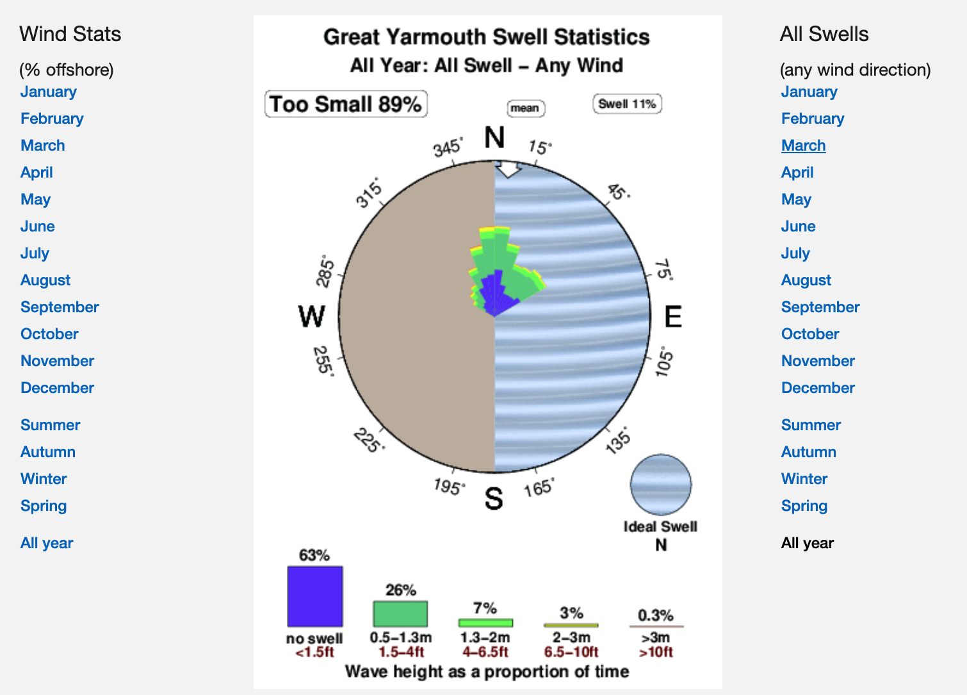
  - A wind rose is included for information. However all waste is stored inside a high (at least 4m high) bunded area where wind will have less/little to no impact.

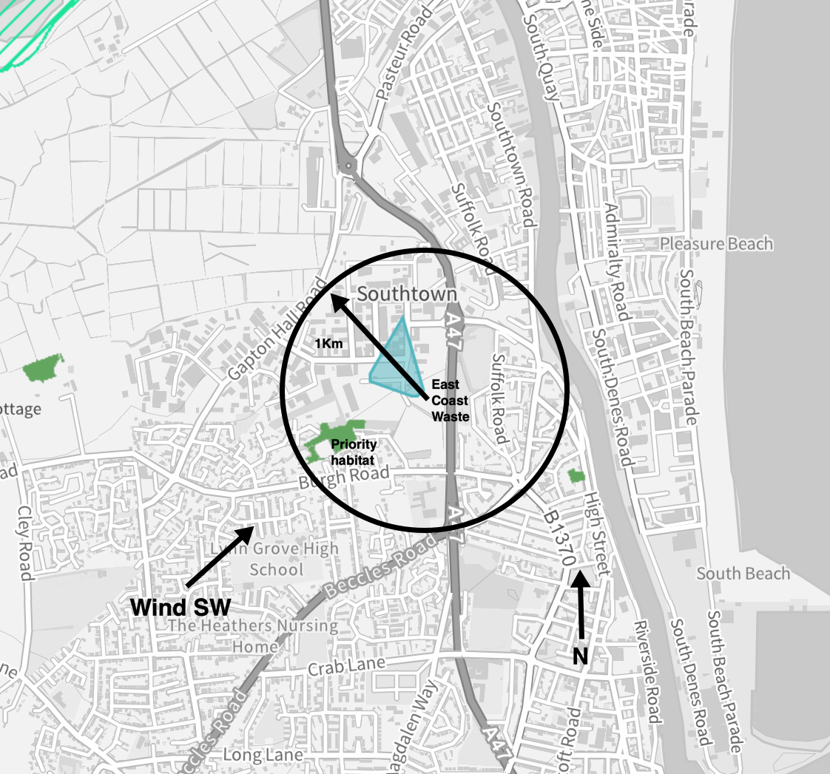

Figure 1: Site and Key Receptors

Receptor | Direction | Distance | Comments
Priority habitat | SW | 500m | Woodland
Nearest Residential | SW | 500m | Residential
A47 | E | 200m | Road
River Yare | E | 950m | River

- PRIMARY EMISSION CONTROL MEASURES
  - The control measures set out in this DEMP are commensurate with the medium mud/dust potential for the wastes.
  - Dust can only cause an impact when it is received at a receptor site. This DEMP has identified that the key opportunities for release of mud/dust are anticipated to be:
- When waste is delivered to site.
- When dust is emitted from crusher/shredder on abatement failure.
3. When wastes are handled on site. The site will minimise drop heights when transferring/loading and unloading materials.

4. When product is loaded and removed from site
Dust Suppression
The site has access to 2 fire hydrants located around the border of the site. Bowsers with water and pumps will be located as strategic places inside the bunds and water from the lagoon will be accessible during dry periods.

There will be no excess water reach drains externally as all systems are operated indoors and do not produce excess water. All water retained by the soil bunds which will be at least 4m high.

The system will have an emergency back up generator in case of power failure.

Deliveries are tipped and are sheeted during transit.
Housekeeping
The site has a roadsweeper that will be used to clean the site and access roads on a daily basis. The sweeper will be maintained to manufacturers standard and will be itself cleaned after use. The sweeper will focus on areas of high dust build up when completing its operation. The company has access to shovels (mechanical) and other cleaning equipment in the event of a spill on site.

Handling
Handling is minimised by careful loading, handling and unloading. This minimises dust emissions but also protects the machinery from adverse wear and tear and is an integral part of the process.

Impacts
  - The impacts of any emissions released as a result of East Coast Waste Limited activities will be linked to the receptors identified in Section 1, although dust is more likely to cause annoyance to neighbours rather than any lasting environmental impact due to it’s inert nature.
  - The receptors are more likely to be impacted upon by emissions in the following conditions:
- Prevailing wind direction is towards receptors; and
- Local weather conditions. Warm weather will contribute to the increased dust levels, although wind would act as the main transport agent.
- Wet weather will damp down dust but contribute to increased levels of mud on surfaces
- Cumulative impacts. It is anticipated that cumulative impacts will be minimal. The site is not in an area dominated by facilities which may cause additional mud/dust.

  - The impacts of emissions from the site are anticipated to be medium, given the nature of the material being handled and the location within an industrial setting. However, this will be confirmed regularly with monitoring and communication with neighbours. Visual monitoring is considered sufficient given prevailing wind direction and distance from human sensitive receptors. The site daily log will record wind direction & strength and note any visible dust blows and act accordingly. The visual monitoring period will be undertaken for 30 minutes and monitoring will be conducted as part of the daily walk around by the on site environmental manager who is familiar with the site and operations. Any blows noted above “normal” during operations will be noted and acted upon as per section 5 below.

Management of Emissions
  - If emission monitoring or complaints indicate a problem, East Coast Waste Limited will respond appropriately. Management measures to control releases will include:
- Reducing the handling time on site of materials. As part of the site’s Management System, information on the materials on site will be recorded via a ticketing system, including arrival time on site. The Site Manager is responsible for ensuring the residence time of materials site does not exceed that set out in the permit and therefore is able to identify how long each material is on site. Minimal handling will ensure that raw material & product are not moved too frequently and dust propagation is minimised

If the Site Manager deems that emissions are causing a disturbance, the Site Manager will log this as an incident, using the appropriate forms from the Management System and will take corrective action

The site management will liaise with the waste producers and transport contractors, with a view to minimising the storage and transport periods for the waste being delivered to the site;

- Unanticipated Emissions. Any unexpected emissions will be recorded as to composition, date and time noted at site and cause.

- Containment and abatement. Given the nature of the material handled on site, it is not considered necessary to implement containment and abatement techniques, other than those mentioned above. However, this is a ‘live’ document and as such will adapt if emissions arise which are not managed by the actions in this DEMP. As standard damping down, wheel washes and sheeting will be employed in any case.

- Monitoring & Trigger Levels

Introduction
  - To ensure that the emissions control measures set out in Section 3 are being effective, East Coast Waste Limited will ensure monitoring is in place and communication with potential receptors is maintained.
  - The following monitoring activities are regularly undertaken to ensure continuous improvement:
- Site inspections by the site manager (as outlined below)
- Site audits conducted by the company’s management;
- Site audits and inspections by the Environment Agency.

  - All site personnel will be responsible for reporting any dust/mud emission problems immediately to the site manager (or deputy).

Emissions monitoring
  - The Site Manager will ensure that regular inspections are made of the site and its perimeter in order to identify any sources of emissions and to establish whether any dust/mud is discernible at the perimeter and thus likely to impact upon receptors and neighbours or other road users.
  - In the event that mud/dust is detected at the site boundary, additional monitoring will be undertaken at the sensitive receptors in accordance with Appendix B.
  - An inspection will also take place in response to complaints. The surveyor will undertake the survey at the location of the complaint and at potentially sensitive receptor locations in the vicinity downwind from the site. At each location observations are made concerning the intensity of the dust/mud, its persistence and character (these details will be logged in the pro forma, see Appendix C).
  - The surveyor may be the site manager or alternatively a staff member from the office or external person who is not used to the emissions on the site.
  - Trigger Levels. If emissions are detected at the assessment location and is judged to be a moderate or unacceptable, as defined in reference Table A - Appendix B, then the Site Manager and Management Team will be informed immediately, and corrective actions will be determined and implemented.
  - Monitoring Frequency will be in accordance with Table 2

Technique | Frequency
Dust/mud Monitoring visible inspection | Daily & Weekly at site perimeter.  Positive Detection will lead to receptor monitoring.  Increase frequency in response to complaints
Complaints system | Continuous (24 hours) via telephone reporting system to Environment Agency  Direct complaints to site in operational hours
Table 2 Monitoring Frequency

Communication
  - Liaison with neighbours. If emissions are anticipated on site or weather conditions predicted indicate dust/mud will increase, the Site Manager will liaise with neighbours and ensure they are aware of the situation, how long it is expected to last and how to make a complaint.
  - Signboard. The site will have a legible signboard giving contact details for the Environment Agency and the operator. These numbers can be used in order to make a complaint.

Complaints procedure
  - All complaints, whether direct from people in the neighbourhood, or via the Environment Agency will be treated seriously by East Coast Waste Limited Limited and recorded in the Complaints Form in Appendix C.
  - Trigger Levels. The operator recognise that persistent dust/mud can be a concern for neighbours and residential areas. Every complaint is a trigger for management to take action to investigate the cause of a complaint, as set out in the complaints form.
Incidents and Emergencies

  - This section of the DEMP relates to potential incidents or emergencies which may impact on the ability of East Coast Waste Limited Limited to control emissions from its site.
  - Potential incidents which may impact on mud/dust are outlined as follows:
Potential Incident | Actions
Delivery of material which meets the requirements of the permit but which is unexpectedly awkward to handle and dusty | The Site Manager will:  - Refuse to accept the material if it is deemed inappropriate for the site.  - If the material can be managed on site, an appropriate storage area will be used or a suitable area undercover will be used  - Record the incident in the site diary and using the appropriate management system forms and records.
High wind/still conditions | If monitoring detects a problem, the site manager will:  - Ensure handling is kept to a minimum  - Record the incident in the site diary and using the appropriate management system forms and records.

Appendix-A

A1

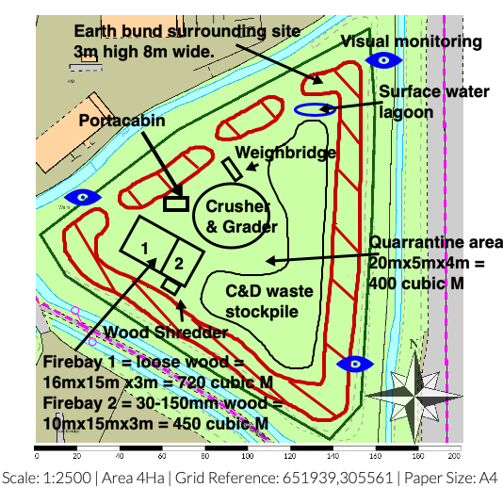

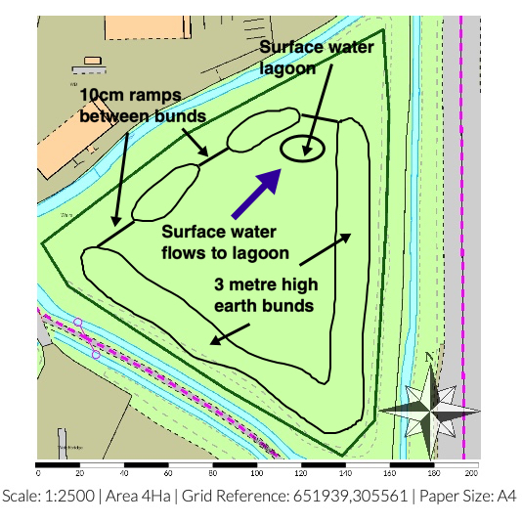

Drainage plan – no discharged to SW. All run off collected in lagoon and recycled for damping down.

Appendix B Emissions Survey Form

Emissions Survey Recording Form |  | Reason for Survey | Mud/dust detected at boundary? Y/N  Complaint Y/N  Other
Name of Surveyor |  | Job Title
Date |  | Time of Survey Start/Finish
Air Temp. ºC |  | Wind Direction
Survey Results
Location | Mud/dust Intensity  See Reference Table A | Mud/dust Extent  See Reference Table B | Description of emission  e.g. intermittent, ongoing?

Reference Table A: Emission Intensity
Intensity | Description
1 | No detectable emissions
2 | Slight dust noticeable (barely detectable, need to stand still and look into wind)
3 | Moderate dust (easily detectable while walking, possibly offensive)
4 | High dust levels (bearable, but intrusive and affects eyesight)
5 | Very high dust/mud

Reference Table B: Emission Extent
Extent | Description
1 | Local and not persistent (only detected during brief periods when wind blows)
2 | Not persistent as above, but detected away from site boundary
3 | Persistent but fairly localised
4 | Persistent and pervasive up to 50m from site boundary
5 | Persistent and widespread (detected >50m from site boundary)

Appendix C Emissions Complaint Form
Complainant Details
Time and Date of Complaint
Complainant Name & Address
Complainant Phone Number/ Email address
Emission Details
Date noticed
Time noticed
Location of emission (if not address above)
Wind Direction (e.g. From South West)
Complainants Description of Emission:
-What does it look like
-Intensity (see reference Table A, Appendix B)
Duration – how long was it detected for
Constant/intermittent in this period
Complainant comments/observations
Additional Information
Are there other complaints from this area?
Is East Coast Waste Limited the likely source of the emission?
What was happening on site when the emission occurred?
Corrective Actions
Actions Required
Deadline for Actions
Person Responsible for implementing actions
Form completed by
-Name and Role
Date
Signature

Appendix D Source/Pathway/Receptor Model

Source | Pathway | Receptor | Type of impact | Where relationship can be interrupted
Mud | Tracking dust on wheels and vehicles, then mud dropping off wheels/vehicles when dry | Roadways/ local environs / businesses | Visual soiling, also consequent resuspension as airborne particulates | Remove mud before vehicles leave site by wheel washing. Need for a road sweeper to be on site every day
Dust | Blown off material  piles and from vehicle movements | Roadways, protected habitats & species/businesses | Visual dust deposition on vehicles/business housing | Cover lorries before leaving site. Bowsers can damp down dust and sprinklers keep dust on the ground
Tipping, storage and sorting of material in the open | Atmospheric dispersion | Businesses, protected habitats/species | Visual dust deposition on vehicles/housing | Minimise dust emissions by handling in low wind conditions and damping. Sheet vehicles and bays.
Dust | Atmospheric dispersion | Businesses, protected habitats/species | Wind direction predominantly towards residents | Minimise dust emissions by handling in low wind conditions and damping. Sheet vehicles.
Vehicle exhaust emissions | Atmospheric dispersion | Businesses, protected habitats/species | Airborne particulates | Regulatory controls and best-practice maintenance measures to minimise source strength
Non-road going machinery exhaust emissions | Atmospheric dispersion | Businesses, protected habitats/species | Airborne particulates | Regulatory controls and best-practice maintenance measures to minimise source strength

Appendix 1 Complaints & Neighbourly Relations

EP7 Complaints & Neighbourly Relations
- Any abnormal emission to the environment evident, such as mud on roads or dust will be recorded in the site diary.
- Any complaints received by the site, concerning emissions to the environment, will be recorded in the site diary. Any complaint made by an external source will be documented and dealt with in accordance with this procedure. It will be the responsibility of management to arrange for the complaint to be investigated, take any remedial action necessary and respond to the complaint if appropriate. Any written documents concerning the complaint will be kept for at least 2 years.
- The complainant will be updated on investigations of the complaint within 5 working days
- If several complaints are made simultaneously then work will be suspended pending further investigation
- If it is visually evident that substances (mud, dust) are being tracked out of the site onto the public highway, steps will be immediately taken within the site to prevent further transfer of material and the public highway will be cleaned by the end of the working day. Any such event will be recorded in the site diary.
- The site boundary will be visually inspected weekly by management for dust and debris; this would be in conjunction with the weekly boundary security inspection. If any material has fallen over/ outside the boundary it will be cleared as soon as practically possible, but within a week of discovery and so prior to the next weekly inspection. Litter will be cleared on the day of discovery. The weekly checks will be recorded in the site diary.

http://www.metoffice.gov.uk/climate/uk/regional-climates/so

