Fire Prevention Plan

Drurys Environmental Services Ltd

June 2021

Version 8

**Contents Page**

|  |  |  |
| --- | --- | --- |
| **Document**  **Reference** | **Section Title** | **Page Number** |
| 1  2  3  4  5  6  7  8  9  10  11  12  13  14  15  16  17  18  19 | Purpose  Scope  Management Responsibilities  3.1 Company Directors/Managers  3.2 Site Operatives  The Site  4.1 Site Location  Using the Fire Prevention Plan  Fire Prevention Plan Contents  6.1 Activities at the Site  3.2 Site Plans and Maps  Manage Common Causes of Fire  7.1 Arson  7.2 Plant and Equipment  7.3 Electrical Faults Including Damaged or Exposed Electrical Cables  7.4 Discarded Smoking Materials  7.5 Hot Works  7.6 Industrial Heaters  7.7 Hot Exhausts  7.8 Ignition Sources  7.9 Batteries and ELV’s  7.10 Leaks and Spillages of Oils and Fuels  7.11 Build-Up of Loose Combustible Waste, Dust and Fluff  7.12 Reactions Between Wastes  7.13 Deposited Hot Loads  Prevent Self-Combustion  8.1 Manage Storage Times  8.2 Monitor and Control Temperature  8.3 Waste Bale Storage  Manage Waste Piles  9.1 Maximum Pile Sizes  Where Maximum Pile Sizes Do Not Apply  Prevent Fire from Spreading  11.1 Separation Distances  11.2 Fire Walls and Bays  Quarantine Area  Detecting Fires  Suppressing Fires  Firefighting Techniques  Water Supplies  Managing Fire Water  During and After an Incident  Submitting the Fire Prevention Plan |  |

**1.Purpose**

The purpose of this document is to identify potential fire hazards, detail the controls implemented to prevent fires and the actions taken to reduce the impacts should there be a fire on site.

This plan has been prepared in conjunction with the format prescribed by the Environment Agency and detailed in the Environment Agency Guidance Notes.

**2.Scope**

This Fire Prevention Plan is applicable for Drurys Environmental Services, Folgate Road, Lyngate Industrial Estate, North Walsham, Norfolk, NR28 0AJ and adjoining Land on Cornish Way Business Park.

**3.Management Responsibilities**

3.1 The Company Directors and Site Manager

* Ensure the effective implementation of the Fire Prevention Plan.
* Allocate sufficient resources to ensure the Fire Prevention Plan can be implemented without causing implications to other operations.
* Ensure site staff are trained and have a basis level of competence to manage the arrangement for fire prevention and fire protection.
* Monitor the overall effectiveness of the Fire Prevention Plan through planned site inspections and record any findings.
* Review and update the Fire Prevention Plan as required.

3.2 The Site Operatives

* Follow operating instructions and report discrepancies between these instructions and the work to the site manager
* Maintain the fire prevention controls implemented by Drurys Environmental Services (as detailed in this Fire Prevention Plan).
* Report any activity or events which could jeopardise the site Fire Safety Strategy

**4.The Site**

4.1 The Site Location

Drurys Environmental Services, Folgate Road, Lyngate Industrial Estate, North Walsham, Norfolk, NR28 0AJ and Adjoining Land on Cornish way Business Park North Walsham NR28 0FE.



**Drurys Environmental**

**Process Site**

The site is located North West of North Walsham Town Centre on the Lyngate Industrial Estate. It is in close proximity of the B1145 and has a local road (Lyngate Road) run parallel along the Northern boundary. Access is via the Eastern side of the site which brings you onsite straight into the operational center.

The inert waste processing site is located nearby at end of private road on Cornish Way Business Park as outlined in red on plan below.

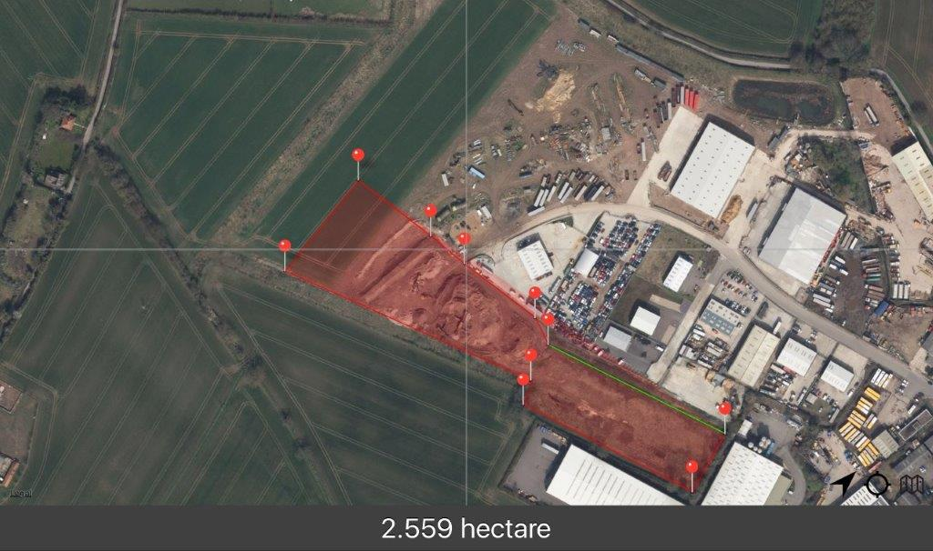

Drury Environmental Services have a throughput maximum of approximately 750000 tonnes of waste each calendar year with an average of 135 tonnes each working day (220 days). This waste is made up of Mixed construction and demolition waste, mixed municipal waste and soil/stones. The site has listed in its Environmental Management System maximum storage the following amounts:

* 50000 tonnes of Inert waste
* 3000 tonnes of Non-hazardous waste including plastics, paper, wood, card and green waste etc
* 250 tonnes of Metals.
* 10 tonnes of mirror entry (WFD) hazardous waste

**5.Using the Fire Prevention Plan**

All staff are aware that a copy of the fire prevention plan is kept in the office. All staff are required to attend an annual meeting with regards to the contents of the fire prevention plan. Any visitors or contractors working on site are required to firstly sign in at the office and to read and then sign the site safety rules which includes any fire prevention and instructions of what to do in the event of a fire on site. Any new staff are required to complete an induction process which includes the fire prevention plan and what to do in the event of a fire.

Emergency evacuations of the site are completed once every 6 months.

**6.0 Fire Prevention Plan Contents**

6.1 Activities at the site

All possible sources of ignition relating to the operations of the site have been included in the fire risk assessment. The possible sources are as follows.

Combustible of flammable waste including self combustion during storage

Smoking outside permitted areas

Electrical faults

Hot work

Machinery friction on hard surfaces

Shredding waste and associated processes

Hazardous materials are locked in a fire-resistant cabinet. Individual data sheets and risk assessments are also available. Flammable gas cylinders are kept in a caged area away from possible sources of ignition. The site plan includes two designated smoking areas.

6.2 Site Plans and Maps

Refer attached plans numbered 22209/1001, 22209/1003, 22209/1004

Local Receptors

Within 1km of the site the following key receptors are located (see also plan showing these):

* Lyngate Industrial Estate spreads out to 600 metres to the South West of the site with approximately 60 business operating.
* The Town Drain runs adjacent to the boundary on the West side of the site.
* One residential property located 150 metres to the East.
* B1145 runs in a North/South direction 400 metres to the East.
* Lynfield Road housing development (500+ residual dwellings) 450 metres to the East and South East.
* The small hamlet village of Swaffield is located 1000 metres to the North East of the site.
* National rail line located 800 metres to the South West of the site.

These local receptors would be impacted by a large fire on site, however, the prevailing wind direction is South-Westerly, thus significantly reducing the likelihood of impact of air emissions to those receptors located South and west of the site. In a prevailing wind event, the receptors in a direct path of air emissions are the residential properties located 600 metres to the North East towards Swafield.

The remaining land to the North of the site is mainly used for agricultural production. There are no protected habitats within 1km of the site.

**7. Manage Common Causes of Fire**

7.1 Arson

The site is protected from trespassers out of hours by a perimeter fence, hedge, town drain, locked gates and CCTV.

7.2 Plant and Equipment

All plant is inspected and recorded on a daily check basis and subject to an ongoing maintenance schedule. Mobile plant is parked away from combustible waste. Some equipment has integral fire suppression and there are adequate fire extinguishers attached to or nearby other machinery and equipment.

7.3 Electrical Faults Including Damaged Or Exposed Electrical Cables

All electrical wiring is checked regularly by a registered electrical contractor and portable appliance testing is also carried out annually.

7.4 Discarded Smoking Materials

There are two designated smoking areas in the Yard a significant distance from combustible waste. Staff are aware of the smoking areas included in the induction process. Subcontractors and customers are made aware of the smoking areas when they enter the site as part of the signing in procedure.

7.5 Hot Works

Hot works is not regularly part of Drury’s every day activities. Individual risk assessments and extra control measures are assessed before any such work can commence.

7.6 Industrial Heaters

Not Applicable

7.7 Hot Exhausts

Fire watch is completed at regular intervals during the day. The first visual check is completed before morning break at 10am. The second check is completed before lunch at 1pm. The third is completed before afternoon break at 3pm and finally at the end of the day approximately 4.30pm-5pm and entered in the daily site diary.

7.8 Ignition Sources

The wood burner is located in bay 7 which is more than 6 metres away from combustible and flammable waste.

7.9 Batteries And ELV’s

Non Applicable as not ELV site

7.10 Leaks And Spillages Of Oils And Fuels

Not Applicable as not ELV site

7.11 Build-Up Of Loose Combustible Waste, Dust And Fluff

Daily vehicle and plant checks are completed and recorded. The picking line is checked and where necessary cleaned regularly (every break time at 10am, 1pm, 3pm and end of day 4.30pm-5pm). The Yard is tidied and swept on a daily basis and where necessary a water bowser is deployed at regular intervals to dampen down the dust.

7.12 Reactions Between Wastes

All waste loads are checked for signs of items such as batteries and it is ensured that segregation of certain waste types is done including use of the quarantine area away from the waste processing area.

7.13 Deposited Hot Loads

Any such loads will be checked carefully and use made of quarantine area as necessary

**8. Prevent Self-Combustion**

8.1 Manage Storage Times

Some materials can spontaneously combust. This risk increases when materials are stored for prolonged periods.

The storage time limits are as follows:

|  |  |
| --- | --- |
| Combustible waste type | Maximum storage time |
| Non shredded | Up to 6 months |
| Baled and compacted wastes (if kept longer the bales need to be broken and re-baled) | Up to 6 months |
| Shredded | Up to 3 months |

The limits are adhered to at all times and checked on a weekly basis by the Yard Manager and/or Yard Supervisor. This is controlled and monitored by using stock rotation.

Stock rotation is used when placing new materials in each bay. This is completed in a methodical manner. Working from left to right along the bays.

8.2 Monitor And Control Temperature

The stored waste is checked at regular intervals at least weekly (checks are completed using random sampling ) using a temperature probe. A record of temperatures is taken and if levels are increasing suitable extra measures are then undertaken and recorded. All waste is removed from site within the specified maximum storage times.

If the waste has undergone any treatment on site such as shredding or baling further temperature checks are completed using a temperature probe. The waste is checked immediately after processing then again at the end of the day.

Detection of hotspots and training for detecting and managing hotspots.

Waste piles are turned routinely as part of the Yard management process. A site diary is used daily to identify possible external heating during the hotter months. If the weather is particularly hot the waste piles are moved to a shaded area.

8.3 Waste Bale Storage

Cardboard is baled on site. The bales are checked for hotspots after they have been through the baling process. Further temperature checks are made on a weekly basis assessing for any hotspots. The sampling protocol is 10% of all bales.

**9. Manage Waste Piles**

Pile sizes are minimised by the width of the bays and fully comply with the maximum pile sizes as specified by the guidance notes.

9.1 Maximum Pile Sizes

|  |  |  |  |
| --- | --- | --- | --- |
| Waste Type | Loose and more than 150mm | 30 to 150mm or baled | Less than 30mm |
| Tyres and Rubber | 450 cubic metres | 300 cubic metres | 300 cubic metres |
| Wood | 750 cubic metres | 450 cubic metres | 300 cubic metres |
| Green Waste | 750 cubic metres | 450 cubic metres | 450 cubic metres |
| Plastics | 750 cubic metres | 450 cubic metres | 300 cubic metres |
| Paper and Cardboard | 750 cubic metres | 750 cubic metres | 450 cubic metres |
| Textiles | 750 cubic metres | 750 cubic metres | 400 cubic metres |
| WEEE containing Plastics including Fridges, Computers and Televisions | 450 cubic metres | 450 cubic metres | 450 cubic metres |
| Metals other than WEEE | 750 cubic metres | 450 cubic metres | 450 cubic metres |

For all waste piles the maximum height allowed is 4 metres. The height is measured using the longest measurement between the base of the pile and the top.

For all waste piles the maximum length or width allowed is 20 metres.

For any waste piles containing a mixture of combustible wastes the maximum limit is based on the type of waste that makes up most of a mixed pile.

All waste piles adhere to the above restrictions.

**10. Where Maximum Pile Sizes Do Not Apply**

Not Applicable

**11. Prevent Fire From Spreading**

11.1 Separation Distances

The combustible waste piles are separated alternatively by the distance between the bays of a distance greater than 6 metres. The empty gas cylinder storage is completely segregated in another area of the yard next to the car parking bays (distance exceeding the 6 metre requirement). The flammable liquids are kept in a lockable flame resistant cabinet in the workshop (distance exceeding the 6 metre requirement).

11.2 Fire Walls And Bays

The storage bay walls are configured in such a way that they will act as fire breaks to minimize the spread of fire across the site. Predominantly the walling for the bays are constructed out of interlocking concrete blocks.

By using information provided by Legato™ Interlocking Concrete Block suppliers the radiated insulation properties of the blocks are sufficient to prevent transfer of fire via radiation through the blocks. These are listed giving a 120 minute integrity. Therefore, risk of a potential fire spreading across the storage bays would be because of winds fanning the flames between the bays.

**12. Quarantine Area**

A designated area within the skip storage area will be used or other suitable such areas within the processing area or vehicle parking area as a temporary facility for storage.

**13. Detecting Fires**

A manual fire alarm system will be in operation covering the waste processing areas.

**14. Suppressing Fires**

A water system using the permanent supply of water from the attenuation pond and town drain will be utilised for supressing fires.

**15. Firefighting Techniques**

There are several items of heavy plant available for active firefighting. These include loading shovels and teleporters

There is at edge of site an attenuation pond and the town drain with ample water sources and a full water bowser at all times on site. A pumping system can be used from the town drain which is also used for dust suppression on site.

The company has adequate finances for upkeep of above.

A combination of firefighting techniques would be used to extinguish the fire. These include:

1. Applying water to cool unburned material and other hazards.
2. Separating unburned material from the fire using heavy plant.
3. Separating burning material from the fire to quench it with hoses.

**16. Water Supplies**

The site has access to water supplies. There is access to hydrants (see plan 22209/1009), stored water from attenuation pond and running water from town drain alongside the site and a mains water supply. The following calculation has been completed for the largest waste pile catching fire which would be the worst case scenario.

The site would need at least 2877 litres a minute for a minimum of 4.3 hours for a 432 cubic metre pile of combustible waste.

**17. Managing Fire Water**

The waste sorting yard area is 100% concrete and is contoured in such a way to allow surface water to be contained within the boundaries of the site before it passes through an interceptor and discharged to the drain.

The site is bounded by a raised edge consisting of kerbs or precast concrete lips. The outside process area is approximately 5000m2 and has the potential to contain 15cm of fire water following the sealing of drainage gullies as detailed on the site plan. Therefore, the containment for fire-fighting water can be calculated as:

|  |
| --- |
| Containment on site: 5000m2 x 0.15m = 750m3 which is equivalent of 750,000 litres |

There is an increased potential for water to escape from the drainage gully that is in the middle of the yard. This gully will be sealed off with the gully seal in the emergency response kit located at the weighbridge.

There is also a potential for waters to escape the site into the Town Drain from the process area adjacent to the exit route. In any emergency event where there was a potential for waters to escape, temporary bunds will be made with woodchip/soil from the stockpiles. In any worse case scenario, the drain will be blocked upstream from the road culvert using inert soils from site to mitigate the potential pollution situation further downstream.

Any excess fire water would be tankered off site if deemed necessary after an emergency event. Drurys Environmental Services has contacts with local companies offering waste water tanker services.

There is one area of the site where the impermeable surface is not complete. It is located at the far end of the site and is used for empty skip storage.

In an event of a fire , the fire water would not flow to this area due to the higher level in that part of the yard.

**18. During And After An Incident**

Arrangements have been made with other nearby waste companies for diverting waste which are included in our sites disaster recovery plan.

We would also use the press leaflets and social media to inform nearby receptors of the situation also outlined in our disaster recovery plan.

Due to our previous experience of dealing with a major fire on site we also now have procedures for disposal of contaminated fire damaged waste and water. Isolation methods are also adopted on site to prevent water run off following a fire into mains drainage and town drainage systems.

**19. Submitting The Fire Prevention Plan**

A copy of the fire prevention plan has been sent to the Environment Agency.